Governance and Social Inclusion: Sustaining multi-sectoral food and resilience programs| 20 Nov 2019
Number of participants: Full plenary
Discussion highlights and conclusions
WHAT did we learn about approaches and interventions/activities? (all speakers consolidated)
- Shift to federalism mid-program required programs to reexamine their governance approaches to better connect communities to new ward-level government officials. PAHAL’s loose networks approach and Sabal’s inclusive governance framework were critical to enhancing these connections, particularly for disadvantaged households
- Bottom-up interventions - such as empowering poor, vulnerable and socially excluded people to organize and advocate for their needs - had to be complemented by top-down interventions – strengthening local government’s capacity for delivering quality services

What did we learn about HOW to implement and manage projects? (all speakers consolidated)
- Organizing community members into user groups (farmer groups, water users, cooperatives) was key to ensuring sustainable implementation of governance approaches. Through these groups, members were able to prioritize their needs in an inclusive and participatory way – and to then communicate these to the government efficiently
- Leadership building is time intensive but crucial, particularly for disadvantaged groups. Each groups needs must be assessed regularly to tailor capacity strengthening initiatives and to encourage an iterative process
- Creating space for negotiation and feedback between representatives and community members was critical to building trust of citizens in their governance and to fostering longer term relationships. This has improved linking and bonding social capital, critical for resilience to future shocks and stresses.

What do we RECOMMEND based on our learning (WHAT and HOW)? (all speakers consolidated)
- Use social accountability tools to keep community members informed on what civil society groups are doing. These tools increase transparency, build trust and facilitate better collaboration
- Ensure you have robust criteria for selecting disadvantaged households; it’s the engagement of the most marginalized community members in governance that can bring real transformation
- Assess the capacity of civil society groups on a regular basis and tailor your training modules accordingly – groups will have very different needs
- Think beyond user groups; intentionally connecting groups into larger civil society networks and beyond ward levels to municipality level and beyond will be key to sustainability and influence
- Register groups to ensure the government formally recognizes them. Registration builds group members’ confidence their ability to cope in the face of a shock or stress, and the likelihood government will support them if hit with a disaster (safety nets)

Key learnings (3-5) – to be elicited by moderator during the last few minutes of the session
- Governance and social inclusion are the cornerstone of transformational capacity. Inclusive, participatory governance interventions lead to real impacts – including improved social capital, access to infrastructure, access to agricultural services and formal safety nets
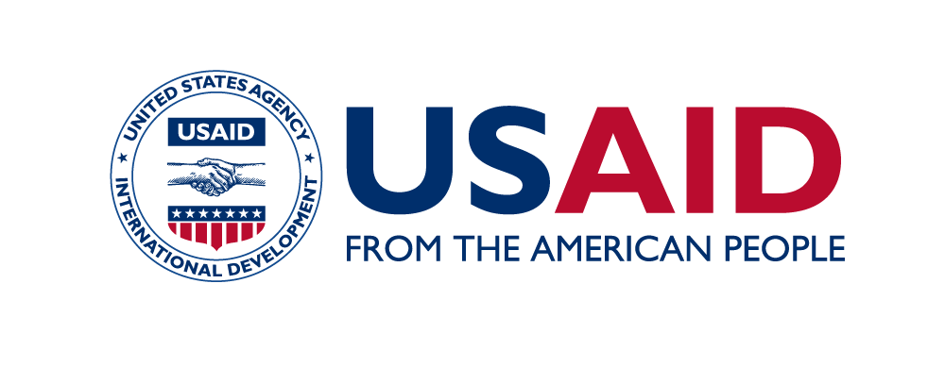
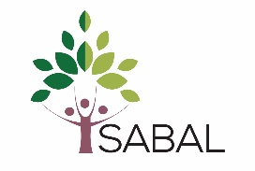
- Organizing community groups into user groups facilitates communication, efficient advocacy and capacity strengthening, but the long-term sustainability and influence of these groups requires strong linkages with larger networks, as well as recognition from government
- Like all interventions in Nepal, governance activities must be grounded in the context, tailored to specific group needs and iterative – this requires ongoing assessments, deep understanding of social dynamics, and intentional integration across program activities

