 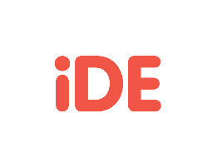

SANITATION POSSIBILITIES MAP CANVAS

The Sanitation Possibilities Map (SPM) is an adaptable tool that can be used anytime during the project cycle. It opens our minds to innovation and help us develop more user-centered sustainable solutions. This canvas will take you through the six steps needed to complete the SPM. To view the full quick guide, visit <https://www.fsnnetwork.org/resource/sanitation-possibilities-map>.

STEP 1

With your team, think about your intervention (project, product, or service), and list the full range of activities you think are necessary for your intervention to be successful. This is a key step to ensure you are considering the full range of activities to design. Then, plot the activities along the below value chain.

Example 1: Value Chain Example 2: Value Chain Filled Out

A set of empty boxes Icons and text descriptions for each: 
Barriers, Accelerators, Program Design, Product Design, Stakeholder Engagement, Private Sector Engagement, Training, Financing, Sales, Marketing, Transport, Installation, Adoption, and After Support

OPTION #1: Below are boxes to brainstorm and create your own value chain. You can type in the boxes. Use only the boxes you need.

START 

END

CONTINUE…

CONTINUE…

(type here)

OPTION #2: Print/Cut/Write - If you prefer to brainstorm on paper with your team members, you can print this page. Then cut the boxes out, write all activities and place them on a table or wall in the order for your team to view and edit until you come up with an accurate value chain. This method is helpful for step #3 to visualize with your group together.

STEP 2

Decide who the actors are along this value-chain and create a persona for EACH segment based on collected data and understanding of lived experience. For example, you may want to consider sanitation users, entrepreneurs, and sales agents. This activity is best undertaken with a wide range of stakeholder and staff members. Find the blank sheet on page 4 to create your persona.

Example 1 Persona Example 2 Persona Filled Out

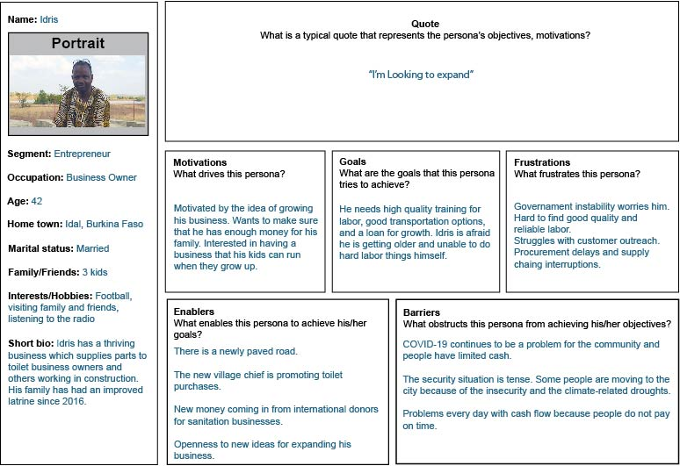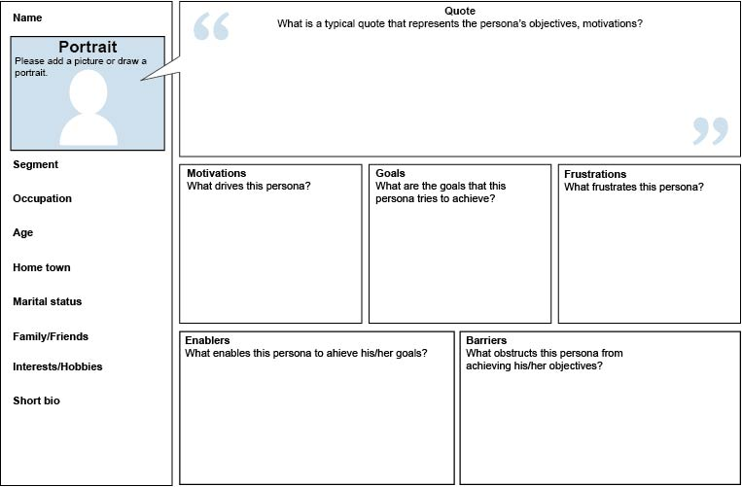

**Enablers**  
What enables this persona to achieve his/her goals?

**Barriers**  
What obstructs this persona from achieving his/her objectives?

**Motivations**  
What drives this persona?

**Goals**  
What are the goals that this persona tries to achieve?

**Frustrations**  
What frustrates this persona?

**Portrait**  
Add a picture or draw a portrait.

**Segment:**

**Occupation:**

**Age:**

**Hometown:**

**Marital Status:**

**Family/Friends:**

**Interests/Hobbies:**

**Short Bio:**

**Name:**

**PERSONA CANVAS**

**Quote**  
What is a typical quote that represents the person’s objectives, motivations?

STEP 3

Time for possibilities! Now you are able to begin brainstorming your possibilities. Use lots of sticky notes and don’t limit yourself. Any possibility you can dream of can be added here. Using the decided value chain activities on the X axis and the personas on the Y axis, move through each persona and brainstorm possibilities for that persona at each activity. You may want to use the paper value chain you created in step 2 with your created personas. You can also do this step on flipchart paper, or use an online collaborative tool such as Miro, Mural, or Google documents.

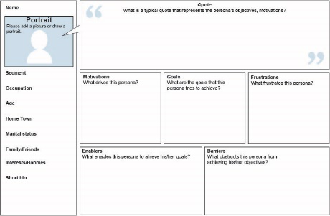

1 2 3 4 5 6 7 8 9 10 11 12

A.

B.

C.

STEP 4

Vote! Depending on the quantity of possibilities you have, you will give team members the opportunity to vote for their top 3-5 options. If you are doing this on paper, you might want to use markers or stickers to show which options are the most liked. If you are using a virtual platform such as MURAL, Miro, or Google docs, people can vote by using + signs or other icons. This round of voting should focus only on what is liked by you/participants.

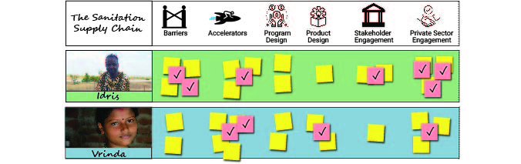

STEP 5

The winning possibilities. Those with the most votes move forward to a HCD analysis of “is this desirable, feasible, viable, and transformational?” You can type each possibility in the idea line below.

Use a (✓) check or (-) minus for each lens.

If an idea *does not satisfy all four*, then it *cannot move on.*

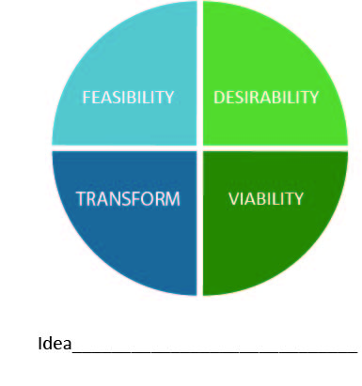

**Desirability**

* What’s the unique value proposition?
* Do people want this product or service?
* Does it make sense for them?

**Feasibility**

* Does this work?
* Is it functionally possible in the foreseeable   
  future?

**Viability**

* Can we build a sustainable business?
* What has to be true for this business to work?
* What are the costs?
* How will you pay for it?

**Transformative**

* Does it have potential to create  
  market system transformation?

Step 6

The HOW. Fill out a SCEMES canvas for each of your final ideas. These can be further refined in a co-creation session with your stakeholders or used to test/pilot ideas.

**Space:** When, where, and how will this idea take place?

**Cash:** What financial resources are needed to make this solution a reality?

**Helpers/People:** Who will implement this? Is support needed from other stakeholders to make this happen? How will government, local leaders, and other partners be engaged?

**Equipment:** What equipment does this solution need (e.g., cell phones, trucks)?

**Materials:** What material does this solution require and how will produce/acquire these (e.g., banners, handouts, cement)?

**Expertise:** What experts are needed to implement this solution effectively (e.g., marketing firm, digital dashboard designer)?

**Systems:** What systems are needed to be used or built to carry out this solution and who will support this (e.g., sales agents)?

**Space**

**Cash**

**Helpers/People**

**Equipment**

**Materials**

**Expertise**

**Systems**