Increasing Savings and Access to Loans: Building Resilience or Reinforcing Cycles of Debt
Nov. 20, 2019
Panelists: Penny Anderson, IDEAL, Sagar Pokharel, PAHAL, Toynath Pandey, DEPROSEC (SABAL Partner), Noor Pradhan, Lumbini General Insurance Co. (SABAL Partner)
Discussion highlights and conclusions
WHAT did we learn about approaches and interventions/activities? (all speakers consolidated)
• PAHAL focused on linking participants to more formal financial services, such as Cooperatives, which PAHAL theorized would yield more resilient outcomes. Chose to work with Cooperatives to build their membership base and with cooperative members to increase their financial knowledge to understand/use financial services.
• SABAL focused on VSLA (Village Savings and Loan Association) model to increase savings and offer access to loans to provide a coping mechanism to manage shocks and stresses. These were supported by linking participants to micro health insurance, private livestock and crop insurance and linking VSLAs to formal financial service providers (cooperatives, microfinance development banks).
• SABAL partnered with private insurance companies and government to increase access/use of livestock and crop insurance through subsides with several lessons learned for insurance providers, local gov. and supporting institutions like SABAL.

What did we learn about HOW to implement and manage projects? (all speakers consolidated)
• PAHAL used a Recurrent Monitoring System (RMS) to understand how financial services were being used and if use of these services contributed to resilience outcomes. When early findings showed an increase in household (consumption loans), it gave PAHAL a chance to correct this. Documenting behavior like whether participants used one loan to repay another, which was very low, helped show that participants were not going into debt to repay a loan.
• SABAL used VSLAs to link members to other financial services while offering a key service, a safe place to deposit funds and access to loans to cope with shocks & stresses.
• Livestock insurance was a key risk mitigation strategy for vulnerable populations and when subsidies were offered it made it a commercially viable product that was attractive to participants.

What do we RECOMMEND based on our learning (WHAT and HOW)? (all speakers consolidated)
• PAHAL recommends incorporating financial literacy training (FLT) into financial inclusion interventions to encourage positive behaviors, such as, 96% cutting expenses, 70% (participants) joining a cooperative, 62% creating a family budget, 53% increasing savings, and 40% taking a loan. FLT also helped encourage positive coping strategies for how to use loans, such as, investing in multi-use water systems, non-farm livelihood activities, and kitchen garden inputs.
• SABAL’s recommendations for uptake of insurance products include: 1) train community members to sell & explain policies. 2) work with local insurance providers for ag insurance offerings and 2) focus on quality of health services to micro health insurance.
• Livestock insurance recommendations for: 1) insurers – focus on improving settling claims/losses promptly, 2) Government – providing too high of a subsidy or for too long could create a disincentive to take care of livestock, 3) for partners (like SABAL) – catalyze innovation, make process smoother for providers and insured e.g. mobile app to process claims & take premium payments

Key learnings (3-5) – to be elicited by moderator during the last few minutes of the session
• Savings are key for ultra-poor and landless; are there are other pro-poor financial services that can serve vulnerable populations?
• Through supporting Cooperatives (financial literacy training) and improving public trust in joining Cooperatives, it enabled Cooperatives to offer improved financial services (e.g. lower interest rate loans) that were shown to be used for positive coping strategies (e.g. invest in non-farm livelihoods or ag inputs).
• Financial literacy pushes and promotes savings. If we can increase savings, we can increase sustainability of institutions and (potentially) help them to more resilient to shocks and stresses and be there for communities in times of need.
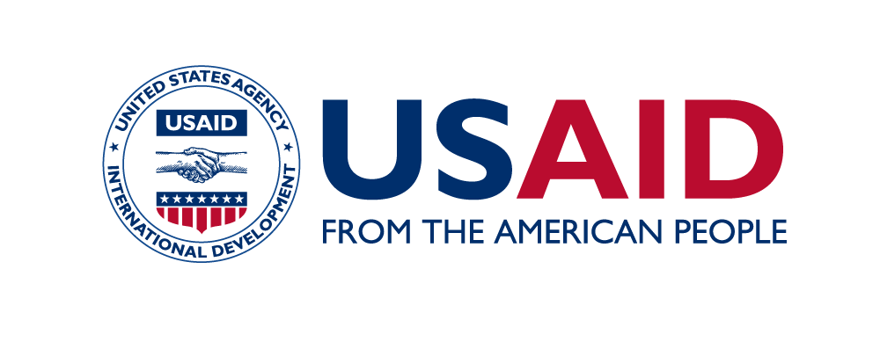
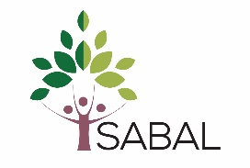
• Insurance, private sector partners, being supported by Government can offer good services, especially for livestock and crop, but we need to do a better job of increasing access to insurance
• Still women who are saving, accessing loans so we should focus on their financial service needs.

