Program Achievement and Impacts – Day 1, Nov 19, 10:30 am
Number of participants: Plenary
Discussion highlights and conclusions
WHAT did we learn about approaches and interventions/activities? (all speakers consolidated)
- Dina Esposito, current VP at Mercy Corps and former Director of FFP, set the stage for the PAHAL/Sabal solicitation in 2012/13, that coincided with the launch of USAID’s first resilience strategy, an agency wide shift away from programming direct in kind food aid, and a call for integrated programming approaches.
- Multi-sectoral and multi-scale (individual, hh, community, system) interventions, with multiple partners to facilitate multi-level linkages and interventions.
- Dynamic context/ shocks: earthquake, fuel embargo, federalism, market/price fluctuations
- Sabal, key components: Tools and data for theory or change (TOC) revision, used routine monitoring data from mid-term, implementation plan progress, case study insights; revision assessed extent to which activities were sufficiently integrated (e.g., DRR/CCA with farmer/nutrition groups), measuring against TOC.
- PAHAL TOC focused on resilience capacities, strategies to use them to manage risks/ improve food security and livelihood outcomes in the face of shocks. STRESS assessment critical component. “Full integration” led to improvement to manage shocks; improve confidence to access government services

What did we learn about HOW to implement and manage projects? (all speakers consolidated)
- Targeting: PVCA participatory vulnerability and capacity assessment, well-being ranking/ established vulnerability criteria (eg, forest user groups with criteria established by gvt.)
- Designed specific tool to help field team monitor and measure resilience (integrated monitoring tool, PAHAL), and assist with consultative workplanning/M&E
- Sabal: moved from district to cluster approach, which required more integration and improved
- TOC developed at senior management level; later in program tried to unpack and understand diversity at local level, and this led to a better understanding of resilience capacities program could support and engagement with local partners and community stakeholders to map resources at local level, led to better implementation to address gaps

What do we RECOMMEND based on our learning (WHAT and HOW)? (all speakers consolidated)
- Increase opportunities for programmatic cross-learning / importance of mission leadership
- Potential for a ‘procurement of service’ approach for NGOs to provide specific services needed, with clear SOWs (in lieu of large consortia approach)
- Include local partners from the beginning, e.g., design/ revision of TOC – need understanding of how these activities contribute to higher level. Make it practical and easy to understand.
- Streamline contractual/ partner arrangements
- Co-locate key partner staff, with common guidance

Key learnings (3-5) – to be elicited by moderator during the last few minutes of the session
- Leadership matters (Primes, IPs, Mission)
- Move technical expertise closer to the ground
- Streamline contractual agreements/ procurement of services approach
- A “cluster” approach can improve coordination
- Assessment is a critical up-front investment
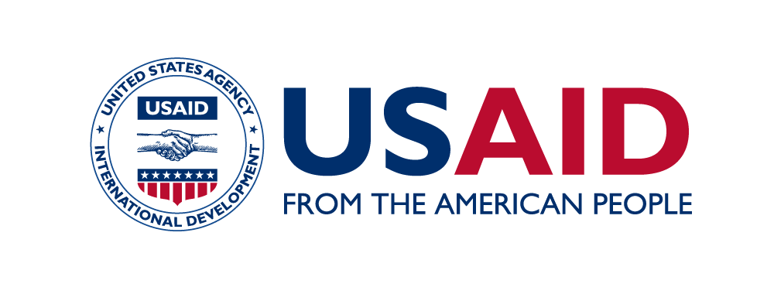
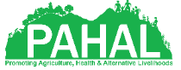
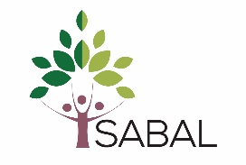
- Process oriented mid-term evaluation useful for course correction and TOC refinement (use of new tools: matrix tools, FFP checklist) and M&E against TOC to understand how interventions contribute to strategic pathways

