HELEN KELLER INTERNATIONAL VIETNAM
Barrier Analysis “Children aged 11-15 years in some secondary schools in Ba Vi District, Ha Noi with refractive errors wear eyeglasses prescribed by eye doctors at least 4 days from Monday to Friday”
FORMATIVE RESEARCH EXERCISE

Contents
1. Introduction 2
1.1. Background: 2
1.2. Justification for using the Barrier Analysis: 2
2. Development of the Social and Behavior Change Strategy 3
Annexes 13
Annex 1: BA training schedule 13
Annex 2: Data Collectors, Data Collection Teams and Team supervisors 14
Annex 3: Data Collection Schedule, Communities Visited each day by teams 15
Annex 4: Completed DBC Frameworks 16
Annex 4: photos of field work 31

1. Introduction

1.1. Background:

During Barrier Analysis and Behavior Change Designing Workshop organized by Helen Keller International in (HKI Viet Nam) with funding source from the Top Small Grant Programs (TOPs), 2 HKI VN staff (Nguyen Thi Thu Lien and Hoang Ngoc Lan) attended this workshop. By the end of the workshop, 2 topics were selected as a formative research exercises by HKI, namely i) Diversity Complementary feeding for children aged 12 to 23 months and ii) Children aged 11-15 years with refractive errors wear eyeglasses prescribed by eye doctors at least 4 days from Monday to Friday.
This exercise is one of the two topics mentioned above.
The exercise was done under the project name: “Scaling up HKI’s School-based Vision Care Services in Son Tay, Phuc Tho and Ba Vi Districts, Ha Noi, Viet Nam”.
The project was funded by USAID for the timeline in the period between April 2016 and March 2017. The project’s objectives included: to improve the vision of children in Son Tay, Ba Vi and Phuc Tho Districts and strengthen the capacity among health personnel to provide pediatric eye care in Son Tay Hospital.
The project target groups: secondary and primary schoolchildren
Behaviors being promoted: Children’s wearing eyeglasses prescribed by eye doctors
Situation that required the behavior change design modification: there exist rumors about wearing eyeglasses, such as: eyeglasses increase refractive errors (myopia, hyperopia, astigmatism), massage can decrease refractive errors rather than eyeglasses, etc.

1.2. Justification for using the Barrier Analysis:
Barrier analysis was used rather than any other research methods because it is a “rapid assessment tool used in behavior change projects” while HKI’s ChildSight® promotes children with refractive errors to wear eyeglasses. “The purpose of barrier analysis is to identify behavioral determinants, so that more effective behavior change, communication messages, strategies, and supporting activities can be developed. Barrier analysis is a relatively easy approach that can be conducted in a short period of time, allowing implementers to quickly make decisions based on the findings”.

2. Development of the Social and Behavior Change Strategy
Objective of the Work: (1 – 2 paragraphs) also explain how the behaviors studied were chosen (the justification):
The study aims at learning about the schoolchildren with refractive errors (knowledge, attitude and practices relating to school-based eye care) and design behavior change communication activities for the future interventions/projects among HKI program.
- Description of the Designing for Behavior Change framework and Barrier Analysis study
The plan and outline of the behavior change framework and Barrier Analysis study include the questionnaires designed by HKI staff with consultation with the trainer.
- Designing the Questionnaire(s)
The questionnaire was orginally developed by Pham Kim Ngoc (HKI Country Director) with some inputs by Nguyen Thi Thu Lien (HKI Senior Program Officer). Then it was translated into Vietnamese and tested with several schools in Son Tay town (USAID project site) by Lien and Phan Hong Van (consultant).
- Barrier Analysis Training
Training was done by Lien on 17 March 2016 for 4 trainees:
- Phan Hong Van, HKI consultant. Van had a Bachelor Degree of English (University of Language and International Studies, Ha Noi National University and MBA from French Vietnamese Center of Management (CFVG)
- Vu Thuan Yen, HKI intern. Yen had Bachelor Degree of Management Science from Keuka University, US
- Pham Van Quyet, 4th year student, preventive medicine major, Ha Noi Medical University
- Nguyen Manh Tien, 4th year student, public health major, Ha Noi School of Public Health.

Field Work/Data Collection
(Sampling criteria, communities visited, data collection teams – list names in the annexes, data collection schedule, any challenges)
Sampling criteria included:
- Age: 11-15 years in secondary schools of HKI project sites
- Diagnosis: having refractive errors and prescribed eyeglasses by either the project eye doctors or someone else
- Behavior: Wearing eyeglasses to improve vision
- Frequency: Wearing eyeglasses at least 4 out of 5 schooldays (Monday to Friday)
To ensure 90 questionnaires as required (ideally 45 Doers and 45 Non-doers), additional 20% children were listed (totally 108 children) from each school. Then, from these 108 children, the children were interviewed until the number of Doers and Non-doers reached the expected ones. Finally, 45 Doers and 47 Non-doers were selected (see Table 1 below).
Data collection was done on 20, 23 and 24 March 2017 by the assessment team including 6 members, namely Lien, Lan, Yen (HKI), Van (consultant), Tien and Quyet (volunteers) (See Annex 2), in which Lien was the supervisor.

Table 1: Sampling and data collection schedule
No. | Schools | # children w/ refractive errors | Expected # children from each school | # children to be enrolled | Date | Data collectors
 | Tan Da Secondary School | 125 | 26 | 32 | 20 March 2017 | Lan, Van, Yen
 | Van Thang Secondary School | 140 | 30 | 35 | 23 March (morning) | Lan, Van, Tien, Quyet
 | Boarding School for Ethnic Minority Children | 102 | 21 | 26 | 23 March (afternoon) | Lan, Van, Tien, Quyet
 | Phu Chau Secondary School | 60 | 13 | 15 | 24 March | Van, Tien, Quyet
 | Total | 427 | 90 | 108

- Coding, Tabulation and Analysis of study results (1 - 2 paragraphs)
Coding was done by Lien and Yen on 6 April in HKI office. It was a bit challenging for us due to limited human resources. The completed tabulation sheets in annex 4.
Results of the Barrier Analysis (BA) Study
Below is the summary of BA study including:
- Priority group: secondary schoolchildren diagnosed with refractive errors who were wearing eyeglasses for better vision in their study and daily life activities. 92 eligible children were interviewed, including 45 Doers and Non-doers. Two criteria for identifying Doers included:
  - Their eyeglasses were prescribed by eye doctors, and
  - They wore eyeglasses at least 4 out of 5 schooldays (from Monday to Friday)
- Determinants and Significant Responses in the table below:

Total Doers | 45
Total Non-doers | 47
Estimated Prevalence of Behavior | 10% | (If unknown, leave as 10%)
Determinants | Doers: +Exp.  (A) | Non-doers: +Exp.  (B) | Doers: -Exp. (C) |  |  | Non-doers: -Exp. (D) | Doers % |  | Non-doers % |  | Diff. |  |  | p-value |  | Doers | Non-doers
1. Self - Efficacy: What makes it easier? |  |  | 45 |  |  | 47 | 0% |  | 0% |  | 0% |  |  | 1.000
Can see clearly from distance | 1 | 7 | 44 |  |  | 40 | 2% |  | 15% |  | -13% |  |  | 0.034 |  |  | Non-doers are 6.9 more likely to give this response than Doers.
3. Self - Efficacy: Makes it Difficult: |  |  |  |  |  |  | 0% |  | 0% |  | 0%
Inconvenient | 35 | 29 | 10 |  |  | 18 | 78% |  | 62% |  | 16% |  |  | 0.073
5. Social Norms: Do most people approve?
Yes | 25 | 14 | 20 |  |  | 33 | 56% |  | 30% |  | 26% |  |  | 0.011 |  | Doers are 2.6 times more likely to give this response than Non-doers.
9. Access - How difficult is it for your family to pay for your prescription eyeglasses? |  |  |  |  |  |  | 0% |  | 0% |  | 0%
Not difficult at all | 41 | 36 | 4 |  |  | 11 | 91% |  | 77% |  | 15% |  |  | 0.053
10. Reminders - How difficult is it to remember to wear your prescription eyeglasses every day? |  |  |  |  |  |  | 0% |  | 0% |  | 0%
Not difficult at all | 32 | 26 | 13 |  |  | 21 | 71% |  | 55% |  | 16% |  |  | 0.088
14. Divine Will - Do you think that God causes people to have poor eye sight? |  |  |  |  |  |  | 0% |  | 0% |  | 0%
Yes | 2 | 1 | 43 |  |  | 46 | 4% |  | 2% |  | 2% |  |  | 0.484
Maybe | 20 | 6 | 25 |  |  | 41 | 44% |  | 13% |  | 32% |  |  | 0.001 |  | Doers are 4.2 times more likely to give this response than Non-doers.
No | 23 | 40 | 22 |  |  | 7 | 51% |  | 85% |  | -34% |  |  | 0.000 |  |  | Non-doers are 4.3 more likely to give this response than Doers.
16. Culture - Are there any cultural rules or taboos against you wearing eyeglasses every day that were prescribed by a trained eye doctor? |  |  |  |  |  |  | 0% |  | 0% |  | 0%
Yes | 1 | 9 | 44 |  |  | 38 | 2% |  | 19% |  | -17% |  |  | 0.009 |  |  | Non-doers are 9.3 more likely to give this response than Doers.
Maybe | 3 | 0 | 42 |  |  | 47 | 7% |  | 0% |  | 7% |  |  | 0.113
No | 42 | 37 | 3 |  |  | 10 | 93% |  | 79% |  | 15% |  |  | 0.042 |  | Doers are 3.5 times more likely to give this response than Non-doers.

Significant findings from the Barrier Analysis Study
Behavior statement with priority group | Determinants | Significant Response/Code | Ranking by gap and/or  p-value | Bridge to Activities
Children aged 11-15 with refractive errors wear eyeglasses prescribed by eye doctors at least 4 out of 5 schooldays (Monday to Friday) | Self - Efficacy: Makes it Difficult:
 |  | Inconvenient | 16% | Increase the children’s perception about the benefits of wearing eyeglass for vision correction: not only for better vision but also for their study  Pay more attention to the design of the eyeglass to make the eyeglasses more comfortable and less inconvenient for the users (in playing sports, physical activities, in rainy seasons, etc.)
 | Social Norms: Do most people approve?
 |  | Yes | 26% | Increase the perception of the children and their parents/caregivers about benefits of the eyeglasses for the children’s eyes.
 | Access - How difficult is it for your family to pay for your prescription eyeglasses?
 |  | Not difficult at all | 15% | Increase awareness of the children about willingness to pay for eyeglasses for their own benefits and responsibility for treatment/correction of their vision problem
 | Divine Will - Do you think that God causes people to have poor eye sight?
 |  | Maybe | 32% | Increase the knowledge of the children about the risk factors of poor eyesight especially for children with refractive errors
 | Culture - Are there any cultural rules or taboos against you wearing eyeglasses every day that were prescribed by a trained eye doctor?
 |  | Yes | -17% | Correct the rumors/misunderstanding about wearing eyeglasses among the children, parents/caregivers/schoolmates

C. Behavior Change Activity Descriptions (by Priority Group and Behavior): What is the activity and how will the content of that activity address the Bridges to Activities?

Bridge to Activities | Activities
Increase the children’s perception about the benefits of wearing eyeglass for vision correction: not only for better vision but also for their study  Pay more attention to the design of the eyeglassea to make the eyeglasses more comfortable and less inconvenient for the users (in playing sports, physical activities, in rainy seasons, etc.) | - Behavior change activities for awareness raising regarding refractive errors (causes, risk factors, treatment, preventive measures, etc.) in different forms, including  - personal communication  - small group communication  - large group communication (school-based or class-based activities)  - leaflets  - posters  - art-based performance  - talk show by specialist  - fanpage  - livestream
Increase the perception of the children and their parents/caregivers about benefits of the eyeglasses for the children’s eyes.
Increase awareness of the children about willingness to pay for eyeglasses for their own benefits and responsibility for treatment/correction of their vision problem
Increase the knowledge of the children about the causes of poor eyesight
Correct the rumors/misunderstanding about wearing eyeglasses among the children, parents/caregivers/schoolmates

Annexes

Annex 1: BA training schedule
Schools | # children with refractive errors | Expected | Expected # children from each school (*) | Date
Tan Da Secondary School | 125 |  | 32 | 20 March 2017
Van Thang Secondary School | 140 |  | 35 | 23 March (morning)
Boarding School for Ethnic Minority Children | 102 |  | 26 | 23 March (afternoon)
Phu Chau Secondary School | 60 |  | 15 | 24 March
 | 427 | 90  (45 doers, 45 non-doers) | 108
(*) = 120% of the expected number of children

Annex 2: Data Collectors, Data Collection Teams and Team supervisors
Data collectors:

- Hoang Ngoc Lan, HKI Project Coordinator
- Phan Hong Van, HKI consultant. Van had a Bachelor Degree of English (University of Language and International Studies, Ha Noi National University and MBA from French Vietnamese Center of Management (CFVG)
- Vu Thuan Yen, HKI intern. Yen had Bachelor Degree of Management Science from Keuka University, US
- Pham Van Quyet, 4th year student, preventive medicine major, Ha Noi Medical University
- Nguyen Manh Tien, 4th year student, public health major, Ha Noi School of Public Health.
Team supervisor: Nguyen Thi Thu Lien, HKI Senior Program Officer.

Annex 3: Data Collection Schedule, Communities Visited each day by teams

Schools | # children w/ refractive errors | Expected # children from each school | # children to be enrolled | Date | Data collectors
Tan Da Secondary School | 125 | 26 | 32 | 20 March 2017 | Lan, Van, Yen
Van Thang Secondary School | 140 | 30 | 35 | 23 March (morning) | Lan, Van, Tien, Quyet
Boarding School for Ethnic Minority Children | 102 | 21 | 26 | 23 March (afternoon) | Lan, Van, Tien, Quyet
Phu Chau Secondary School | 60 | 13 | 15 | 24 March | Van, Tien, Quyet
total | 427 | 90 | 108

Annex 4: Completed DBC Frameworks

Study Description
Country: | Viet Nam
Area 1: | Ba Vi District, Ha Noi City
Date BA study was completed: | 24-Mar-17
NGO/PVO name: | Helen Keller International
Details of study/executive summary: | Behavior Analysis (BA) study was conducted in 4 secondary schools (in 4 different communes) in Ba Vi District, Ha Noi, Viet Nam
Link for downloading this study (if available):
Behavior statement: | Targeted secondary school children (aged 11-15 years) with refractive errors wear  eye glasses prescribed by a trained eye doctor at least 4 days from Monday to Saturday

Barrier Analysis Tabulation Sheet (05/02/2016)
[Targeted secondary school children (aged 11-15 years) with refractive errors wear
eye glasses prescribed by a trained eye doctor at least 4 days from Monday to Saturday ]
Total Doers | 45
Total Non-doers | 47
Estimated Prevalence of Behavior | 10% | (If unknown, leave as 10%)
Determinants | Doers: +Exp.  (A) | Non-doers: +Exp.  (B) | Doers: -Exp. (C) | Non-doers: -Exp. (D) | Doers % |  | Non-doers % | Diff. |  | Odds Ratio | Confidence Interval |  |  |  | Estim. Relative Risk |  | p-value | Doers |  | Non-doers
 |  |  |  |  |  |  |  |  |  |  | Lower Limit |  | Upper Limit
1. Self - Efficacy: What makes it easier? |  |  | 45 | 47 | 0% |  | 0% | 0% |  |  |  |  |  |  |  |  | 1.000
better vision for every thing, less blurred | 34 | 39 | 11 | 8 | 76% |  | 83% | -7% |  | 0.63 | 0.23 |  | 1.76 |  | 0.67 |  | 0.267
Eyeglasses are easy to wear, fits me, nice color, | 5 | 1 | 40 | 46 | 11% |  | 2% | 9% |  | 5.75 | 0.64 |  | 51.30 |  | 4.01 |  | 0.092
My parents take me to eye examination or at school and buy eyeglasses for me | 4 | 2 | 41 | 45 | 9% |  | 4% | 5% |  | 2.20 | 0.38 |  | 12.62 |  | 1.97 |  | 0.318
Better performance at school | 3 | 5 | 42 | 42 | 7% |  | 11% | -4% |  | 0.60 | 0.13 |  | 2.67 |  | 0.63 |  | 0.382
Comfortable with eyeglass | 2 |  | 43 | 47 | 4% |  | 0% | 4% |  |  |  |  |  |  | 10.42 |  | 0.237
Can see clearly from distance | 1 | 7 | 44 | 40 | 2% |  | 15% | -13% |  | 0.13 | 0.02 |  | 1.10 |  | 0.14 |  | 0.034 |  |  | Non-doers are 6.9 more likely to give this response than Doers.
It's difficult to see without eyeglass | 1 |  | 44 | 47 | 2% |  | 0% | 2% |  |  |  |  |  |  | 10.20 |  | 0.489
more confident w eyeglass, not confused | 2 |  | 43 | 47 | 4% |  | 0% | 4% |  |  |  |  |  |  | 10.42 |  | 0.237
Always do things more easily | 1 | 3 | 44 | 44 | 2% |  | 6% | -4% |  | 0.33 | 0.03 |  | 3.33 |  | 0.36 |  | 0.325
My eyes do not have to accommodate; less tired and dizzy | 2 | 1 | 43 | 46 | 4% |  | 2% | 2% |  | 2.14 | 0.19 |  | 24.45 |  | 1.92 |  | 0.484
I can work and learn normally | 1 |  | 44 | 47 | 2% |  | 0% | 2% |  |  |  |  |  |  | 10.20 |  | 0.489
to be reminded to wear eyeglasses by parents | 1 | 1 | 44 | 46 | 2% |  | 2% | 0% |  | 1.05 | 0.06 |  | 17.24 |  | 1.04 |  | 0.742
Correct correction (by the medical doctors/refractionists) |  | 1 | 45 | 46 | 0% |  | 2% | -2% |  | 0.00 |  |  |  |  | 0.00 |  | 0.511
3. Self - Efficacy: Makes it Difficult: |  |  |  |  | 0% |  | 0% | 0%
Inconvenient | 35 | 29 | 10 | 18 | 78% |  | 62% | 16% |  | 2.17 | 0.87 |  | 5.43 |  | 2.03 |  | 0.073
None | 11 | 17 | 34 | 30 | 24% |  | 36% | -12% |  | 0.57 | 0.23 |  | 1.41 |  | 0.60 |  | 0.160
Inconvenient, including |  |  | 45 | 47 | 0% |  | 0% | 0% |  |  |  |  |  |  |  |  | 1.000
My eyes became a bit tired (at the beginning) | 6 | 1 | 39 | 46 | 13% |  | 2% | 11% |  | 7.08 | 0.82 |  | 61.34 |  | 4.58 |  | 0.049 | Doers are 4.6 times more likely to give this response than Non-doers.
Eyeglasses are easy to drop down when touched by anybody/anything | 3 | 2 | 42 | 45 | 7% |  | 4% | 2% |  | 1.61 | 0.26 |  | 10.10 |  | 1.52 |  | 0.479
Headache/blurred for my first time of wearing | 3 | 1 | 42 | 46 | 7% |  | 2% | 5% |  | 3.29 | 0.33 |  | 32.82 |  | 2.70 |  | 0.292
I was teased by friends | 2 | 2 | 43 | 45 | 4% |  | 4% | 0% |  | 1.05 | 0.14 |  | 7.76 |  | 1.04 |  | 0.675
My eyes are tired if I do not wear eyeglass | 1 |  | 44 | 47 | 2% |  | 0% | 2% |  |  |  |  |  |  | 10.20 |  | 0.489
I always have to carry my eyeglasses with me; | 1 |  | 44 | 47 | 2% |  | 0% | 2% |  |  |  |  |  |  | 10.20 |  | 0.489
My eyes are dazed while traveling in a sunny day | 1 | 2 | 44 | 45 | 2% |  | 4% | -2% |  | 0.51 | 0.04 |  | 5.84 |  | 0.54 |  | 0.516
I lose self-confidence |  | 1 | 45 | 46 | 0% |  | 2% | -2% |  | 0.00 |  |  |  |  | 0.00 |  | 0.511
I am not used to my eyeglasses; I feel inferior complex and unconfident |  | 1 | 45 | 46 | 0% |  | 2% | -2% |  | 0.00 |  |  |  |  | 0.00 |  | 0.511
My parents asked me why I did not take off my eyeglasses |  | 1 | 45 | 46 | 0% |  | 2% | -2% |  | 0.00 |  |  |  |  | 0.00 |  | 0.511
my eyes look more ugly with eyeglasses |  | 1 | 45 | 46 | 0% |  | 2% | -2% |  | 0.00 |  |  |  |  | 0.00 |  | 0.511
I look unusual with eyeglasses |  | 1 | 45 | 46 | 0% |  | 2% | -2% |  | 0.00 |  |  |  |  | 0.00 |  | 0.511
my nose is a bit painful when I take eyeglass off |  | 1 | 45 | 46 | 0% |  | 2% | -2% |  | 0.00 |  |  |  |  | 0.00 |  | 0.511
Headache if wearing for a long time |  | 2 | 45 | 45 | 0% |  | 4% | -4% |  | 0.00 |  |  |  |  | 0.00 |  | 0.258
Become dependent on eyeglasses |  | 2 | 45 | 45 | 0% |  | 4% | -4% |  | 0.00 |  |  |  |  | 0.00 |  | 0.258
My eyes look glassy without eyeglasses |  | 1 | 45 | 46 | 0% |  | 2% | -2% |  | 0.00 |  |  |  |  | 0.00 |  | 0.511
I feel embarrassed while wearing eyeglasses |  | 1 | 45 | 46 | 0% |  | 2% | -2% |  | 0.00 |  |  |  |  | 0.00 |  | 0.511
4. Positive Consequences: What are the advantages? |  |  |  |  | 0% |  | 0% | 0%
Better vision | 37 | 34 | 8 | 13 | 82% |  | 72% | 10% |  | 1.77 | 0.65 |  | 4.79 |  | 1.68 |  | 0.190
Better learning | 10 | 8 | 35 | 39 | 22% |  | 17% | 5% |  | 1.39 | 0.49 |  | 3.92 |  | 1.34 |  | 0.357
avoid increasing myopia | 9 | 14 | 36 | 33 | 20% |  | 30% | -10% |  | 0.59 | 0.23 |  | 1.54 |  | 0.62 |  | 0.200
Avoid accommodation | 1 |  | 44 | 47 | 2% |  | 0% | 2% |  |  |  |  |  |  | 10.20 |  | 0.489
Avoid early blurred vision when I get older |  | 1 | 45 | 46 | 0% |  | 2% | -2% |  | 0.00 |  |  |  |  | 0.00 |  | 0.511
Can help my parents with housework | 1 | 1 | 44 | 46 | 2% |  | 2% | 0% |  | 1.05 | 0.06 |  | 17.24 |  | 1.04 |  | 0.742
I look nicer/more handsome with eyeglasses | 5 |  | 40 | 47 | 11% |  | 0% | 11% |  |  |  |  |  |  | 11.13 |  | 0.025 | Doers are 11.1 times more likely to give this response than Non-doers.
More confident | 2 | 2 | 43 | 45 | 4% |  | 4% | 0% |  | 1.05 | 0.14 |  | 7.76 |  | 1.04 |  | 0.675
eyeglasses do not do harm to my eyes | 1 |  | 44 | 47 | 2% |  | 0% | 2% |  |  |  |  |  |  | 10.20 |  | 0.489
it's safer while I am traveling in the darkness |  | 3 | 45 | 44 | 0% |  | 6% | -6% |  | 0.00 |  |  |  |  | 0.00 |  | 0.129
My eyes are protected and prevented from harm | 1 | 1 | 44 | 46 | 2% |  | 2% | 0% |  | 1.05 | 0.06 |  | 17.24 |  | 1.04 |  | 0.742
see better in the darkness | 1 |  | 44 | 47 | 2% |  | 0% | 2% |  |  |  |  |  |  | 10.20 |  | 0.489
I look more stylish | 2 |  | 43 | 47 | 4% |  | 0% | 4% |  |  |  |  |  |  | 10.42 |  | 0.237
See better from distance | 1 | 5 | 44 | 42 | 2% |  | 11% | -8% |  | 0.19 | 0.02 |  | 1.70 |  | 0.21 |  | 0.112
My vision will not became blurred early when I get old |  | 1 | 45 | 46 | 0% |  | 2% | -2% |  | 0.00 |  |  |  |  | 0.00 |  | 0.511
No headache |  | 1 | 45 | 46 | 0% |  | 2% | -2% |  | 0.00 |  |  |  |  | 0.00 |  | 0.511
myopia decreases |  | 1 | 45 | 46 | 0% |  | 2% | -2% |  | 0.00 |  |  |  |  | 0.00 |  | 0.511
With eyeglasses, it takes me less time to arrange my papers and work |  | 1 | 45 | 46 | 0% |  | 2% | -2% |  | 0.00 |  |  |  |  | 0.00 |  | 0.511
I do not have to ask my friends when I cannot see clearly |  | 1 | 45 | 46 | 0% |  | 2% | -2% |  | 0.00 |  |  |  |  | 0.00 |  | 0.511
I do not have to bend my neck while reading/writing |  | 1 | 45 | 46 | 0% |  | 2% | -2% |  | 0.00 |  |  |  |  | 0.00 |  | 0.511
My eyes will become convex |  | 2 | 45 | 45 | 0% |  | 4% | -4% |  | 0.00 |  |  |  |  | 0.00 |  | 0.258
my eyes feel comfortable while watching TV |  | 1 | 45 | 46 | 0% |  | 2% | -2% |  | 0.00 |  |  |  |  | 0.00 |  | 0.511
My eyes get used to eyeglasses |  | 1 | 45 | 46 | 0% |  | 2% | -2% |  | 0.00 |  |  |  |  | 0.00 |  | 0.511
1 of my eyes is myopic. Eyeglass will improve the vision of that eye |  | 1 | 45 | 46 | 0% |  | 2% | -2% |  | 0.00 |  |  |  |  | 0.00 |  | 0.511
Slower the progress of myopia |  | 1 |  |  | 0% |  | 2% | -2%
5. Social Norms: Do most people approve? |  |  |  |  | 0% |  | 0% | 0%
Yes | 25 | 14 | 20 | 33 | 56% |  | 30% | 26% |  | 2.95 | 1.25 |  | 6.95 |  | 2.61 |  | 0.011 | Doers are 2.6 times more likely to give this response than Non-doers.
Possibly | 10 | 9 | 35 | 38 | 22% |  | 19% | 3% |  | 1.21 | 0.44 |  | 3.32 |  | 1.18 |  | 0.457
No | 2 | 2 | 43 | 45 | 4% |  | 4% | 0% |  | 1.05 | 0.14 |  | 7.76 |  | 1.04 |  | 0.675
6. Social Norms: Who approves? |  |  |  |  | 0% |  | 0% | 0%
Parents | 36 | 37 | 9 | 10 | 80% |  | 79% | 1% |  | 1.08 | 0.39 |  | 2.97 |  | 1.07 |  | 0.543
Friends | 21 | 26 | 24 | 21 | 47% |  | 55% | -9% |  | 0.71 | 0.31 |  | 1.61 |  | 0.73 |  | 0.267
Teachers | 11 | 16 | 34 | 31 | 24% |  | 34% | -10% |  | 0.63 | 0.25 |  | 1.56 |  | 0.65 |  | 0.217
Grandparents and other relatives | 10 | 17 | 35 | 30 | 22% |  | 36% | -14% |  | 0.50 | 0.20 |  | 1.27 |  | 0.54 |  | 0.107
Sibling | 7 | 5 | 38 | 42 | 16% |  | 11% | 5% |  | 1.55 | 0.45 |  | 5.29 |  | 1.47 |  | 0.348
Medical doctors | 4 | 2 | 41 | 45 | 9% |  | 4% | 5% |  | 2.20 | 0.38 |  | 12.62 |  | 1.97 |  | 0.318
Cousin |  | 1 | 45 | 46 | 0% |  | 2% | -2% |  | 0.00 |  |  |  |  | 0.00 |  | 0.511
7. Social Norms: Who disapproves |  |  |  |  | 0% |  | 0% | 0%
None | 26 | 20 | 19 | 27 | 58% |  | 43% | 15% |  | 1.85 | 0.81 |  | 4.22 |  | 1.74 |  | 0.105
Parents | 5 | 12 | 40 | 35 | 11% |  | 26% | -14% |  | 0.36 | 0.12 |  | 1.14 |  | 0.39 |  | 0.064
friend | 4 | 7 | 41 | 40 | 9% |  | 15% | -6% |  | 0.56 | 0.15 |  | 2.05 |  | 0.59 |  | 0.287
Grandparent/relatives | 4 | 9 | 41 | 38 | 9% |  | 19% | -10% |  | 0.41 | 0.12 |  | 1.45 |  | 0.44 |  | 0.133
Sibling | 3 | 6 | 42 | 41 | 7% |  | 13% | -6% |  | 0.49 | 0.11 |  | 2.08 |  | 0.52 |  | 0.265
Myself | 1 | 1 | 44 | 46 | 2% |  | 2% | 0% |  | 1.05 | 0.06 |  | 17.24 |  | 1.04 |  | 0.742
8. Access - how difficult is it to get what you need to do the behavior? |  |  |  |  | 0% |  | 0% | 0% |  |  |  |  |  |  |  |  | 1.000
Very difficult | 1 | 2 | 44 | 45 | 2% |  | 4% | -2% |  | 0.51 | 0.04 |  | 5.84 |  | 0.54 |  | 0.516
Somewhat difficult | 22 | 19 | 23 | 28 | 49% |  | 40% | 8% |  | 1.41 | 0.62 |  | 3.22 |  | 1.36 |  | 0.272
Not difficult at all | 22 | 26 | 23 | 21 | 49% |  | 55% | -6% |  | 0.77 | 0.34 |  | 1.75 |  | 0.79 |  | 0.342
 |  |  | 45 | 47 | 0% |  | 0% | 0% |  |  |  |  |  |  |  |  | 1.000
9. Access - How difficult is it for your family to pay for your prescription eyeglasses? |  |  |  |  | 0% |  | 0% | 0%
Very difficult | 1 | 4 | 44 | 43 | 2% |  | 9% | -6% |  | 0.24 | 0.03 |  | 2.28 |  | 0.27 |  | 0.194
Somewhat difficult | 3 | 7 | 42 | 40 | 7% |  | 15% | -8% |  | 0.41 | 0.10 |  | 1.69 |  | 0.44 |  | 0.176
Not difficult at all | 41 | 36 | 4 | 11 | 91% |  | 77% | 15% |  | 3.13 | 0.92 |  | 10.70 |  | 2.88 |  | 0.053
10. Reminders - How difficult is it to remember to wear your prescription eyeglasses every day? |  |  |  |  | 0% |  | 0% | 0%
Very difficult | 2 | 4 | 43 | 43 | 4% |  | 9% | -4% |  | 0.50 | 0.09 |  | 2.88 |  | 0.53 |  | 0.359
Somewhat difficult | 11 | 18 | 34 | 29 | 24% |  | 38% | -14% |  | 0.52 | 0.21 |  | 1.28 |  | 0.55 |  | 0.114
Not difficult at all | 32 | 26 | 13 | 21 | 71% |  | 55% | 16% |  | 1.99 | 0.84 |  | 4.72 |  | 1.86 |  | 0.088
11. Risk- How likely is it that you will do poorly in school next year if you couldn’t see well? |  |  |  |  | 0% |  | 0% | 0%
Very likely | 23 | 21 | 22 | 26 | 51% |  | 45% | 6% |  | 1.29 | 0.57 |  | 2.94 |  | 1.26 |  | 0.342
Somewhat likely | 20 | 20 | 25 | 27 | 44% |  | 43% | 2% |  | 1.08 | 0.47 |  | 2.46 |  | 1.07 |  | 0.511
Not likely at all | 2 | 6 | 43 | 41 | 4% |  | 13% | -8% |  | 0.32 | 0.06 |  | 1.67 |  | 0.34 |  | 0.148
 |  |  | 45 | 47 | 0% |  | 0% | 0% |  |  |  |  |  |  |  |  | 1.000
 |  |  | 45 | 47 | 0% |  | 0% | 0% |  |  |  |  |  |  |  |  | 1.000
12. Severity - How serious would it be if you performed badly in school if you couldn’t see well? |  |  |  |  | 0% |  | 0% | 0%
Very serious | 25 | 28 | 20 | 19 | 56% |  | 60% | -4% |  | 0.85 | 0.37 |  | 1.94 |  | 0.86 |  | 0.429
Somewhat serious | 19 | 16 | 26 | 31 | 42% |  | 34% | 8% |  | 1.42 | 0.61 |  | 3.30 |  | 1.37 |  | 0.277
Not serious at all | 1 | 3 | 44 | 44 | 2% |  | 6% | -4% |  | 0.33 | 0.03 |  | 3.33 |  | 0.36 |  | 0.325
13. Action Efficacy - How likely is it that you will perform well in school if you wore prescription eye glasses every day? |  |  |  |  | 0% |  | 0% | 0%
Very likely | 20 | 24 | 25 | 23 | 44% |  | 51% | -7% |  | 0.77 | 0.34 |  | 1.74 |  | 0.79 |  | 0.335
Somewhat likely | 22 | 20 | 23 | 27 | 49% |  | 43% | 6% |  | 1.29 | 0.57 |  | 2.94 |  | 1.26 |  | 0.344
Not likely at all | 3 | 3 | 42 | 44 | 7% |  | 6% | 0% |  | 1.05 | 0.20 |  | 5.48 |  | 1.04 |  | 0.641
14. Divine Will - Do you think that God causes people to have poor eye sight? |  |  |  |  | 0% |  | 0% | 0%
Yes | 2 | 1 | 43 | 46 | 4% |  | 2% | 2% |  | 2.14 | 0.19 |  | 24.45 |  | 1.92 |  | 0.484
Maybe | 20 | 6 | 25 | 41 | 44% |  | 13% | 32% |  | 5.47 | 1.93 |  | 15.45 |  | 4.22 |  | 0.001 | Doers are 4.2 times more likely to give this response than Non-doers.
No | 23 | 40 | 22 | 7 | 51% |  | 85% | -34% |  | 0.18 | 0.07 |  | 0.49 |  | 0.23 |  | 0.000 |  |  | Non-doers are 4.3 more likely to give this response than Doers.
15. Policy - Are there any community laws or rules in place that make it less likely that you would wear eyeglasses prescribed by a trained eye doctor? |  |  |  |  | 0% |  | 0% | 0%
Yes | 1 | 2 | 44 | 45 | 2% |  | 4% | -2% |  | 0.51 | 0.04 |  | 5.84 |  | 0.54 |  | 0.516
Maybe | 0 | 0 | 45 | 47 | 0% |  | 0% | 0% |  |  |  |  |  |  |  |  | 1.000
No | 44 | 45 | 1 | 2 | 98% |  | 96% | 2% |  | 1.96 | 0.17 |  | 22.35 |  | 1.86 |  | 0.516
16. Culture - Are there any cultural rules or taboos against you wearing eyeglasses every day that were prescribed by a trained eye doctor? |  |  |  |  | 0% |  | 0% | 0%
Yes | 0 | 9 | 45 | 38 | 0% |  | 19% | -19% |  | 0.00 |  |  |  |  | 0.00 |  | 0.002 |  |  | #DIV/0!
Maybe | 3 | 0 | 42 | 47 | 7% |  | 0% | 7% |  |  |  |  |  |  | 10.64 |  | 0.113
No | 42 | 37 | 3 | 10 | 93% |  | 79% | 15% |  | 3.78 | 0.97 |  | 14.80 |  | 3.46 |  | 0.042 | Doers are 3.5 times more likely to give this response than Non-doers.
17. Universal Motivators - What do you desire most in life?
Healthy eyes, free from myopia and do not have to wear eyeglass | 20 | 25 | 25 | 22 | 44% |  | 53% | -9% |  | 0.70 | 0.31 |  | 1.60 |  | 0.73 |  | 0.264
Myopia does not increase | 6 | 3 | 39 | 44 | 13% |  | 6% | 7% |  | 2.26 | 0.53 |  | 9.63 |  | 2.02 |  | 0.221
Become a distinct schoolchild | 5 | 6 | 40 | 41 | 11% |  | 13% | -2% |  | 0.85 | 0.24 |  | 3.02 |  | 0.87 |  | 0.531
myopia decreases | 2 | 1 | 43 | 46 | 4% |  | 2% | 2% |  | 2.14 | 0.19 |  | 24.45 |  | 1.92 |  | 0.484
Better vision | 1 | 2 | 44 | 45 | 2% |  | 4% | -2% |  | 0.51 | 0.04 |  | 5.84 |  | 0.54 |  | 0.516
To live a happy life/successful life | 5 | 2 | 40 | 45 | 11% |  | 4% | 7% |  | 2.81 | 0.52 |  | 15.31 |  | 2.40 |  | 0.200
Better performance at school | 1 | 6 | 44 | 41 | 2% |  | 13% | -11% |  | 0.16 | 0.02 |  | 1.35 |  | 0.17 |  | 0.062
Have holidays in Da Lat City | 1 |  | 44 | 47 | 2% |  | 0% | 2% |  |  |  |  |  |  | 10.20 |  | 0.489
My parents do not have to work hard any longer | 1 |  | 44 | 47 | 2% |  | 0% | 2% |  |  |  |  |  |  | 10.20 |  | 0.489
Everybody get on well with each other | 1 |  | 44 | 47 | 2% |  | 0% | 2% |  |  |  |  |  |  | 10.20 |  | 0.489
Go to school with my friends | 1 |  | 44 | 47 | 2% |  | 0% | 2% |  |  |  |  |  |  | 10.20 |  | 0.489
Less people suffer from myopia | 1 | 1 | 44 | 46 | 2% |  | 2% | 0% |  | 1.05 | 0.06 |  | 17.24 |  | 1.04 |  | 0.742
My parents approve my eyeglasses use |  | 1 | 45 | 46 | 0% |  | 2% | -2% |  | 0.00 |  |  |  |  | 0.00 |  | 0.511
 |  |  | 45 | 47 | 0% |  | 0% | 0% |  |  |  |  |  |  |  |  | 1.000

Annex 4: photos of field work
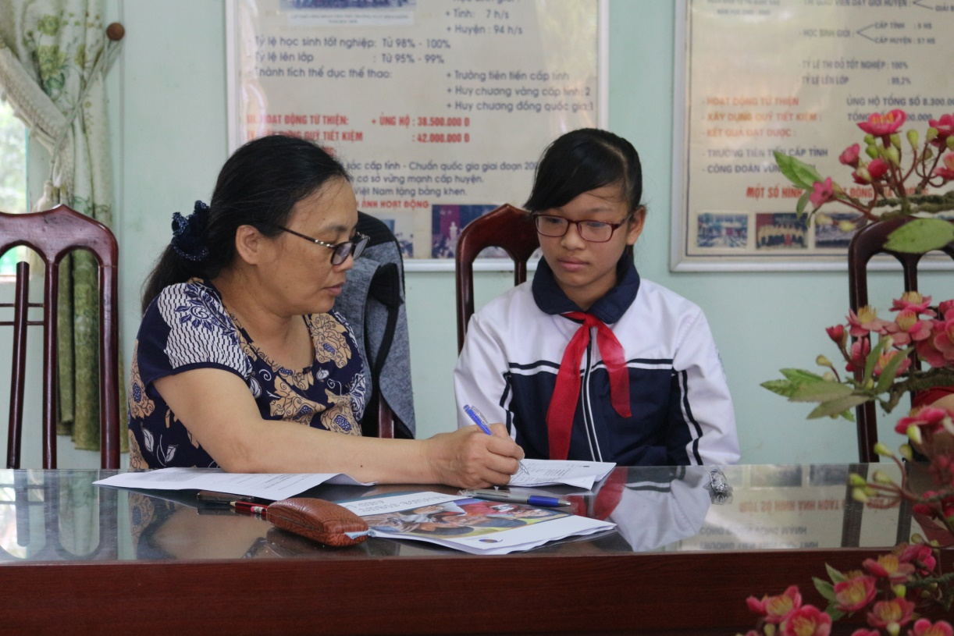

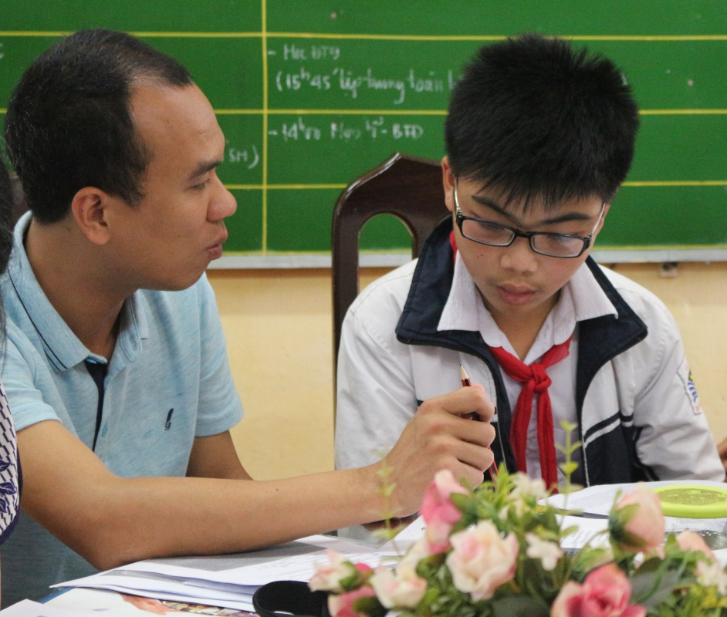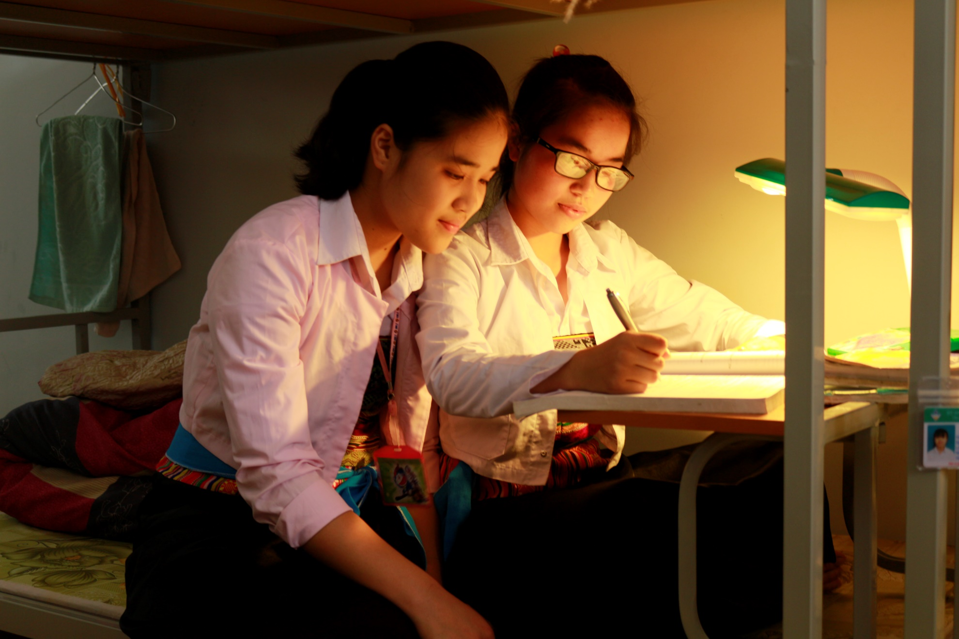

&2 : https://en.wikipedia.org/wiki/Barrier_analysis

