Make Me a Change Agent:
A Multisectoral SBC Resource for Community Workers and Field Staff

The Technical and Operational Performance Support (TOPS) Program is the USAID/Food for Peace-funded learning mechanism that generates, captures, disseminates, and applies the highest quality information, knowledge, and promising practices in development food assistance programming, to ensure that more communities and households benefit from the U.S. Government’s investment in fighting global hunger. Through technical capacity building, a small grants program to fund research, documentation and innovation, and an in-person and online community of practice (the Food Security and Nutrition [FSN] Network), The TOPS Program empowers food security implementers and the donor community to make a lasting impact for millions of the world’s most vulnerable people.
Led by Save the Children, The TOPS Program is a consortium program drawing on the expertise of its partners: CORE Group (knowledge management), Food for the Hungry (social and behavioral change), Mercy Corps (agriculture and natural resource management), and TANGO International (monitoring and evaluation). Save the Children brings its experience and expertise in commodity management, gender, and nutrition and food technology, as well as the management of this 5-year (2010–2015) US$20 million award.
Disclaimer:
The TOPS Program and the FSN Network were made possible by the generous support and contribution of the American people through the U.S. Agency for International Development (USAID). The contents of this guide were created by The TOPS Program and do not necessarily reflect the views of USAID or the U.S. Government.
Citation:
The FSN Network and CORE Group. 2015. Make Me a Change Agent: A Multisectoral SBC Resource for Community Workers and Field Staff. Washington, DC: The TOPS Program.
All illustrations were created by Regina Doyle, except for the illustration of a bug found in Lesson 1 Handout 6: Drawing to Practice Listening. The bug illustration is based on a similar drawing found in Building Dynamic Groups: Draw a Bug by The Ohio State University Extension, available at http://hostedweb.cfaes.ohio-state.edu/bdg/pdf_docs/g/G06_1.pdf.
Contact:
The TOPS Program
c/o Save the Children USA
2000 L Street, NW, Suite 500
Washington, DC 20036
info@thetopsprogram.org
www.thetopsprogram.org
www.fsnnetwork.org

Contents
Abbreviations and Acronyms i
Acknowledgements ii
Introduction iii
Lesson 1: Behavior Change through Effective Communication 1

Why this Lesson? 1

Advanced Preparation 1

Tasks.... 2

Lesson 1 Handout 1: Good Communication 12

Lesson 1 Handout 2: Respect Wheel 13

Lesson 1 Handout 3: Showing Respect 14

Lesson 1 Handout 4: Listening Role Plays 15

Lesson 1 Handout 5: Listening Techniques 17

Lesson 1 Handout 6: Drawing to Practice Listening 18

Lesson 1 Handout 7: Open-Ended and Closed Questions 19
Lesson 2: Empathy: Understanding the Perspective of Another 21

Why this Lesson? 21

Advanced Preparation 21

Tasks.... 22

Lesson 2 Handout 1: The Definition of Empathy 27

Lesson 2 Handout 2: Four Skills for Improving Empathy 28

Lesson 2 Handout 3: Smiley-Face Feelings Guide 29
Lesson 3: Negotiated Behavior Change 30

Why this Lesson? 30

Advanced Preparation 31

Tasks...... 31

Lesson 3 Handout 1: Negotiated Behavior Change 36

Lesson 3 Handout 2: Role Play Dialogues: Negotiated Behavior Change 37

Lesson 3 Handout 3: Illustrations of the Steps in the Process of Negotiated Behavior Change 43

Lesson 3 Handout 4: Steps in the Process of Negotiated Behavior Change 60

Lesson 3 Handout 5: Role Play Scenarios 61

Lesson 3 Handout 6: Observation Checklist 62
Lesson 4: Home Visits/Individual Counseling 63

Why this Lesson? 63

Advanced Preparation 63

Tasks.... 64

Lesson 4 Handout 1: Purpose of a Home Visit 69

Lesson 4 Handout 2: Role Play Dialogue: Showing Steps in a Home Visit using the Negotiated Behavior Change Process 70

Lesson 4 Handout 3: Steps in Conducting a Home Visit Using Negotiated Behavior Change 74

Lesson 4 Handout 4: Quality Improvement and Verification Checklist: Home Visits/Negotiated Behavior Change 75
Lesson 5: Behavior Change through Guided Testimonials 76

Why this Lesson? 76

Advanced Preparation 76

Tasks..... 77

Lesson 5 Handout 1: Why are Testimonials Effective? 81

Lesson 5 Handout 2: Steps to Organizing a Testimonial 82

Lesson 5 Handout 3: Example Testimonial 84

Lesson 5 Handout 4: Small Group Instructions for Preparing Testimonials 85
Lesson 6: Storytelling for Behavior Change 87

Why this Lesson? 87

Advanced Preparation 88

Tasks..... 88

Lesson 6 Handout 1: Closed-Ended Story: Blood Worms 96

Lesson 6 Handout 2: Open-Ended Stories 97

Lesson 6 Handout 3: Discussion Questions for Closed-Ended Stories 98

Lesson 6 Handout 4: Discussion Questions for Open-Ended Stories 99

Lesson 6 Handout 5: Guidelines for Developing Behavior Change Stories 100

Lesson 6 Handout 6: Elements of a Story 102
Lesson 7: Learning through Cross-Site Visits 103

Why this Lesson? 103

Advanced Preparation 103

Tasks..... 103

Lesson 7 Handout 1: Story of a Cross-Site Visit 107

Lesson 7 Handout 2: Checklist for Planning a Cross-Site Visit 108
Lesson 8: Behavior Change through Effective Facilitation 111

Why this Lesson? 111

Advanced Preparation 111

Tasks..... 112

Lesson 8 Handout 1: Quality Improvement and Verification Checklist (QIVC) for Behavior Change Agents’ Facilitation Skills 117

Lesson 8 Handout 2: Facilitation Skills: Suggestions from an Experienced Facilitator 119
Advanced Lesson 1: Quality Improvement and Verification Checklists (QIVCs) and Giving Feedback 120

Why this Lesson? 120

Advanced Preparation 121

Tasks..... 122

Advanced Lesson 1 Handout 1: Quality Improvement and Verification Checklist (QIVC) for Education Session Facilitation 128

Advanced Lesson 1 Handout 2: Quality Improvement and Verification Checklist (QIVC) to Evaluate Positive Feedback 130

Advanced Lesson 1 Handout 3: Role Play Part 1: Education Session 132

Advanced Lesson 1 Handout 4: Role Play Part 2: Giving Feedback 133

Advanced Lesson 1 Handout 5: Steps for Giving Feedback to Workers 134
Advanced Lesson 2: Motivating Conversations: Conversations for Change 135

Why this Lesson? 135

Advanced Preparation 136

Tasks..... 136

Advanced Lesson 2 Handout 1: Role Play Response Prompt Cards 145

Advanced Lesson 2 Handout 2: Background Information and Resources about Motivational Interviewing 146
Advanced Lesson 3: Story Editing 147

Lesson Overview 147

Additional Resources 147

Part 1: Best Possible Selves 148

Part 2: Story Prompting 151

Part 3: Personal Values Exercise 157

Abbreviations and Acronyms
BCA Behavior Change Agent
CHW community health worker
EBF exclusive breastfeeding
FSN Food Security and Nutrition (as in The FSN Network)
HIV human immunodeficiency virus
MC Motivating Conversation
MI Motivational Interviewing
MMCA Make Me a Change Agent (this curriculum)
NGO nongovernmental organization
NW neighbor woman
ORS oral rehydration solution
PTA parent-teacher association
QIVC quality improvement and verification checklist
SBC social and behavioral change
TIPS Trials of Improved Practices
TOPS Technical and Operational Performance Support (as in The TOPS Program)
VHC Village Health Committee

Acknowledgements
The Make Me a Change Agent curriculum would not have come to fruition if not for the dedication and many hours of work provided by Tom Davis (Feed the Children), Mary DeCoster (Food for the Hungry), Jennifer Weiss (Concern International), Amelia Brandt (Medicines for Humanity), Bonnie Kittle (independent consultant), Tara Kovach (FHI 360), Fe Garcia (World Vision), Anna Schurmann (IntraHealth International), Beth Outterson (Save the Children), Terry Laura (Compassion International), Donna Rzewnicki (independent consultant), and Jennifer Nielsen (Helen Keller International). These individuals developed the lessons included in this curriculum. We also appreciate Mathias Pollock’s (Mercy Corps) help with role play development for the lesson on Negotiated Behavior Change.
In addition, Christy Gavitt (American Red Cross) was instrumental in organizing the field testing of several lessons by American Red Cross/Indonesia, and the detailed feedback and suggestions garnered from this field testing helped strengthen the lesson on communication. Mary DeCoster and Bonnie Kittle reviewed the lessons and ensured that all examples are field friendly, follow standard formatting, and use the Dialogue Education method. The lessons were subsequently field tested in the Democratic Republic of Congo with support from Mercy Corps and in Bangladesh, Niger, and Washington, D.C., with support from The TOPS Program, after which Mary DeCoster, Bonnie Kittle, and Donna Rzewnicki made additional adjustments.
We are grateful to Regina Doyle for her beautiful illustrations, to Mesa Somer for copy editing, and to Rachel Elrom for final editing and formatting.

Introduction
The Technical and Operational Performance Support (TOPS) Program, the Food Security and Nutrition (FSN) Network’s Social and Behavioral Change (SBC) Task Force, and the CORE Group SBC Working Group are pleased to offer this set of field-friendly SBC lessons entitled Make Me a Change Agent, or MMCA. These lessons seek to build the skills of community-level workers, such as community development agents, community health workers, and agriculture extension agents, so that they can be more effective behavior change promoters in their communities. The lessons are not sector specific, but are tried and true generic skills, such as communication and storytelling, that can help a development worker in any sector become more effective as an agent of behavior change.
These lessons were developed by experienced SBC specialists from multiple nongovernmental organizations (NGOs), most of whom are active members of the CORE Group SBC Working Group and the FSN Network SBC Task Force. Together these people worked voluntarily to identify the necessary skills related to behavior change, establish a lesson plan format and preferred training methodology, design the lessons, develop the handouts and visual aids, and review and test the materials. The CORE Group SBC Working Group reviewed the lesson plans, which also have been field tested. Many of the lessons had already been used by individuals or organizations, were adapted for this curriculum, and are now being offered as part of this set of skill-building exercises.
Knowing that community-based development workers often are too busy to attend a lengthy course or might prefer to learn one skill at a time, the MMCA lessons were designed to be conducted individually or as a cohesive curriculum. Most lessons range in duration from a few hours to a half-day. They could be offered as a week-long training or as a continuing education course over a period of time. Supervisors and their teams could select specific skills that need to be built or reinforced and cover only those lessons, or the entire curriculum can be offered. The lessons are arranged in a suggested order because some build on the skills developed during previous lessons.

Lesson 1: Behavior Change through
Effective Communication
Achievement-Based Objectives
By the end of this lesson, participants will have:
- Described why a Behavior Change Agent (BCA) needs good communication skills
- Defined good communication
- Practiced three types of listening, including reflective listening
- Given examples of open-ended and closed questions
Duration
4–5 hours
Materials
- Flip chart paper and markers, masking tape, blank paper (letter size), note cards or small pieces of paper, and pencils with erasers (1 for each participant)
- Lesson 1 Handout 1: Good Communication (1 copy per participant)
- Lesson 1 Handout 2: Respect Wheel (1 copy for each group of 4–5 participants)
- Lesson 1 Handout 3: Showing Respect (1 copy per participant)
- Lesson 1 Handout 4: Listening Role Plays (6 copies)
- Lesson 1 Handout 5: Listening Techniques (1 copy per participant)
- Lesson 1 Handout 6: Drawing a Bug to Practice Listening
(1 large copy or drawing to show participants at the end of exercise)
- Lesson 1 Handout 7: Open-Ended and Closed Questions (1 copy per participant)

Why this Lesson?
Effective communication is one of the most important skills Behavior Change Agents (BCAs) need, but much of their training is on technical content and program messages. This lesson will help BCAs improve their communication skills so they can work more effectively with communities to promote behavior change.

Advanced Preparation
Throughout this manual, the term BCA is used to represent the wide variety of roles held by workers that promote change. When facilitating this lesson and others, replace “BCA” with a title that is appropriate for your audience (such as agriculture extension agent, community health worker, or peer educator).
For Task 4, review the three role plays in Lesson 1 Handout 4: Listening Role Plays. If appropriate, adapt the role plays to fit the topics or issues covered by the participants’ program area(s). Select 6 participants (2 for each role play) and give them copies of the role plays in advance so they can practice.
Read the two sets of questions in Lesson 1 Handout 7: Open-Ended and Closed Questions. Decide which option best meets the needs of your group, or write an example that is more relevant.

Tasks
1. Warm-Up Activity (15 minutes)
1a. Divide the group of participants into pairs. Explain that the partners will interview each other about the following questions then use the information gathered to introduce their partners to the larger group. If needed, write the questions on the flipchart.
- Who is someone you really like to talk with, and why?
- Name a communication skill that YOU feel you do well?
1b. Allow participants about 5 minutes to talk together, then ask each person to introduce their partner and present their responses to the group. On the flipchart, list the communication skills mentioned by the participants (the skills of the person they like to talk with, as well as the skills that they do well).
1c. When everyone has been introduced, read the list of communication skills out loud. Note that this list shows that the participants are already very familiar with what “good communication” is and that they already have practice with many communication skills. Facilitate a brief discussion using the following questions.
- For the skill that you do well, is this a skill that you’ve always had? If not, how did you improve? Can someone share an example of how you improved a communication skill?
- Which of these skills do you think you could continue to improve?
1d. Note that during this lesson, participants will have an opportunity to learn not just from the activities, but also from each other. Encourage participants to use their best communication skills during the training and to pay attention to what others do well and give those skills a try themselves.
2. Good Communication (10 minutes)
2a. Ask participants to imagine that the list is a description of good communication. Ask them if anything is missing. Ask them to think about the type of communication skills needed by a BCA; what else should be added to the list?
2b. Distribute Lesson 1 Handout 1: Good Communication. Ask a volunteer to read the definition aloud. Ask participants if they would add to or change the definition in any way.
2c. Continue with a discussion based on the following questions.
- What differences can you see between the list of skills in this handout and the flip chart list? (Encourage participants to add items from the flip charts to their handout).
- Why is it important for Behavior Change Agents to learn and practice communication skills? (Listen to the group’s response then add any of these points if they were not mentioned: Good communication builds trust; it makes people feel respected and heard and, as a result, more likely to listen to and learn from you; it helps ensure that people understand what you are saying; good communication, encouragement, and support build people’s confidence to try new behaviors and skills.)
2d. Summarize by explaining to participants: When you communicate well by showing respect, listening, promoting dialogue, being supportive, learning about people’s realities, and adapting what you say to people’s situations, you will have a better chance of succeeding at helping people learn information, get services, and try new behaviors.
When you get to know families on a more personal level, you can better understand the difficulties they face in trying new behaviors and talk with them to help them find ways to remove or overcome those difficulties. This is much more effective and respectful than insisting on behaviors that may be unrealistic. It makes it more likely that they will be able to do the new behaviors and continue to do them over a long period of time.
3. Showing Respect (30 minutes)
3a. Explain to participants: To communicate well with people, you must be able to make them feel comfortable and respected. In this activity, we will discuss what makes people feel respected and how you can show respect to the families you will work with. The following activity provides a chance to explore what makes people feel respected and how we can show respect to the people and families with which we work.
3b. Tell participants: Quietly on your own, take a minute to think about a time when you felt respected. What was happening that caused you to feel respected?
3c. After a couple minutes, divide participants into small groups of four or five people. Give each group a copy of Lesson 1 Handout 2: Respect Wheel and a marker.
3d. Explain to participants: Now you will have 10 minutes for the next part of the activity. Share your thoughts with your small group members. Then, as a group, choose short phrases or words that complete the statement: “I know that I am being respected when…” Write these short phrases or words on the spokes of your group’s respect wheel. You can add more spokes and phrases if needed.
3e. After 10 minutes, ask all groups to post their respect wheels on the wall and have participants circulate the room to view everyone’s work. Ask participants to use a marker to draw a smiley face (or other symbol) on any of the wheels next to a way that they often show respect to others already and a star (or other symbol different from the first) next to a practice they would like to increase or improve.
3f. Ask participants to return to their seats. Then facilitate a discussion based on the following questions.
- How can we show respect for the people we serve and for the people we work with?
- Are there ways we can ask others to show respect for us?
3g. Distribute Lesson 1 Handout 3: Showing Respect. Ask participants to read the handout (or ask a volunteer to read the list out loud) and compare the items on the list to the items they wrote on the respect wheels. Ask participants to add things from their own lists to the handout to make a more complete list.
3h. Summarize by telling participants: Effective communication creates a feeling of security and respect. A Behavior Change Agent must create this feeling of security and respect with each family so that family members feel comfortable sharing their ideas without fear of rejection or disapproval. Respect for the ideas, customs, and rights of the family members should form the basis for all of your interactions. During this training let’s practice showing respect for each other.
4. Listening Skills (30 minutes)
4a. Tell participants: As we have discussed, Behavior Change Agents must use good communication skills to help improve the welfare of families in their communities. Part of being a good communicator is listening well. In this activity we will focus on our listening skills.
4b. Ask the group the following questions and encourage a brief discussion that could include the answers given below each question.
- What is the difference between “hearing” and “listening?”

- Hearing is involuntary; listening is voluntary.
- We always hear things around us, but we don’t always pay attention to what we’re hearing.
- Hearing something doesn’t mean that you understand it.
- Hearing doesn’t require any effort.
- Listening well takes some effort.
- When we listen we try to understand; we listen for meaning, not just the words.
- What do you think you must do in order to listen well?
- Pay attention to what the person is saying.
- Avoid becoming distracted or thinking about other things while the person is talking.
- Show that you are listening by looking at the person, responding to what the person is saying, or asking questions if appropriate.
- Avoid thinking so much about your response that you don’t truly hear and understand what the person is saying.
- If you are not paying attention or if you are thinking ahead to how you will respond while the other person is talking, how might this affect communication?
- You may not understand the person’s specific situation.
- You might not fully understand what is being said.
- You might interrupt or frustrate the person.
- The person will stop sharing information and feel that he/she is not being listened to.
- Why is it important for Behavior Change Agents to listen well when they communicate with families or other community members?
- BCAs must communicate to help people overcome obstacles that prevent them from learning, getting services, and trying new behaviors.
- BCAs must listen well to be able to understand other people’s problems from their perspective and learn about other people’s realities.
4c. Explain to participants: Now you will watch three role plays that demonstrate different listening techniques, all of which are important to Behavior Change Agents.
4d. Post three blank pieces of flip chart paper on the wall. Invite the participants you selected to act out the role plays in Lesson 1 Handout 4: Listening Role Plays to come to the front of the room and perform. Limit each role play to a few minutes. Ask participants to watch each listener carefully during the role plays to see what they are doing. Do not tell the group what technique each role play will be demonstrating.
4e. After the first role play ask participants the following question, and write responses briefly on the first blank flip chart sheet that you posted, leaving a blank space at the top of the sheet: What did the listener do during the role play? (For example, the listener used only non-verbal communication, such as eye contact and nodding her/his head, and brief responses, such as “yes,” “I see,” “uh huh,” to show interest and to encourage the person to continue speaking)
4f. Repeat this process with the remaining two role plays on asking clarifying questions and listening and reformulating.
4g. After all three role plays are completed review each flip chart with answers to the question “What did the listener do during the role play?” After you review each sheet, write the name of the listening technique at the top of the sheet, either:
- Listen without Responding
- Ask Clarifying Questions
- Listen and Reformulate
4h. Ask the following questions and encourage a brief discussion. Potential answers follow in parentheses.
- When do you think it would be most effective to use the “listen without responding” technique? (When someone is very upset or emotional about something, when someone is staying on the topic and does not need much prompting or help to continue speaking, when you understand everything that is being said)
- When do you think it would be most effective to use the “ask clarifying questions” method? (When you are trying to learn something, when you are not sure you have understood everything that has been said, when you need more information, when you are trying to help a person brainstorm solutions to a problem)
- When do you think it would be most effective to use the “listen and reformulate” technique? (When you are trying to understand someone’s perspective on an issue, when you want the person to know that you understood what he/she said, when you want to reinforce a key message)
4i. Direct participants to Lesson 1 Handout 5: Listening Techniques for more information about these techniques.
4j. Tell participants: While each of these listening techniques may work best at different times, good listeners often switch between all three within one conversation. All three listening techniques are important, and a good Behavior Change Agent should learn and practice using all of them.
5. Practice Listening (45 minutes)
5a. Explain to participants: We are now going to practice our listening skills.
5b. Distribute a blank piece of letter-sized paper and a pencil with eraser to each participant.
5c. Explain the task to participants: Your task is to listen to my instructions and draw what I tell you on the blank piece of paper. You will only listen and draw. You may not ask questions or make comments. You may not look at anyone else’s drawing.
5d. Verbally give participants instructions for drawing the image in Lesson 1 Handout 6: Draw a Bug to Practice Listening, line by line (see below). Give detailed instructions so that participants will be able to reproduce the drawing as best they can (but don’t show them the image). You may repeat each instruction once only. Do not let participants ask questions or make comments; they should draw in silence. Do not show the image to participants. Do not let participants look at each other’s drawings.
Instructions to Give Participants on How to Draw the Bug
- The bug is round.
- The bug has 8 legs, grouped in pairs, with 4 legs on the left and 4 legs on the right. In the pairs, one leg is longer than the other.
- The bug has 2 eyes on top of the body.
- The bug has 2 squiggly antennas.
- The bug has 2 pea-pod shaped wings.
- The bug has a spot next to each wing.
- The bug has a triangular stinger on the bottom of its body.
- The bug has 2 feelers on each foot, one longer than the other and both coming from the same side of the leg.
- The bug has a round mouth, placed between the 2 eyes.
- The bug laid 5 square eggs to the left of the stinger.

5e. After you have finished giving instructions for the drawing, DO NOT show participants the original drawing yet. Lead a brief discussion by asking:
- How close do you think your drawings are to the original drawing?
- How did you feel not being allowed to see the original drawing or ask any questions?
5f. Tell the participants: You can now ask me a few questions to clarify the drawing instructions and to make some changes to your drawing, if you think it’s necessary. Spend about 5 minutes doing this.
5g. When participants have finished improving their drawings, show the large drawing you prepared. Ask participants to hold up their drawings so everyone can see them.
5h. Ask participants the following questions and encourage a brief discussion.
- Which of these drawings are most similar to the original drawing?
- For people whose drawings are the most similar to the original: How did you do this?
- For everyone: What helped you the most as you were drawing?
- What was frustrating or unhelpful as you were drawing?
- How did it help to be able to ask clarifying questions?
- What did you learn from this exercise?
5i. Tell participants: You have just practiced two of the listening techniques: “listening without responding” and “asking clarifying questions.” Both listening techniques are useful. While listening without responding can be effective, asking questions for clarification often helps you better understand what someone is saying to you. Knowing when to pose questions and which questions to ask also are important skills.
5j. Tell participants: Now we will practice “listening and reformulating.” This is the most challenging listening technique. Let’s review what we mean by reformulating.
5k. Divide the group in half and ask the two smaller groups to sit in two circles so that all the group members are able to see and hear each other easily. Ask participants to listen carefully. Explain the exercise: Both small groups will discuss an assigned topic (select a mildly controversial topic that everyone should have an opinion about and consider asking some people to take a position opposite to their true opinion to assure a more lively discussion). Everyone should participate in the discussion, but there is no prescribed order. Both small group discussions will happen simultaneously. One group member will start the discussion by expressing an idea or opinion about the topic. Before a second person can respond or contribute his/her own idea, he/she first has to reformulate or summarize what the first person said. It’s important when reformulating to avoid simply repeating what the first person has said; the idea should be expressed in different words. The first person has to be satisfied that his/her idea has been reformulated accurately. Only then can the second person contribute his/her own ideas. A third person reformulates the second person’s idea, then adds his/her own idea. Continue the discussion in this way. Everyone should participate in the discussion. You will continue the discussion until everyone has had a chance to speak, or until time is up.
5l. Tell participants: You have just practiced the third listening technique: “listening and reformulating.” This kind of listening is also sometimes called “reflective listening.” This has several purposes: it can help the listener be sure they understand correctly and it helps the speaker feel heard and understood. This can be especially helpful when dealing with difficult or controversial topics or when settling disputes and can help build trust and mutual respect.
6. Open-Ended and Closed Questions (1 hour)
6a. Explain to participants: In order to start a discussion with a mother or to understand the concerns of a farmer, you need to ask some questions. It is important to ask questions in a way that encourages people to talk with you and share more information. This helps you learn more in the time available. Two types of questions that we commonly use are open-ended and closed. Does anyone know the difference between these types of questions? (Answers: Closed questions can usually be answered by a “yes” or “no” answer or are limited to a short list of answers, and open-ended questions allow for the respondent to form a response on his/her own that is usually fuller and tells more about the respondent’s opinions.)
6b. Add:
- Open-ended questions are usually the most helpful if you want to start a discussion. To answer them, a person must give you some information. Open-ended questions usually start with “How? What? When? Where?” For example, “How are you feeding your baby?” “What helps you decide when to sell your harvest?”
- Closed questions are usually less helpful to start a discussion. They usually lead to shorter, more limited answers, such as a “Yes” or “No.” Closed questions usually start with words like “Are you…?” or “Did you…?” For example: “Did you breastfeed your last baby?” If a mother says “Yes” to this question, you still don’t know if she only breastfed or if she also used other kinds of food.
6c. Tell participants: Now we are going to practice creating open-ended and closed questions.
6d. Pass out a note card or small piece of paper to each participant. Ask each participant to write one closed question on the card. Collect the cards and redistribute them. Then ask each participant to reformulate the closed question into an open-ended question and write the open-ended question on the other side of the card. When everyone has finished, go around the room and ask each participant to read the closed question and the way he/she reformulated it. Check for understanding. Potential closed questions and their reformulated counterparts are listed below.
Potential Closed Questions  Does your baby sleep with you?  Have grain banks helped your community?  Does your baby eat porridge?  Do you give fruit to your child often?  Does your family drink river water?  Is your baby vaccinated?  Do you know how to prevent malaria? | Reformulated Open-Ended Questions  Where does your baby sleep?  How have grain banks affected families in your community?  What kinds of foods does your baby like to eat?  How often does your child eat fruits?  Where are some places you can get water for your family?  What vaccinations has your baby received?  What have you heard about preventing malaria?

6e. Distribute Lesson 1 Handout 7: Open-Ended and Closed Questions. Let participants know which option will be used (Option 1, Option 2, or another example that you prepared in advance). Ask volunteers to read the words of the community member in each demonstration while you read the part of the BCA. After each demonstration, comment on what the BCA learned.
- Discuss Demonstration A by asking:
- What happened in the role play? (Answers include: the BCA got “yes” and “no” for answers and didn’t learn much, it can be difficult to know what to say next.)
- What kind of information did the BCA get from the person? How much information, and what type? (Answers include: the person answered “yes” or “no” only, the BCA got limited information.)
- Why did this happen? (Answers include: the BCA did not ask questions that encouraged the person to give more information.)
- How helpful was this conversation for the Behavior Change Agent and for the person? (Answers include: probably not that helpful, the BCA got limited information, the person did not learn anything.)
- Discuss Demonstration B by asking:
- What happened in the role play? (Answers include: the BCA started a more open dialogue, more information was shared).
- What kind of information did the Behavior Change Agent get from the person? How much information and what type? (Answers include: the BCA asked open-ended questions, the person could not answer with only a “yes” or a “no,” the person had to give some information, the BCA learned much more.)
- Why did this happen? (Answers include: the BCA asked questions that encouraged the person to give more information.)
- How helpful was this conversation for the Behavior Change Agent and for the person? (Answers include: probably more helpful, the BCA learned more about the person.)
7. Wrap Up (5 minutes)
7a. Wrap up this activity by asking participants what they learned about good communication. Ask them which communication skills they plan to practice during the next week and how they think those skills might improve their work in the community.

Lesson 1 Handout 1: Good Communication
What is “good communication”?
Good communication occurs when a message is sent by one person and received and understood by another person(s), and both parties feel that they have been understood.
Which communication skills does a Behavior Change Agent need?
- Show respect for people.
- Explain things clearly.
- Ask questions to make sure people understand.
- Ask open-ended questions and promote dialogue.
- Learn about and acknowledge people’s ideas and realities.
- Ask about people’s experiences and opinions, and build on them.
- Listen carefully and actively to what people tell you, and show that you understand.
- Observe people’s expressions and body language to see how well you are communicating.
- Have accurate technical knowledge and be honest when you don’t know an answer.
- Shape what you are saying to the person’s situation and reality.
- Do not scold, lecture, or dictate to people.
- Act as a resource, not an authority.
- Be culturally sensitive.
- Be honest about what you can and cannot do.

Lesson 1 Handout 2: Respect Wheel
I know I am respected
when…

Lesson 1 Handout 3: Showing Respect
- Create ways to get to know individual family members and for them to get to know you. Learn the names of all family members and always call people by name.
- Learn about each family’s life and show your understanding of their difficulties and challenges.
- If it is normal for this culture, look at people when you speak with them.
- Listen carefully and thoughtfully.
- Communicate with people one-on-one (not only in large groups).
- Encourage people to share their ideas and opinions.
- Listen to people’s ideas, and give people a chance to discover their own answers and insights.
- Ask open-ended questions about what people already know about the topic you are communicating.
- Show you understand people’s knowledge and the positive, healthy behaviors they already are using.
- Ask open-ended questions so that you can learn about and better understand each family’s situation and life.
- Encourage people to ask questions and answer them to the best of your ability. If you don’t know the answer to a question, say that you do not know but will find out.
- When sharing new information, find out what people already know about the topic and sensitively add information.

Lesson 1 Handout 4: Listening Role Plays

Role Play 1: Listen without Responding
Instructions: The two actors should sit facing each other. The role play should last 1–2 minutes.
Speaker: Tell the listener about someone you know who was sick and what happened to him/her.
Listener: While the speaker is talking, just listen. You will not respond or ask questions, but (if culturally appropriate) you will maintain eye contact with the speaker in a friendly way. Nod and say things like “uh-huh,” “hmm,” and “yes” (sounds of encouragement) from time to time, when appropriate.

Role Play 2: Ask Clarifying Questions
Instructions: The two actors should sit beside each other, not necessarily face to face, but close. The listener is a BCA who has just met a new contact in a new community. The role play should last 1–2 minutes.
Speaker (community member): We’ve had agriculture extension agents do demonstration plots here in the past.
Listener (BCA): Ok, who did they work with?
Speaker: Mostly with the school, I think.
Listener: How did it go?
Speaker: Ok. I think the children enjoyed it.
Listener: What did the community think of the project?
Speaker: They thought it was nice that someone wanted to work with the school.
Listener: Who could I talk with at the school if we wanted to do another demonstration, at the school, or with other people in the community?
Speaker: You could talk with the teacher on Monday, or come to the village council meeting next month.
Listener: Ok, great!

Role Play 3: Listen and Reformulate
Instructions: The two actors should sit beside each other, not necessarily face to face, but close. The speaker should explain his/her opinion about the services he/she received at the health center. The listener should respond by summarizing and restating the speaker’s ideas. The actors should follow this script or create something similar.
Speaker: I can’t believe what happened at the health center today! When I arrived at 8:30 there were already 10 women waiting for their prenatal consultations. I know we usually have to wait, but today it was ridiculous!
Listener: Hmm. Sounds like you had a rough day.
Speaker: Yes. And, after I arrived several other women arrived and we were about 20 altogether, and no one was attending us. We waited until about 11:00 and no one ever arrived, no staff at all! Finally, just as I was getting ready to go home, the cleaning lady came and told us that the nurse had to take a woman in labor to the hospital for an emergency. I wish I’d known that earlier in the day. What a waste of my time.
Listener: It sounds like you are really frustrated because you had to wait a long time. And, you didn’t appreciate being made to wait. It sounds to me like you wish someone had left a note or somehow notified all the women coming for their prenatal visits so you would know not to wait, then it wouldn’t have been such a waste of your time.
Speaker: That’s right!

Lesson 1 Handout 5: Listening Techniques

1. Listen without Responding
The listener uses only non-verbal communication (eye contact, nodding the head, open posture) and brief responses (“uh huh,” “yes,” “umm”) to show interest and to encourage the speaker to continue speaking.
The listener avoids gestures that communicate boredom, like checking his/her watch, drumming his/her fingers, or signs of impatience to get to the point.
This technique encourages the speaker to speak freely and express his/her ideas.

2. Ask Clarifying Questions
The listener asks specific questions of the speaker to clarify what the speaker is saying.
This technique helps the listener get more information about the situation in order to understand the speaker well. It helps the speaker to consider all aspects of the situation or topic by answering questions related to his/her ideas. This technique also can help the speaker and listener evaluate alternatives and possible solutions.

3. Listen and Reformulate
The listener restates in his/her own words what he/she understood the speaker to have said. The listener can use reframing statements to reformulate, such as “it’s like you’re saying,” “what I hear you saying is,” or “so if I understand you correctly.” This technique helps the listener ensure that he/she understood what the speaker said. It also allows the speaker to clarify anything that the listener did not understand because he/she can hear ideas repeated back in summary form and the listener will allow the speaker to correct his/her understanding.

Lesson 1 Handout 6: Drawing to Practice Listening

Lesson 1 Handout 7: Open-Ended and Closed Questions

Option 1: Breastfeeding

Demonstration A: Closed Questions to which the Mother (Mary) can Answer “Yes” or “No”
BCA: Good morning, Mary. I am Martha, the Community Health Worker. Is Peter well?
Mary: Yes, thank you.
BCA: Are you breastfeeding him?
Mary: Yes.
BCA: Are you having any difficulties?
Mary: No.
BCA: Is he breastfeeding very often?
Mary: Yes.

Demonstration B: Open-Ended Questions
BCA: Good morning, Mary. I am Martha, the Community Health Worker. How is Peter doing?
Mary: He is well, and he is very hungry.
BCA: Tell me, how are you feeding him?
Mary: He is breastfeeding. I just have to give him one bottle in the evening.
BCA: What made you decide to do that?
Mary: He cries more at that time of day, so I thought my milk is not enough.

Option 2: Village Savings and Loans Association (VSLA)

Demonstration A: Closed Questions to which the Community Member (Mary) can Answer “Yes” or “No”
BCA: Good morning, Mary. I’m Martha, a member of the village savings and loans association. Have you heard about the association?
Mary: Yes, thank you.
BCA: Can you come to our meeting tomorrow?
Mary: No, I can’t.
BCA: Do you think you’d like to come to one in the future?
Mary: Maybe.
BCA: Do you have any questions about the association?
Mary: Not right now, thank you.

Demonstration B: Open-Ended Questions
BCA: I’m Martha, a member of the village savings and loans association. What have you heard about the association?
Mary: That people can borrow money from you for projects.
BCA: That’s right. How do you think being part of a VSLA might help you and your family?
Mary: I’m not sure. I don’t know much about how it all works.
BCA: How would you feel about coming to our next meeting, just to meet some of the group members and see how it works for them?
Mary: That would be nice, but I’m very busy with chores and the children.
BCA: I understand. A lot of our members are very busy, too. We keep our meetings brief to respect everyone’s time. What time of day works for you?
Mary: In the afternoon, usually.

Lesson 2: Empathy:
Understanding the Perspective of Another
Achievement-Based Objectives
By the end of this lesson, participants will have:
- Explained the basic definition of empathy
- Shared experience of showing empathy/feeling empathy
- Shared an example of a work situation when empathy was/could have been useful
- Practiced naming emotion
- Discussed the importance of properly expressing emotion and accepting difference
- Reviewed reflective listening
Duration
2 hours 20 minutes
Materials
- Flip chart, index cards, and markers
- Lesson 2 Handout 1: The Definition of Empathy (1 copy per participant)
- Lesson 2 Handout 2: Four Skills for Improving Empathy (1 copy per participant)
- Lesson 2 Handout 3: Smiley-Face Feeling Guide (1 copy for each group of 4–5 people)

Why this Lesson?
Empathy has been found to be a facilitator of behavior change. Developing empathy improves a Behavior Change Agent (BCA)’s relationship with community members and increases his/her ability to work with them to address barriers to behavior change.

Advanced Preparation
Throughout this manual, the term Behavior Change Agent (BCA) is used to represent the wide variety of roles held by workers who promote change. When facilitating this lesson and others, replace “BCA” with a title that is appropriate for your audience (such as agriculture extension agent, community health worker, or peer educator).
If you will use photographs instead of the Lesson 2 Handout 3: Smiley-Face Feeling Guide, choose some in advance so they are ready when it’s time to present them.

Tasks
- Warm-Up Activity (15 minutes)
1a. Conduct a beginning exercise that allows the participants to get to know each other a little better.
1b. For example, “two similarities and one difference”: Ask participants to form groups of three people who don’t know each other well. They should talk together and find two interesting things they all have in common and one thing that is different or unique to each person in the group. Give them about 5 minutes to discover their similarities and differences, then ask each group to share with the larger group.
1c. Thank the participants for sharing and facilitate a brief discussion based on the following questions.
- What kinds of questions did you ask to find out your similarities and differences?
- How does exploring these kinds of things improve our relationships with others?
- Defining Empathy (15 minutes)
2a. Explain to participants that today’s session will focus on a relationship skill called “empathy.” Start the discussion with the following: What does “empathy” mean to you? You can give your personal definition or tell us about other words that remind you of empathy or that are similar to empathy.
2b. After several participants share their ideas, summarize and discuss the definitions. If the participants’ input has not covered the following definition, share it with participants: the ability to see and understand from the perspective of another.
2c. Refer participants to Lesson 2 Handout 1: The Definition of Empathy. Ask a volunteer to read the definition out loud, and ask the group for their comments or any additions.
2d. Explain that people often confuse empathy with sympathy. Review the differences and discuss. Ask participants to find the local words for both empathy and sympathy and record them (or ask a participant to record them) on flip chart paper. Post these words (in the local languages or vocabulary) in a visible spot in the room.
- Exploring Personal Experiences with Empathy (30 minutes)
3a. Explain to participants: Now that we’ve defined the word “empathy,” let’s see how it applies to our own lives. Please think for a minute about a time in your own life when you showed empathy to someone else or when someone empathized with you.
As facilitator, you may want to first share a personal example that is simple and clear (for example: “My sister was really nervous because she was going to give a presentation to the village health committee, with her supervisor there at the meeting. I used to get very anxious when I had to speak in public, and I know it can be extra stressful when you want to do well in front of a supervisor. So I talked with her about it to try to understand how she was feeling and to let her know I care.”)
3b. Put the participants in pairs and ask them to share their experience with their partner.
3c. After a few minutes and while the participants are still in pairs, say: Now think of a time when someone did NOT show you empathy.
3d. Ask participants to share their example with their partner. Encourage them to choose an example that is personal but that they feel comfortable sharing with the group. Note that the example does not need to be sensitive or private. For example: “Last week, I had a hard time keeping up at work because I was sick, and one of my coworkers didn’t care that I wasn’t feeling well, and was rude to me about not getting all my work done.”
3e. Ask the group to come together and share any particularly interesting stories they heard. If needed, ask:
- What do you remember feeling when you were in the situation where someone did not show you empathy?
- How was that different from the feelings you had in the first situation, when you were shown empathy?
- How did you react? What did you do in your situation?
3f. Ask participants to think about their personal experiences with empathy. Then ask participants the following questions and write their answers on a flip chart.
- In what ways would showing empathy help a Behavior Change Agent be more effective? (Answers could include: when people feel they are being empathized with, they are more likely to listen to suggestions; when a BCA is empathetic, he/she is more likely to understand the barriers to behavior change and is better able to help the person to adopt a new behavior)
- If a Behavior Change Agent is not empathetic, how will that likely affect his/her work? (Answers could include: people may not like that BCA; people won’t listen to, trust, or follow the BCA’s suggestions; the BCA may feel frustration from not being able to understand situations from the perspectives of community members)

3g. Summarize the discussion by reading the following:
Why is empathy important?
Developing empathy improves a BCA’s relationship with community members and increases his/her ability to understand and work through barriers to behavior change, while also learning more about why the person might want to change.

- How to Build Empathy (15 minutes)
4a. Tell participants: Now that we’ve recognized the importance of empathy, we are going to learn how to build our skills in empathy. Just as people cannot become good at football without practice, it is difficult to see from another’s perspective without practice. However, we all are capable of empathy!
4b. Pass out Lesson 2 Handout 2: Four Skills for Improving Empathy. Ask volunteers to read aloud each section of the handout. Explain that in the remainder of the lesson they will gain skills in each of these areas.
- The Ability to Read Emotion (30 minutes)
5a. Tell participants that to communicate effectively they need to be able to understand how someone is feeling. Divide participants into groups of three or four people, and ask each group to draw a couple of faces from Lesson 2 Handout 3: Smiley-Face Feeling Guide on flip chart paper, or use a few photographs of people with easy to understand expressions. For each face, ask participants: How do you think this person is feeling? How did you know what the person is feeling?
5b. Tell participants: Name some signs of emotion that help us know what people are feeling. Signs of emotion can be spoken, including both the words someone uses and how he/she says them. We also can see emotion through facial expressions and body language. For example, someone with his/her arms crossed may be feeling defensive or uncomfortable. Are there any additional signs that we should look for? (Allow participants to provide some answers.)
5c. Explain that experienced facilitators often read participants’ body language during a training session to see whether participants are bored, frustrated, interested, needing a break, and more. Having an idea of how the group is doing helps enhance the facilitator’s efficacy.
5d. Ask a few volunteers (or all of the participants) to quickly strike a pose to demonstrate with body language an emotion that they have felt in a training session. Then you, the facilitator, must try to name as many emotions as you can. This activity should take one or two minutes and can bring a few laughs. If the group has trouble with this or participants are shy, you can reverse the activity and, as facilitator, demonstrate several emotions (e.g., cross your arms and look defensive, rest your head in your hands and look tired, look eager and wave your hand as if you want to ask a question, scratch your head and look puzzled) while participants try to read your body language.
Tell the group: An effective Behavior Change Agent is alert to both body language and speech and will change his/her approach based on his/her interpretation of those signs; this is one way a Behavior Change Agent can demonstrate empathy.
5e. Ask participants: What are some emotions that you might encounter while working in the community?
As the participants share their answers, write them on individual index cards. If a participant repeats a previously shared answer, you can still write it on an index card. Ask participants to share until you have at least one card for each participant.
5f. Give each participant a card with an emotion written on it. Ask participants to take turns acting out that emotion. As each participant acts out the emotion, the audience participants should guess what the emotion is.
5g. Explain that being able to “read” emotions requires BCAs to pay careful attention.
- Appropriately Expressing Emotion (15 minutes)
6a. Tell participants: The beneficiaries are not the only people that feel a range of emotions. We are people too, just like the community members. To be effective BCAs, we must learn how to appropriately express our own emotions.
6b. Ask participants the following questions and record their answers on the flip chart.
  - What are some emotions you often feel during your work? (Answers could include: happy, frustrated, sad, excited, tired.)
  - What are some appropriate ways to express these emotions? (Answers may include: Use “I” statements; take a deep breath, which is helpful because it gives us extra time to relax ourselves and not respond right away when we are feeling angry or frustrated.)
Note: After each new answer to this question, ask the participant to explain why the action is helpful.
6c. Ask participants: Now let’s compare our list to the list in Handout 1. Is anything missing? If any of the items from the handout are missing from the new list, add them to the flip chart.

- Listening and Reformulating (5 minutes)
7a. Tell participants: In Lesson 1 you learned about different ways of listening. One of them is called “listening and reformulating.” Can anyone remind us what that is? (Answer: Reformulating is when you summarize or restate in your own words what a person has said to you. It is important not to simply repeat what the person has said, but to say the idea in your own words.)
7b. Ask participants: Why do you think this is an important part of empathy? (A possible answer: You need to understand what someone is saying if you want to understand his/her perspective.) Great! Listening and reformulating skills are very important for developing and showing empathy.
- Accepting Differences (5 minutes)
8a. Ask participants: What might we do when you simply don’t agree with the other person’s perspective? (Take a few responses.)
8b. Tell participants: This of course happens to all of us, but as Behavior Change Agents, we want to be able to respond professionally, without damaging the relationships we are building with community members. It is important to remember that we should focus on the behavior that we are trying to change, but not pass judgment on other individuals. Throughout your training, you will learn creative and effective ways to help people change their behavior even when your perspective may be different from theirs.
- Wrap Up (10 minutes)
9a. Tell participants that to wrap up this lesson on empathy, you’d like to hear from them ways they can use empathy in their work next week. Give them a few minutes to share answers with the group.
9b. Tell participants: I encourage you to check in with each other next week to see how well you did with using empathy and if it was helpful.

Lesson 2 Handout 1: The Definition of Empathy

What is “empathy?”
Empathy is the ability to:
- See and understand the perspective of another person
- Put yourself in his/her shoes (or imagine what it would be like to be in his/her situation)
- Understand the emotions and thoughts of another person

What is the difference between “empathy” and “sympathy?”
- Empathy is a stronger emotional feeling, where the on-looker shares the emotional state (e.g., distress, sadness, glee) of the other person as if it was his/her own feeling.
- Sympathy is the recognition, perception, understanding of, and reaction to an emotional state or need of another person.
 | Empathy | Sympathy
Definition | Understanding what others are feeling because you have experienced it yourself or can put yourself in their shoes | Acknowledging another person’s emotional hardships and providing comfort and assurance
Example | I know it’s not easy to lose weight because I have faced similar problems myself | When people try to make changes like this (such as, lose some weight) at first it seems difficult
Relationship | Personal | Friends, family, and community (the experience of others)
Healthcare context | Relating with your patient because you have been in a similar situation or experience | Comforting your patient or his/her family

Lesson 2 Handout 2: Four Skills for Improving Empathy

1. Ability to Read Emotion
- Pay close attention to:
- Words spoken
- Verbal tone
- Facial expressions
- Body language

2. Ability to Appropriately Express Emotion
- Use “I” statements, not “You” statements (e.g., I feel worried that you haven’t been coming to the clinic,” not “You didn’t come to the clinic”).
- Recognize negative emotions and use control methods.
- Take a deep breath, breathe slowly.
- When you know your advice will create difficulties for your clients, begin with an empathetic statement that shows you understand their feelings. Then explain why the change you are suggesting is important and the reason for it. (For example: I realize it’s hard to walk two miles to the clinic. I can understand why you would rather just go to the corner store. But it’s important that you only get the real medicine they give at the clinic because the store medicine won’t work.)
- Leave the situation if necessary (for example, if you are getting angry and feel you won’t be able to express your emotions appropriately at that moment).

3. Ability to Listen Effectively
- Use listening and reformulating skills (i.e., restate or summarize in your own words what you’ve heard, for example “So, I want to make sure I understand: you are feeling frustrated about this because you don’t have enough time,” “What I hear you saying is that…”).

4. Accept Differences
  - Remember that you are trying to change the behavior, not the person.
  - Explore how behavior change is possible while accepting differences of opinion or belief.
  - Ask questions to understand the differences in approaches and what is or could be a motivator for them to change behavior.

Lesson 2 Handout 3: Smiley-Face Feelings Guide

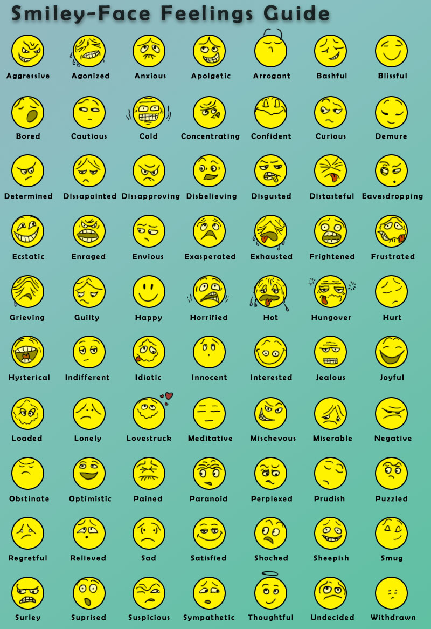

Lesson 3: Negotiated Behavior Change
Achievement-Based Objectives
By the end of this lesson, participants will have:
- Defined the word “negotiate”
- Explained why skills in Negotiated Behavior Change would be useful for a Behavior Change Agent (BCA)
- Identified the steps in Negotiated Behavior Change
- Practiced negotiating a behavior change with a familiar scenario about a relevant topic
- Critiqued their own skills in Negotiated Behavior Change
- Critiqued a fellow participant’s skills in Negotiated Behavior Change
Duration
2.5 to 3.5 hours
Materials
- Flip chart paper, markers, and masking tape
- Pre-written flip chart paper with the list of ideal behaviors being promoted by participants
- Pre-written flip chart paper with the steps of the Negotiated Behavior Change process
- Lesson 3 Handout 1: Negotiated Behavior Change (1 copy per participant)
- Lesson 3 Handout 2: Role Play Dialogues: Negotiated Behavior Change (or adaptation; 2 copies)
- Lesson 3 Handout 3: Illustrations of the Steps in the Process of Negotiated Behavior Change (1 set for each group of 4–5 participants)
- Lesson 3 Handout 4: Steps in the Process of Negotiated Behavior Change (1 copy per participant)
- Lesson 3 Handout 5: Role Play Scenarios (1 copy, with scenarios cut apart)
- Lesson 3 Handout 6: Observation Checklist (1 copy per participant)

Why this Lesson?
In the process of adopting a new behavior people often encounter personal challenges (difficulties, barriers, or obstacles). Behavior Change Agents (BCAs) can learn to help their target audience overcome these obstacles by learning Negotiated Behavior Change skills.

Advanced Preparation
Throughout this manual, the term Behavior Change Agent (BCA) is used to represent the wide variety of roles held by workers who promote change. When facilitating this lesson and others, replace “BCA” with a title that is appropriate for your audience (such as agriculture extension agent, community health worker, peer educator).
If the BCAs promote a set of “ideal behaviors” or “Essential Actions” (such as Essential Nutrition Actions or Essential Hygiene Actions) as part of the project/program, list these behaviors on flip chart paper for use with the introduction to ideal behaviors in Step 2a.
Choose two volunteers to do a role play and ask them to practice ahead of time using one of the scripts in Lesson 3 Handout 2: Role Play Dialogue: Negotiated Behavior Change. Option A is a role play about exclusive breastfeeding. Option B focuses on incorporating fish from personal fishponds into the family diet. These role plays can be changed by the facilitator in advance to include information and behaviors that are more relevant to the local situation and the BCAs’ work in the community. Make sure that each of the eight steps in the process of Negotiated Behavior Change, which are listed in the subheadings of the role play dialogue in Lesson 3 Handout 2, are clearly demonstrated in the role play.
On flip chart paper, prepare a list of the keywords from Lesson 3 Handout 3: Steps in the Process of Negotiated Behavior Change (Greet, Ask, Listen, Identify, Discuss, Recommend and Negotiate, Agree, Appointment).
Copy and cut out the large illustrations in Lesson 3 Handout 4: Illustrations in the Steps in the Process of Negotiated Behavior Change. There is one set of illustrations featuring women and another set featuring men. Facilitators should make additional copies as needed (one set of illustrations featuring either men or women is needed for each small group of four to five participants).
Read and select appropriate role play topics from Lesson 3 Handout 5: Role Play Scenarios. For some groups, the facilitator might need to write new scenarios that are more relevant to the BCAs’ work.

Tasks
1. Warm-Up Activity (20 minutes)
1a. Explain to participants: One of a Behavior Change Agent’s most important tasks is to increase behaviors that we know will help community members be healthier. So, today we will learn about and practice a skill that we can use to help people work through personal obstacles to change.
1b. Explain that they will start the lesson with a quick activity to help “put themselves in the shoes” of community members. Conduct an exercise that allows participants to share some behavior changes that they are working on in their own lives.
For example, you can play “two truths and a lie,” where participants think of two behaviors that they are currently trying to change and one that they are not currently working on. Then they share their three behaviors with the other participants, who try to guess which two are truths and which is a lie. (For example, “I am trying to eat a fruit and a vegetable with every meal” [truth]; “I’m taking acrobat lessons to get more exercise” [lie]; “I’m trying to not text on my phone when I’m with my family” [truth]). Encourage participants to have fun with the activity.
2. Ideal and Next Best Behaviors (20 minutes)
2a. Explain to participants that some of the behaviors they just shared could be described as “ideal behaviors,” or actions that we consider the most beneficial for reaching a certain goal. Ask participants to share some of the ideal behaviors that they promote in their work as BCAs. (If the participants work with a program-specific set of “Essential Actions” or ideal behaviors, share the flip chart list that you prepared in advance.)
2b. Ask participants: Is it always possible or easy for community members to practice the ideal behavior? (They should answer “no.” If they don’t, remind them to think of their own potential barriers to practicing the behaviors they mentioned during the first exercise).
2c. Ask participants: What are some of the reasons that community members might not do the ideal behavior? (Answers could include: no way to get the materials they need, cultural taboos, fear of bad results, difficulty remembering how/when to do the behavior, religious views, fear of bad effects from doing the behavior, thinking the danger isn’t likely to happen to them, thinking the danger isn’t serious)
2d. Ask participants: When mothers or other community members have trouble changing their behavior, what is the role of the Behavior Change Agent? (They should answer: to help the person find ways to overcome the difficulties.)
Explain that one way to overcome difficulties is called Negotiated Behavior Change.
2e. Explain to participants: Before you can use the Negotiated Behavior Change approach, you need to know two things: What is the ideal behavior? What would be a next best behavior that the person could try out, or a behavior that is “on the way” to using the ideal behavior? Sometimes this can be a similar behavior, but done less often or using lower amounts, etc.
- Referring to the flip chart of ideal behaviors, ask participants to write down what they think would be next best behaviors for each of the ideal behaviors shown on the flip chart.
- Ask trainees to share their ideas and discuss. Come to an agreement about the next best behaviors.
3. Definition and Advantages of Negotiated Behavior Change (20 minutes)
3a. Ask the group if they have ever heard of Negotiation for Behavior Change. Ask them to think about what this might mean.
3b. Read out loud and discuss briefly the definition of the approach found in Lesson 3 Handout 1: Negotiated Behavior Change. Take questions.
3c. Divide participants into small groups of four or five and ask them to discuss and make a list of what they think the advantages of Negotiated Behavior Change might be. Give them a few minutes to do this, then ask each group to share a few examples. Write these responses on flip chart paper.
3d. Distribute a copy of Lesson 3 Handout 1: Negotiated Behavior Change to the participants and ask them to compare the advantages list they made to the list found in the handout. Ask them to add to the handout any ideas on their list that they think are important.
4. Naming the Steps in Negotiation (30 minutes)
4a. Explain to participants: You are now going to watch a role play that shows the steps in Negotiated Behavior Change.
4b. Ask the previously chosen volunteers to perform one of the role plays found in Lesson 3 Handout 2: Role Play Dialogues: Negotiated Behavior Change (or the adaptation that was prepared in advance). Make sure that each of the eight steps in the process of Negotiated Behavior Change, which are listed in the subheadings of the role play dialogue in Lesson 3 Handout 2, are clearly demonstrated in the role play.
4c. After the role play is done, ask participants to tell you what they saw, including: What happened first? Then what happened? Show the flip chart list of steps that you prepared in advance (using Lesson 3 Handout 4: Steps in the Process of Negotiated Behavior Change as a guide). Ask participants if they saw all these steps in the role play.
4d. Ask that participants return to their small groups. Provide each small group with a set of the illustrations from Lesson 3 Handout 3: Illustrations of the Steps in the Negotiated Behavior Change Process. Ask each group to arrange the pictures in order, according to the list of steps on the flip chart (and without looking at Lesson 3 Handout 4).
4e. Once participants are done arranging the pictures in order, distribute a copy of Lesson 3 Handout 4: Steps in the Process of Negotiated Behavior Change to each participant and ask each group to compare their order with that in the handout.
Point out that some people find images useful as reminders of the steps in a process. Encourage participants to review the illustrations and/or written descriptions for each step as they continue with this lesson.
4f. Explain to and ask participants: In the negotiation process there needs to be at least one follow up visit. What do you think is the purpose of the follow-up visit? (Answers could include: to see if the mother/person has tried the behavior change and what the results were, to see if the obstacle has been overcome; to find other behaviors that the mother/person might need to adopt.) During the follow-up visit, the Behavior Change Agent should follow the same Negotiated Behavior Change process, only this time the Behavior Change Agent asks about the agreed-upon behavior first and goes on from there.
5. Practicing Our Negotiation Skills (1–2 hours)
5a. Explain to participants: We have discussed some of the theory behind the Negotiated Behavior Change process. Now it’s time to put our knowledge into practice ourselves.
5b. Divide the group into small groups of two or three. Give each small group a different role play scenario from the list in Lesson 3 Handout 5: Role Play Scenarios. (Or, each group can decide to work on another situation that is relevant to their work.) Ask each small group to discuss the scenario and develop a role play of 2–3 minutes on how to negotiate the behavior change. One person will play the role of the BCA, and the other will play the role of the community member. The third person can play the role of an influencing person (like a husband or mother-in-law, if need be). Each small group will take a turn performing its role play in front of the large group.
5c. Before the first role play is performed, distribute Lesson 3 Handout 6: Observation Checklist to each participant and explain that two group members will complete it for each role play (the facilitator should randomly choose two participants to fill the checklist before each role play begins). Share the following instructions for using the checklist.
- Check off the steps of the process as they are completed during the role play.
- When the role play is complete, the participants completing the form will have a few minutes to provide feedback to the performers. They should ask the performers, “What do you think went well?”
- Then, the observers can provide additional constructive feedback if needed, using phrases such as, “What if…?” or “How about …?” (Those giving feedback should be kind and encouraging, and not too detailed – we are just learning! Those receiving feedback should just say “Thank you” and not argue or explain why they did things a certain way.)
- If time permits, other participants will be able to provide additional verbal feedback to the performers.
5d. After all the role plays are complete, facilitate a discussion based on the following questions:
- How did you feel as the community member? How did it go, from your point of view?
- How did you feel as the Behavior Change Agent? How did it go, from your point of view?
- What was difficult?
- What can you improve?
6. Wrap Up (10 minutes)
6a. Explain that the Negotiated Behavior Change approach can be used with any behavior in any sector. Point out that the process requires at least one follow-up visit to see how the recommendation is being followed and to name other behaviors that the person should adopt according to the situation.
6b. Ask participants how they might start incorporating Negotiated Behavior Change into their own work as BCAs.

Lesson 3 Handout 1: Negotiated Behavior Change

Description of the Approach
Negotiating for behavior change means that the Behavior Change Agent (BCA) works together with a community member to consider various options and decide what that person will do. The BCA will not force the person to do something. The BCA listens respectfully to what the other person is saying. In the end, both people will agree with the decision that the other person takes. Remember that this process is a negotiation.

Advantages of Negotiation
- Negotiation encourages continued change because it demonstrates how small steps can help people reach bigger goals.
- Negotiation forms a bridge between the needs and values of the community and scientific knowledge.
- Negotiation helps BCAs learn what community members think, feel, and do by using skills of listening, asking, and negotiating. This information can help the BCA support people as they identify and work around barriers to change.
- Negotiation promotes positive approaches in BCAs and encourages a willingness to learn from the community, empathy for community members’ situations and difficulties, and a better understanding of opportunities for realistic change.
- Negotiation builds trust between the BCA and community members because they have had a chance to express themselves and have their situations taken into account.
- Negotiation with various families identifies the best practices possible within a given situation, even if those are not necessarily the optimal practice.

Lesson 3 Handout 2: Role Play Dialogues:
Negotiated Behavior Change

Option A
Behavior: Exclusive breastfeeding
Scenario: Mother says baby (2 months old) needs to drink water
Actors: Behavior Change Agent (BCA), Mother, Mother-in-Law
Actor | Dialogue
1. Greet
BCA | Good morning, Mary. I am glad to see you. I hope you are doing well. Congratulations on the birth of your son.
Mother | Welcome. I’m glad to see you. Thanks for coming to see me.
2. Ask
3. Listen
BCA | How old is Paul now? How is he doing?
Mother | Paul is 2 months old now, and he’s doing just fine. I weighed him for the first time last week.
BCA | That’s wonderful. What did they tell you about Paul’s weight gain?
Mother | They said he gained the right amount of weight. Look how fat he is!
BCA | That’s good news. Congratulations! Tell me, how is Paul feeding?
Mother | He’s breastfeeding well, both day and night. He’s very hungry all the time.
BCA | That’s good news. Tell me, when you have to work outside the home, who takes care of Paul and how do you manage the feeding?
4. Identify
Mother | Yes, that is a challenge. Sometimes I have to leave Paul at home and my mother-in-law takes care of him. Sometimes she gives him water to drink or juice since it’s so hot these days. She says babies need more fluids during the hot season.
BCA | So your mother-in-law is giving Paul some water and maybe juice. How do you feel about that?
Mother | She has raised many children, so she has a lot of experience.
BCA | Yes, that is true. Is your mother-in-law at home now? Can she join us?
Mother | Yes, she’s here. I’ll call her (calls the mother-in-law to join them). This is my mother-in-law, Helen.
5. Discuss
BCA | Hello. I am happy to meet you. Congratulations on such a beautiful grandson. I understand you are helping Mary take care of Paul when she is away from home. That is very helpful.
Mother-in-Law | It’s nice to meet you. Yes, I enjoy taking care of Paul when Mary is away.
BCA | I understand that you are concerned that when it’s hot like this, that Paul needs to drink more fluids.
Mother-in-Law | Yes, we have known this for a long time. I learned this from my own mother.
BCA | It’s true that when it’s hot everyone needs to drink more, but did you know that breast milk contains a lot of water? So each time Mary breastfeeds Paul, she is giving him water.
Mother-in-Law | I didn’t know that. That’s interesting. But when Mary is away from home, I need to give Paul some water.
6. Recommend
BCA | I understand that you are worried that Paul needs water in this hot weather, but Paul’s stomach won’t be ready for other drinks and food until he’s about 6 months old. Water and juice can upset Paul’s stomach and cause diarrhea. Diarrhea in a young infant can be very serious.  I would like to make a suggestion. When Mary needs to leave Paul with you, she should first give him a good feed and plan to be gone only a few hours. That way she’ll be back in time to feed him again when he’s hungry. Do you think you can do this until Paul is 6 months old and ready for other foods?
Mother | Oh my! Six months—that’s another 4 months!
Mother-in-Law | That’s a long time. Surely he will need food before then.
BCA | I see that another 4 months seems like a long time. How about trying to only give breast milk for the next month? Helen, you can remind Mary to give Paul a good long feed before she goes out. What do you think of that suggestion?
Mother | What do you think, Helen? Just another month? Then we can see.

Actor | Dialogue
7. Agree
BCA | After a month, I can come back and we’ll see if Paul is continuing to gain weight. That is the perfect way to know if he’s healthy. What do you think, Helen?
Mother-in-Law | OK, we can try it for just a month.
BCA | So, do we agree that Paul will only be given breast milk during the coming month?
Mother and Mother-in-Law | Yes.
8. Appointment
BCA | That’s great! I will plan to come back in a few weeks to see how things are going. Is that OK with you? And, if anything comes up in the meantime, please just come see me.
Mother | OK, I will. Thanks for coming by.
BCA | Paul is a lucky baby to have such a loving mother and grandmother!

Option B
Behavior: Incorporating fish from personal fishponds (aquaculture) into children’s diet
Scenario: Mother wants to include fish in children’s diet but husband sells all the fish at market
Actors: Behavior Change Agent (BCA), Mother, Father
Actor | Dialogue
1. Greet
BCA | Good morning, Angela. How are you doing? I hope your fish pond is prospering. Congratulations on the first harvest of fish!
Mother | Welcome. It’s good to see you again. Thanks for coming to visit.
2. Ask
3. Listen
BCA | So I understand it’s been about 6 months since you installed your fishpond. How is it going?
Mother | Things are going pretty well. We received some great training and have been trying to apply everything that the fishery outreach workers taught us.
BCA | That’s good to hear. Didn’t you also have a visit from the local health care worker?
Mother | Oh, yes. She mentioned that many children are undernourished in our community, and that we need to try including other foods in their diet, like fish.
BCA | That’s is true. Fish are an important source of protein! Tell me, how is it going?
Mother | Well, I have been trying, but there are some things that have made it quite difficult.
BCA | It can be hard to try to change your family’s diet, and I’m very happy that you are trying. Can you tell me about some of the things that have made it hard for you?
4. Identify
Mother | Yes, well, my husband doesn’t want me to use the fish from our fishpond in our family meals. He wants to sell all the fish because he says we can make more money.
BCA | So your husband thinks that making money at market is more important for the family than incorporating new foods into your children’s diet?
Mother | Yes, he feels that our kids look just like the rest of the kids in the village and they are all pretty healthy. I mean, they get sick sometimes, but he says that is just normal.
BCA | And what do you think?
Mother | Well, in the education sessions we learned that children should eat more foods and different foods to ensure that they grow up big and strong.
BCA | This is true. Have you tried to talk to your husband about this?
Mother | Yes, but it is hard and he doesn’t always listen.
BCA | Maybe it would help if we talked with him together. Is your husband around? Can he join us?
Mother | Yes, he’s just outside. I’ll call him (calls the husband to join them). This is my husband, Cipriano.

Actor | Dialogue
5. Discuss
BCA | Hello. I am happy to meet you. Congratulations on your beautiful fishpond! I understand it was a lot of work, but that you have finally started harvesting the fish. That is great news.
Father | It’s nice to meet you, too. Yes, I am very proud of our fish. It took a while for them to grow, but now it’s all worth it.
BCA | I understand that you have been selling the fish you harvest at market to get more money.
Father | Yes, almost everyone in our community enjoys eating fish, and my neighbors are happy to buy from me.
BCA | It’s good that people enjoy eating fish. They are a great source of protein, which is important for the body to grow and have energy. Do your kids like to eat fish?
Father | I don’t know. We don’t really feed them fish because they are so valuable I sell them all. I mean, I know my wife wants to feed them fish, but the kids are so small they don’t need to eat that much anyways.
BCA | The kids are small at their young age, but they also have the most growing to do. They actually need even more food at this time in their lives, especially food from animals, so they can continue to grow into strong healthy adults.
Father | Hmm. I never thought of it that way. But, the money is important too.
6. Recommend
BCA | I understand that you need to make money and that selling fish at market adds another source of income. But, it is also important to make sure your kids have enough quality food. The food you feed them now will determine how healthy they are later.  I would like to make a suggestion. When Angela prepares food, why don’t you help her to include some fish for each of the family members: you, her, and each of your children? You will still have a lot of fish to sell and your kids will be getting the nutrients they need. Do you think you can do this?
Mother | Wow! Adding fish to everyone’s plate every day—that is going to be a lot of fish!
Father | Yeah, I don’t think I can afford to keep all those fish for just our family.
BCA | I see that including fish in your household diet every day is a lot to ask. How about trying to add fish to your meals every other day? Angela can you remind Cipriano to save a few fish for you to make with dinner every other day? What do you think of that suggestion?
Mother | What do you think, Cipriano? Every other day would be okay. The kids do love to eat fish…
Father | Well, I guess we can try it out.
7. Agree
BCA | Great! Why don’t you keep track of how many fish you sell per week and how many fish your family eats. Also, we can measure the kids now and then check them again when I come back in a couple months to see how much they grow!
Father | Ok, I guess we can try it for a couple months.
BCA | So, do we agree that Angela will feed everyone in the family fish at least every other day?
Mother and Father | Yes.
8. Appointment
BCA | That’s great! I will plan to come back in 2 months to see how things are going. Is that OK with you? And, if anything comes up in the meantime, please just come see me.
Mother | OK, I will. Thanks for coming by.
BCA | No problem. I am glad the fish pond is working out and that your kids are going to benefit on top of the added income for the family.

Lesson 3 Handout 3: Illustrations of the Steps in the Process of Negotiated Behavior Change
This handout includes two sets of illustrations: one depicting two women chatting and the other depicting two men chatting. Both sets are placed in order of the eight steps of Negotiated Behavior Change.

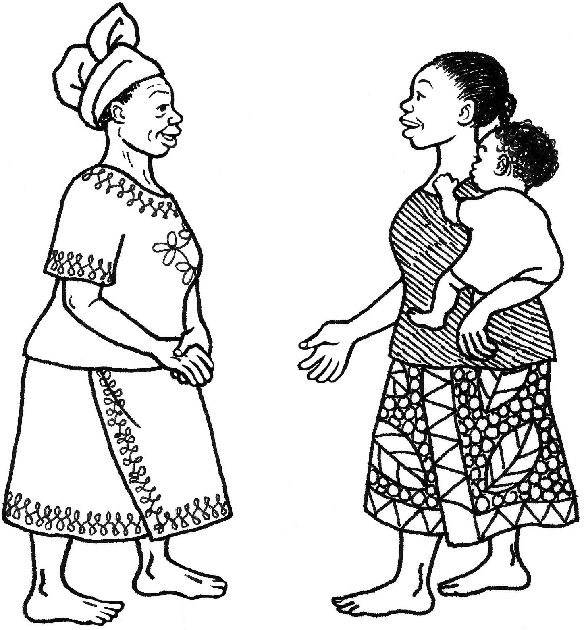

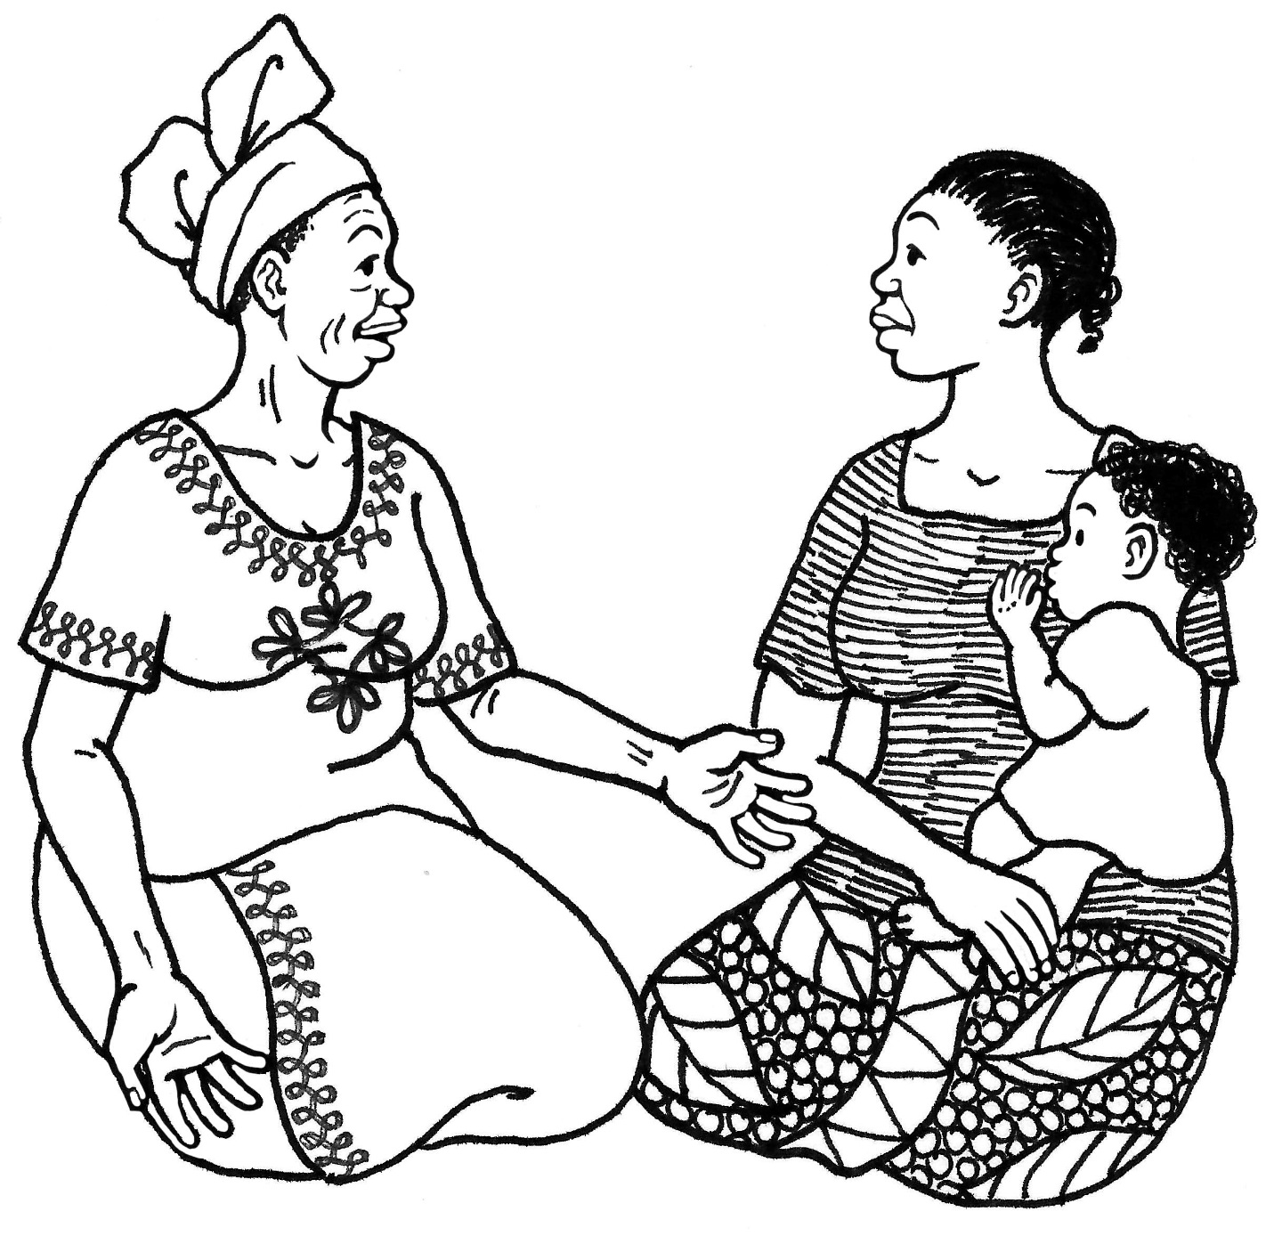

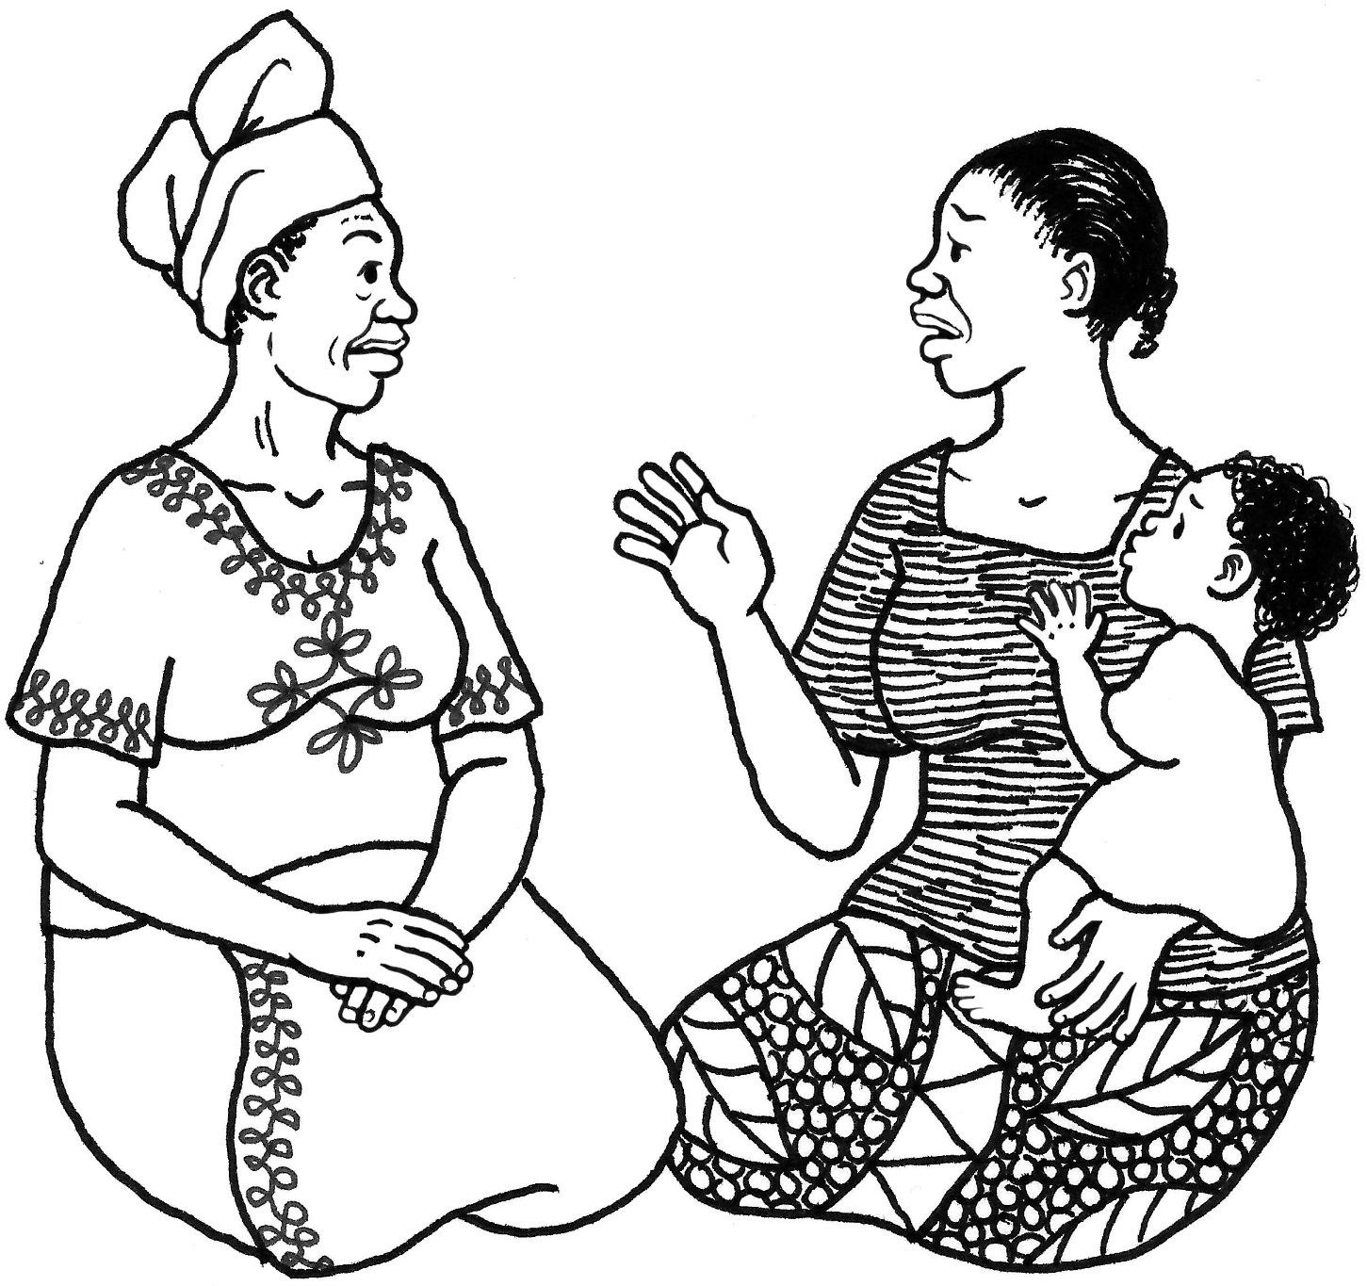

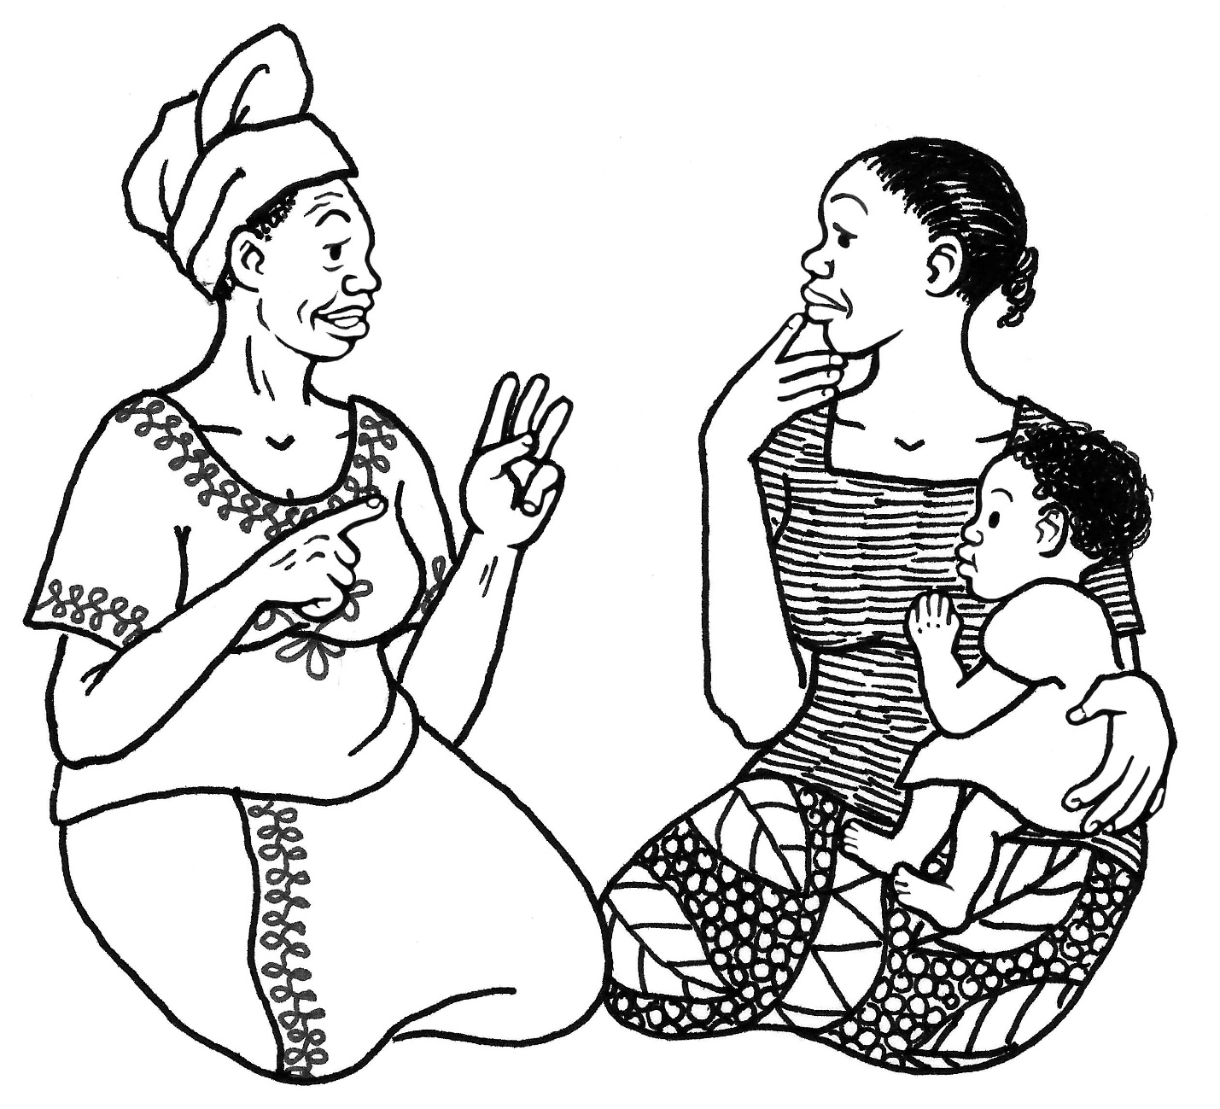

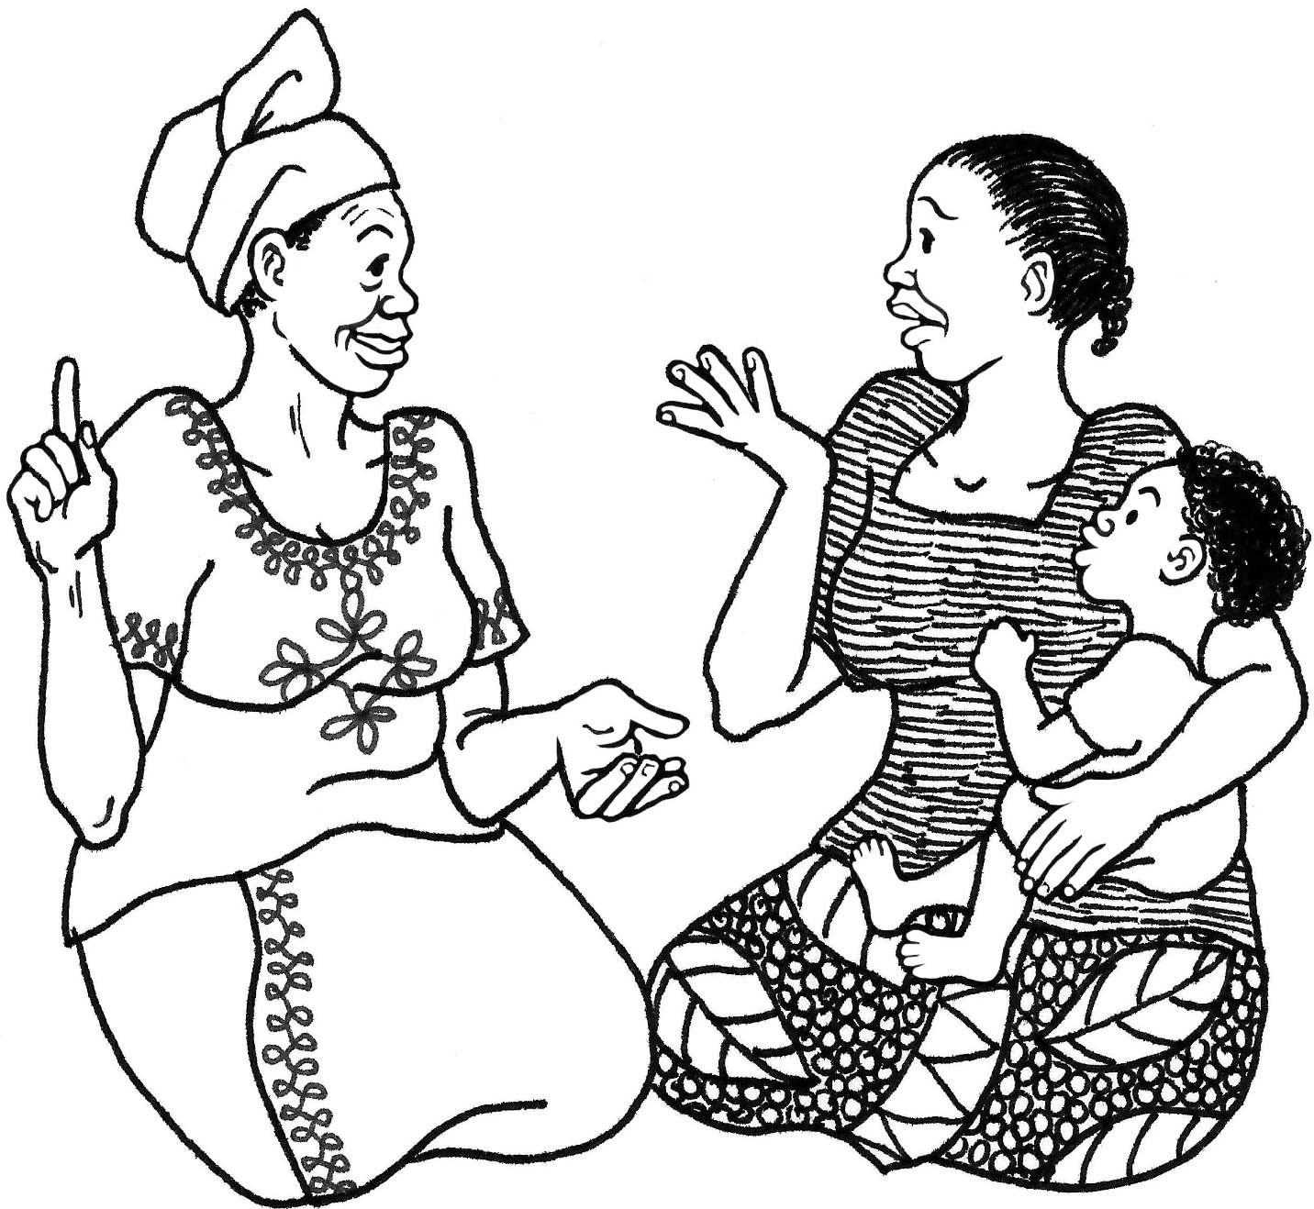

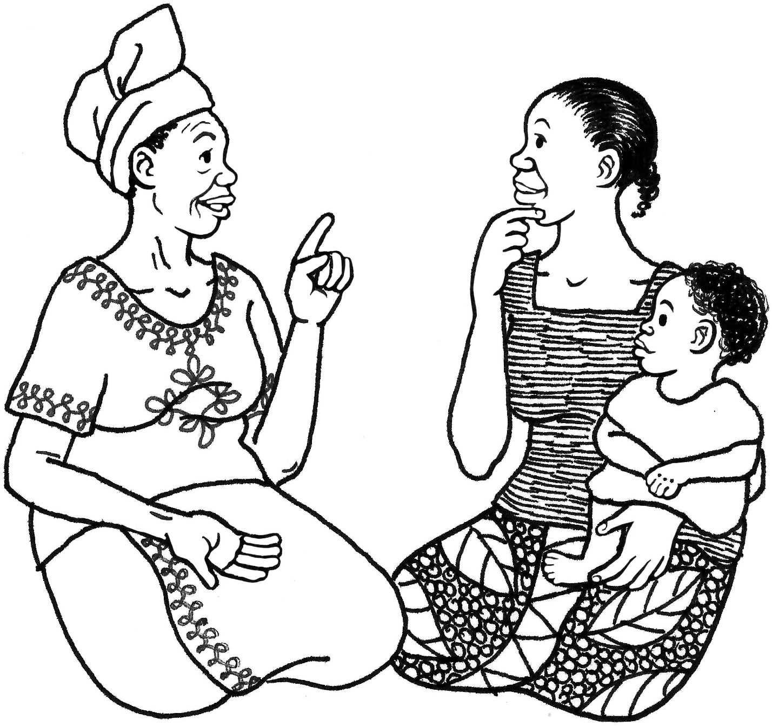

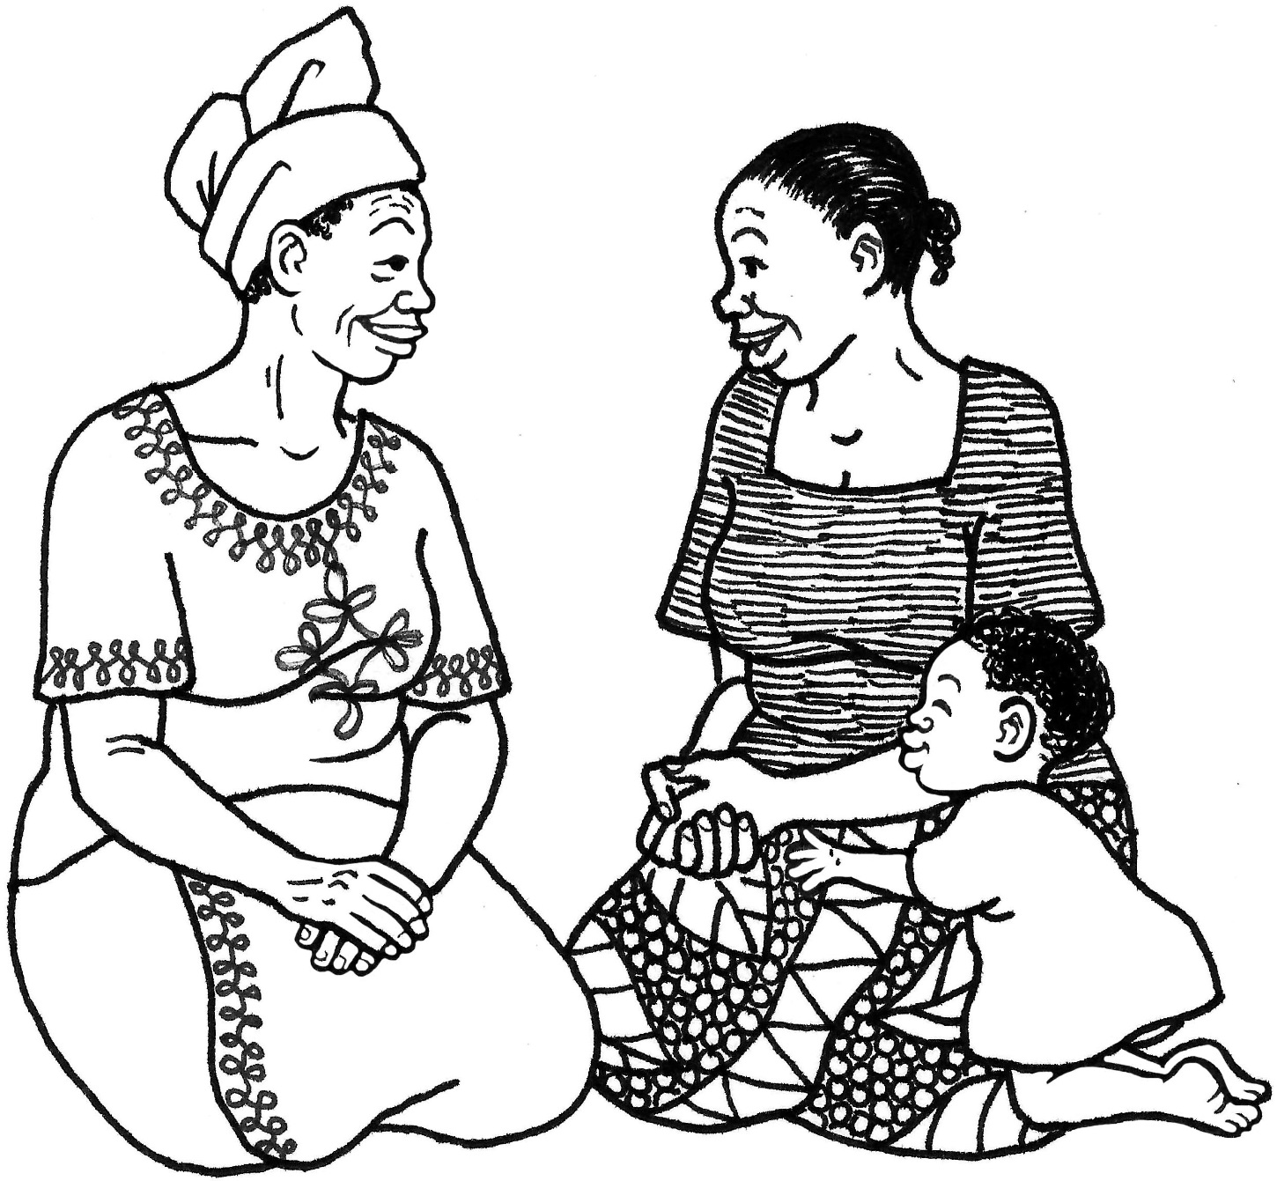

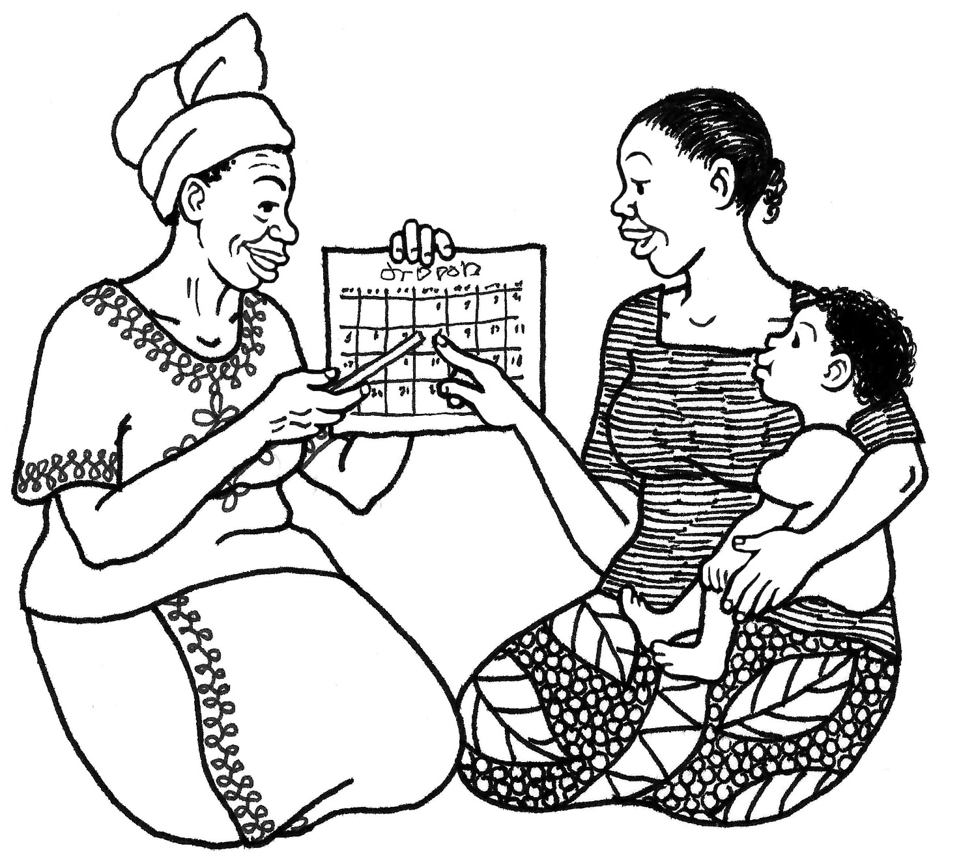

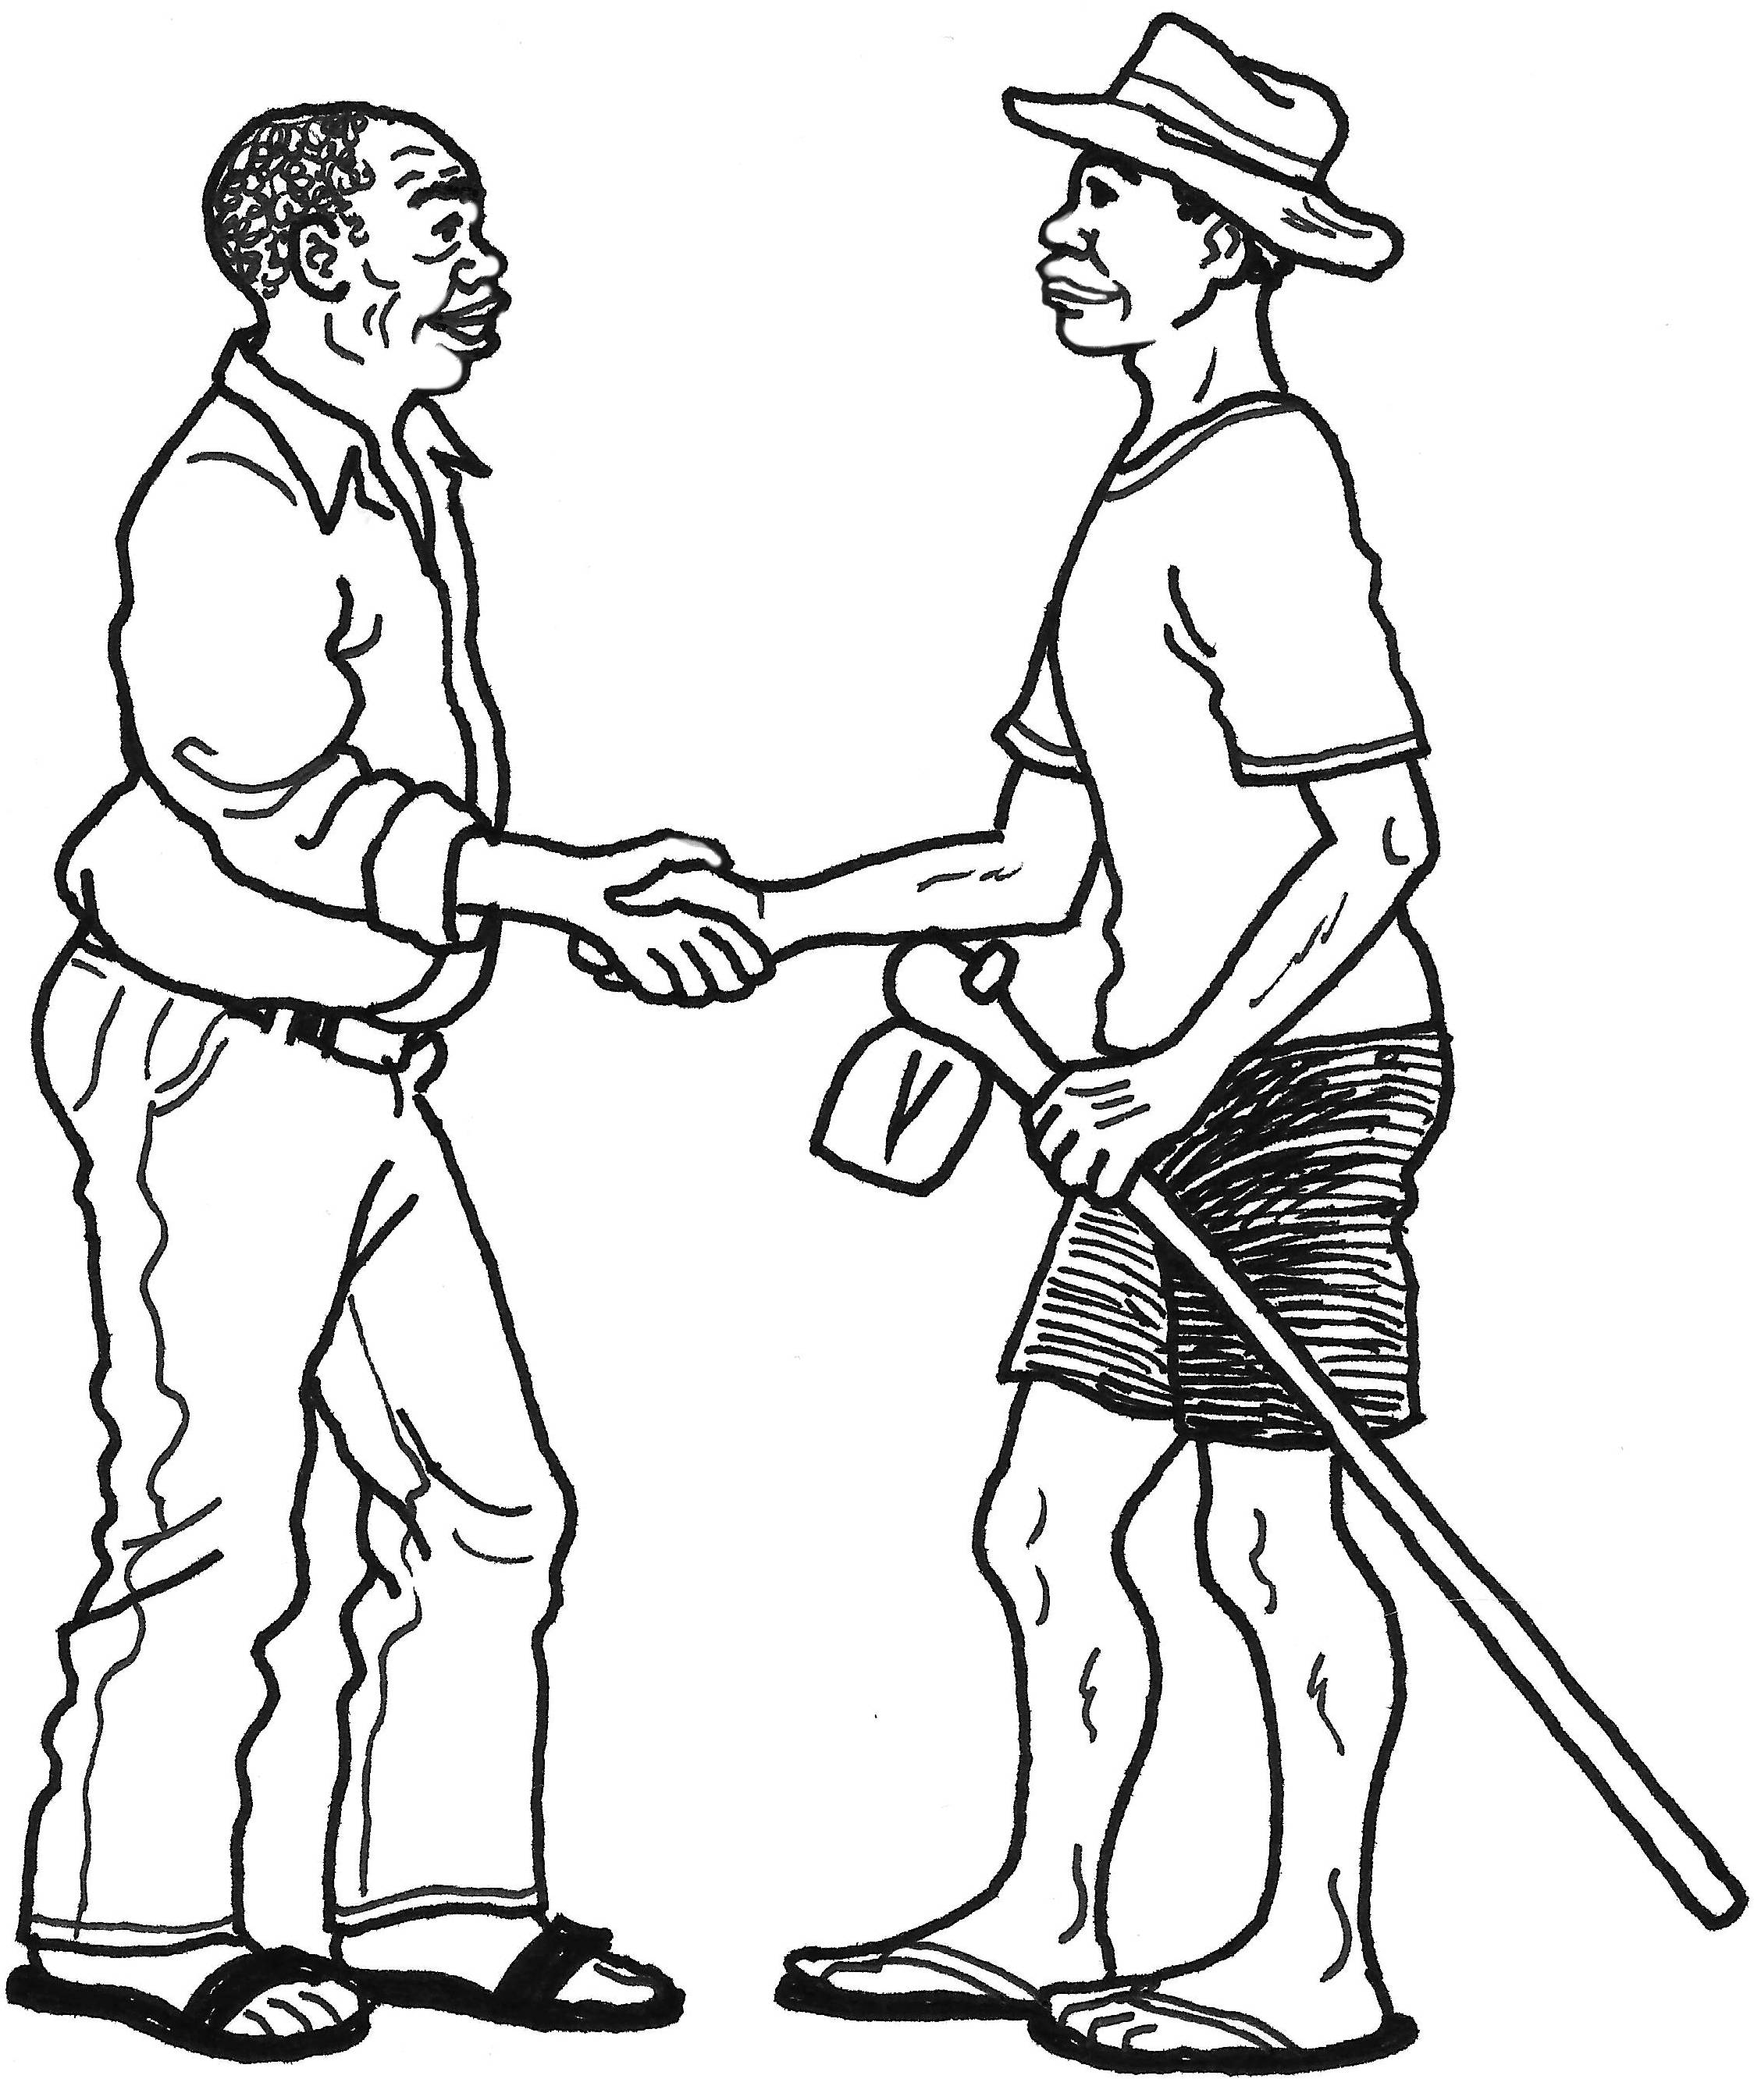

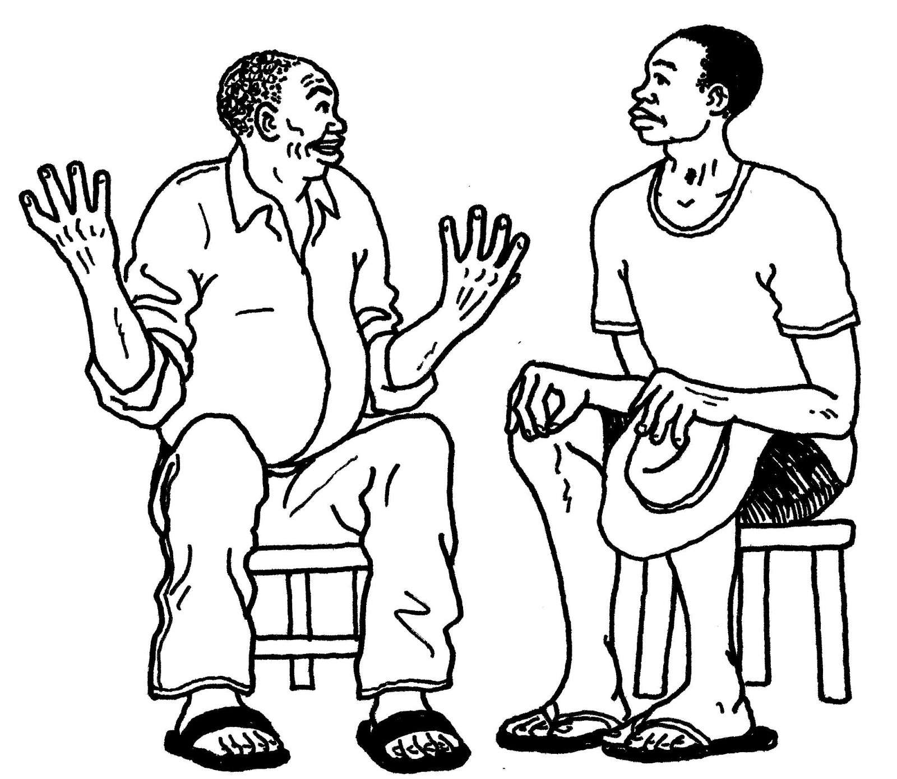

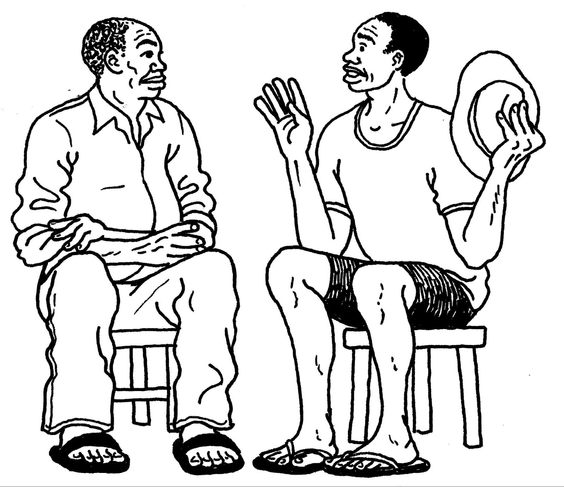

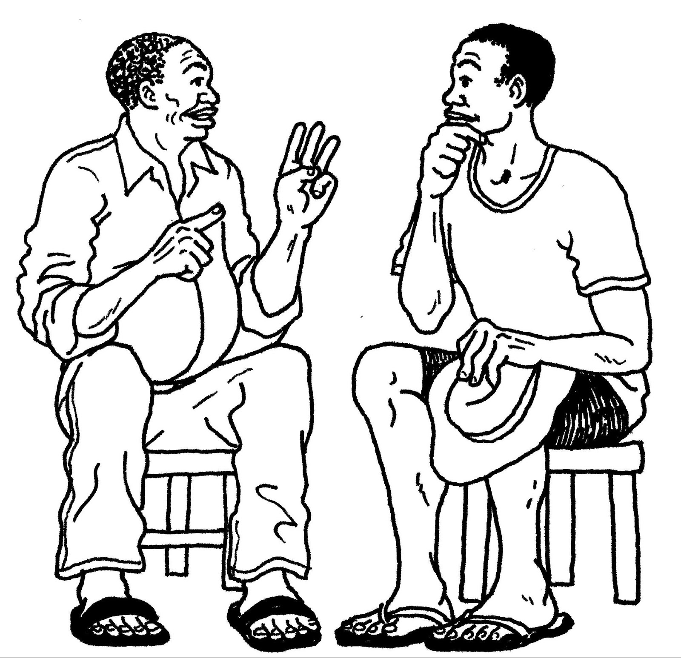

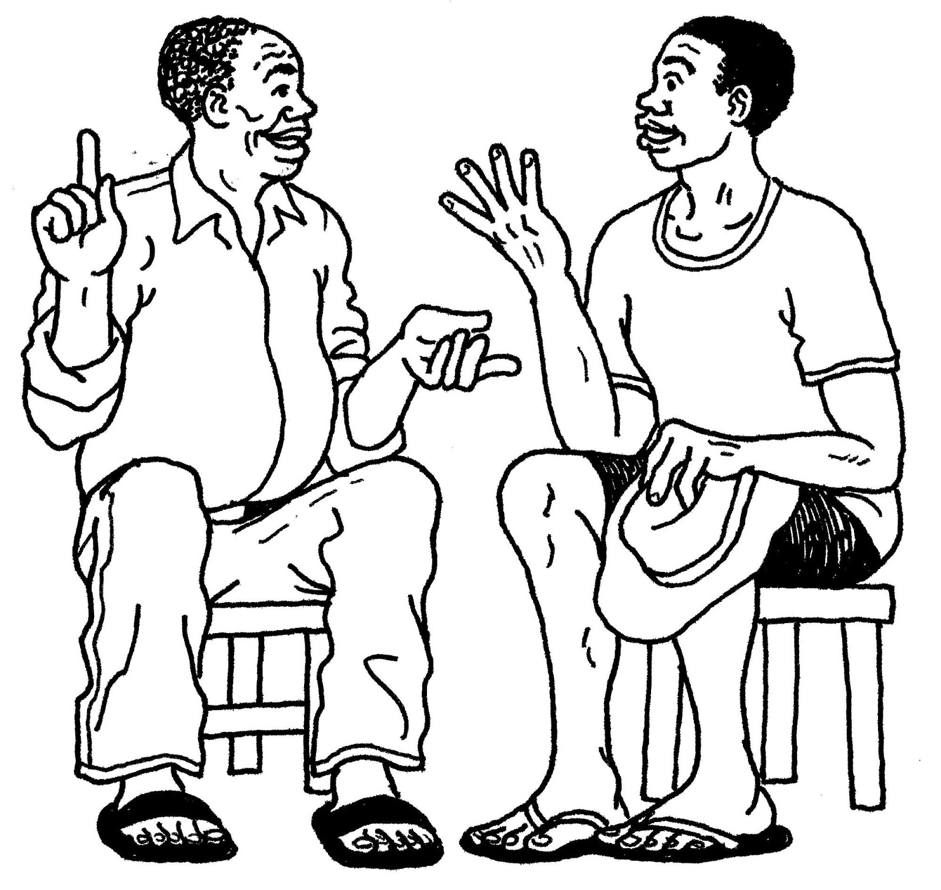

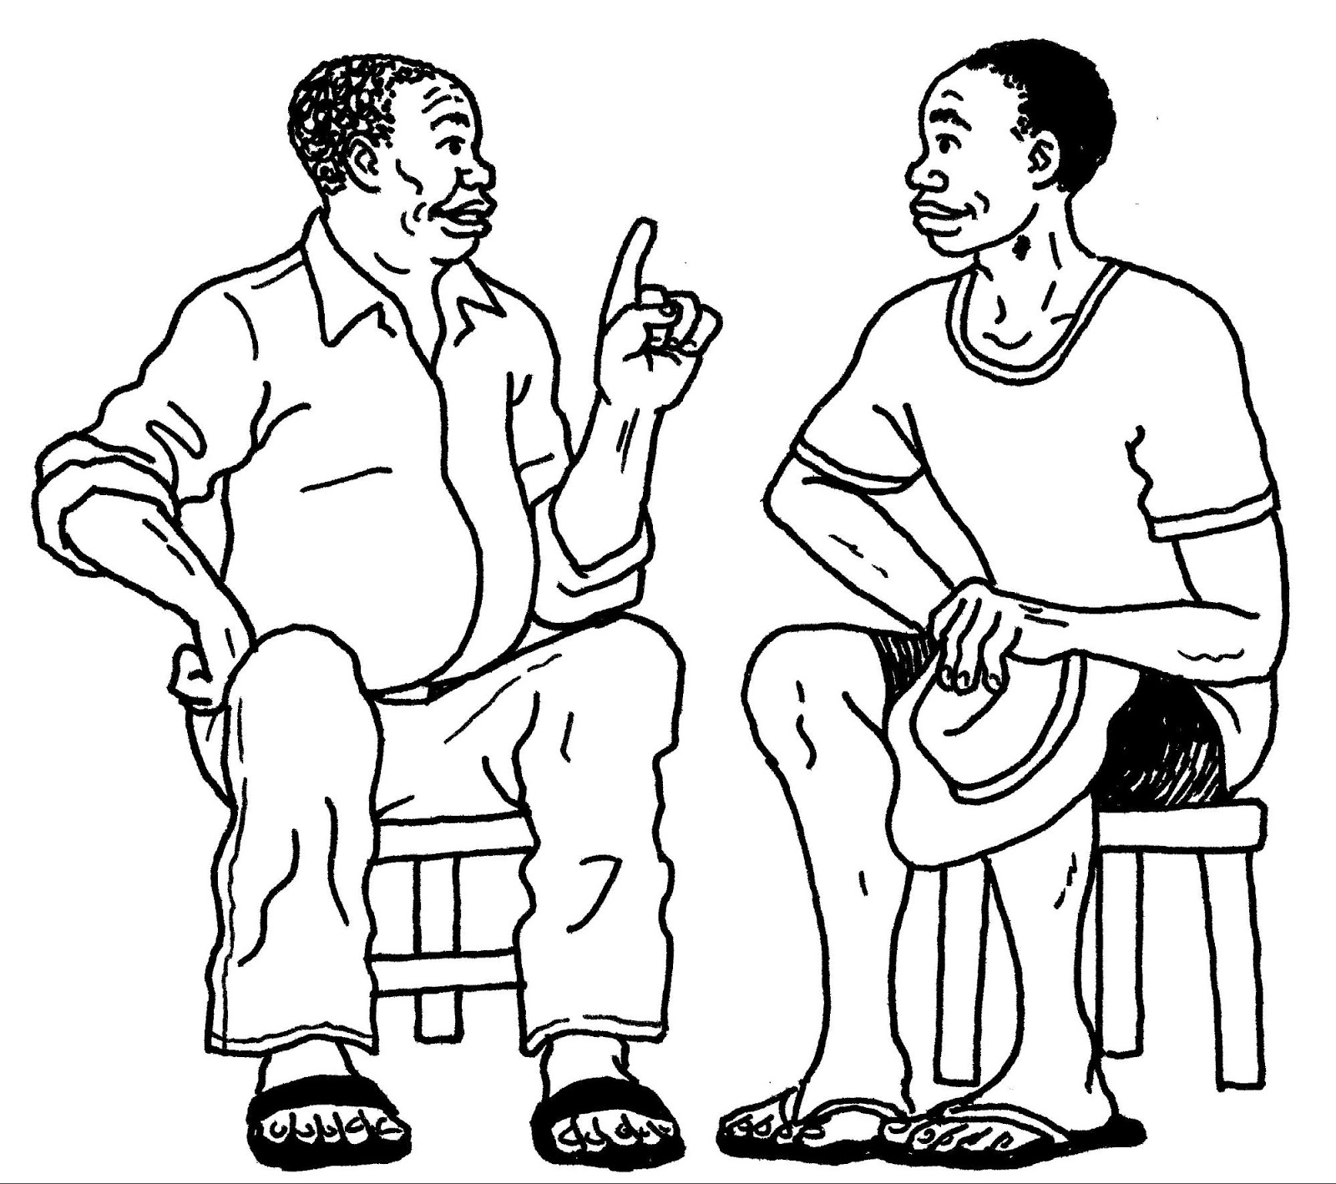

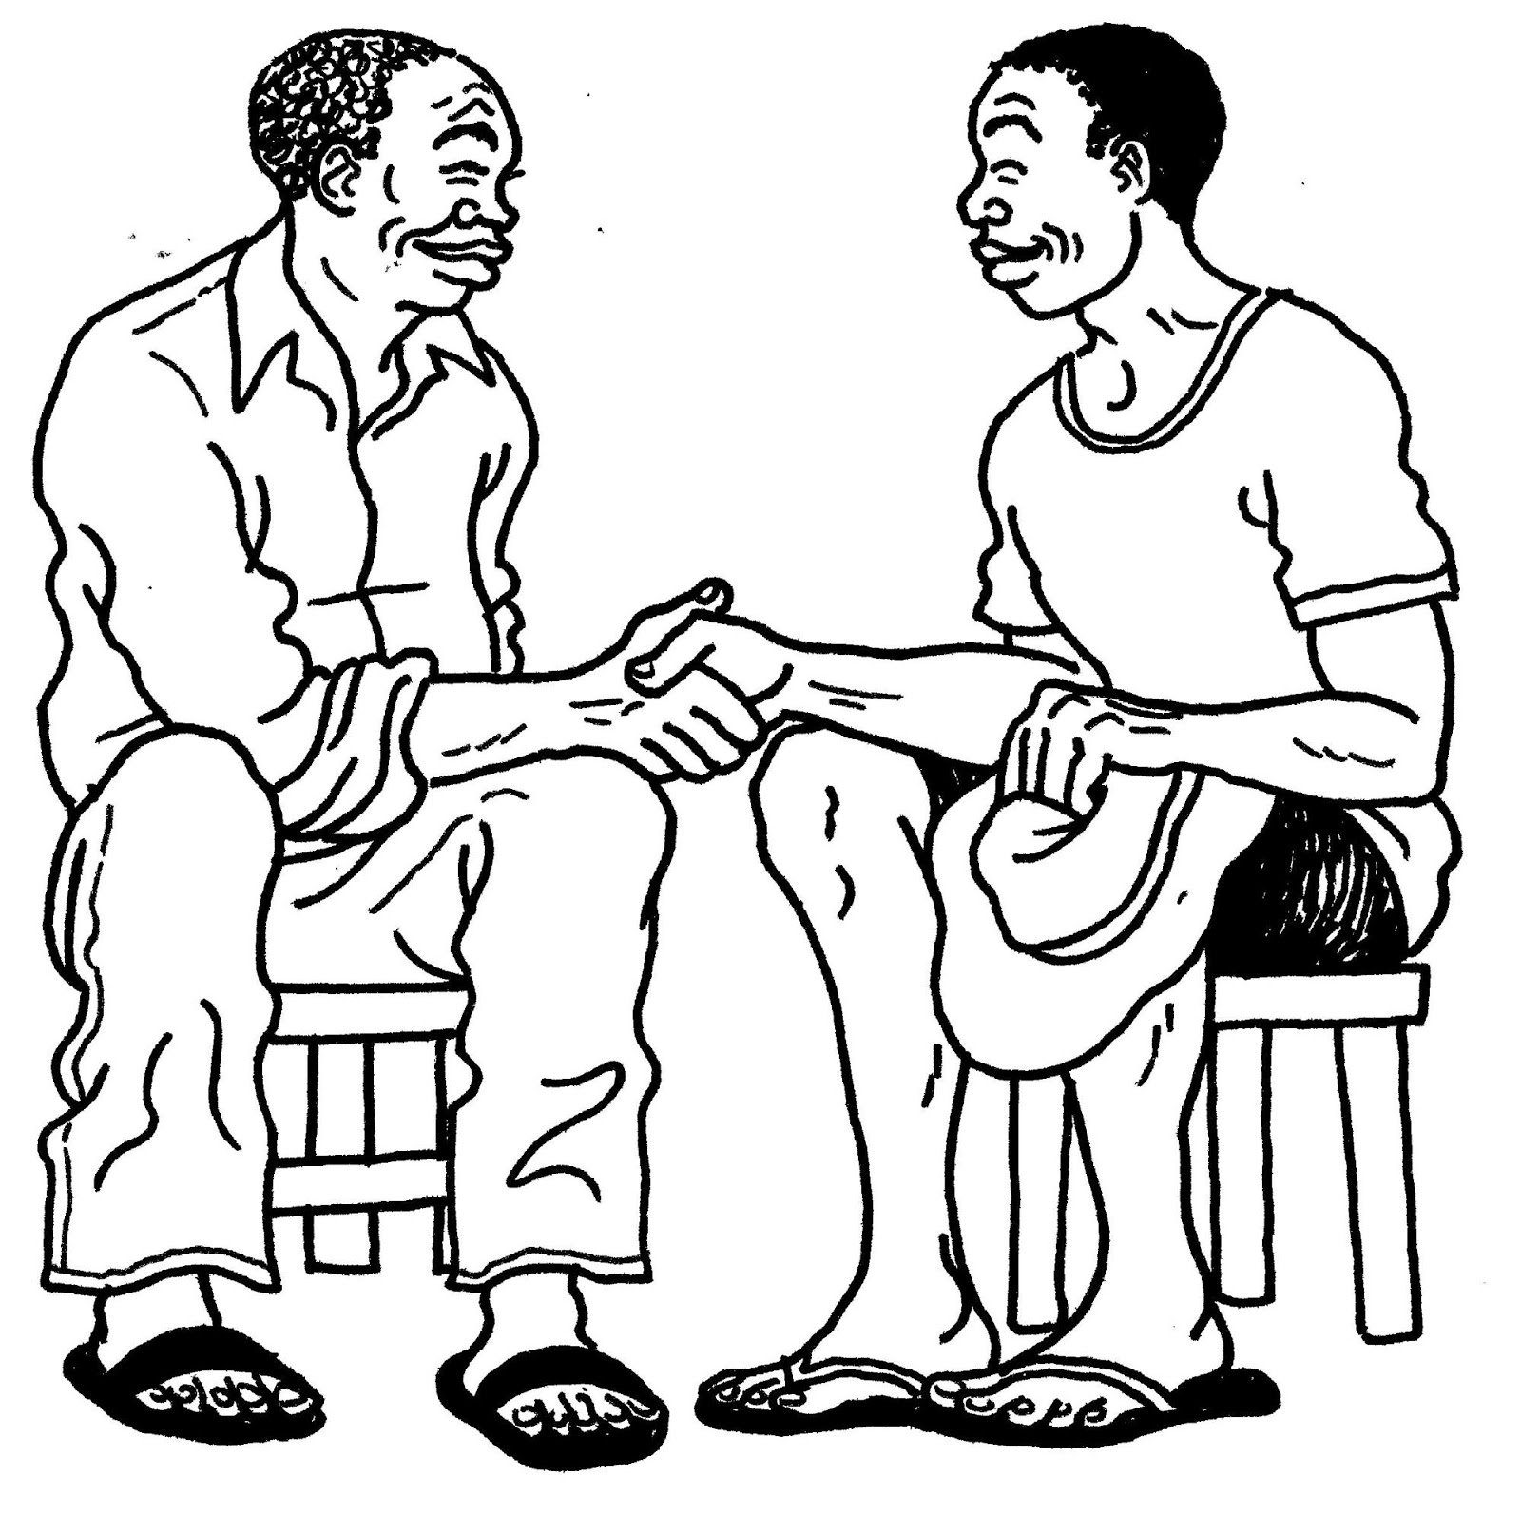

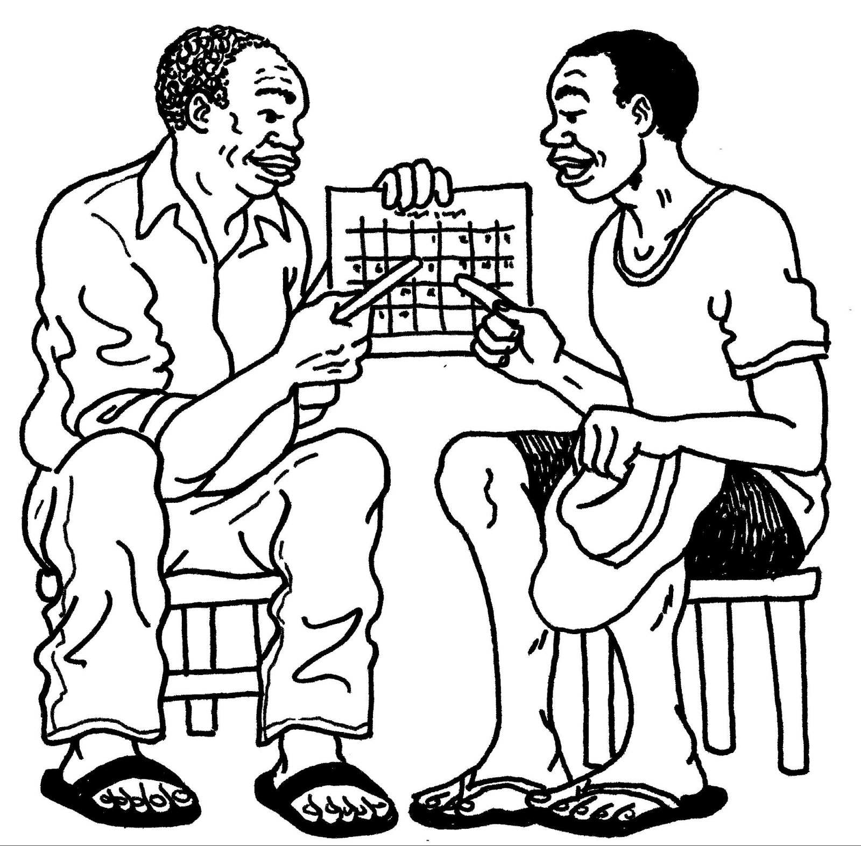

Lesson 3 Handout 4:
Steps in the Process of Negotiated Behavior Change
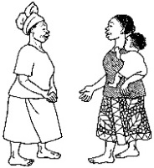 |  | - Greet the person and establish confidence.
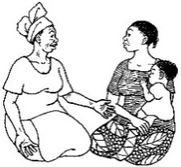 |  | - Ask the person about current behaviors/practices.
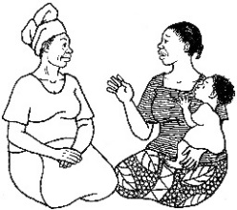 |  | - Listen to/reflect on what the person says.
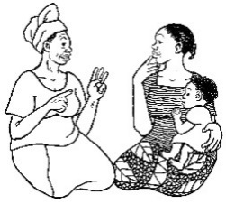 |  | - Identify any difficulties/obstacles and possible causes; select one difficulty/obstacle to work on.
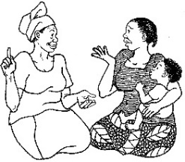 |  | - Discuss with the person different possible ways to overcome the obstacle.
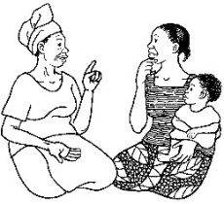 |  | - Recommend and negotiate doable actions: Ask for solutions from the community member; offer additional options/suggestions and NEGOTIATE with the person to help him/her select one option/action that he/she can try.
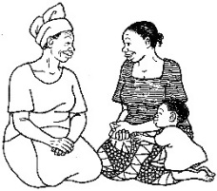 |  | - Person agrees to try one or more of the options, and the person repeats the agreed upon action.
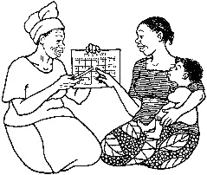 |  | - Make an appointment for the follow-up visit.

Lesson 3 Handout 5: Role Play Scenarios
- A BCA meets a woman who does not feel that she should give her child more food when he is sick.
- A BCA finds out that a herder has not had his animals dewormed by the veterinarian as recommended.
- A BCA finds out that a school director has taken over the supervision of the school improvement project that the parent teacher association (PTA) was supposed to oversee.
- A BCA finds out that some parents are keeping their daughter home from school to do chores. She arrives late to school 3–4 days each week.
- A BCA notices that herders in the community bring their sheep to the community well used for drinking water. The sheep are not only coming to drink, but they are spending a portion of the day resting in the area around the well. There is another well 5 km away.
- A BCA learns that a pregnant woman is sharing her food ration with the families of her two brothers, leaving very little food for herself and her two children, ages 2 and 4.
- A BCA meets a woman who has two children, a boy and a girl both under 5 years of age, and receives food rations for them both. She only gives the rations to her boy child, thinking his health is more important.
- A BCA working with technology support finds out that the records for the program in the subzone are only being kept in paper copy and are not entered in the data filing system.
- A BCA working as a finance manager supervises a field officer who always turns in expense reports without receipts after travel.
- A BCA meets a pregnant woman who thinks the mosquito net is too hot to sleep under.
- A BCA meets a pregnant woman who plans to give birth at home because the health center is too far away.
- A BCA is working with a pregnant woman who thinks having two clinic visits (or antenatal consultations) is plenty.

Lesson 3 Handout 6: Observation Checklist
Did the Behavior Change Agent (BCA) do the following?
- 1. Greet the person and establish confidence.
- 2. Ask the person about current practices.
- 3. Listen to the person.
- 4. Identify obstacles and a next best practice that the person can try.
- 5. Discuss with the person different possible ways to overcome the obstacle.
- 6. Recommend ways to overcome the obstacles and practice an intermediate behavior.
- 7. Gain Agreement of the person to try the recommendation.
- 8. Make an Appointment for the follow-up visit.

Ask the BCA to name one or more thing(s) he/she did well. Note your observations here:

Name one important thing you recommend the BCA work on to improve the next time:

Lesson 4: Home Visits/Individual Counseling
Achievement-Based Objectives
By the end of this session, the participants will have:
  - Discussed their program’s expectations regarding home visits
  - Defined the purpose of the home visit
  - Listed the steps and qualities of an effective home visit
  - Practiced conducting a home visit
  - Critiqued a home visit
Duration
3–3.5 hours
Materials Needed
- Flip chart paper and markers
- Pre-written flip chart entitled “Purpose of a Home Visit”
- Scenarios for role plays (1 scenario per pair of participants)
- Lesson 4 Handout 1: Purpose of a Home Visit (1 copy per participant)
- Lesson 4 Handout 2: Role Play Dialogue: Showing Steps in a Home Visit using the Negotiated Behavior Change Process (2 copies; see “Advanced Preparation” for variations)
- Lesson 4 Handout 3: Steps in Conducting a Home Visit (1 copy per participant)
- Lesson 4 Handout 4: Quality Improvement and Verification Checklist: Home Visits/Negotiated Behavior Change (1 copy per participant)

Why this Lesson?
Frequently a Behavior Change Agent (BCA) is called to visit someone at home—to do a home visit—as part of the behavior change promotion process. BCAs will benefit from knowing the best way to conduct a home visit, the main purpose of which is to promote behavior change.

Advanced Preparation
Throughout this manual, the term Behavior Change Agent (BCA) is used to represent the wide variety of roles held by workers who promote change. When facilitating this lesson and others, replace “BCA” with a title that is appropriate for your audience (such as agriculture extension agent, community health worker, peer educator).
Before conducting this lesson, become informed about the participants’ programs’ policies about home visits. This should include the frequency, the designated audience to be visited, and the purpose of the home visit (if there is a particular one for the project).
Practice the role play in Lesson 4 Handout 2: Role Play Dialogue: Showing Steps in a Home Visit using the Negotiated Behavior Change Process with co-facilitators or, if there are no co-facilitators, share the handout with two randomly chosen participants so they may practice for the role play. Additional role play scripts are available in Lesson 3 Handout 2: Role Play Dialogues: Negotiated Behavior Change. If appropriate, the facilitator should adapt these scripts to suit the responsibilities of the participants.
Develop home visit scenarios (one for each pair of participants) that are based on the behaviors being promoted by the project for the exercise in Task 5: Practicing Home Visits. For scenario ideas, refer to Lesson 3 Handout 5: Role Play Scenarios (from the lesson on Negotiated Behavior Change). In some groups, participants might like to make up their own scenarios in order to practice on a case that is especially relevant to their own experience in the community.

Tasks
1. Warm-Up Activity (15 minutes)
1a. Conduct a brief introductory exercise to help participants get comfortable with talking with each other and start thinking about home visits. For example, have participants talk with a partner (preferably someone they don’t know well) about a type of food they like to prepare when someone is visiting their home or about a traditional food that they enjoy eating when they visit friends and families.
1b. Allow about 5 minutes for discussion, then ask participants to share their findings with the larger group.
1c. Facilitate a discussion based on the following questions.
- Why do you choose to share that particular food with guests?
- Or, why do you think your hosts choose that food to share with you?
- What are some of the other ways that you make guests feel welcome in your home?
2. Structure of BCA Home Visits (15 minutes)
2a. Explain to participants that one of the responsibilities of many BCAs is to visit people at home, also known as conducting a home visit. Note that meeting with someone in his/her own home is a powerful way to connect with that person, learn about his/her life, and provide support throughout the behavior change process.
2b. Ask participants to think for a moment about what might be the same and what might be different about making a visit to the home of a friend or relative compared to visiting the home of a community member in the role of BCA. (Similarities might include: it’s important to show respect and warmth, ask about how the people in the home are doing. Differences might include: a BCA’s visit to a community member has a particular purpose, the BCA will usually not discuss his/her own personal issues, there is less sharing of food/gifts. Here you may also want to briefly discuss the cultural and program concerns, expectations, or policies related to food during home visits. For example, in some programs, the BCA may accept tea during a home visit but is expected to politely refuse food that is offered.)
2c. After a brief discussion, note that today’s lesson will review the structure and purpose of home visits conducted by a BCA. Note that participants will have an opportunity to practice the steps of a home visit and learn how to use their time with community members more effectively.
2d. Ask the participants to recall their project’s proposed home visit schedule. As participants explain their project’s protocol, write some notes about it on a flip chart.
3. Purpose of the Home Visit (10 minutes)
3a. Ask participants: What do you understand is the purpose of a Behavior Change Agent’s home visit?
Remind them that a home visit usually takes place after the BCA has already conducted some educational activities.
3b. Write participants’ ideas on a flip chart entitled “Purpose of a Home Visit.” Brainstorm for about 5 minutes.
3c. Refer participants to the Lesson 4 Handout 1: Purpose of a Home Visit. Compare and contrast the participants’ list with the handout.
4. How to Conduct a Home Visit (30 minutes)
4a. Ask participants the following questions and lead a discussion.
- Have any of you ever been visited at home by someone like a Behavior Change Agent, such as a church member or health worker?
- Thinking about that home visit you received, can you share how you felt about it?
- Was it a positive experience? If yes, what made it positive?
- How did the person doing the visit act?
- How did you feel?
If none of the participants has experienced a home visit, ask: What do you think are the qualities of a good home visit by a Behavior Change Agent?
4b. Divide participants into small groups and pass out flip chart paper and markers. Ask the participants to list on the flip chart paper the qualities of a good home visit. Ask them to think about specific communication skills they might use and actions they might do during the visit. Give them a few minutes to do this, then ask a few small groups to share their lists. (The lists might include: show respect by calling the person by name, ask if the time of the visit is convenient, ask about the welfare of family members, be culturally sensitive, provide context-specific information, show interest in understanding the person’s particular situation, not be intrusive, be patient, and actively listen. )
4c. Explain to participants: Now let’s look at the steps for conducting a home visit.
4d. Demonstrate the role play in Lesson 4 Handout 2: Role Play Dialogue: Showing Steps in a Home Visit using the Negotiated Behavior Change Process, which describes a simple home visit that includes the steps in Negotiated Behavior Change. Instruct the participants to try to name the different steps while they watch the role play.
4e. After the role play, ask participants to name the steps they observed. List them in order on a flip chart.
4f. Ask participants: What surprised you in this home visit? What stood out for you? Was anything about it different from home visits that you have been doing or have seen? (Answers should include: the focus on promoting behavior change, specifically through negotiation)
4g. Distribute Lesson 4 Handout 3: Steps in Conducting a Home Visit Using Negotiated Behavior Change. Ask participants to review the steps and discuss the following.
- What difficulties might you have in conducting a home visit like this?
- What skills can you use to work around those difficulties?
4h. If any of the participants supervise BCAs, discuss the following: Part of your job is to help Behavior Change Agents conduct effective home visits, during which they support and assist people in adopting new behaviors. How might you evaluate and, if needed, help them to improve the quality of their home visits? (Answers can include: join them on a home visit, provide feedback, arrange for the BCA to accompany an experienced BCA on a home visit)
5. Practicing Home Visits (1.5–2 hours)
5a. Explain to participants: One of the best ways to work around difficulties and improve the effectiveness of home visits is to practice. The more we practice, the more comfortable we will feel with the steps of the process, and the more we will be able to act naturally with community members while in their homes. This will help us have an open dialogue and learn more about the community members. During this part of the lesson you will have a chance to use the skills and knowledge you have gained about home visits.
Note: If the participants have already completed Lesson 1: Behavior Change through Effective Communication and/or Lesson 4: Negotiated Behavior Change, encourage them to practice those skills as they continue with this lesson.
5b. Remind the group of the lists they made of the communication skills and actions they would use to make a good home visit. Inform them that they will now practice combining these skills with the steps in Negotiated Behavior Change.
5d. Divide the group into pairs. Assign a role play scenario to each pair (or ask each pair to think of a home visit scenario that is relevant to their project). Explain that each pair will now develop a role play lasting no more than 5 minutes, where one person is the BCA and the other is the person being visited.
5e. Distribute Lesson 4 Handout 4: Quality Improvement and Verification Checklist: Home Visits/Negotiated Behavior Change and explain that these are the basic steps/qualities we look for in the home visit. Tell participants that they should make sure to follow these steps when developing their home visit role plays. They should also use Lesson 4 Handout 3 as a guide. Allow 20 minutes for the pairs to prepare and practice their role plays.
5f. Ask for two volunteers per role play to complete Lesson 4 Handout 4 while watching the role play, then give these to the role play pair as written feedback. Explain that Advanced Lesson 1 provides more detail on how to use quality improvement and verification checklists (QIVCs). These checklists are meant to help workers know what is expected of them and to encourage them, to monitor their work, and to improve performance.
5g. Ask pairs to come forward and present their role play. Applaud and thank each pair. Ask presenters to share what they thought went well and what was difficult, if anything.
Note: The facilitator should time each role play and stop it (even if it’s not done) after 5 minutes. If there is more than one facilitator and if time is short and/or there are many participants, consider dividing the trainees into two groups and conducting the roles plays simultaneously, with one facilitator observing each group.
6. Wrap Up (10 minutes)
6a. Wrap up with a discussion of the lessons learned through the home visit role plays, asking:
- How do you now feel about your skills in doing an effective home visit?
- To what extent do you think your home visits will be more effective in promoting behavior change?
- How do you think the person being visited will feel about receiving such a home visit from you?

Lesson 4 Handout 1: Purpose of a Home Visit
- Get to know community members better; allow time for direct dialogue.
- Get to know the other members of the family and engage any influencing groups.
- Build trust between you and community members.
- Learn about and show respect for what community members are already doing well in their own homes.
- Learn about the context in which the behaviors will be practiced and be better able to suggest way to overcome obstacles.
- Check for practice of the behavior.
- Negotiate with the community member about trying the new behavior.
- Demonstrate to the community member that you care about him/her.

Lesson 4 Handout 2: Role Play Dialogue: Showing Steps in a Home Visit using the Negotiated Behavior Change Process
Scenario: Mary’s baby Paul has diarrhea and she took him to the clinic for treatment, but waited longer than 24 hours to do so because her husband did not approve
Actors: Behavior Change Agent (BCA), Mother, Mother-in-Law
Actor | Dialogue
1. GREET the person being visited in a friendly manner and introduce yourself to/greet the head of the household (if present). Ask if other members of the family are present who might need to participate in the discussion (influencing groups).
BCA | Good morning, Mary. How are you doing? Did you remember that I was going to visit you today?
Mother | Hi Rosemary, yes, I remembered. Welcome. Come in.
BCA | Thanks. How is your husband? Is he here now?
Mother | Oh he’s fine. But, he’s at work now.
BCA | Please tell him I said hello.
Mother | OK, I will. Thanks.
BCA | Is your mother-in-law at home now? I would like her to join us if she can.
Mother | Yes, she’s here. Let me get her.
BCA | Hello, my name is Rosemary, and I’m here to talk with Mary about what she can do to keep the family healthy. We have been meeting with other mothers in the neighborhood these past few months to talk about this. I think your input will be important in this discussion.
Mother-in-Law | Hi, my name is Fancy. Yes, Mary has told me a bit about the meetings. I also think it’s important to talk about ways to keep the family healthy.
2. ASK the person (people) how things are going, with a focus on issues relevant to the BCA’s program.
3. LISTEN and reflect on what is said.
BCA | How are Paul and Timothy doing?
Mother | Both the kids are doing well now, thanks. But, last week Paul had a bout of diarrhea.
BCA | Hmm, I’m sorry to hear that. Tell me about what happened.
Mother | Well, it started on Monday. He had several loose stools for 2 days.
BCA | Hmm. That sounds serious. What did you do?
Mother | Well, the first day I didn’t do anything, since all children get diarrhea from time to time. But then he got very weak, and I got scared.
BCA | What did you do then?
Mother | I talked with my husband, and we decided to wait another day to see what would happen.
BCA | I see. During this time, what were you giving Paul to eat and drink?
Mother | Well, I remembered the lesson, so I prepared the oral rehydration solution and gave that to him. I also encouraged him to eat. But, he refused.
BCA | That’s very good, Mary. I am so pleased you prepared the ORS. It’s also important that children with diarrhea continue to eat.  Then what happened?
Mother | As I said, even though I gave him the ORS, because he wasn’t eating and the diarrhea continued, he got very weak. On the third day we finally decided to take him to the clinic, where they gave him some medicine and he got better quickly.
BCA | I am glad you decided to take him to the clinic. How do you feel about that decision, Fancy?
Mother-in-Law | Well, I wish we had taken Paul to the clinic sooner. The clinic is fairly close. But, my son didn’t approve.
4. IDENTIFY difficulties/obstacles.
Optional step: If this is not the first home visit, review the key points of the last (prior) meeting, if relevant to the difficulties/obstacles.
BCA | I see. So your son was not in favor of going to the clinic right away.  Mary can you tell me what you remember about the lesson about seeking help at the clinic when a child has diarrhea?
Mother | Hmm. We talked about how dangerous diarrhea in children can be and that it’s important to go to the clinic. And, that’s what we did.
BCA | That’s true. Do you remember what we said about WHEN you should take a sick child to the clinic—how quickly?
Mother-in-Law | I think Mary told me that it’s important to go right away, like during the first day—24 hours.
BCA | That’s right, Fancy. Good memory! If a child passes three loose stools in a day or has blood in the stool, it’s very important to go to the clinic immediately. Waiting at home, even if you are giving ORS, can be dangerous. A young child can easily die if the diarrhea is bad enough.  What prevented you from going to the clinic more quickly?
Mother | Well, my husband thought we should wait. He didn’t think it was that serious.
BCA | Reflecting on Mary’s response. Hmm, I see.  So, having permission from your husband to take the child to the clinic is a critical step and if he doesn’t agree…
Mother | Well, if he doesn’t agree, then we can’t go.
Mother-in-Law | Yes, he needs to give Mary the money to buy the medicines.
5. DISCUSS ways the person or people can overcome the difficulties.
BCA | I see. So in the future it would be important to make sure your husband understands how serious diarrhea in children can be. How do you think we could help him understand this? What can you do?
Mother | Well, I can talk to him and tell him the things I learned in the meeting. I could arrange for you to talk to him.
BCA | Fancy, is there anything you can do?
Mother-in-Law | Well, I also could talk to him about the importance of seeking health care quickly, and if this happens again, I can remind him that we shouldn’t wait. If he doesn’t agree, then I will try to convince him.
6. RECOMMEND and negotiate doable actions and help select one option/action to try.
BCA | Those are all great ideas! So you could talk with him together, or separately about how serious diarrhea can be and about getting health care within 24 hours of it starting. Which would work better for you?

Actor | Dialogue
7. The person AGREES to try one or more of the options, and REPEATS the agreed upon action.
Mother | Ok, I think I would like for Fancy and me talk to him together about what we learned: about the importance of going to the clinic quickly when one of the kids has diarrhea and what can happen if we wait too long.  Fancy, can you help me?
Mother-in-Law | Yes, I can help you, for sure.
8. Make an APPOINTMENT for the follow-up visit.
BCA | That sounds like a fine plan. I also can lend you the flip charts from the lesson. When do you think you’ll have time to talk with him?
Mother | That would be great. The pictures will help to convince him. I’ll try to do it this week. OK?
BCA | Yes, that’s fine. Then would it be OK if I passed by the week after next—say 2 weeks from today—to see how things went?
Mother | Yes, that would be fine.
Mother-in-Law | Yes, no problem.
BCA | Well, Mary, I want you to know that it was great that you remembered to give ORS to Paul when he had diarrhea. That really helped him a lot. Keep up the good work. And I’ll see you 2 weeks from today.
Mother | Thanks for the visit, Rosemary.
Mother-in-Law | Yes, thanks for including me in the discussion. We look forward to seeing you again.

Lesson 4 Handout 3: Steps in Conducting a Home Visit
Using Negotiated Behavior Change
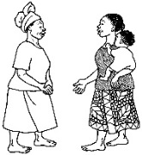 |  | 1. Greet the person in a friendly way and introduce yourself to the head of household (if present). Show interest in the situation of each family member. Ask if other members of the family are present that might need to participate in the discussion (influencing groups).
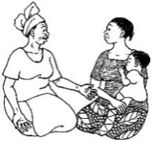 |  | 2. Ask the person about how things are going with current and new behaviors, with a focus on issues relevant to the project.
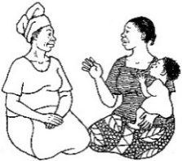 |  | 3. Listen to /reflect on what the person says.
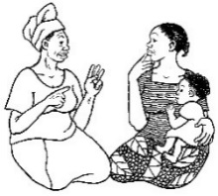 |  | 4. Identify any difficulties/obstacles and select one to work on. Optional step: If this is not the first home visit, review the key points of the last (prior) meeting, if relevant to the difficulties/obstacles. If there are urgent issues (such as a sick child) make these a priority.
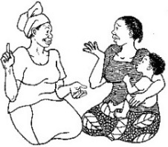 |  | 5. Discuss ways the community member(s) can overcome the difficulties.
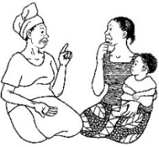 |  | 6. Recommend and negotiate doable actions and help select one option/action to try.
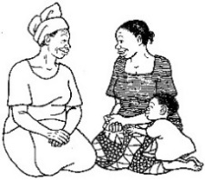 |  | 7. Person agrees to try one or more of the options, and the person repeats the agreed upon action.
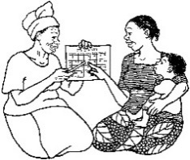 |  | 8. Make an appointment for the follow-up visit. Congratulate the person on his/her good work. Thank him/her for making time to talk with you and remind him/her when you will be coming back for a follow-up visit.

Lesson 4 Handout 4: Quality Improvement and Verification Checklist: Home Visits/Negotiated Behavior Change
Name of the Supervisor/person completing the QIVC: _________________________________________
Name of the Behavior Change Agent (BCA) being observed: ____________________________________
Community: ____________________________________ Date: _________________________________
Yes No
- Did the BCA greet the person being visited and establish confidence?.........................................
- Did the BCA introduce him/herself and greet the head of household (if present)?……………………
- Did the BCA ask if other members of the family are present that might need to participate in the discussion (influencing groups)?....................................................................................................
- Did the BCA talk with the person being visited about how things are going with current or new behaviors?......................................................................................................................................
- If there were urgent issues (such as a sick child), did the BCA prioritize them and make appropriate recommendations or referrals?……………….....................................................................................
- Did the BCA review the key points of the last (prior) meeting?.....................................................
- Did the BCA listen to/reflect on what the person being visited said?............................................
- Did the BCA identify difficulties/obstacles to behavior adoption?.…………………………………………….
- Did the BCA discuss realistic options for overcoming the obstacles?............................................
- Did the BCA recommend/ask for doable actions?.........................................................................
- Did the BCA ask the person/people to agree to try one or more of the solutions?......................
- Did the BCA ask the person/people to repeat the agreed-upon action?.......................................
- Did the BCA set a date for the follow-up visit?..............................................................................
- Did the BCA congratulate the person/people on their good work?..............................................
- Did the BCA thank the person/people for making time to meet?..................................................
- Did the BCA remind the person/people of the date for the follow-up visit?.................................
Score: _________________ (Calculate the score by counting the number of yes answers and dividing by the total number of questions that were applicable to the situation. This number is usually kept as a percentage. See Advanced Lesson 1 for more information).
Comments: __________________________________________________________________________________________________________________________________________________________________________________________________________________________________________________________________________________________________________________________________________

Lesson 5: Behavior Change through
Guided Testimonials
Achievement-Based Objectives
By the end of this session, participants will have:
- Defined “testimonial” and “guided testimonial”
- Generated a list of advantages of using testimonials
- Heard an explanation of some of the ways that testimonials help change behavior
- Listed the steps in using guided testimonials
- Practiced coaching/guiding someone to give a good testimonial
- Practiced/observed someone giving a good guided testimonial
Duration
4 hours
Materials Needed
- Pre-written flip chart with the definition of a testimonial
- Lesson 5 Handout 1: Why are Testimonials Effective? (1 copy per participant)
- Lesson 5 Handout 2: Steps in Organizing a Testimonial (1 copy per participant)
- Lesson 5 Handout 3: Example Testimonial (1 copy per participant)
- Lesson 5 Handout 4: Small Group Instructions for Preparing Testimonials (1 copy for each group of 4 participants)

Why this Lesson?
Guided testimonials can be an effective way for Behavior Change Agents (BCAs) to change the misperception that no one else is practicing a particular behavior (e.g., contraception, using new seeds) or using a product (e.g., oral rehydration solution [ORS] with zinc). Testimonials give people a chance to see someone “like them” talking about the advantages of a behavior or product. Learning how to plan a guided testimonial, as opposed to a spontaneous testimonial, is a useful tool for a BCA’s work in the community.

Advanced Preparation
Throughout this manual, the term Behavior Change Agent (BCA) is used to represent the wide variety of roles held by workers who promote change. When facilitating this lesson and others, replace “BCA” with a title that is appropriate for your audience (such as agriculture extension agent, community health worker, peer educator).
On flip chart paper, write the “Definition of a Testimonial” as shown in the text box in Task 3.

Tasks
1. Warm-Up Activity (10 minutes)
1a. Conduct a quick activity that gets the participants laughing and comfortable with interacting with each other.
1b. For example, ask participants to form a large circle. Toss a soft ball (or ball of crumpled paper) to a participant, stating his/her name as you do so. Ask that person to then toss the ball to another person, while also stating their name loudly. Repeat until everyone has tossed the ball and the last person has thrown it back to you (the facilitator). Ask them to repeat the process again, a bit more quickly, throwing the ball to the same person each time and repeating the names loudly and clearly. About halfway through the cycle, toss in another ball. A moment or two later, add another. Try to keep the cycle going for another one or two rounds, with all three balls in play.
1c. This exercise is usually fun and helps participants feel more relaxed (and have a chance to laugh a little) with each other. When they return to their seats, remind them that laughter can be helpful in their work as BCAs, Ask them to share some thoughts about the benefits of laughter in their work with communities. This game may also remind BCAs of all the different things they have to pay attention to in their work. Sometimes there is a lot going on at once!
2. Introduction to the Lesson (10 minutes)
2a. Explain to participants that we will start today’s lesson by reflecting for a moment on our own lives. Ask participants: How many of you have felt that you were doing something a bit unusual, that others around you didn’t normally do? How did that make you feel? Thank them for sharing and note that those kinds of thoughts/feelings are very common – and they are also experienced by people in the communities in which we work.
2b. Share the following with the participants: Research has revealed that people who live in communities where it’s important to be seen as “one of the group” or “not outside the norm” are strongly motivated by the idea that everyone is doing or approves of a behavior. In societies like this, showing that other people approve of the behavior or that others are doing it already can be a very powerful force for behavior change. In this lesson, we will learn how to use the power of social norms—this desire to do what is approved of or to be “one of the group”—to promote behavior change through the use of guided testimonials.
3. What is a Testimonial? (15 minutes)
3a. Start by asking participants: Has anyone heard of testimonials before? What are they?
Listen to their responses, then reveal the following definition, already written on a flip chart.
Definition of a Testimonial
A testimonial is a first-hand written or spoken report of one person’s experience with a product or behavior. It is given to influence another person’s opinion about the benefits or value of something and to show how barriers to behavior change were overcome.

3b. Some examples of testimonials are:
- A farmer explaining to a group why she terraced her land and the benefits that she saw from that in terms of soil conservation
- A mother explaining to other women in her church why she decided to have her child vaccinated and how she made that happen
- A youth explaining over the radio the benefits of volunteering in his community to help the elderly
- A mother explaining to a group why she decided to not give a laxative to her newborn baby
3c. Explain to participants: When a celebrity gives a testimonial for a product or behavior, we usually call it an “endorsement.” We call it a testimonial when ordinary people promote a product or behavior.
3d. Ask participants: Have you ever heard endorsements or testimonials on the radio or television? For which products or services?
3e. Ask participants: Has anyone ever heard of a guided testimonial?
3f. Explain to participants: A guided testimonial is when a Behavior Change Agent coaches or assists a person who has experience doing the behavior in how to deliver a testimonial more effectively.
4. What Makes Testimonials Effective? (15 minutes)
4a. Ask participants: Why do you think people use testimonials? What are their advantages?
4b. Refer participants to Lesson 5 Handout 1: Why are Testimonials Effective? Ask participants to read individually (or in small groups) and identify the reason they think would be most likely to get them to change their own behavior.

5. The Steps Involved in a Guided Testimonial (30 minutes)
5a. Ask participants if any of them have used testimonials to promote behavior change. Ask one or two participants to describe the process they used to organize the testimonial.
5b. Distribute Lesson 5 Handout 2: Steps in Organizing a Testimonial and ask participants to compare the processes their fellow participants just described with what is written in the handout. If they don’t mention it, note to participants that Lesson 5 Handout 2 describes a very deliberate process. Explain that for testimonials to have the optimal effect, it’s not enough to ask someone to talk about his/her experience; the testimonial should be thought through and well prepared. It might be helpful for some groups to review the eight steps of organizing a testimonial by reading them out loud and having someone in each group write them on flip chart paper (for use as an additional guide during the role play preparation).
5c. Distribute Lesson 5 Handout 3: Example Testimonial. Ask participants to read it and identify the eight different elements that a testimonial should include. Ask what else could be added to the testimonial to make it even more convincing.
6. Guided Testimonials Practice (90 minutes)
6a. Divide the participants into small groups of about four people each. Ask each group to select a person to be their group leader (or you may wish to assign a person as small group leader when dividing up the group).
6b. Give each small group leader the set of instructions in Lesson 5 Handout 4: Small Group Instructions for Preparing Testimonials. Ask the small groups to read and follow the instructions for planning a testimonial, including getting approval for the testimonial topic.
6c. Tell the participants that they will now practice preparing someone to give a testimonial (remember it is not just one person who prepares the testimonial; the group helps the selected person by asking them questions about the new behavior). Once the testimonials have been prepared, move on to Task 7.
7. Practice Giving a Guided Testimonial (70 minutes)
7a. Have the participants from each small group give their testimonials to the larger group. After each testimonial, ask the larger group to share:
- What they liked about the testimonial
- What they think could be done to further improve the testimonial
7b. You may wish to create a competition by having the participants vote on which testimonial was the most convincing.
8. Wrap Up (10 minutes)
8a. Ask participants to share ideas on the following questions.
- Why do you think testimonials are an effective behavior change strategy?
- What needs to be included in the testimonial to make it convincing?
- What kinds of questions should the Behavior Change Agent or facilitator ask after a testimonial to ensure that the key messages were received by the audience?

Lesson 5 Handout 1: Why are Testimonials Effective?
- Testimonials are first-hand, meaning that the presenter is presenting his/her own experience. Using the example of improved silos, if a leader in your community talks about how well it worked for him during the last harvest season, you will be more likely to believe him and try it yourself.
- Testimonials often reach people on an emotional level. The person not only presents the facts about the thing being promoted, but also promotes how he/she felt about it. If the mother promoting oral rehydration solution (ORS) is very excited about it, you, as a mother, will be more likely to get excited about it, too. People get other people excited. Reading something on a poster will rarely excite people.
- When a volunteer gives a testimonial, people usually think that he/she is honest and objective because he/she is not paid by anyone to give the testimonial. The people hearing the testimonial are more likely to think that the person is promoting the item or behavior just because it works and he/she likes it, not because someone paid him/her to promote it. The same is not always true of a nongovernmental organization (NGO) worker promoting the advantages of something; people may believe the worker has to promote it as part of their job.
- A group’s trust and respect for the person giving the testimonial makes it easier for others to believe and try out what the person is presenting. They may say, “Just because Henry has recommended it, I will try it!”
- If a person has heard a testimonial and decides not to try the thing being promoted, he/she perceives that it could affect his/her relationship with the person giving the testimonial in a negative way. On the other hand, someone who does try out what is being promoted may have a better relationship with the person giving the testimonial. Sometimes people will try something that they really do not expect to work just because of the person who recommended it.
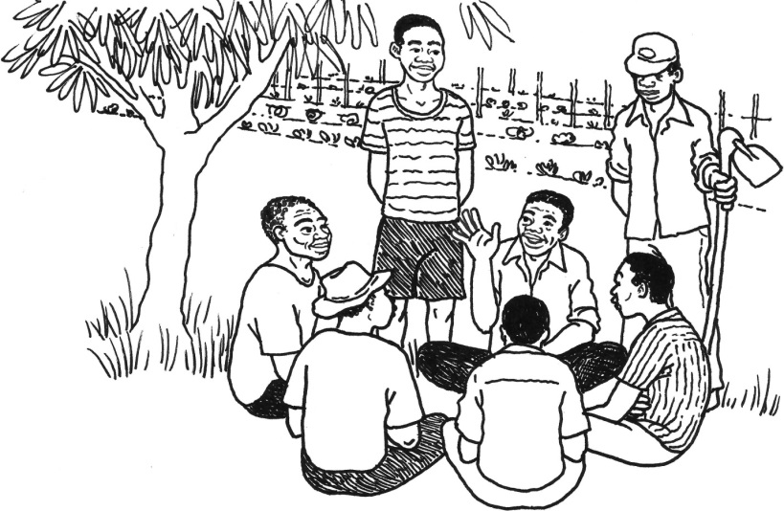

Lesson 5 Handout 2: Steps to Organizing a Testimonial
- Identify the behaviors that you are promoting that have low or less than desired adoption rates, such as behaviors that require a person to use a service or do an action that is disapproved of by influential people in their lives. That means that you might start by promoting the new behavior with a small group of community members through an approach such as Trials of Improved Practices (TIPS), then begin using guided testimonials after some people have adopted the behavior.
- Identify the people in the community that have experience practicing the behavior and that know the benefits of it. Choose the person to give the testimonial carefully, after talking with multiple people that practice the behavior. Make sure the person is respected in the community and is excited about the product or behavior that you want to promote.
- If the person is excited about the product or behavior, ask him/her questions to help him/her to state what barriers he/she overcame to be able to practice the behavior and what the positive results of practicing the behavior are. Explain that many people have not even tried what is being promoted. Ask if he/she would like to share his/her story with others so that they will be more willing to try it out. Explain how important it is that more people begin doing what is being promoted.
- If he/she agrees to share his/her story, explain:
- When and where you will need him/her to speak
- To which group of people he/she will be speaking
- What should be included in the testimonial
Things to Include in a Guided Testimonial
- Name the behavior being discussed.
- Explain how you learned about the product or practice (behavior).
- Share your initial reaction to the product or practice.
- State how and when you first tried the product or practice.
- Explain how you worked through any barriers.
- Explain the advantages you discovered.
- Share who supported your decision to use the product or practice (e.g., husband, mother).
- Explain why you decided to keep doing the practice or using the product.

- How long the testimonial should last (probably 5–15 minutes)
- The importance of telling the story with enough information and specific detail that people can understand and relate to why the person is excited about this product or practice in the testimonial
- The importance of showing enthusiasm for what is being promoted
- Give the person some time (e.g., a few days to a week) to prepare what to say and to practice it.
- Have the person practice telling you the testimonial at least twice and, if you have the option, record it on tape or video. Coach the person to include all of the important parts of the testimonial (in the list above) and to leave out anything that is not useful or that would be discouraging to other people. When the person can give the testimonial with enough details without reading it from written notes and you think he/she is ready to address a group, invite him/her to a group meeting to give the testimonial.
- Have the person give the testimonial to a group (e.g., mothers club, farmers’ association) that you are regularly meeting with to promote behaviors. Do not interrupt the person while he/she is giving the testimonial. But, when the testimonial is finished, ask questions so that he/she can include any details that may have been left out of the testimonial. Discuss the product, technique, or behavior being promoted by referring back to what this opinion leader said in the testimonial.
- Get commitment from the group. Ask the group, “How many of you would be willing to try out what Mr. [Name] tried out?”
- Tell the group that you want to hear someone else’s testimonial the next time you meet (if the product or behavior is something that can be tried out before the next meeting). Choose the person who will give the next testimonial by talking with people informally after the meeting. Assure that the person selected is someone who can give a positive testimonial. Subsequent testimonials after the first can be more natural and may not need as much coaching, but with less practice and coaching, you may have to ask future presenters more questions after they give their testimonials.

Some General Guidelines
- Include a problem solved (or objection that is overcome).
- Have the person include a lot of examples or specifics in the testimonial, which makes it more real and easier to understand and imagine.
- Target testimonials to the specific audience you have in mind, and have people give testimonials to a group of people “like them” (e.g., fathers giving testimonials to other fathers, youth giving testimonials to other youth).
- Use “live” (in-person) or video testimonials rather than written ones, where possible. Radio is another medium that can be used to share testimonials.

Lesson 5 Handout 3: Example Testimonial
Good morning everyone. I’d like to share with you today my story about why I decided to get a dog as a guardian. For the longest time a man from our neighborhood was our guardian. Joshua became a friend of the family, and he was with us for a very long time. Over that time he got older, of course, and it became harder and harder for him to stay awake during the entire night, which is when we really needed him. Also over those years, things changed in our neighborhood. The youth became bolder and things became more dangerous as thugs started roaming the streets and taking advantage of innocent people. There were many break-ins and many guards were injured while defending the property of their employers.
When Joshua became too old and frail, we decided to get a dog to be our guardian. We had heard from some friends that people in rural areas use dogs and they are very effective. At first I wasn’t too keen on the idea because I have never been a “dog lover” and I thought it would cost a lot to maintain the dog. I thought the dog would be dirty and smelly. But someone offered me a guard dog and I decided to give it a try, since we felt very vulnerable, not being guarded by anyone, especially at night. In fact, before we finally got the dog, someone broke into our house at night and stole our new radio. That incident really motivated me.
So, I had to think through what it would require of me to own a guard dog. We had to build a shelter for the dog to keep it out of the sun and the rain. We just built a small lean-to, so that was easy. Then I had to figure out what to feed the dog. At first I thought dogs need to always eat meat and that I’d have to buy expensive food. But, my friends told me that dogs eat almost anything, so, as it turned out, he was fine to eat the scraps from our meals. I only have to feed him a decent meal about once a week. This costs less than what we paid Joshua. Then we had to train the dog to recognize and become friendly with the family members. Of course, he immediately liked me because I’m the one who feeds him. But, the rest of the family deliberately played with him, praised him, and called him by name, and after a week or so he knew everyone in our family and began to feel loyal toward us. I also soon learned that dogs kept in families aren’t dirty or smelly.
What I didn’t know would happen is that he’d make everyone feel happy! Even though this is a serious guard dog, he also is fun, and when you return home each day, he greets each person wagging his tail and he seems to be smiling. We also felt very secure when he was guarding the house at night.
Where I live people are typically afraid of strange dogs, so they naturally stay away, but our dog is very alert to strange sounds, especially at night, and when people walk too closely to our gate or the wall that surrounds our house, the dog jumps up and begins to investigate. If he feels there is a threat he begins to bark—not a friendly little bark, but a menacing scary bark that tells the potential intruder that he means business.
Everyone in the house, but especially my mother-in-law, is so happy with my decision to get a guard dog. We feel so much safer and we sleep soundly. In fact, ours is one of the few houses in our neighborhood that hasn’t been robbed since we got the dog a year ago. So we plan to keep using a dog as our guardian.

Lesson 5 Handout 4: Small Group
Instructions for Preparing Testimonials
- Choose one person who will lead the small group work for this exercise (the “group leader” mentioned below).
- The group leader should ask each member of their small group to name a practice (behavior) that he/she adopted in the past 5 years. This can be a development practice (e.g., taking their children for vaccines, using oral rehydration solution [ORS], building an improved silo, terracing land) or a personal behavior that they feel has benefited them and/or their family members. (It is possible to give a testimonial about a product, but for this lesson create a testimonial about a behavior.) Ask:
- Who encouraged you to adopt the practice?
- Why did you adopt this practice?
- What are the benefits (advantages) of the practice that you adopted?
- What sort of results did you see when you adopted the practice?
- Given the participants’ responses, the group leader will identify one person who would be able to provide the best testimonial for the behavior. This should be a person who can list multiple reasons for adopting a practice and who was happy about the results.
- Once the behavior and the testifier have been selected, get approval from the workshop facilitator to move ahead with that behavior.
- The small group leader should ask the volunteer testifier a few questions to help him/her recall details about the process of what was done and the results. See if the volunteer can recall enough of the details to provide a good testimonial. If he/she cannot, choose a different person to give the testimonial.
- Once the volunteer testifier has been selected, ask the volunteer the following questions so he/she knows what to include in the testimonial. Have the volunteer make a few notes of his/her responses to remember what to say.
- How did you learn about this practice? Who suggested that you do it?
- What was your initial reaction when someone suggested that you do it?
- When did you first try it out?
- How did you try it out? What did you do, specifically? (Make sure the volunteer testifier gives details on this and does not just say “I gave my child ORS.” The testifier should explain it in a way that you can see in your mind exactly what he/she did.)
- Did you encounter any barriers when you tried it out? How did you work through those barriers?
- What advantages did you discover when you tried the practice out?
- Who supported your decision to do it? What did they say to you about it (if anything)? (Prompt for specific people who may have supported them: What did your mother think about it? Your husband? The nurse? The field agent?)
- What are the main reasons you decided to continue doing the practice?
- Remind the volunteer testifier that it is important to include a lot of details when sharing the testimonial and to look interested in what he/she is saying (e.g., smiling, maintaining eye contact, other culturally specific cues to show that he/she honestly is excited about what he/she saying in the testimonial).
- Explain to the volunteer that he/she will now practice giving the testimonial to the small group without you asking a lot of questions. The volunteer should include the same information that he/she mentioned when you asked questions, but put it into a short speech about the practice he/she will promote with the testimonial.
- As the volunteer is practicing the testimonial, he/she can refer to written notes to remember the key points to make.
- Once the volunteer finishes practicing the testimonial, ask the other small group members what they liked about the testimonial and to give suggestions for ways to improve the content and/or the delivery.
- If the volunteer needs more practice, have him/her give the testimonial again. Try to offer fewer prompts/less coaching this time.
- Return to the larger group.

Lesson 6: Storytelling for Behavior Change
Achievement-Based Objectives
By the end of this session, participants will have:
- Articulated the importance of storytelling as a Behavior Change Agent (BCA) skill
- Identified the difference between an open-ended story and a closed-ended story and in what situations each type should be used
- Written an open-ended and a closed-ended story using the steps to writing a better story
- Practiced storytelling
- Critiqued their own and their co-participants’ storytelling skills
Duration
3 hours
Materials
- Flip chart with Story Definitions
- Flip chart with the Adult Learning Cycle
- List of behavior changes promoted by the participants in their work
- Lesson 6 Handout 1: Closed-Ended Story: Blood Worms (1 copy per participant)
- Lesson 6 Handout 2: Open-Ended Stories (1 copy per participant)
- Lesson 6 Handout 3: Discussion Questions for Closed-Ended Stories (1 copy per participant)
- Lesson 6 Handout 4: Discussion Questions for Open-Ended Stories (1 copy per participant)
- Lesson 6 Handout 5: Guidelines for Developing Behavior Change Stories (1 copy per participant)
- Lesson 6 Handout 6: Elements of a Story (1 copy per participant)

Why this Lesson?
Behavior Change Agents (BCAs) can use stories to effectively connect with their intended audiences and move them to take action. Stories are entertaining and easy to remember, and they tend to provide emotional and cultural “hooks,” allowing the audience to identify with the place and characters without making them feel bad about their current lack of knowledge or inaction. Stories can move us to action by:
- Inspiring or motivating us to do something
- Showing us how a problem can be solved

Advanced Preparation
Throughout this manual, the term Behavior Change Agent (BCA) is used to represent the wide variety of roles held by workers who promote change. When facilitating this lesson and others, replace “BCA” with a title that is appropriate for your audience (such as agriculture extension agent, community health worker, peer educator).
Prepare a flip chart with the Story Definitions (from Task 3). Prepare another flip chart with the Adult Learning Cycle shown in Task 5.
Change the names and other details of the stories in Lesson 6 Handout 1: Closed-Ended Story: Blood Worms and Lesson 6 Handout 2: Open-Ended Story: Story of a Death so that they are appropriate for your local audience. Practice reading the stories aloud.
Develop a list of behavior changes that are promoted by the BCAs in their work. In Task 7, these behaviors will be assigned to participants as the focus of the stories they will develop.
In Task 8, the facilitator demonstrates effective storytelling techniques. This can be done using a story from Handout 1 or Handout 2 or one of the stories created by the participants earlier in the session. Or, if appropriate, the facilitator can prepare a story in advance that matches the participants’ project or program topics.

Tasks
1. Warm-Up Activity (5 minutes)
1a. Tell participants that today’s lesson will focus on storytelling, so they will start with an activity that will help them tap into their natural creativity. Explain that they will work as a group to make up a story, taking turns to complete the phrases “Unfortunately, ….” then “But fortunately…”
1b. For example, the first person starts the story with a sentence such as, “Unfortunately, my goat ran away last week.” Then the next person adds, “Fortunately, it was found by my cousin in the next village over.” The next person continues, “Unfortunately, my cousin couldn’t bring my goat back because the goat had begun behaving very strangely…” and so on. The process continues, alternating between “fortunately” and “unfortunately” until all participants have had a chance to contribute to the story.
1c. Remind participants that they do not have to be serious or realistic during this activity. Encourage them to have fun and get in touch with a childlike sense of creativity. The game works best if participants think quickly and don’t worry about doing it perfectly. Continue until the story reaches a natural stopping point, it becomes so ridiculous everyone is laughing, or time is up.

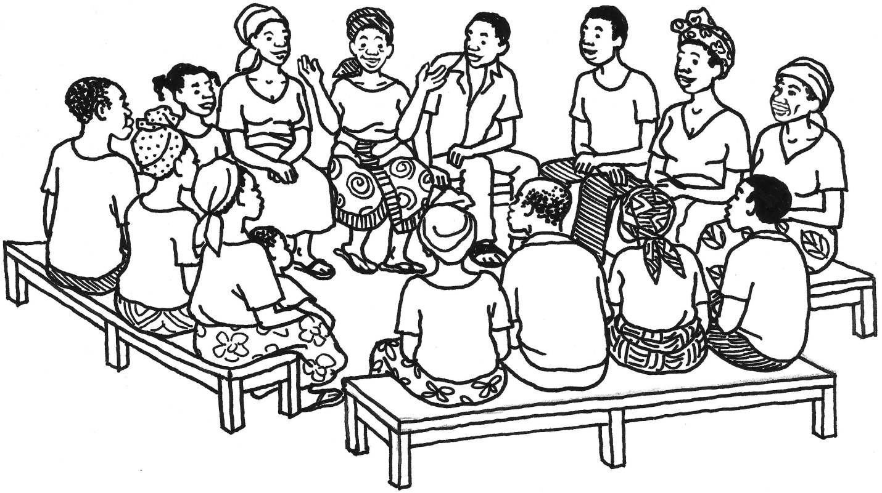
2. Stories for Behavior Change (10 minutes)
2a. Tell participants: In our jobs as Behavior Change Agents we are trying to solve problems such as ill health, malnutrition, or poor agricultural production. To do this we encourage people to adopt new behaviors. One of the ways we can encourage people to adopt new behaviors is by telling stories. How many of you have recently heard or told some stories? What kinds of stories can you think of? Where did you hear them, or to whom did you tell them?
2b. Explain to participants: There are stories about talking animals and people with special powers, there are stories to help us remember how things were long ago, there are love stories and adventure stories with happy endings and with sad endings, and many more kinds of stories. Some stories are mostly for entertainment, others are intended as teaching stories, and often the stories we love the most are entertaining, emotional, and help us learn something about ourselves or something that relates to our own lives. Why do you think that stories are used so often with children?
2c. Explain to participants: Despite the detailed information that is often found in a story, stories are one of the easier things for us to remember. Stories are also entertaining. They tend to hold the attention of both children and adults much better than a lot of other education methods.
2d. Explain to participants: Teaching through stories also is helpful when you do not want to make someone feel bad about their lack of knowledge. It helps the person to think about what needs to happen in a given situation. It also allows them to identify with the character in the story who finds a solution to the problem.
3. Definitions and Examples: Closed-Ended and Open-Ended Stories (25 minutes)
3a. Explain to participants: In this lesson we are going to talk about two types of teaching stories: closed-ended and open-ended. A “closed-ended story” is an account of an event, true or imaginary, that promotes the adoption of actions or attitudes. Specific behaviors are mentioned in the story that we want to promote in communities.
3b. Display the flip chart that you prepared in advance with the story definitions (below) and explain the definition of a closed-ended story.
Story Definitions
Closed-Ended Stories promote a specific behavior to solve a particular problem
Open-Ended Stories generate many possible solutions to a complex problem

3c. Distribute Lesson 6 Handout 1: Closed-Ended Story: Blood Worms. Read the story with participants. (Note: Practice ahead of time and be sure to watch your pace, be animated, and use different voices for different characters. Change the names of the characters to local names to make it feel more familiar to the listeners.) Then use the following questions to discuss.
- What was the main problem in the story? (Answer: Bloodworms, Schistosomiasis)
- What happened to the two brothers after bathing in the water? What symptoms did they have? (Answer: Belly pains, blood in urine)
- What did they think caused their illness? (Answer: The townspeople are poisoning us!)
- What did their neighbors and the chief tell them? (Answer: Each family had their own well, the history of the problem and how the community solved it)
- What was the solution to the problem? (Answer: Stopped urinating in river, dug wells for drinking, got treatment for disease, stopped bathing in contaminated or uncertain water)
- In terms of health, what are the things that we learned to do from this story? (Answer: Construct and use latrines, construct and use wells for drinking / washing water, treatment of disease)
- Have people in your community (or country) had problems that stemmed from using river water? Could they resolve the problems they have by doing similar things (latrines, wells)?
3d. Explain to participants: Now I am going to tell you a different type of story. This next one is an example of an open-ended story. Some people also call it a “problem story” since it tells about a problem but doesn’t explain what to do about it; rather, the listeners are asked to propose their own solutions to the problem.
3e. Distribute Lesson 6 Handout 2: Open-Ended Stories. You can choose to work with Option A: The Star Student or Option B: Story of a Death. Read through the story with participants. (Note: Practice ahead of time and be sure to watch your pace, be animated, and use different voices for different characters. Change the names of the characters to local names to make it feel more familiar to the listeners.) Then discuss the story by posing the questions for each option, below.
- Option A: The Star Student
- What were the main problems in the story? What went wrong? (Answers can include: Leila’s mother doesn’t have a lot of support, Leila is responsible for most of the household chores, she has a long walk to school, she isn’t able to get enough sleep, she doesn’t have time to study)
- How could these problems have been prevented? (Answer: Identifying and addressing barriers to attending school)
- Have people in your community ever had these kinds of problems?
- How can we prevent this problem?
- Option B: Story of a Death
- What were the main problems in the story? What went wrong? (Answers can include: Amina doesn’t rest when needed, she doesn’t know what danger signs to look for, she and her husband do not have a plan for emergencies)
- How could these problems have been prevented? (Answer: Identifying and addressing barriers to receiving antenatal care)
- Have people in your community ever had these kinds of problems?
How can we prevent this problem?
4. Uses and Limitations of Both Types of Stories (5 minutes)
4a. Ask participants: In what situations do you think you would want to use a closed-ended story? (Answers are as follows.)
- You should use closed-ended stories when you want to promote a specific behavior or set of behaviors to resolve a problem. Closed-ended stories are appropriate for promoting specific behaviors, like exclusive breastfeeding, use of latrines, hand washing, and other key actions. They are not the best method to use when you want to generate ideas concerning many alternative ways of dealing with a problem. For example, if there is a problem with violence against women in a community or people do not have a way to get crops to market and you want to involve people in deciding what things they would do to solve that problem, an open-ended story would be more appropriate.
- Open-ended stories are used when you want to generate discussion to identify many possible solutions to more complex problems. When you do not have an idea of a clear strategy to tackle a particular problem, think of using an open-ended story. With an open-ended story, you can generate a list of ideas for solutions that could be used in the community to combat a problem. Afterwards, you could use a closed-ended story to promote one or more of the behaviors (e.g., a story on how to convince younger girls not to marry older men). You should not use an open-ended story when people already have decided what action they will be taking to resolve a problem or when there is really only one good way to properly resolve a problem.
5. Developing Discussion Questions (20 minutes)
5a. Ask participants: What did we do after I told each story? (Answer: we discussed it) How does the discussion make the story more effective? (Answer: it helps people imagine the situation happening in their own community; it identifies new, locally appropriate solutions)
5b. Explain to participants: It’s very important to always have a discussion after a story is told.
5c. Ask participants: What types of questions do you think would be useful to discuss after a closed-ended story is told?
5d. Explain to participants: After you have given community members the “direct experience” of a story, there are several questions you can ask to help them reflect, make a decision for themselves, and consider practicing the behavior themselves.
5e. Show the flip chart that you prepared in advance, with the Adult Learning Cycle (below), and review the steps of the cycle. Explain that the story itself is a kind of direct experience: when you listen to a story you imagine you are there.
Flip Chart: Adult Learning Cycle
1. Direct Experience
4. Application
2. Reflecting on Experience
3. Decision: Generalizing about the Experience

5f. Distribute Lesson 6 Handout 3: Discussion Questions for Closed-Ended Stories and ask participants to review it individually (or ask a volunteer to read it out loud). Ask participants what other questions they might add to encourage the listeners to reflect, make a decision, and consider practicing the behavior. Ask for a few suggestions and encourage participants to write those on the handout.
5g. Ask participants: What type of discussion questions would be useful to ask after an open-ended story is told?
5h. Distribute Lesson 6 Handout 4: Discussion Questions for Open-Ended Stories and ask participants to read it individually (or ask a volunteer to read it out loud). Ask what other questions could be asked to help the discussion. Hear a few suggestions and encourage participants to write those on the handout.
5i. Tell participants: Remember…
- It is extremely important to let people discover the message for themselves, rather than telling them all the answers.
- The questions used after a story should point out the negative consequences of negative behaviors and the positive consequences of positive behaviors.
6. Guidelines for Writing Stories (15 minutes)
6a. Distribute Lesson 6 Handout 5: Guidelines for Developing Behavior Change Stories and ask participants to review the guidelines. Take questions about the guidelines.
6b. Distribute Lesson 6 Handout 6: Elements of a Story. Explain to participants: Brian McDonald, the author of Invisible Ink: A Practical Guide to Building Stories that Resonate, gives these steps as a guide to writing a better story. Though the guide is flexible and not all stories need to follow it exactly, he says that most stories have these steps.
6c. Divide the participants into pairs and ask each pair to review the stories in Lesson 6 Handout 1 and in Lesson 6 Handout 2. Ask each pair to try to fit each story into these seven steps. Select two to three pairs to share what they did. Did both stories have all the steps? Why or why not?
7. Writing Stories (20 minutes)
7a. Assign each pair a behavior from their project. Ask pairs to develop a short story that promotes the assigned behavior. Give them 15–20 minutes to work on their story.
8. Storytelling Technique (60 minutes)
8a. Explain to participants: Now that we have learned how to write stories, we are going to look at what it takes to be a good storyteller.
8b. Choose one story from the handouts or from among those just written, or bring another short example from your project to practice storytelling for the participants. You will read the same story twice. The first time, read the story in a boring way. The second time, tell the same story with changes in tone and volume and with enthusiasm.
8c. After telling the story, ask participants to identify the differences between the two “tellings.” Explain that a story can be very well written, but if it is not delivered well, it will not capture and hold the attention of the listener.
8d. Combine the pairs that developed stories into small groups of four. Using the stories that the pairs wrote for this lesson, ask each person to practice telling their story to the others in their group using their best storytelling skills. The facilitators should circulate and observe the groups, giving a little feedback if appropriate (for example, share two positive observations, plus one thing to work on, using phrases such as, “What if… ?” as in, “What if you showed a little more excitement?” or, “What if you used more gestures?”
8e. After everyone has had a chance to tell their story, the small group should select one person from their group to present their story to the larger group. Listen to one story from each small group. Ask a few participants to tell the storytellers something they really liked about the story and how it was told. Thank the presenters, and give them a round of applause.
9. Wrap Up (10 minutes)
9a. Ask the participants the following questions.
- What opportunities exist in your project for using storytelling to promote behavior change?
- How would you know when to use an open-ended or closed-ended story? Can someone share an example of how you might use one or the other?
- How can you use storytelling in your work during the next few months?
- What steps would you take to get ready to tell a story and help make sure the story will work well before using it with the community?

Lesson 6 Handout 1: Closed-Ended Story: Blood Worms
There were once two brothers named Fernando and Hernando. The two brothers decided to go visit some relatives who live in a distant village. During their visit, they would walk to the river each day to bathe, and they talked about how surprising it was that hardly anyone else frequented the river. They asked their neighbor, Mr. Tufo, about the situation, and he told them that each family had their own well. Fernando looked at Hernando and frowned, but said nothing. Later the two brothers talked about how unsociable this was for each family to have their own well instead of gathering at the river! After 3 months, both brothers began having belly pains and soon started noticing blood in their urine. Hernando grabbed his brother by the arm, looked him in the eyes in a panic, and said, “Brother, the townspeople are poisoning us! They do not like visitors here!” They went to the village chief to complain.
Upon explaining their troubles to the chief, the brothers were told that, years ago many of the people in the village had belly trouble and blood in their urine. One of the tribes in the community began to argue with the other tribe, and neighbors accused each other of putting curses on their households and making them bleed. The smaller tribe of people was planning on leaving and moving to another village when a health worker advised them that the disease came from tiny creatures living in pools and streams where people bathed. These baby worms went through the skin of the bathers and traveled through the blood to their bellies. The villagers also learned that the eggs of the worms were passed in people’s urine or feces and would be washed by rain into the pools.
Both tribes, upon the advice of the health worker, began to use shovels to bury their feces, built latrines, and stopped urinating in the river. They also dug wells to draw water for drinking and washing. Soon, no one in the village complained of belly pain and bloody urine. The two tribes began to get along with each other, as well.
The two brothers followed the example of the rest of the villagers and soon became healthy again. After that, whenever they had a problem, they were sure to first discuss it with their neighbors to see what they could learn from them.

Lesson 6 Handout 2: Open-Ended Stories

Option A: The Star Student
Leila enjoys school, and she especially enjoys learning about math and practicing her reading. Last year, she was one of the top students in the 4th grade! Unfortunately, she hasn’t been able to go to class very often this year. She has a new baby sister and her father has traveled to another part of the country to look for work. She has two older brothers and two younger sisters, one of whom is her sweet new baby sister. Leila’s mother needs her help to take care of them all. Leila loves her brothers and sisters and wants to help, though she also misses school, her teacher, and her friends.
There are many chores to do each day, and Leila does them very well. She goes to the river to get the water, washes clothes, and prepares the meals. She often helps with the weeding in the family’s small field. She wakes up early and works hard all day. Sometimes she goes to the market to help her mother when they have some extra vegetables to sell. Even when she makes it to school, she is often too tired from her chores and the long walk to pay attention, and there is not much time for studying when she gets home.
This year, she missed so much school that she will not pass to the next grade. She feels very embarrassed and sad. She decides to focus on helping her mother and not worry about going to school.

Option B: Story of a Death
Amina is pregnant. She wakes up early and works hard all day. Sometimes she lifts heavy things. She doesn’t have any help. She has no time to rest. In the afternoon, Amina sees her pregnant friends on their way to the health facility for their antenatal visits, but she doesn’t join them. She continues to work. One day while working in the fields, Amina notices blood on her clothes. She doesn’t tell anyone. Amina washes her clothes but she doesn’t tell anyone about the blood because she doesn’t know any of the danger signs to look for when she’s pregnant.
The next morning Amina wakes up with a lot of blood on her mat. She calls to her husband to get help. Amina’s husband runs around the village looking for transportation. He finds that most of the men are in the fields. It takes him a long time.
By the time he has found help and comes back to the house he sees that Amina has died.

Lesson 6 Handout 3: Discussion Questions for Closed-Ended Stories
Here are some example questions that correspond to each of the steps in the Adult Learning Cycle.
1. Direct Experience
4. Application
2. Reflecting on Experience
3. Decision: Generalizing about the Experience

Reflection
- What were the main problems raised in the story?
- How did people try to resolve the problems? What happened? How did they finally resolve the problem?
- In terms of health (or agriculture or another sector, depending on the story), what were the most important practices that were mentioned in this story?

Generalization/Personalization
- Who do you identify with in this story? What would you do?
- What did you learn from this story?
- Have you seen that problem in your community?
- Do you know people who might identify with the different characters in the story?
- Would it be possible for people in your community to resolve problems in the same way as the people in the story? What might the challenges be? What would be easy to implement? Should we do that?

Application
- What do we need to do to encourage people in this community to adopt this behavior? How could we begin that work?

Lesson 6 Handout 4: Discussion Questions for Open-Ended Stories
Here are some example questions that correspond to each of the steps in the Adult Learning Cycle.
1. Direct Experience
4. Application
2. Reflecting on Experience
3. Decision: Generalizing about the Experience

Reflection
- What were the main problems raised in the story?
- What else might cause difficulties related to these problems that was not talked about directly in this story?
- How could the people in the story solve the problem?
- How could the people in the story prevent the problem?
- How would you describe the reasons for the problem in this story to a friend?

Generalization/Personalization
- Who do you identify with in this story? What would you do?
- What did you learn from this story?
- Have you seen that problem in your community?
- Do you know people who might identify with the different characters in the story?

Application
- What are the ways that we could prevent that problem (or solve it) in this community?
- What do we need to do to encourage people in this community to adopt this behavior? How could we begin that work?

Lesson 6 Handout 5: Guidelines for Developing
Behavior Change Stories
- Remember that a closed-ended story should be used when you are trying to promote a specific behavior. Clearly identify the specific behavior that someone did in the story, and repeat the behavior throughout the story.
- For example, it would be better to say “Martine persuaded her relatives to help her build a hand washing station at their home” than to say “Martine decided she wanted to have better cleanliness and hygiene at her home.”
- An open-ended story should be used when you want to start a discussion about many possible solutions to a problem.
- Give names to the people and the setting in your story, or mention their profession (for example, the schoolteacher) instead of calling them “the man” or “the youth.” That makes it easier to remember the story.
- Use place names that sound familiar and believable, but don’t use the name of a real place (to avoid stigma).
- The situation in the story should look like something that could be true. In some cultures, a real situation can be acted out in the story by animals or other characters who represent certain personalities and meanings.
- Make the story simple and clear.
- The story should focus on a specific behavior change, not just on receiving information or learning about a new practice.
- It should take no more than 5 minutes to tell the story. (This does not include the questions that are discussed after the story.)
- Include enough detail to make the story interesting, but not so much that the important messages get lost.
- Be descriptive and dramatic about important parts of the story. Let the reader know what people’s emotions were at different parts of the story. Help the reader visualize what is happening in the story, as if they were watching it happen.
- For example, instead of saying, “The Promoter found that Felipe had a fever,” you could say “Andrea, the Promoter, noticed that beads of sweat were forming on Felipe’s forehead as he struggled to breathe. She quickly took his temperature, and both she and Felipe’s mother gasped when they found that it was already 41 degrees!”
- At times, you should use a little bit of humor in your stories, but the humor should not be the central focus of the story. It is good when stories are funny enough or unique enough that people want to tell the story to other people.
- Stories should be constructed to include traditional knowledge or beliefs when relevant. Remember, many traditional practices can be positive, and some that are harmful or no longer helpful might be respectfully adapted to incorporate newer practices. When writing a story, be careful not to always make local or traditional practices or people look bad. If the weakness of a local custom is pointed out, you may want to mention that people have good reasons for what they did in the past, but sometimes circumstances change or we have new information and practices change over time.
- You can draw comparisons in your stories.
- For example, you can compare a family who took its sick baby to the health facility for treatment to a family who did not. Or you can write a story that starts with a description of someone’s life before they practiced a certain behavior, then explains how they learned to do the new behavior, and later describes his/her life when applying the skills that they learned.
12. If your project has done formative research on the behavior and you know what the most important barriers to adopting the new behavior are, incorporate that information into the story showing a way to overcome the obstacle.

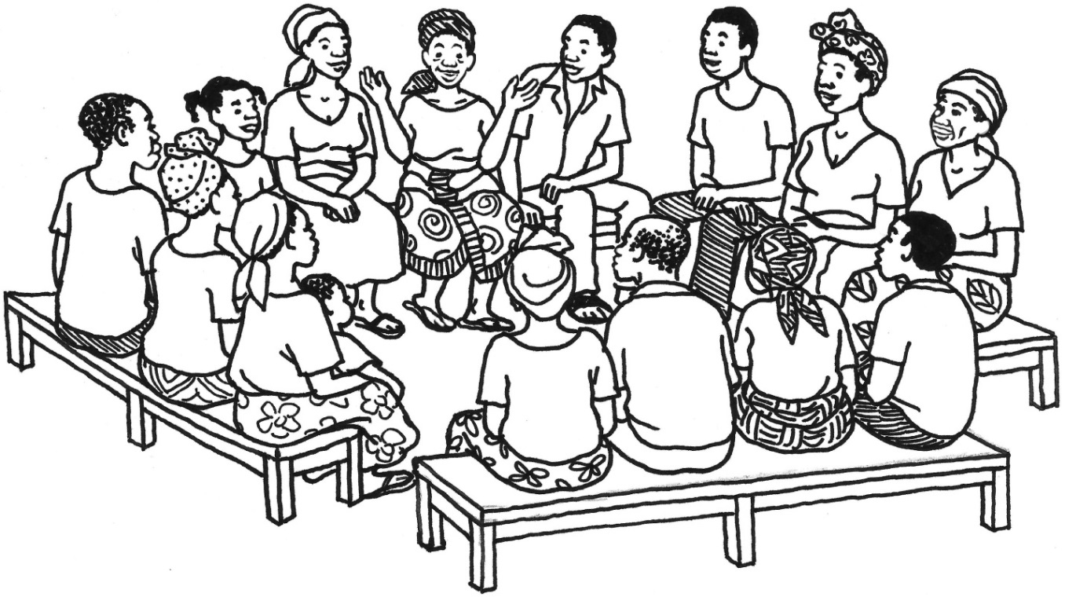

Lesson 6 Handout 6: Elements of a Story
- There was a time when __________
- And every day ___________
- Until one day __________
- And because of this __________
- And because of this ___________
- Until finally __________
7. And ever since that day ___________

Lesson 7: Learning through Cross-Site Visits
Achievement-Based Objectives
By the end of this lesson, participants will have:
- Identified the qualities that make a cross-site visit a valuable learning experience
- Reviewed steps for planning a cross-site visit
- Created a cross-site visit itinerary to meet the needs of the learners
- Discussed how to use cross-site visits to promote behavior change in their communities
Duration
1.5 hours
Materials
- Paper, pencils, and markers
- Lesson 7 Handout 1: Story of a Cross-Site Visit (1 copy per participant)
- Lesson 7 Handout 2: Checklist for Planning a Cross-Site Visit (1 copy per participant)

Why this Lesson?
There are many ways that Behavior Change Agents (BCAs) can help community members to learn about a new behavior/practice. One way is to have members of one community visit members of another, nearby community to learn how they solved a problem. For a cross-site visit to be a good learning experience, planning is required. In this lesson we will learn how to plan and carry out a cross-site visit to promote behavior change.

Advanced Preparation
Throughout this manual, the term Behavior Change Agent (BCA) is used to represent the wide variety of roles held by workers who promote change. When facilitating this lesson and others, replace “BCA” with a title that is appropriate for your audience (such as agriculture extension agent, community health worker, peer educator).

Tasks
1. Warm-Up Activity (30 minutes)
1a. Conduct an introductory exercise that gets participants talking to each other and thinking about sharing their knowledge and experience.
1b. For example: Divide participants into four groups. Give each group a piece of paper and pens/pencils/markers. Ask them to imagine that they are going to live on a deserted island for 5 years. (Or, the facilitator can pick another isolated location, such as the moon, on a boat, or on a mountaintop). Explain that they can only take five items with them to this place. They must decide as a group which five items they would like to take. Each group should sit far enough away from the other groups that they cannot hear or see what the others are discussing. They can write out their list or make drawings of the five items.
1c. After about 5–10 minutes, explain that each group will now have an opportunity to choose a representative who will visit another group, see which items they have selected, ask a few questions, then report back to their own group. Each group will then have a few minutes to make changes to their own list, based on any new ideas gained from other groups.
1d. Ask the representatives to switch between groups (for example, the representative from Group 1 visits Group 2, and vice versa; Group 3 visits Group 4, and vice versa). Allow about 2 minutes for the representatives to review the items and ask questions of the group members.
1e. Instruct the representatives to return to their original groups and allow 3–5 minutes for the groups to discuss and make changes to their lists, if desired.
1f. Allow each group to present its list. Then facilitate a discussion based on the following questions.
- How did you decide on the five items to bring along? What difficulties did you have in coming to an agreement? How did you work through this?
- How did your list change after learning about another group’s list? If you made some changes, what inspired you to do so? If you didn’t make changes, what made you decide to stick with your original plan?
- What did you think of sending a representative to visit another group? What would have been different if everyone could see the other lists for themselves? Would it be helpful to be able to visit multiple groups or to choose which group to visit? Why?
- After learning about each group’s list, what other changes might you make to your own lists?
1g. Thank the participants for their creativity and share the following: As Behavior Change Agents, one of our responsibilities is to help community members figure out how to solve problems through new behaviors or practices. But neither a BCA nor a single community has all the answers to every problem. So one of the ways we can help is to bring together communities and help them learn from each other. That is the theme of this lesson: helping communities to learn from each other through cross-site visits.

2. Group Discussion about Cross-Site Visits (10 minutes)
2a. Ask participants to reflect for a moment on a cross-site visit or field visit they participated in or organized. If participants have no prior experience with these, ask them to think of a time when they learned and were inspired by seeing how others were solving a problem or using a new/different technique, product, or practice.
2b. Explain that both sides— the people visiting the new site and the people who are being visited—benefit during a cross-site visit. Facilitate a discussion based on the following questions.
- For those of you that have visited another site, what worked well about the visit? How did seeing the technique or practice first-hand help you learn? (Responses might include: While some people learn best in a classroom, I like to see the solution in action and maybe have a chance to try it out myself; it’s more believable and realistic to see other people doing the practice; I can learn how to do the same thing in my own community by talking with others and asking questions; it’s nice to know that there are other people I can rely on for help/advice if I decide to try it)
- For those of you who hosted visitors, how was that helpful for you? (Responses might include: I felt proud of how well our project was going; I felt motivated to continue after seeing how what we were doing could help others; I liked being able to share our mistakes and solutions so that others don’t need to waste their own time/effort)
- If few or none of the group members have participated in a cross-site visit, ask participants to imagine what would be helpful about visiting and hosting
3. Planning a Cross-Site Visit to Enhance Learning and Behavior Change (45 minutes)
3a. Emphasize that, for all the reasons just shared, a cross-site visit can be a fun and very inspiring way to encourage behavior change in our communities.
3b. Note that in order for community members to get the most benefit from the visit, the BCA should make sure it is well organized. Ask participants for some thoughts about how a poorly-organized visit might affect community members’ experience. (Responses might include: They might focus on the frustration of waiting or wasting time, instead of the benefits of the new practice; their frustration could make them feel less motivated to try the new behavior; they might lose trust in the BCA and the other community)
3c. Emphasize that these frustrations can be avoided by doing some planning and organization in advance. Explain that they will now work together to review the steps for planning a site visit. By the end of the lesson, they will have practiced completing a checklist they can use to help their next site visit go smoothly.
3d. Read the example of a cross-site visit in Lesson 7 Handout 1: Story of a Cross-Site Visit. Adapt the terms and topic as needed to match the interests of your participants and the focus of their project area(s).
3e. Ask the participants how they think this visit would be helpful to both the visitors and the hosts. Ask them how they think the visit was able to go so smoothly.
3f. Distribute Lesson 7 Handout 2: Checklist for Planning a Cross-Site Visit. Explain that this is a tool that BCAs and community members can use to make sure that a cross-site visit is as effective and fun as possible. Ask them to imagine that they are the BCA who prepared the visit they just heard about. Read through the checklist as a group, verbally completing each section using the example that you just read out loud.
For example, for “What do we want to learn?” ask participants to imagine what topics/questions/concerns the BCA wrote down as part of the planning process. (Responses might include: steps of the process, costs, materials needed, problems and solutions, benefits for families)
3g. Now ask participants to think of a site that their community members (or BCAs) could visit sometime during the next few months. Encourage them to be realistic and to use this opportunity to practice preparing as if for an actual site visit. Ask them to work individually to complete as much of the checklist and schedule as possible. After 10 minutes, ask a few participants to share their plans with the larger group.
4. Wrap Up (10 minutes)
4a. Tell participants: There are many ways that Behavior Change Agents can help community members learn. The Behavior Change Agent doesn’t always have to have the answers or the solutions to a community’s problems. Some solutions can be found by learning from what other communities have done. This is why organizing cross-site visits can be so beneficial. However, for cross-site visits to be effective learning opportunities, they need to be well organized. If they are well organized and well implemented, cross-site visits can be very powerful learning experiences.
4b. Facilitate a brief discussion based on the following questions.
- How can you use cross-site visits in your work?
- How might your community benefit from hosting visitors? How could you make this happen?

Lesson 7 Handout 1: Story of a Cross-Site Visit
A group of 10 farmers from a village association wanted to learn more about aquaculture. They worked with their local Behavior Change Agent (BCA) to arrange a visit to a nearby community where people had been doing fish farming for several years. They took the bus and arrived at 9 am. The visitors were greeted by John, a community leader who had helped arrange the visit.
After a brief introduction, the visitors went to the pond of a farmer named Michael, who was just starting out. He showed them how he was digging the pond and some of the tools and materials he was using. The visitors asked questions about planning, costs, and the time involved.
Then they visited another farmer named Mary, who had been maintaining her ponds for some time. She demonstrated to the visitors the different ways of feeding and caring for the fish. The visitors had an opportunity to observe and practice catching, checking, and feeding the fish. They talked with Mary about problems she had experienced and how she dealt with them.
Finally, they met with Esther and Martin, who showed the visitors how they harvest, package, and store the fish. They talked about how they have added the fish to their meals and how they sell some of the fish.
The fish farmers and their families demonstrated how they cook the fish. The visitors had brought some vegetables and other foods to share. They all ate a meal together and talked more about their families, communities, and the projects they were working on for the next year.

Lesson 7 Handout 2: Checklist for Planning a Cross-Site Visit

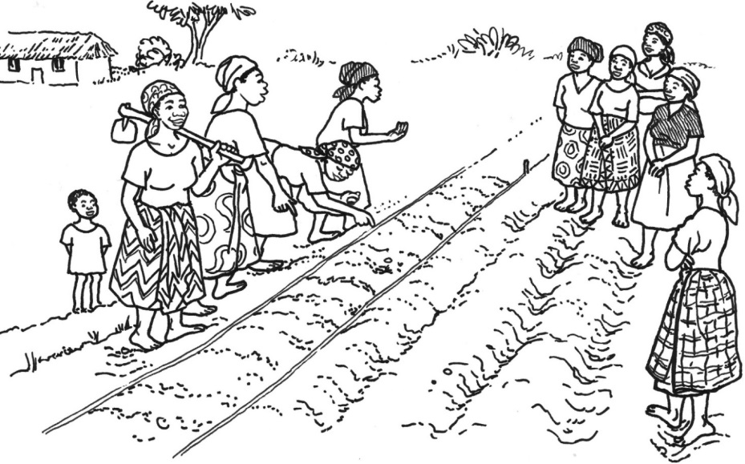

Why and Where Should We Visit?
- What do we want to learn?
___________________________________________________________________________
___________________________________________________________________________
__________________________________________________________________________
- Who can teach us about this?
Community contact person: ____________________________________________________
Other community members we’d like to meet with (who has been involved and can teach us the different steps?): _________________________________________________________
___________________________________________________________________________
- What questions do we want to ask? What would we like to see? Email or talk with the hosts about these questions and interests before the visit. Confirm arrangements to meet with people who can provide answers and demonstrate the practices/techniques/behaviors.
Questions:________________________________________________________________________________________________________________________________________________________________________________________________________________________
Things to see/observe/practice: ________________________________________________
___________________________________________________________________________
___________________________________________________________________________

What Other Information Do We Need Before the Visit?
- How long will it take to get there? _______________________________________________
- What mode of transportation will we take?: _______________________________________
- How do we get there? (directions to the site): _____________________________________
___________________________________________________________________________
- What time should we arrive? ___________________________________________________
- How long will we stay? ________________________________________________________
- What will the schedule be? (use the form, below, as a guide)
- Does the community agree to the schedule? YES / NO

Things to Take
- Letter of introduction or invitation to show to authorities if the group is stopped on the road (if needed)
- Refreshments or box lunches/food to share with hosts (if needed)
- Cameras (if photos or video are wanted/needed)
- Notebooks and pencil/pens, for note taking; If the group would like to assign a recorder, who should it be? ________________________________________

After the Visit
- Discuss the visit and lessons learned. Sample discussion questions include:
    - What was your favorite part of the visit? What made that special for you?
    - What surprised you?
    - What would you like to try out for yourself? What are the first steps you’ll take? What other resources or information do you need? How can we work together to do that?
    - What do you think you might do differently? What are the first steps you’ll take to try it this way?
    - What projects or practices are done in this community that you might like to share with others?
  - Prepare a cross-site visit report with the date, itinerary, participants’ names, and contact information for the people at the other site, learning objectives, important lessons learned, and follow-up action steps.

Sample Schedule

Arrival Time: ___________________________________________________________________

Meet with hosts/introduction activity.

Discuss ground rules (e.g., show respect, allow time for demonstration then share questions/answers, give constructive feedback, no cell phone use)
- Review the schedule.
First Presentation/Demonstration
- Name: _____________________________________________________________________
- Topic: _____________________________________________________________________
- Start time: __________________________________________________________________
- End time: ___________________________________________________________________
Second Presentation/Demonstration (optional)
- Name: _____________________________________________________________________
- Topic: _____________________________________________________________________
- Start time: __________________________________________________________________
- End time: ___________________________________________________________________
Add Additional Presentations/Demonstrations, as needed…
Discussion/Final Questions and Answers
- Time: ______________________________________________________________________
- Questions to ask: ____________________________________________________________
___________________________________________________________________________
___________________________________________________________________________
___________________________________________________________________________
___________________________________________________________________________
Thank You/Conclusion: Time: ______________________________________________________
Departure Time:________________________________________________________________

Lesson 8: Behavior Change through
Effective Facilitation
Achievement-Based Objectives
By the end of this lesson, participants will have:
- Described why a Behavior Change Agent (BCA) needs good facilitation skills
- Created a list of the most effective facilitation skills
- Ranked facilitation skills by importance
- Identified facilitation skills they need to improve
- Practiced effective facilitation skills
- Received and given constructive feedback on a facilitation exercise
Duration
2.5 to 4 hours
Materials
- Flip chart paper, markers, masking tape, and index cards
- List of topics for facilitation practice session (1 topic for each pair of participants)
- Lesson 8 Handout 1: Quality Improvement and Verification Checklist (QIVC) for Behavior Change Agents’ Facilitation Skills (2 copies per participant)
- Lesson 8 Handout 2: Facilitation Skills: Suggestions from an Experienced Facilitator (1 copy per participant)

Why this Lesson?
Effective facilitation skills, which are used to conduct education sessions and meetings, are one of the most important skills needed by a BCA. The typical BCA spends much of his/her time promoting behavior change by facilitating education sessions (e.g., trainings, meetings, and demonstrations). Unfortunately, most BCA’s skill development focuses on technical content for his/her project area, not on how to facilitate the learning process. This lesson will improve BCA’s ability to facilitate in a way that more effectively contributes to behavior change.

Advanced Preparation
Throughout this manual, the term BCA is used to represent the wide variety of roles held by workers who promote change. When facilitating this lesson and others, replace “BCA” with a title that is appropriate for your audience (such as agriculture extension agent, community health worker, peer educator).
Prepare a warm-up activity for Task 1 in case none of the participants volunteer to conduct an activity of their own.
In Task 5, participants will work in pairs to practice leading a 10-minute session on a topic related to their program area. Prepare a list of potential lesson topics that might be relevant to the participants and their programs.

Tasks
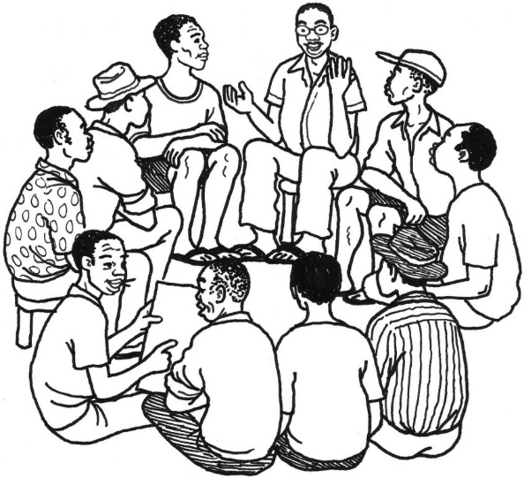
1. Warm-Up Activity (10–20 minutes)
1a. Explain to participants that this lesson is about gaining and improving facilitation skills. Note that many facilitators start a lesson with a quick game or activity. Ask participants why they think so many facilitators begin a session in this way. (Answers may include: to energize people and get them thinking, help people feel comfortable with speaking around each other, help them learn more about and trust each other, introduce the topic in a fun and memorable way)
1b. Ask participants if they have a favorite activity that they like to do when they facilitate, or if there’s an activity that they enjoyed doing when they participated in a previous workshop or training. Request that a volunteer conduct his/her preferred activity with the group. (The facilitator should have an example warm-up activity ready, in case no one is comfortable facilitating their own on short notice.)
1c. Thank the volunteer and note that being able to facilitate an activity or lesson on short notice is a skill that takes experience and practice. Tell them that today’s lesson will provide an opportunity to do this sort of lesson practice and get constructive feedback, so that they can work toward feeling more comfortable and natural as facilitators.
2. Reflecting on Our Own Experience (30 minutes)
2a. Ask participants the following questions.
- Why is it so important for Behavior Change Agents to practice and maintain effective facilitation skills?
- What parts of your jobs require you to use facilitation skills?
2b. Explain that effective facilitation skills are central to the BCA’s job. For a person to change their behavior, they often need to gain new skills, acquire new information, or change their attitude. A BCA uses facilitation skills to enable these.
2c. Ask participants to remember an exceptionally good training they attended or a better-than-average education session or demonstration they participated in—any time when someone else was facilitating a learning opportunity in an effective way. Working individually, ask participants to list all the things the facilitator/trainer did well, i.e., things that made it easy and enjoyable for them to learn.
2d. Divide the group into smaller groups of 3–4 participants. Ask them to share their lists with their small group members, combine them to make one large list of facilitation skills, and write these on flip chart paper. Give participants 10 minutes to do this, then ask them to post their flip charts on the wall.
2e. Have the participants do a gallery walk around the room and read the other groups’ lists. Have them take note of things other facilitators/trainers did well that they had not previously thought of.
2f. Ask the small groups to select one person from their group to make one large list of facilitation skills compiled from all the skills mentioned on all of the lists developed by the small groups so that each group has a master list of facilitation skills. Each group will need this full list for the next activity. (Later, you or a co-facilitator should type this master list up, print it, and distribute it to the participants.)
2g. Point out to participants that being an effective facilitator requires good planning, as well as effective management of the learning process.

3. Ranking Facilitation Skills (30 minutes)
3a. Using the master list of facilitation skills prepared in the last activity, ask each small group to work together to rank the facilitation skills by relative importance.
Note: There are a couple ways of doing this. You can instruct participants to write a number next to the skills on the list to rank them. Or you can ask them to write each skill on an individual index card and arrange them by importance.
3b. Have one of the small groups report out the top five facilitation skills on their list. As they read each skill, write it on a flip chart and have the participants in the other groups raise their hands if they also have that skill in their top five. When the first group is finished, ask the second group to share any skills in their top five that have not been mentioned yet. Continue in this way until all the groups have shared. When they have finished, label the flip chart “Top Facilitation Skills.”
3c. Distribute Lesson 8 Handout 1: Quality Improvement and Verification Checklist (QIVC) for Behavior Change Agents’ Facilitation Skills and explain that this checklist is used to help monitor the quality of facilitation. Ask participants to compare the items on the QIVC with those on their master lists of facilitation skills. Ask them to note how many are on the QIVC and which are missing. Explain that this QIVC is only one example, and their organization(s) may develop new QIVCS or adapt existing QIVCs for their program(s) to include other skills the organization considers important.
4. Facilitation Skills Self-Assessment (10 minutes)
4a. Distribute an index card to each participant. Referring to the master list of facilitation skills, ask participants to identify the skills that they would like to improve (or add other skills that have not been mentioned yet) and to write these on the index card.
4d. Invite a few participants to volunteer to share one item they wrote on their index cards. Ask all the participants to keep their cards for later use.
5. Practicing Facilitation Skills (1–2 hours)
5a. Distribute Lesson 8 Handout 2: Facilitation Skills: Suggestions from an Experienced Facilitator. Discuss each point and take questions, then ask participants if they learned anything new from the suggestions or if any of the suggestions would be hard to do.
5b. Note that there is blank space on the back of the handout. Ask a few participants to share some additional suggestions, and encourage everyone to write down any ideas that they think would be helpful in their own work.
5c. Explain to participants that knowing about good facilitation skills is a good start, but it takes practice to become a good facilitator.
5d. Divide the participants into pairs. Assign each pair a topic relevant to their program area (from the list that was prepared in advanced). Tell participants that they will create a lesson on their topic, lasting no more than 10 minutes.
5e. Ask each pair to prepare to present their lesson to the rest of the participants. Encourage them to create a written outline of the lesson to ensure that they are able to effectively present their topic within 10 minutes. Their lessons should include the facilitation skills that they want to improve. They can either make visual aids or use pretend visual aids. Give participants 25 minutes to prepare their lessons.
5f. Depending on the number of participants and the time available, choose one of the following procedures.
- Stay in the large group and have each pair present their lesson for the rest of the group.
Or
- Divide the large group in half or into three small groups and situate the small groups in different corners/areas of the space. Assign one person to moderate the small group work. Each pair in the small groups will then present their lesson to the rest of the small group so that all of the groups can work simultaneously.
5g. Explain that before each pair starts their facilitation exercise, they should share with the group the aspects of facilitation that they want to improve (previously written on the index cards).
5h. Before the presentations begin, distribute another copy of the QIVC in Lesson 8 Handout 1 to each participant. Before each facilitation exercise, ask one person to complete a QIVC for the lesson and return it to the facilitator afterward. If the participants are working in smaller groups, ask the moderator of each group to choose the person to complete the QIVC. Give each participant 10 minutes to present; the facilitator/moderator should stop the exercise after 10 minutes, even if it’s not finished.
5i. After each facilitation exercise, ask two observers to share one thing that they liked/thought went well, then ask two other observers to make one recommendation each about how to improve the facilitation. Remind participants that constructive feedback consists of concrete suggestions on what to do better and how (e.g., “I suggest that…”). Also, since this is not a discussion, the only response from the participant receiving the feedback should be “thank you.”
6. Wrap Up (10 minutes)
6a. Ask participants to write down all the positive facilitation skills they observed during this lesson.
6b. Ask participants to share things that they learned about their own facilitation skills and what they hope to continue to improve on.
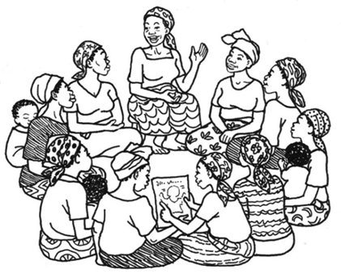

Lesson 8 Handout 1: Quality Improvement and Verification Checklist (QIVC) for Behavior Change Agents’ Facilitation Skills
Name of Behavior Change Agent (BCA): _____________________________________________
Evaluator:_____________________________________________________________________
Community: ____________________________________ Date: __________________________
METHODS Yes No
Set Up
- Did the BCA seat people so that all could see each other’s faces?.............................................
- Did the BCA wear appropriate clothing? ....................................................................................
- Did the BCA sit at the same level as the other participants? .....................................................
- If using a lesson plan: Did the BCA follow the lesson plan in the curriculum? ...........................
Overall Communication
- Did the BCA speak loud enough so that everyone could hear? .................................................
- Did the BCA use proper eye contact with everyone? .................................................................
- Did the BCA use changes in voice intonation (not monotone)? .................................................
- Did the BCA speak slowly and clearly? .......................................................................................
- Did the BCA move around the room/area without distracting the group? ...............................
- Did the BCA always use examples/terminology that were culturally appropriate?……..............
- Did the BCA encourage comments by nodding, smiling, or other actions that show he/she was listening? ....................................................................................................................................
- Did the BCA ALWAYS reply to participants in a courteous and diplomatic way? ………..............
- Did the BCA prevent domination of the discussion by 1 or 2 people? .......................................
- Did the BCA encourage timid participants to speak/participate? ..............................................
- Did the BCA use a participatory method? (game, skit, song, story, other: SPECIFY:__________________________) .................................................................................
- Did the BCA ask the participants lots of (non-rhetorical) questions? ........................................
- Did the BCA give participants adequate time to answer questions? .........................................
- Did the BCA encourage discussion amongst participants? ........................................................
Beginning
- Did the BCA clarify what behavior(s) would be discussed during the session? ……………………….
- Did the BCA clarify who should practice the behavior being discussed? ………………………………..
- Did the BCA ask questions to relate the topic to the participants’ experiences? ……………………
- Did the BCA ask about the current practices of the participants?..............................................

METHODS Yes No
Middle
- Did the BCA use any props or tell a story to promote discussion? …..........................................
- If pictures with key messages were used: Did the BCA explain the meaning of each picture?...
- Did the BCA pass the pictures around so participants could see them up close? ……………………
- Did the BCA demonstrate any skills that he/she was promoting? .............................................
- Did the BCA ask participants what barriers to the promoted practices they might encounter?
- Did the BCA elicit from the participants strategies to overcome barriers?................................
- Did the BCA suggest other strategies to overcome barriers? ....................................................
- Did the BCA encourage comments by paraphrasing what people said (repeating statements in his/her own words)? …...............................................................................................................
- Did the BCA ask participants if they agree with other participants’ responses? ….....................
- Did the participants make lots of comments? ...........................................................................
- Did the BCA summarize the participants’ discussion? ...............................................................
- Did the BCA reinforce statements by sharing relevant personal experience or by asking others to share personal experience? ….....................................................................................................
End
- Did the BCA verify that people understood the main points, using open-ended questions?.....
- Did the BCA summarize the essential points of the lesson? .......................................................
- Did the BCA ask the participants to commit to try the new behavior? ......................................
- Did the BCA finish the session within the allotted time? ...........................................................
Content
- Was the content of the educational messages CORRECT? ........................................................
1 2 3 4 5 6 7 8 9 10
Poor Excellent
- Was the content of the educational messages RELEVANT to the participants? ……………………..
1 2 3 4 5 6 7 8 9 10
Poor Excellent
- Was the content of the educational messages COMPLETE? .....................................................
1 2 3 4 5 6 7 8 9 10
Poor Excellent
- OVERALL EVALUATION OF THE BCA’s PERFORMANCE: 1 2 3 4 5 6 7 8 9 10
Poor Excellent
Scoring: Yes = ____ Used (Yes + No) = _____ Score= ______%
Recommendations/Suggestions for Action/Comments: _______________________________________ _______________________________________________________________________________________________________________________________________________________________________________________________________________________________________________________________

Lesson 8 Handout 2: Facilitation Skills:
Suggestions from an Experienced Facilitator
- Select just one or two behaviors/practices to focus on during a lesson so that you can discuss them in more detail.
- Start the lesson off by introducing the topic, then asking the audience what they already know about the behavior/practice. Ask specific questions that will get people thinking realistically about the topic. For example, instead of asking “What do you know about this?” start the discussion with a question like “What do women do when they get pregnant to make sure they are healthy?”
- Have laminated pictures that emphasize important aspects of the lesson. These should be about the size of copy paper or a bit smaller so they can be seen by many people, but also passed around so each person can get a closer look.
- Lessons that tell a story, where people have names and get “introduced” to the group, are best. Stories that present a problem, share information, and require a decision are especially helpful (See Lesson 3). For example: “This is Fatimata. Fatimata just realized that she is pregnant. This will be her first baby and she’s not exactly sure what to do. What advice would you give to her?”
- During the lesson, the facilitator should ask questions almost as often as he/she provides information. These questions should not just be about getting a list of facts (for example, "How many prenatal consultations should a pregnant woman have?”). Instead, they should encourage the audience to reflect (“Why do you think it’s important to have your first prenatal care visit during the first trimester?”). Many people in the group will already know some good reasons for the behavior and the facilitator just draws out that information and adds to it as needed. The lesson should be a real back and forth conversation, not a lecture.
- A great facilitator creates an opportunity for the learners to discover for themselves and share knowledge with others.
- When talking about behavior change, there always should be a discussion of barriers and solutions. Ask, “What will make it difficult for you to practice this behavior?” and then brainstorm as a group about how to overcome the barriers. The facilitator should not feel that he/she has to give the solution all the time.
- Commitment is important. At the end of the lesson, it can be very powerful for people to say individually and out loud if they are willing to try the new behavior. The facilitator can also help people identify someone who will help them if they encounter problems while trying out the behavior (e.g., “Who would be willing to help Maria talk to her mother-in-law about the importance of exclusive breastfeeding?”).

Advanced Lesson 1:
Quality Improvement and Verification Checklists (QIVCs) and Giving Feedback
Achievement-Based Objectives
By the end of this lesson, participants will have:
- Reviewed two quality improvement and verification checklists (QIVCs)
- Observed a simulated use of the QIVC
- Completed and scored two QIVCs
- Reviewed the steps for giving positive feedback
Duration
2 hours
Materials Needed
- Flip chart paper, markers, and pencils
- 20 small balls (or crumpled pieces of paper), a plastic bag, and a shoebox or similarly sized container or box
- Pre-labeled flip charts: Purpose of the QIVC and How to Score the QIVC
- Advanced Lesson 1 Handout 1: Quality Improvement and Verification Checklist (QIVC) for Education Session Facilitation (2 copies per participant)
- Advanced Lesson 1 Handout 2: Quality Improvement and Verification Checklist (QIVC) for Giving Feedback (2 copies per participant)
- Advanced Lesson 1 Handout 3: Role Play Part 1: Education Session (2 copies)
- Advanced Lesson 1 Handout 4: Role Play Part 2: Giving Feedback (2 copies)
- Advanced Lesson 1 Handout 5: Steps for Giving Feedback to Workers (1 copy per participant)

Why this Lesson?
As Behavior Change Agents (BCAs) participate in trainings and gain experience and practice in their communities, they also can benefit from effective supervision of the quality of their ongoing work. The QIVC, developed by Food for the Hungry, is a tool that has been found to help improve the performance of workers involved in behavior change programming. This lesson is designed to be used by BCAs at all levels and their supervisors in order to obtain the sort of feedback that helps workers become more effective agents of change in their communities.

Advanced Preparation
Throughout this manual, the term BCA is used to represent the wide variety of roles held by workers who promote change. When facilitating this lesson and others, replace “BCA” with a title that is appropriate for your audience (such as agriculture extension agent, community health worker, peer educator).
For the activity in Task 1, locate a shoebox or similarly sized container or box, 20 small balls or pieces of paper crumpled into a ball shape, and a bag in which to place the balls.
Prepare a flip chart with the three main purposes of the QIVC for Education Session Facilitation, as listed in Task 3b. Also prepare a flip chart with the information in the box How to Score the QIVC in Task 5e.
For Task 5, prepare to present a short role play of a BCA demonstrating a behavior/practice. Advanced Lesson 1 Handout 3: Role Play Part 1: Education Session describes a demonstration of how to make oral rehydration solution (ORS). If appropriate, this example can be replaced with a demonstration that is more relevant to participants’ program area(s). If the example is modified, the outline in Advanced Lesson 1 Handout 4: Role Play Part 2: Giving Feedback also should be updated.
If there are two facilitators at the training, it would be best if they did the role play in Task 5 together, with one facilitator playing the role of the BCA and the other playing the role of the supervisor. If there is only one facilitator, choose a very competent participant to play the role of the BCA. Either way, practice the role play ahead of time. You also will need to ask a few participants to play the role of the people who are attending the education session.
With your co-facilitator or experienced participant, review Advanced Lesson 1 Handout 1: Quality Improvement and Verification Checklist (QIVC) for Education Session Facilitation, Advanced Lesson 1 Handout 2: Quality Improvement and Verification Checklist (QIVC) for Giving Feedback, Advanced Lesson 1 Handout 3, Advanced Lesson 1 Handout 4, and the instructions in Task 5. These materials will help the person playing the BCA know what good things to do. Work together to choose two or three things for the BCA to deliberately do wrong. This way the person playing the supervisor will be prepared to give appropriate feedback.
It is very important that the person playing the BCA not try to entertain the audience by acting silly during the skit, or making too many errors. This learning activity should provide realistic examples of effective and ineffective techniques and how the supervisor works with the BCA to improve. Also, make sure you have practiced giving appropriate feedback before training others.
In many cultures, supervisors are more prone to mark “no” for very tiny faults instead of marking “yes” if the facilitator in general completed the given task. Be sure to model how the QIVC is a tool to compassionately encourage and improve the ability of workers. It is not a tool used to discourage a worker or to try to shame them into change.

Tasks
1. Warm-Up Activity (20 minutes)
1a. Explain to participants that the lesson will start with a quick activity to get them thinking about today’s topic: giving feedback. Request that a volunteer come to the front of the room and face the rest of the participants. Instruct him/her to remain facing forward. Then, quietly place a box or container somewhere behind the volunteer (in a way that he/she does not see or sense its location).
1b. Give the volunteer the bag of 20 small balls or crumbled pieces of paper. Explain that the volunteer will try to get ten balls into the box by tossing them over his/her shoulder—without looking! The volunteer will need to rely on the input and feedback of the rest of the participants.
1c. After each throw, the facilitator should choose one participant to give information to the volunteer (for example, “a little to the right” or “further back”). At first, the volunteer will not be able to ask any questions or respond to the feedback.
1d. About halfway through (after about 10 tosses), ask the volunteer to pause. Check in with him/her to see if the feedback and input has been helpful. Allow him/her to ask clarifying questions from that point on. If needed, remind participants of the importance of being supportive when giving feedback.
1e. When the volunteer has tossed ten balls into the box or runs out of balls (whichever comes first), thank everyone for helping with the activity. Facilitate a brief discussion based on the following questions.
- What was challenging about this exercise? What went well?
- How did it change the outcome to be able to have a dialogue about what was needed? How did using positive comments help the conversation?
- How did practicing and gaining experience with this exercise change the outcome?
- Has anyone ever felt like this in your work, like you’re trying to reach a goal, but you aren’t sure whether you’re on the right track? What examples can you share?
2. The Importance of Monitoring and Evaluation (10 minutes)
2a. Explain to participants: It takes a lot of practice and support to become an effective Behavior Change Agent, but continually trying to improve is worth the effort! Even if a certain behavior change strategy has been proven to be very effective, it might not work if it isn’t presented or shared well. That’s why programs do monitoring and evaluation, so we can see how things are going.
2b. Point out that we look at both quantity and quality when we track a program’s progress. Ask participants: What countable things do you usually monitor in your program? (Answers could include: how many trainings were conducted, how many demonstration plots were established, how many people attended education sessions)
2c. Tell participants: The amount of work done is important, but it’s equally if not more important to know how well an education session was facilitated and how engaged the community members were in the program. To focus our attention on how well tasks and activities are done, Food for the Hungry developed a tool called the quality improvement and verification checklist, or QIVC.
3. The Quality Improvement and Verification Checklist Tool and How It Is Used (10 minutes)
3a. Refer participants to Advanced Lesson 1 Handout 1: Quality Improvement and Verification Checklist (QIVC) for Education Session Facilitation and Advanced Lesson 1 Handout 2: Quality Improvement and Verification Checklist (QIVC) for Giving Feedback. Explain that while we will be using these two QIVCs during this session, there are many other QIVCs that focus on other tasks. Other QIVCs created by Food for the Hungry can be found at http://www.caregroupinfo.org/docs/QIVC_Files.zip.
3b. Explain that the QIVC for Education Session Facilitation has three main purposes. Show the list that you prepared on the flip chart:
- To encourage a facilitator
- To monitor a facilitator
- To improve a facilitator’s performance
3c. Ask participants: Who are the facilitators in your program? The QIVC can be used to encourage, monitor, and improve the work of each one of the team members in your program that are responsible for facilitating a learning experience.
3d. Explain to participants: The QIVC rapidly increases performance. Small improvements in performance can cause large changes in impact. However, QIVCs are useful only for tasks that can be observed and have multiple steps.
3e. Ask participants: What are some activities in our program that you can observe? Which of these activities is a process with multiple steps?

4. Review the Quality Improvement and Verification Checklist (15 minutes)
4a. Go through each point on Handout 1 with participants. Make sure that they understand what each question means.
4b. Explain to participants that most questions on the QIVC have a yes or no answer. After reading the question, they should decide if the answer is “yes” or “no” and mark the corresponding box.
4c. If the question is not relevant for a particular training, then draw a line through the YES or NO boxes. For example:
- In question 11, if the topic was exclusive breastfeeding (EBF), the facilitator would have a difficult time demonstrating this activity. It is possible for the facilitator to demonstrate proper breastfeeding attachment, but EBF is not something that needs to be demonstrated during the lesson. You would mark a line through the yes or no.
- In question 16, if participants do not mention any barriers, cross out this line when monitoring the worker.
4d. Tell participants: QIVCs should be adapted to fit the culture and design of different programs. After using the QIVC for 3 or 4 months, ask staff and volunteers to meet together to discuss the checklist. If specific questions are not appropriate or applicable to your situation, adapt or revise them as needed. However, be cautious. The QIVC was designed to ensure participatory teaching methods are used in each lesson. Make sure your final version continues to reinforce the key principles of participatory learning. For more information on key practices of adult learning, see Freedom from Hunger’s Adult Education Materials at http://www.ffhtechnical.org/resources/education-modules.
5. Quality Improvement and Verification Checklist in Action (40 minutes)
- Explain to participants: Now we’re going to learn how the QIVC would be used. You are going to watch a role play of the Behavior Change Agent facilitating an education session and how the supervisor, who has come to watch, provides feedback to the Behavior Change Agent. During the role play, keep an eye on your copy of the QIVC and see for yourself how well the Behavior Change Agent conducts the education session. Then, when the supervisor gives feedback, use the other QIVC to see how well he/she does.
- Explain to participants that the QIVC is only completed after the event, not during. This is done so the person filling out the QIVC can pay attention during the event being evaluated and not be distracted by filling out the QIVC.
- Explain that the role play will be done in two parts. In the first part, a BCA facilitates a meeting. In the second part, the Supervisor gives feedback to the BCA. Instruct participants to fill out the right QIVC after each role play. Answer any questions.
- Distribute an extra copy of each QIVC to participants. First carry out the role plays found in Advanced Lesson 1 Handout 3: Role Play Part 1: Education Session and make sure that the BCA teaches the audience how to do something, such as prepare ORS.
- After completing the role play, ask each participant to fill out and score their copies of the QIVC for Education Session Facilitation. Show the instructions in How to Score the QIVC, below, which you previously prepared on a flip chart. Ask some participants to share the scores they gave.
How to Score the QIVC
- Count the number of “yes” responses.
- Divide the number of “yes” responses by the total number of answered questions (questions answered with either a “yes” or “no” response).
- Do not count the questions that are not applicable (those that are crossed out).

- Repeat this process using Advanced Lesson 1 Handout 4: Role Play Part 2: Giving Feedback and Advanced Lesson 1 Handout 2.
- Ask participants the following questions. They should answer the questions based on what they saw in the skit.
- What should you say to the Behavior Change Agent when you visit her/him and plan to use a QIVC?
Answers should include:
- Don’t worry!
- This is not a test, but a tool to help you improve.
- Teach as you normally do.
- What comments did the supervisor make during the educational lesson?
Answers should include:
- None! The supervisor should observe only and not interrupt or make comments to the facilitator.
- After the session, the supervisor can address the participants as appropriate.

- Where did the supervisor talk about each of the points in the QIVC with the Behavior Change Agent?
Answers should include:
- In private, not in front of other people.
- Why did the supervisor explain the checklist to the Behavior Change Agent?
Answers should include:
- Because it is also a method for improving and encouraging the worker’s performance.
- The actions we consider to be perfect performance should not be kept secret from the worker.
- All workers should know exactly what is expected of them.
- How should the supervisor speak to the Behavior Change Agent?
Answers should include:
- The supervisor needs to be gentle so the BCA does not feel shame.
- Even if the BCA did very poorly on the checklist, the supervisor should emphasize areas where he/she has shown some improvement.
- Ask the BCA which areas she wants to work on.
- Focus on asking, not on telling.
6. More on Giving Feedback (15 minutes)
6a. Read the following information to participants.
The Importance of Giving Positive Feedback
(From “Positive Image, Positive Action: The Affirmative Basis of Organizing” by David Cooperrider)
Many people believe that pointing out mistakes will eliminate failures and improve performance. However, studies have shown that the opposite is true especially when it comes to learning new tasks. In one experiment, for example, Kirschenbaum (1984) compared three sets of bowlers.
Group A did not receive any lessons, but tried to learn how to bowl on their own.
Group B was videotaped. All of the good things they did while bowling were compiled, and the mistakes were deleted from the tapes. These positive tapes were reviewed with each bowler pointing out the things they had done well to help them improve.
Group C also was videotaped. All of the bowling mistakes they made were compiled, and the good things they did were deleted off the tapes. The mistake tapes were reviewed with this group, pointing out areas they needed to improve.
Group B improved significantly more than all the others, and the unskilled bowlers in Group B (average of 125 pins) improved substantially (more than 100%) more than all other groups.
Since then, these results have been replicated with other athletic activities, giving the same results. Pointing out the things people do well helps them learn new skills and improves their performance in mastering new tasks.

6b. Facilitate a discussion based on the following questions:
- We have talked a lot about positive feedback. What’s wrong with negative feedback?
- Wouldn’t the worker improve faster if we told him/her everything that was done wrong? What is your opinion?
6c. Refer participants to Advanced Lesson 1 Handout 5: Steps for Giving Feedback to Workers. Tell participants that they will now review exactly how feedback should be given after an observation.
6d. Working in pairs, have participants review the handout and compare the points to what they observed in the role play. Ask some participants to share their observations.
6e. Ask participants the following questions and discuss responses.
- How is this way of giving feedback different from the way it is usually done?
- Which way do you think will result in improved performance?
- Which approach would help workers stay more motivated? Why?
7. Wrap Up (10 minutes)
7a. Facilitate a brief discussion based on the following questions.
- How do you think you can use these tools in your work? Can someone provide a specific example of how they plan to incorporate the QIVC?
- How might this help improve your program’s outcomes?

Advanced Lesson 1 Handout 1: Quality Improvement and Verification Checklist (QIVC) for Education Session Facilitation
Name of facilitator: ________________________ Date: ________________________________
Evaluator: ________________________________ Community: __________________________
METHODS Yes No
- Did the facilitator seat people so that all could see each other’s faces? ......................
- Did the facilitator sit at the same level as the other participants? …………………………….
- Did the facilitator introduce the topic well (who he/she is, topic, time)? ………………….
- Did the facilitator speak loud enough so that everyone could hear? ………………………..
- Did the facilitator use proper eye contact with everyone? ……………………………………….
- Did the facilitator change his/her voice intonation (not monotone)? ………………………
- Did the facilitator speak slowly and clearly? ……………………………………………………………..
- Did the facilitator ask about the current practices of the participants? …………………….
- Did the facilitator read each caption aloud to the participants? ……………………………….
- Did the facilitator explain the meaning of each picture? ..…………………………………………
- Did the facilitator demonstrate any skills that he/she was promoting? …………………….
- Did the facilitator verify that people understood the main points using open-ended questions? ………………………………………………………………………………………………………………..
DISCUSSION Yes No
- Did the facilitator ask the participants lots of non-rhetorical questions?......................
- Did the facilitator give participants adequate time to answer questions?....................
- Did the facilitator ask participants if there were barriers that might prevent them
from trying the new practices? ………………………………………………….……………………………..
- Did the facilitator encourage discussion among participants to work around the barriers mentioned? ………………………………………………………………………………………………………………
- Did the facilitator encourage comments by paraphrasing what people said (repeating statements in his/her own words)? …………………………………………………………………………..
- Did the facilitator ask participants if they agree with other participants’ responses?..
- Did the facilitator encourage comments by nodding, smiling or other actions to show
he/she was listening? ……………………………………………………………………………………………….
- Did the facilitator always reply to participants in a courteous and diplomatic way?....
- Did the participants make lots of comments? …………………………….…………………………….
- Did the facilitator prevent domination of the discussion by one or two people? ………
DISCUSSION (continued) Yes No
- Did the facilitator encourage timid participants to speak/participate? ………………………
- Did the facilitator summarize the discussion? …………………………………………………………..
- Did the facilitator reinforce statements by sharing relevant personal experience or
by asking others to share personal experience? ………………………………………………………..
- Did the facilitator ask each person to make a commitment? …………………………………….
- Did the facilitator ask each person about previous commitments? …………………………..
CONTENT Yes No
- Was the content of the educational messages correct? ……………………………………………
- Was the content of the educational messages relevant? ………………………………………….
- Was the content of the educational messages complete? …………………………………........
- Overall evaluation of the facilitator’s performance:
Score: __________________________________
Comments: ______________________________________________________________________________
______________________________________________________________________________
______________________________________________________________________________
______________________________________________________________________________
______________________________________________________________________________

Advanced Lesson 1 Handout 2: Quality Improvement and Verification Checklist (QIVC) to Evaluate Positive Feedback
Name of the person using this list: _________________________________________________
Name of the person evaluated: ___________________________________________________
Community: ____________________________ Date: ____________________
Number of yeses: _________ Number of lines: __________
Present grade: ____________% Previous grade: ___________%
CONTENT Yes No
- Did the evaluator explain the purpose of the QIVC (to improve and measure work
quality)? …………………………………………………………………………………………………………………..
- Did the evaluator tell the person evaluated not to be afraid, that this is not a test, but rather something to help him/her improve? ……………………………………………………………………….
- Did the evaluator advise the person being evaluated not to say anything to the evaluator while being observed? ……………………………………………………………………………………………..
DURING THE OBSERVATION Yes No
- Did the evaluator avoid making comments to the person evaluated during the health lesson? ……………………………………………………………………………………………………………………..
- Did the evaluator mark all the questions (yes or no) during or right after the
observation? …………………………………………………………………………………………………………….
FEEDBACK Yes No
- Did the evaluator give the feedback in a private place?................................................
- Did the evaluator ask the person evaluated to take notes on his/her comments?..…..
- Did the evaluator discuss each positive point on the form? ……………………………………..
- Did the evaluator encourage the person evaluated about the things he/she did
correctly? …………………………………………………………………………………………………………………
- Did the evaluator use positive body language when providing positive feedback to the person? …………………………………………………………………………………………………………………….
- Did the evaluator use many encouraging words (e.g., excellent, very good) when providing positive feedback to the person? ……………………………………………………………………………..
- Did the evaluator avoid the use of too many mixed comments (e.g., “This was excellent,
but you have to …”) when providing feedback? ……………………………………………………….
- Did the evaluator always respond to the comments from the person evaluated in a courteous and diplomatic manner? ………………………………………………………………………….

FEEDBACK Yes No
- Did the evaluator mention the area(s) where the performance of the person evaluated
was better than the majority of other people? …………………………………………………………
- Did the evaluator discuss each negative point on the form? ……………………………………
- Did the evaluator often ask the person evaluated to discuss the negative points in his/her performance self-evaluation before providing an opinion? ……………………………………..
- Did the evaluator use several examples to explain the correct manner of performing the parts of the process that were done incorrectly? ………………………................................
- Did the evaluator maintain control of the evaluation process in an appropriate
manner? ………………………………………………………………………………………………………………….
- Did the evaluator help the person evaluated find solutions to the problems he/she has
(e.g., in the community), where possible? ………………………………………………………………..
- Did the evaluator keep the attention of the person evaluated? ……………………………….
- Were the evaluator’s suggestions correct? ………………………………………………………………
- Were the evaluator’s suggestions appropriate for the context of the person being evaluated? ……………………………………………………………………………………………………………….
- Were the evaluator’s suggestions complete? …………………………………………………………..
- Were the evaluator’s suggestions very specific? ………………………………………………………
AT THE END OF THE EVALUATION Yes No
- Did the evaluator ask the person evaluated to give a summary of the things that should be improved? …………………………………………………………………………………………………………………
- Did the evaluator complete this list if the person evaluated could not remember all the things that needed improvement? ……………………………………………………………………………
- Did the evaluator ask the person evaluated to indicate his/her commitment to improve these things? …………………………………………………………………………………………………………….
- Did the evaluator ask the person to give a summary of the positive things that he/she
did? …………………………………………………………………………………………………………………………..
- Did the evaluator complete this list if the person evaluated could not remember all the things he/she did that were positive? ………………………………………………………………………
Score: __________________________________
Comments: ____________________________________________________________________
______________________________________________________________________________
______________________________________________________________________________
______________________________________________________________________________

Advanced Lesson 1 Handout 3: Role Play Part 1: Education Session

Introduction
Read the following introduction aloud to participants.
The Behavior Change Agent is in the middle of an education session with a neighbor women’s group about children and diarrhea. She has already taken attendance, told a story, and reviewed a flip chart with information. Now, during the break, she is preparing to demonstrate how to make oral rehydration solution for children with diarrhea. She is arranging the sugar, salt, container of drinking water, and container to mix the solution in (a 1 liter bottle). She has prepared a space for the NW to sit in front of her in a semi-circle so all the women can see each other. As the BCA is getting ready, her supervisor arrives and they have the following discussion.

Role Play
Supervisor: Good morning Maria. How are you doing?
BCA: Welcome! I’m fine. It’s good to see you.
Supervisor: I’ve come to pay you a visit and to observe your meeting. During this visit I will be completing the Quality Improvement and Verification Checklist for Education Session Facilitation. Remember the QIVC will help improve your work as a facilitator. It’s not a test, so there’s no need to be nervous. [She shows the QIVC to the BCA.] This is the same form that we have used before.
BCA: Yes, I remember. I was just getting ready to show the women how to prepare ORS. The women will be joining me here. Since you are here, if I have any questions or problems, I’ll be sure to ask for your help.
Supervisor: Actually, Maria, I will just be watching you and not participating at all. Just carry on as if I wasn’t here. Afterward we will talk about how the meeting went.
The BCA sits down and calls the NW to join her. The Supervisor sits to the side holding her QIVC. Once all the NW are sitting, one last woman arrives and sits behind everyone else, a little outside the group. The BCA conducts a 5–10 minute instruction of how to prepare ORS, reminding the NW about what they learned from the story and the flip chart that were covered prior to the demonstration. She makes sure everyone but the mother sitting a little outside the group has a chance to participate. The BCA does almost everything well but she does not ask the NW if they have any experience making ORS, and she does not make sure at the end that they all understood. The demonstration ends, and the BCA thanks the NW for coming.

Advanced Lesson 1 Handout 4: Role Play Part 2: Giving Feedback
The Behavior Change Agent (BCA) and the supervisor privately discuss the education session. The supervisor uses the following outline to discuss the BCA’s performance.
- Ask, “How do you think you did?”
- Agree with positive points and mistakes the BCA mentions, as appropriate. Probe as needed: “What things did you do well? What things would you have done differently?”
- Review the positive things on the quality improvement and verification checklist (QIVC) (everything marked yes).
- If not mentioned earlier, ask the BCA about areas that you marked “no.” For example, “Tell me about the woman who came in last, I thought she seemed left out of the group.” Or “How did you think you did in reviewing the mothers’ prior experience in making oral rehydration solution?”
- Reinforce things that the BCA says that could help her improve in these areas. Do not concentrate too much on what the BCA did wrong, but rather what she did well. Help her come up with ways to strengthen areas that need improvement.
- Ask the BCA to summarize the things that you discussed today (positive things and areas to improve).
- Give the BCA her score, and summarize anything that was missed.
- Ask her to commit to changing these things.
- Thank the BCA.

Advanced Lesson 1 Handout 5: Steps for
Giving Feedback to Workers
- Give feedback in private.
- Ask the person being evaluated to take notes.
- Discuss each positive point.
- Encourage the worker on the things he/she did well.
- Use positive body language.
- Respond to the worker in a courteous and diplomatic manner.
- Mention things the worker does especially well.
- Discuss each negative point on the form, but remember to give three positive comments for every one comment about an area to improve.
- Do not use make confusing, mixed comments that are partly positive and partly negative, such as “you spoke clearly, but I couldn’t hear you.”
- Ask the worker to discuss his/her performance before giving your opinion.
- Offer several examples to explain the correct manner of performing the tasks where the worker received a “no” on the quality improvement and verification checklist (QIVC).
- Maintain control of the evaluation.
- Help the worker find solutions to problems when possible.
- Keep the worker’s attention.
- Focus on what is correct, appropriate, and complete.
- At the end of the evaluation, ask the worker to summarize the things he/she will improve.
- If he/she forgot any areas, remind him/her of them.
- Ask the worker to make a commitment to improve these issues.
- Ask the worker to give a summary of the things he/she did well.
- Add to this list if the worker forgot any positive areas.

Advanced Lesson 2: Motivating Conversations: Conversations for Change
Achievement-Based Objectives
By the end of this session, participants will have:
- Understood how a Motivating Conversations (MC) approach can help Behavior Change Agents (BCAs) and community members work together to change behaviors
- Reviewed key MC principles and communication skills
- Practiced using the MC approach in difficult behavior change scenarios
Duration
2.25 hours
Materials
- Flip chart paper, markers, index cards or paper, and pencils/pens
- Soft ball or object that can be thrown by participants
- Pre-written flip chart paper with the Definition and Guiding Principles of MC
- Advanced Lesson 2 Handout 1: Role Play Response Prompt Cards (enough copies that each pair of participants will have 3 cards)
- Advanced Lesson 2 Handout 2: Background Information and Resources about Motivational Interviewing (1 copy per participant)

Why this Lesson?
Advanced Lesson 2 introduces a communication style called Motivating Conversations (MC), which is based on key concepts of Motivational Interviewing (MI). For more information about MI, refer to Advanced Lesson 2 Handout 2: Background Information and Resources about Motivational Interviewing. This kind of communication allows BCAs to help community members find their own solutions to their problems and get in touch with their own motivations for change.
This lesson is designed to build on BCAs’ existing interpersonal and communication skills and to show how they can talk with community members in a way that promotes change. It should be done with groups of BCAs that have already completed Lesson 1: Behavior Change through Effective Communication.

Advanced Preparation
Throughout this manual, the term BCA is used to represent the wide variety of roles held by workers who promote change. When facilitating this lesson and others, replace “BCA” with a title that is appropriate for your audience (such as agriculture extension agent, community health worker, peer educator).
This lesson provides agriculture-related examples of MC responses/techniques. Please read the examples in advance and, if needed, adapt them to meet the needs of your BCAs.
Before the meeting, prepare a flipchart with the definition and guiding principles of MC found in Task 3a. In addition, make copies of and cut apart the cards in Advanced Lesson 3 Handout 1: Role Play Response Prompt Cards for use in the role-play at the end of the lesson. Make enough copies that pairs of participants will each have three prompt cards.

Tasks
1. Warm-Up Activity (10 minutes)
1a. Introduce this lesson by telling participants: One of a Behavior Change Agent’s responsibilities is to support individuals through the process of changing their behaviors to improve the health of families and entire communities.
1b. Ask participants to form a large circle. Explain that they will do a quick activity to review some of the changes they would like to see in their communities. Toss a ball to one participant and ask him/her to share a behavior that he/she would like to see more of (for example, planting green manures). Ask that participant to toss the ball to someone else, who will then share an action or behavior that he/she would like to see less of (for example, burning of fields). Ask that person to toss the ball to another, who will share another “more” behavior. Continue in this way, alternating between “less” and “more,” until all participants have shared.
2. Our Experiences as Change Agents (10 minutes)
2a. Explain to participants that helping people to do more of some behaviors and less of others can be very rewarding, but it can also be very hard and frustrating. Ask the participants to raise their hands if they ever have been frustrated or disappointed by people not using a new or healthier behavior. Explain that this lesson will provide a chance to learn about a way of communicating to help BCAs be more successful in changing behavior in tough situations and to help reduce their feelings of frustration.
2b. Ask each participant to think of a time when an individual or a group of people did not practice a new behavior or did not continue a behavior that was used at first. Now ask participants to think of how they felt about the people who did not change. For example:
Behavior Change Experience: A young man who had received education about HIV insists, “I’m not going to use condoms anyway.”
My reaction: Why are you being so irresponsible?!
Or
Behavior Change Experience: A farmer who has learned about a new method agrees that it is helpful, but after several months still has not used it.
My reaction: You are so stubborn!
2c. Request that a few participants share their Behavior Change Experience and Reaction. Alternatively, participants can write their responses on note cards and the facilitator can redistribute them to other participants to be read out loud.
2d. Ask participants for their thoughts on why they sometimes feel frustrated when people don’t change. (Answers might include: we believe that the behavior change can improve health and well-being, we worry that not changing the behavior can cause harm, we want to meet our program goals and we feel stressed when people won’t change)
- Note that a person’s behaviors and decisions may be confusing or frustrating when we have our own ideas about the “right” choice. Sometimes it seems that people don’t think through their actions logically, their actions don’t match their values or goals, they don’t take information or facts seriously, or they say one thing but then do another.
- Emphasize to participants: Frustration, anger, and disappointment are common reactions when someone you are trying to help seems to be making unhealthy or unhelpful choices. It is normal to feel this way when you believe in the benefits of the behavior change and/or feel pressure to meet program goals. When we share knowledge or teach a new method and the community member does not use it, we might feel disappointed in that person and in ourselves!
2e. Offer this different way of thinking about these tough situations: Let’s assume that each person has very good reasons for acting as they do and we can learn a lot from an honest discussion with the person about those reasons. For example, let’s believe that the farmer has excellent reasons for not using a new farming method. Let’s consider that he has been farming for decades and is an expert in his own life and which methods work best for him.
2f. Explain to participants that today they will practice skills that will help them talk with people in a way that focuses on partnership, acceptance, and the other person’s existing strengths.
- Encourage participants to try to see themselves not as experts who share information or give advice, but rather as helpers who promote behavior change among people who already have a lifetime of personal experience and knowledge.
- Share that the skills in this lesson can help BCAs have conversations with community members that identify their personal reasons for wanting to change.
- Note that they are probably already practicing many of these skills every day!
3. Introduction to Motivating Conversations (10 minutes)
3a. Display a flip chart with the definition and guiding principles of MC written on it and ask a volunteer to read the definition out loud. Explain that we will be learning how to talk with people in a way that helps change behavior.
Definition of Motivating Conversations
Motivating Conversations is a method for increasing people’s reasons for changing by helping them to understand their mixed feelings about a new behavior.
Guiding Principles of Motivating Conversations
- Working Together
- Building on Existing Strengths
- Emphasizing Free Choice
- Connecting Behavior with Values/Goals

3b. Ask participants for their thoughts about “mixed feelings” about a behavior change. Remind them of the example of the farmer who agrees that a new method is helpful, but still doesn’t use it. Participants might mention that some people believe in the education provided by a BCA, but do not practice the recommended behaviors, or that some people value health and education, but their behavior choices don’t always match their values.
3c. Explain that the guiding principles of MC help us think about how to talk with people in a way that encourages them to find their own good reasons to change. Describe the following principles:
- Working Together: We honor the person’s experience and perspective and assume that we can learn from each other.
- Building on Existing Strengths: The person already has the resources and motivation to change and we will work together to find them. We help people learn from their own experiences.
- Emphasizing Free Choice: We respect the person’s right to decide what to do. No one can make another person change.
- Connecting Behavior with Values/Goals: We can help people identify their personal values and goals, and to see how their present behavior might not match those values and goals. In this way, we motivate them to make changes that fit their life plans and hopes.
4. Creating a Good Relationship (10 minutes)
4a. Explain to participants that they will now learn more about how to have the kinds of conversations that can motivate people in the community to make changes in their own lives. Emphasize again that they are probably already using a lot of these skills in their work and daily lives.
4b. Remind participants that in order to talk with someone about changing a behavior, they must first build a good relationship with that person. Ask them how they usually create a good relationship with people in their community. List their suggestions on flip chart paper. (Answers could include: get to know a person by asking about their family, work, or interests; ask why the person is interested in your program/service and listen to the response; make positive comments; be friendly and welcoming; avoid giving advice or focusing on problems)
4c. Note that the ability to connect with people comes naturally to some BCAs; for others, it may be a new skill that can be improved with practice.
4d. Point out that early conversations with community members do not have to focus on behavior change or on giving information/advice about a BCA’s program area. In order to show that they care about a person and their family, a BCA might not talk about any behavior changes at all until some trust has been created!
4e. Discuss the following questions.
- In the communities in which you work, how do you know when you’ve established trust with community members?
- What do you do when you’re not able to create a good relationship with some people?
5. How to Talk in a Way that Motivates Change (45 minutes)
5a. Explain that now they will review and practice some ways of talking with people that can help them build strong relationships in the community and motivate behavior change, even with people that are sometimes hard to connect with. (Prepare to list the skills on flip-chart paper as you review each one. The list will include: “open-ended questions,” “provide information only after asking,” “take a break,” “personal control,” “positive comments,” “reflections,” and “the power of silence.”)
5b. Write “open-ended questions” on a piece of flip-chart paper. Ask someone to explain what an open-ended question is. (The answer should be: a question that cannot be answered with just a “yes” or “no” or another short response, which is typical of closed questions). If needed, add that open-ended questions encourage dialogue and show respect. They also show that you are interested in the other person and want more details. They can lead to a deeper conversation, especially with people who may be shy or not very talkative.
- For example: “Do you think organic pesticides are a good idea?” (closed) versus “What do you think are the benefits of organic pesticides?” (open-ended)
- Divide the group into pairs. Ask each pair to develop two open-ended questions that they could use to get to know a community member and two open-ended questions that they could use to find out how much a community member already knows about a behavior change being promoted by their program. Give the pairs about 10 minutes to write or discuss their questions, then ask a few volunteers to share their questions with the larger group.
- For more about open-ended questions, refer to Lesson 1: Behavior Change through Effective Communication.
5c. Note that since many BCAs are excited about their project and are under pressure to meet program goals, it can be easy to start teaching, giving advice, or sharing personal stories soon after meeting a community member. But, if we want to talk with people in a way that really encourages behavior change, we first need to listen to them and understand what they already know and think.
- Ask the group how they think someone feels when they are shown respect for their personal experience, instead of being given information or advice. For example, “How do you think people would feel if you first asked what they already do to improve their families’ health, instead of starting a discussion with a list of the benefits of your recommended behavior change? (Responses could include: valued, capable, proud, understood, appreciated)
- Write “provide information only after asking if it’s wanted/needed” on the flip chart. Explain that we want to listen to the community member, not just tell them what we know. Information and education are important, but in order to change behavior we want to focus on personal motivations, which usually are not directly linked to facts or information.
- For example, a BCA working with hand washing could find out how much the person already knows by asking, “What have you learned about how hand washing helps people stay healthy?” Find out if he/she would like additional information by asking, “Would you like to hear more about how hand washing can prevent illness?”
5d. Ask participants how they would respond if a community member said that he/she did not want to learn any more about their program or if the conversation became tense or got “stuck?” Add “take a break” to the list on the flip chart and remind participants that no one can make somebody else change or force someone to participate in a program.
- Ask participants what they might say to shift the conversation away from behavior change if the community member becomes uncomfortable, upset, or disinterested. (Examples could include: “It’s ok if we don’t talk about this now,” “No changes need to be made today,” “That’s fine, thank you for letting me share a little about our program,” “How about you tell me some more about what is working well for you now?”
- Emphasize that the purpose of taking a break is to pause the conversation, not end it completely. By respecting the community member’s opinion at that moment, the BCA can improve the relationship in a way that might allow the conversation to continue in a more positive way during future visits.
5e. Add “personal control” to the list on the flip chart and reinforce that BCAs cannot force people to change their behaviors. Ask participants for examples of how they would let a community member know that he/she is in control. (Examples can include: “I’m very interested in listening to your decision about this change,” “It’s your choice,” “No one can make you do it,” “It’s totally up to you.”)
- Note that in many communities, some people may feel that they are not in control of their decisions due to family and social pressure or other circumstances. Emphasize that with MC, the BCA is careful to not place additional pressure on the person. Rather, the BCA uses effective communication skills to help the person feel supported and to draw out the strength that he/she already has to make realistic changes, even in tough situations.
- Explain that participants will have an opportunity in a few minutes to practice using MC by creating a role play. Encourage them to use this opportunity to see how MC can help them support community members who often feel powerless and unable to make changes in their lives.
- Ask participants how they think emphasizing free choice also can help the BCA. Remind them of the frustrating scenarios from the beginning of the lesson. Note that not even the most experienced BCA can force people to change, so placing control of the behavior change decision back in the hands of community members can reduce BCAs feelings of personal frustration, disappointment, and failure. It also helps BCAs see the change process as a collaboration between two people who respect each other.
5f. Write “positive comments” on the flip chart. Explain that focusing on a person’s successes or strengths shows respect for what they already have done.
- Request that participants write down or think about two positive comments they have received recently: one related to their work as a BCA and one related to their lives outside their BCA work.
- Discuss the following questions with the participants.
- How did those positive comments affect your feelings about yourself and your abilities?
- How do you think making positive comments might affect your relationship with community members?
- What are some examples of positive comments that you can make related to your program area? (Examples can include: “I can tell that the health of your family is really important to you,” “I’ve seen that you do a great job teaching your children what they need to know,” “Good job, I know that you worked really hard on your crop last season,” “I’ve seen you do a great job sharing your knowledge with other farmers.”)
5g. Add “reflections” to the list on the flip chart. Explain that, during a conversation, BCAs can restate what they hear as short statements about the speaker’s thoughts or feelings. This can be especially helpful when the person’s behavior choices do not seem to match their values. Sometimes you might guess wrong—that’s OK! Allow the other person to correct you. The explanation might turn into an honest talk about what would be needed for change to be possible for that person.
- For example: A farmer says, “I understand the benefits of organic pesticides for health and the environment, but I already work so hard and just don’t have the time for it.” The BCA responds, “Health is important to you, but right now doesn’t seem like a good time to make those big changes that could improve your health and help the environment.”
- Reflections also can be longer summaries of what someone has said. Summarizing shows respect by demonstrating that you paid attention and want to understand the other person.
- Remind participants that a key goal of MC is to find the motivations for change that already exist inside the other person. As BCAs, we need to listen carefully and understand the person’s values and help them practice behaviors that match those positive values and personal goals.
5h. Ask participants: Who do you think should do more talking during a conversation with a community member: the BCA or the community member? What are the benefits of the community member talking more than the BCA?
- Write “the power of silence” on the flip chart. Explain that today we are practicing a communication style that encourages the community member to share their thoughts, existing knowledge, doubts, concerns, hopes, and motivations. We want to give them a chance to talk openly.
- Discuss the timing and possible difficulties of being silent and allowing the other person to talk. Note that the meaning of silence might vary based on culture, age, etc.; discuss these differences.
6. Practicing Motivating Conversations Communication Skills (45 minutes)
6a. Explain that now participants are going to practice the MC style of talking by doing role plays of the difficult situations they shared at the beginning of this lesson. If some participants brought up a different situation during the “personal control” discussion, they can focus on that instead.
6b. Divide participants into pairs. Distribute to each pair three cards from Advanced Lesson 2 Handout 1: Role Play Response Prompt Cards, which you made copies of in preparation for this lesson.
6c. Ask participants to review with their partners the difficult situations they shared at the beginning of the lesson. They should discuss the behaviors and communication styles in each situation and decide together which behavior/situation to work on.
6d. Ask each pair to develop a 2–3 minute role play that uses the types of responses found on their three response prompt cards as a way of drawing out a conversation about change from the community member (one participant will play the community member, the other will be the BCA). Explain that each pair will have an opportunity to present to the group.
6e. Allow 10–15 minutes for the groups to prepare their role plays. Visit each pair and provide additional information about the MC skills as needed. Encourage the participants to focus on learning about the community member’s personal goals and motivations and how they’re related to the behavior change.
6f. Ask several pairs to present their role plays. Request that the other participants try to identify the MC skills that were used by the BCA during the role play.
6g. After each presentation, ask the participants how the BCA spoke in a way that improved the relationship with the community member and/or helped him/her find a personal motivation for change.
7. Wrap Up (5 minutes)
7a. Close the session by asking participants to think about MC as a “conversation about change,” a communication style about personal strengths, values, and interests. We can use this respectful approach to increase behavior change among community members, in our own families, and even for ourselves. We cannot make anyone change, but we can help create a way of talking that helps people get in touch with their own personal motivations and develop realistic plans that can lead to long-term change.
7b. If participants would like additional information about Motivational Interviewing, distribute Advanced Lesson 2 Handout 2: Background Information and Resources about Motivational Interviewing.

Advanced Lesson 2 Handout 1: Role Play Response Prompt Cards
Open-ended questions
Silence
Offering information only after
asking if it’s wanted/needed
Positive comments
Reflections
Emphasizing personal control
Taking a break

Advanced Lesson 2 Handout 2: Background Information and Resources about Motivational Interviewing
The activities in the lesson titled “Motivating Conversations” are based on a counseling approach called Motivational Interviewing (MI). MI was developed by the psychologists W.R. Miller and S. Rollnick and has been described as “a conversation about change” (Miller & Rollnick, 2013, p. 12).
This lesson is intended to help participants apply the “spirit” of MI to the change work they conduct every day as Behavior Change Agents (BCAs). Whether they are teaching new farming techniques, promoting microfinance projects, or counseling to reduce sexual risk, BCAs are focused on facilitating positive change in their community. As they talk with people, BCAs serve as partners in the change process.
This session should not be considered a training on MI. Indeed, Miller and Rollnick have noted that MI is not a “technique” or “gimmick” and that the “difference between doing MI and being MI” is “about 10 years” (2013, p. 35). Therefore, this session applies an MI perspective to help BCAs draw on and improve the positive conversation and counseling skills they already possess in order to work more effectively with community members. While the activities provide information and practice on the language style and conversational skills that can contribute to behavior change, the main emphasis is on developing and demonstrating an attitude of compassion and respect for others—a conversational style that naturally creates the space in which people can “talk themselves into change, based on their own values and interests” (Miller & Rollnick, 2013, p. 4). This session does not teach many of the terms and phrases associated with MI, such as “rolling with resistance;” rather, it includes activities that draw out the participants’ natural conversation skills and promote the development of the “spirit of MI,” as described by Miller and Rollnick in the third edition of Motivational Interviewing (see Chapter 2).

Resources
- Miller, W.R., & Rollnick, S. (2013). Motivational Interviewing: Helping People Change (3rd ed.). New York: Guilford Press.
Note: Many of the key concepts in these sessions draw inspiration from the most recent edition of Motivational Interviewing. However, these sessions are not intended to be a formal, comprehensive training on MI.
- Wagner, C.C., & Ingersoll, K.S. (2012). Motivational Interviewing in Groups (Applications of Motivational Interviewing). New York: Guildford Press.
Note: Many BCAs work with small groups and may be interested in incorporating MI into group settings. Miller and Rollnick (2013) note that group MI can be challenging because each group member has less time to develop and voice their own change talk, and the group dynamic can alter outcomes for individual members. However, Wagner & Ingersoll (2012) provide information about how MI is applied in group psychotherapy.
For more resources, including books, articles, training exercises, video links, and more, see: http://www.motivationalinterviewing.org/motivational-interviewing-resources.

Advanced Lesson 3: Story Editing

Lesson Overview
According to Timothy D. Wilson, “we all have personal stories about who we are and what the world is like. These stories aren’t necessarily conscious, but they are the narratives by which we live our lives” (Cook, 2011). While many people develop optimistic personal stories that help them live healthy, happy lives, others carry around negative stories about themselves and the world around them. These pessimistic, and sometimes deeply fatalistic - and often false - views create cycles of negative thoughts and assumptions that can lead to poor coping skills and self-destructive life choices.
The “story editing” approach helps people change these pessimistic stories in ways that can contribute to lasting, positive behavior change. The techniques involved in story editing are related to cognitive behavioral therapy and have been tested and proven to be effective in changing behaviors and wellbeing.
This lesson is divided into three parts:
- Part 1: Best Possible Selves (45 minutes)
- Part 2: Story Prompting (1 hour)
- Part 3: Personal Values Exercise (45 minutes)
The activities in these sessions help people develop new interpretations of themselves, past experiences, and their situation in life. Use of these exercises has resulted in increased optimism, overall life satisfaction, and improved health (Peters, 2013).
These activities can be used with Behavior Change Agents (BCAs), then adapted by BCAs as appropriate for their work with community members. The three parts can be done together as one session (approximately 3 hours long) or as individual activities.

Additional Resources
- Cook, G. (2011, September 13). “How to Improve Your Life with ‘Story Editing’.” Scientific American. Available at: http://www.scientificamerican.com/article/how-to-improve-your-life-with-story-editing/
- Wilson, T.D. (2011). Redirect: The Surprising New Science of Psychological Change. New York: Little, Brown and Company.
- Peters, et al. (2013). Specificity of the Best Possible Self intervention for increasing optimism: Comparison with a gratitude intervention. Terapia psicológica Sociedad Chilena de Psicología Clínica 31(1): 93–100. Available at: http://www.scielo.cl/pdf/terpsicol/v31n1/art09.pdf

Part 1: Best Possible Selves
Achievement-Based Objectives
By the end of this session, participants will have:
- Recognized that everyone experiences periods of stress and discouragement and that various strategies can help us make positive decisions even during challenging times
- Practiced the Best Possible Selves activity
- Discussed how to adapt the activity to their work and communities
Duration
45 minutes
Materials Needed
- Paper and pencils/pens

Why this Lesson?
Everyone, including Behavior Change Agents (BCAs) and the community members they serve, goes through times of stress and discouragement. While some people are able to keep a positive view of life, others get caught in negative cycles of thinking. These negative patterns can affect the choices we make about our behaviors and the future.
However, these patterns of thinking can be changed. The Best Possible Selves exercise helps people imagine how well things can turn out in the future, with a focus on the steps they can take to reach those goals (since research shows that people who focus on the process of reaching a goal are more likely to reach and maintain it than those who only focus on the goal itself).

Advanced Preparation
Throughout this manual, the term BCA is used to represent the wide variety of roles held by workers who promote change. When facilitating this lesson and others, replace “BCA” with a title that is appropriate for your audience (such as agriculture extension agent, community health worker, peer educator).

Tasks
- Introduce the activity by telling participants: As Behavior Change Agents, we talk a lot about how hard it can be to start and keep doing new behaviors. It’s not always easy! Change is especially hard when the stress of daily life makes us feel distracted or discouraged. Today we’re going to do an activity that can help us work towards our goals even during tough times.
- Ask participants to think back over the past week or so and remember a time when they felt discouraged or frustrated at work, home, school, on a sports team, or in another activity or relationship. Ask them to raise their hands when they’ve thought of an example (but note that they don’t have to share with the group). Once everyone is ready, request that they reflect silently for a moment on the types of thoughts and feelings that went through their minds during that time.
- Note that negative thoughts can distract us and keep us from working on the steps that can get us to where we want to be. So, we will be doing an activity today that can help us get back in touch with the big goals and dreams that we have for ourselves, both personally and professionally. The exercise can be helpful for not only getting through tough times, but also for taking advantage of opportunities for change in our daily lives.
- Read the following instructions to the group: “Think about your life in the future. Imagine that everything has gone as well as it possibly could. You have worked hard and reached all your life goals. You are living your life dream.” Pause for a moment to allow the group to reflect.
- Continue with the instructions: “Now you will have about 10 minutes to focus on this dream and the steps you took to make it happen.” Explain that participants can choose to write, draw, or talk about their “best possible self” and the details about how they got there (e.g., going to school, getting a particular job, changing a behavior).
5a. Ask participants to raise their hands if they would like to work on their own and write or draw. Give those participants paper and pencil.
5b. Divide the remaining participants into pairs and inform them that they will talk with their partner for 5 minutes each about their “best possible self” and the steps required to get there. Note that while one person is sharing their partner should use active listening skills without providing their own opinion or feedback.
5c. Before the participants begin, explain that they will continue this activity during three more short sessions, so they don’t need to rush. Remind them to include details about the steps they would take to become this future self. Emphasize that this activity is intended to prompt personal reflection and that there are no right or wrong answers.
- Allow participants to spread out and find quiet spaces as needed. Let all participants know when 5 minutes have passed; for the participants who chose to talk in pairs, instruct the partners to switch. Bring the group back together after 10 minutes.
During these 10 minutes, remain available and reread the initial instructions to participants as needed: “Think about your life in the future. Imagine that everything has gone as well as it possibly could. You have worked hard and reached all your life goals. You are living your life dream. Now draw/write/talk about this dream and the steps you took to get there.”
- After 10 minutes, call the participants back to the larger group. Ask them to repeat this exercise for 10 minutes tonight and the following two evenings.
7a. Those who are writing or drawing can add or remove steps and details and even rewrite/redraw their future life.
7b. Those who spoke with a partner can meet up with that person or continue the discussion with someone they trust and with whom they feel comfortable sharing their honest thoughts. They may even want to invite the new partner to take a turn as well, sharing their dreams of a future self.
7c. Remind the group that that this exercise is very flexible and can be personalized to fit what works for them. As they continue to think about their “best possible self” over the next few days, they may come up with new goals and ideas about what their future life looks like. They also can try out the different versions of the activity as desired (writing, drawing, or talking).
- Invite participants to discuss with the larger group what it was like for them to start this activity and what they are thinking and feeling as a result.
- Explain that participants can use this activity for themselves or with community members that may be frustrated or discouraged. The BCA might play the role of the friend and listen to the community member talk about their future life for 10 minutes a day without offering feedback or criticism. The BCA and community member also can work together to draw a picture depicting details of the community member’s “best possible self” and the steps taken to get there to help prompt further thought.
- Facilitate a discussion about other possible adaptations for local use.
10a. For example, the BCA can give people in a farmers’ group the following task:
“Think about your farm in the future. Imagine that everything has gone as well as it possibly could. You have succeeded at having the best farm possible. Now, write/draw/talk about what you imagined. What did you do, specifically, to make that happen?”
10b. A parents’ group could be asked to do this task:
“Think about your child in the future. Imagine that everything has gone as well as it possibly could in terms of your child’s growth and health. You have worked hard and everything has turned out well for your child. Now, write/draw/talk about what you imagined. What did you do, specifically, to make that happen?”
10c. A youth group could be asked to do this task:
“Think about your life’s work in the future. Imagine that everything has gone as well as it possibly could in terms of your education and job training. Everything has turned out well for you. Now, write/draw/talk about what you imagined. What did you do, specifically, to make that happen?
- Wrap up: Ask participants to share what they will take away from this activity and how they might use some of what they have learned in their work.

Part 2: Story Prompting
Achievement-Based Objectives
By the end of this session, participants will have:
- Recognized how personal interpretations of events and behaviors can be incorrect and can create negative cycles of belief and action
- Learned how story prompting can help people to “reframe” events and shift negative thought cycles into more positive thought cycles, thus promoting positive behavior change
- Developed story prompts that they can use in their own work and to help members of their communities
Duration
1 hour
Materials Needed
- Flip chart paper, markers, paper, and pencils/pens

Why this Lesson?
We each have unique, personal versions of our life events and our own ideas about how the world works. These ideas about our personal story help us make sense of why things happen and often determine how we will respond. This activity helps participants see how their thoughts about themselves and their place in the world are connected to their behaviors and life choices. It demonstrates how “story prompts” can help people think differently about tough situations and take more positive and helpful actions.

Advanced Preparation
Depending on the audience, the facilitator may need to develop a more relevant example for Task 2. Suggestions include: a farmer who had a crop failure after trying a new method, an unmarried teenager who had unprotected sex after receiving prevention education, a woman who has been trying to make healthier decisions to control her diabetes.

Tasks
- Introduce the activity by telling participants: As Behavior Change Agents, we think a lot about the choices that community members make and why they make those choices. Sometimes it’s hard to understand why people decide to do things that might not seem “right” to us. Remember, sometimes our own decisions might not make sense to other people! One reason for this is that people can view the same situation very differently, based on their personal experiences. Each person then makes decisions based on their version, or story, about what is happening. Today we’re going to look at how we can help people see tough situations in a more positive way and make more helpful decisions for themselves and their families in the future.
- Read the following example: A new agriculture extension agent is almost finished with her third quarter of work. She is reviewing her first and second quarterly reports and looking at the information she’ll need for her annual report. She is nervous because she has not had many participants in her program, even though she worked very hard and believes that the program could help farmers. As she works on the third quarter report, she sees that she is probably not going to meet the goals that she was given for the year. Her brain immediately starts to explain why she did not reach the program goals.
2a. Ask the participants for ideas about what might be going through her mind.
2b. Explain that this agriculture extension agent’s thoughts can have a big impact on what she decides to do next. For example:
- She might decide that she is simply not good at extension work and starts to think about quitting. She might think, “I guess I’m just not good enough at this and people don’t want to work with me, so I shouldn’t waste my time on extension work.” The more she thinks about quitting, the less she wants to spend time meeting with other agents, attending program meetings, or visiting the farmers in her area. This creates a negative cycle, where she spends less time with her fellow volunteers, avoids her supervisor, and weakens relationships with the farmers.
Ask participants if they can imagine what might happen next with her work. Discuss how those results would affect the way she thinks about her work in the future. (Example: She will have even lower participation and feel even more certain that she should quit)
- Or she might see things differently: Another option is to consider is that she is new in this job and hasn’t spent enough time building strong relationships with the farmers. She decides that she will need to spend even more time in the field for her program to do well. She starts spending more time with the farmers and less in the office and asks for help from her supervisor. She meets with an experienced agent who has been successful in recent years and asks for help with getting more farmers involved.
Ask participants if they can imagine what might happen next and how those results would affect the way she thinks about her work in the future. (Example: More farmers participate in her programs and she feels motivated to continue to improve as an extension volunteer)
2c. Emphasize that this is an example of how one situation can be viewed in very different ways and how the person’s thoughts influenced the behaviors that led to very different results. Those results are then connected to future thoughts and attitudes about the behavior, leading to a repeating cycle.
- Ask participants to think (silently) for a moment about which type of thoughts they usually have when they’re having a hard time: the more negative type in the first example or the more positive type in the second. Note that both types of thoughts are common and that it’s normal to feel pessimistic in some situations and more optimistic in others. Ask them to think about how we can help ourselves and other people in our lives or work make a switch from a negative cycle of thinking to a more positive cycle.
- After several minutes of discussion, thank the participants for their suggestions, and explain that an additional method for changing our thoughts is called Story Prompting, which helps people change the stories they usually use to explain why things happen. This is also sometimes called “reframing,” like putting a new “frame” around the same picture so that you see it differently.
- Here’s an example of how Story Prompting works: Some students have a really hard time when they start out at a new school. However, they do better when they are told that lots of other students also struggle and worry at first, then slowly improve. They learn that their struggle is a common, normal one and that they are not less skilled or less intelligent than everyone else. They also learn that even if their situation seems very difficult right now, other people feel the same way and there is hope that their situation can improve in the future, just as it did for many others. They alter their story to think, “This is normal, lots of people go through this, and I will also get through it and do better eventually.”
- How can we use this sort of story prompt to help other community members? Ask for some examples.
- If needed and appropriate, share the following story about a woman named Maria who is struggling with exclusive breastfeeding: Maria is only giving her newborn baby her breastmilk, nothing else. At first things seem to be going ok, but when her baby, Joel, is 3 weeks old, he starts crying a lot. By the next week, he is crying even more. Every week, for 3 weeks, there is more and more crying. What is happening here?
7a. Ask the group for possible explanations and write them down on the flip chart. Ask them to include explanations that might be heard from members of the community (for example: baby has colic, mother’s milk is too weak, mother is not making enough milk, evil eye, food disagrees with baby, need to give tea, the husband is being unfaithful to the mother).
7b. Now give more information: The baby is growing well and the Behavior Change Agent says the baby looks very healthy. Ask for more possible explanations of the crying and write them on the flip chart.
7c. Next, give participants information about normal newborn crying. For example: people who study infant behavior have found that most babies start crying more around 2 or 3 weeks, and the amount of time they spend crying increases until around 6 weeks of age. This is very normal. Then crying slowly decreases over time. This is true for babies who are breastfed or formula fed.
7d. Explain to the group that many mothers give up breastfeeding in the early weeks because the baby is crying a lot. Ask for a volunteer to describe the possible negative cycle of thought that a mother might have about this situation. If a prompt is needed, ask the group to imagine a mother who thinks, “My baby is crying because I’m a bad mother,” “maybe this is a just a bad baby,” “my baby doesn’t like me,” or “it’s because my milk is bad.” How does this mother feel? What does she do?
7e. Ask the participants: Would it help a mother think differently if she knew that many mothers worry about this same thing and that it is normal for new babies to cry a lot? What if she also learned that there are some ways to help them cry less that don’t involve giving up exclusive breastfeeding?
7f. Ask group members for ideas on how we could help the mother change her story. If needed, share the following example of an alternate explanation that you could give to the mother when you visit to help her change the story
- “Most babies cry a lot. It’s normal for babies to cry more and more until they are about 6 weeks of age, then the crying starts to decrease. Your baby is healthy and the growth chart shows that she is growing well. Let’s see if we can find a way to help your baby calm herself down. Just gently hold her hands together across her chest like this… Look, she calmed herself down! What a smart baby you have! And, how patient you are!”
- Tell participants: Babies are trying to tell us what they need when they are crying. Parents can learn to read and respond to their signals and this may reduce crying and help parents become more confident and enjoy their babies more.
- Discuss with participants: How would this mother feel now? What might she do differently if she accepts this story (narrative) about her baby and herself?
7g. Reinforce the idea that by changing her personal narrative—the way she “frames” what is happening with her baby—the mother creates a more positive cycle of thought and behavior that can be beneficial for her and her baby.
- Note that these changes in thinking can be helpful for all sorts of people and in many different situations. Ask participants to share comments or negative thought cycles they often hear in their communities. One key to identifying these negative thought cycles is to think about things that people tell themselves when confronting common challenges that make them “give up” long before they should. For example:
- “We don’t want to build latrines because we tried that years ago and it didn’t work, so it is a waste of time to introduce them now.”
- “People argued too much when we tried to set up that community group, so there’s no use in trying to set up other ones.”
- “I’ve tried adding more nutritious foods to my family’s diet, but it’s too much work and nobody likes the new foods.”
- “I learned about a new farming technique, but my neighbors made fun of me, so I gave it up.”
- Acknowledge that sometimes it is ok to let go of something if it is not working. Also emphasize that positive narratives need to be based on the truth. Ask for examples of situations where it may be misleading or unhelpful to insist that things will get better.
9a. Note that story editing is useful in situations where people might give up before giving a strategy time to work. Remind participants that many people find it comforting and helpful to learn that other people have struggled with a similar issue, but were eventually able to overcome it and achieve their goal.
- Ask participants to work with partner to describe a positive and a negative thought cycle about one of the situations listed in Step 8 (or another situation that they encounter in their communities or families). They can discuss the thought cycles with their partner, write them down, or draw them. Request that one or two pairs show their examples to the larger group.
- Ask the group if they would like an additional example, and, if needed, share the following: A community leader may think, “We installed tube wells and soon after, they were broken and no one used them. People are so careless. And I must not be a very good leader or I could have convinced them to take better care of them. I guess they were a waste of time and we shouldn’t bother to fix them.” A more positive story prompt (“frame”) could be: “It’s normal that a tube well will often get broken or damaged when it is first introduced in a community, as some of our tube wells did. Not all of them broke. This is something that many community leaders encounter. We just need to form a group of volunteers to repair and maintain the tube wells and to teach other community members about their maintenance.”
- Discuss as a large group how they can first identify negative narratives in their communities and then work with community members to change this thought cycle. Explain that one method is to create or share positive stories or testimonials with community members that are starting a new initiative or trying to make a difficult change. Examples might include skits, videotaped interviews, recorded testimonials, or written interviews that can be shared as part of the training or during follow-up sessions and site visits.
12a. Ask participants to work again with their partner to develop a testimonial or mock interview about the challenging situation they just discussed. The testimonial should focus on how they changed their personal story about it and include the story prompt features mentioned earlier (for example: many people have a hard time when they start something new, hard work and repeatedly practicing new skills can help us do better, focusing on finding solutions gets better results than blaming ourselves and others).
12b. Request that one or two of the partners present their example.
- Wrap up: Ask group members how they plan to use what they have learned in this lesson in their work as a BCA.

Part 3: Personal Values Exercise
Achievement-Based Objectives
By the end of this session, participants will have:
- Understood how negative thought cycles can impact behaviors and performance
- Learned how focusing on personal values can help people get through difficult situations
- Adapted the values exercise to the needs of the Behavior Change Agent (BCA) or his/her community
Duration
45 minutes
Materials Needed
- Paper and pencils/pens

Why this Lesson?
As BCAs we help people in our communities make healthier decisions for themselves and their families. An important factor in being able to make and keep changes in our behaviors is a strong sense of self-worth. However, we all experience times in our lives when we feel “less than” other people or other groups of people. There may be beliefs that a particular group to which you belong (based on age, gender, social class, sexual orientation, race, educational level, tribe, ethnic group, or other characteristic) is somehow not as good as others. Sometimes the differences are real because of lower access to resources or opportunities, and sometimes what seems like a difference is actually an incorrect belief.
These feelings of being “less than” can create a negative cycle of ideas about ourselves and our ability to change and reach our goals. But, this cycle can be corrected by focusing on the good aspects of the group (or groups) to which we belong.
This lesson presents a simple exercise that has been found to help people focus on their most important values to increase the positive thoughts that can lead to beneficial behavior change.

Facilitator’s Notes
For more on the research about the “value exercise,” refer to Wilson, 2011, pages 225–234.

Tasks
- Tell participants: As Behavior Change Agents, we help people in our communities make healthier decisions for themselves and their families.
1a. Ask participants how they think community members need to feel about themselves in order to make changes in their own lives. (Answers can include: good self-esteem, that they have control over their lives, that they are good people)
- Ask participants for examples of a group of people seen as “less than” or “not as good as” others in the community. These can be examples that they personally have experienced or that are experienced by some of the community members with whom they work. (Examples: men are not good at taking care of children, girls are not good at sports or math, boys can’t cook, women can’t drive as well as men, teenagers aren’t hardworking)
- Explain that you are going to share an example of how negative ideas about a group can affect the people in that group. Read the following.
In the United States, there is an old belief that people of color are less intelligent than whites. Even though science has shown that there is no inborn difference in intelligence between racial groups, this old belief still affects people. For example, in one study, when black students were given a test and told that it was a test of intelligence, they did not do as well on the test as white students. If they were not told that the test measured intelligence, they did just as well as whites on the very same test.
3a. Ask the participants what they think might have made the students get lower scores when they thought the test measured their intelligence.
3b. Explain that when people feel that they belong to a group that is believed to be “less than” other groups, they worry that they will prove everyone right, that they really aren’t as good as others. This worry and anxiety makes it harder to concentrate, and they often do not do as well.
- Explain that people do better when they see themselves as good, competent, and respected by others. When people feel that they are part of a group that is not as good as others, personal setbacks (such as a poor harvest or having a child who is malnourished) can be even more hurtful.
4a. Share this example: It’s been found that mothers are less likely to go to the clinic when a child is malnourished than when the child is sick. Ask the group what they think might be going through the mind of the mother of the child who needs malnutrition services compared to the mother of the child who is sick (examples can include stigma and shame).
4b. If appropriate, the group also can discuss a situation that is more relevant to their work, such as a farmer who has had a poor harvest but doesn’t want to work with an agriculture extension agent.
- Share the following with the participants: When someone you know is a member of a group that is seen as “less than” others, you can remind him/her of the things that he/she does well and of the strengths in his/her culture or group. Research has shown that focusing on the strengths and values that are important to a person’s group improves how they see themselves. They also do better when faced with tests or hard situations, especially when the test might prove or disprove those negative beliefs about their group.
- A simple exercise can help people focus on these positive values and break that negative cycle of thinking.
6a. Divide participants into small groups and hand out sheets of paper and pencils/pens.
6b. Ask participants to pick a group about which their community sometimes holds negative beliefs. Ask them to list important positive values for that group or for people that they know who belong to that group (examples can include: strong family relationships, loyal friendships, hard work, religious participation, musical traditions, artistic expression, or political involvement). Allow a few minutes for the groups to create their lists.
6c. Then ask participants to take a moment, individually, to imagine that they are a member of that group. Ask them to pick the value from the list that would be most important to them and write about why. Alternately, participants can prepare a short speech, about 1–2 minutes long, explaining why the value is important. Note that they do not have to share their responses with the group if they don’t want to.
6d. Ask for a couple of volunteers to share the value they wrote about or the short speech they prepared.
- Now, ask the participants to think about a time when they felt “not good enough” or “less than” because they belong to a certain group. Ask them to repeat the value writing or speech exercise for themselves (make a list of important values, then focus on the most important value). Note that they do not have to share their responses with the group if they don’t want to. Ask a few volunteers to share their thoughts.
- Thank the volunteers for sharing, and reinforce that this simple values exercise can interrupt a negative thought (and behavior) cycle when used during times of upcoming stress or struggle.
8a. Acknowledge that a values exercise cannot take the place of larger social and structural changes to increase fairness and decrease poverty and discrimination. It also cannot directly change the negative beliefs held by others against certain groups. However, members of those groups can help themselves interrupt the self-destructive thought patterns that might keep them from working through such difficulties.
- Wrap up: Ask the group how they might incorporate this values activity into their work with community members. (Examples include: Prior to asking women to take on leadership positions, have them do an exercise where they talk or write about things that they value or that are important to them; frequently invite group members to mention a value during group meetings and give them the opportunity to share positive stories about how their values helped them believe in themselves during stressful times)

If you distribute the entire lesson to participants, consider changing the diagram and instructions so they will not have seen it already.
Clark, et al. 2013. Facilitators and barriers to initiating change in medical intensive care unit survivors with alcohol use disorders: A qualitative study. Journal of Critical Care 28(5): 849–856. Available at: http://www.ncbi.nlm.nih.gov/pubmed/23876701
Note to Trainers: Participants in this lesson would benefit from already having been trained in good communication skills (listening, open-ended questions, respect, and empathy). Furthermore, trainers might like to choose between this lesson and Lesson 5: Home Visits/Individual Counseling, since they teach the same method for changing behavior.
This lesson is best done after Lesson 1: Behavior Change through Effective Communication. Also, this lesson can be helpful in reinforcing the concepts shared in Lesson 4: Negotiated Behavior Change. However, for some groups, Lesson 4 and Lesson 5 may seem too similar and the facilitator may choose to do one or the other, not both.
Alternatively, the role play script can be read aloud by some participants so that everyone can note the steps as they follow along with the dialogue. Additional role play scripts are available in Lesson 3 Handout 2: Role Play Dialogues: Negotiated Behavior Change.
Additional information and instruction on using the QIVC is available in Advanced Lesson 1: Quality Improvement and Verification Checklists (QIVCs) and Giving Feedback. Adaptable copies of QIVCs and related training slides and videos are available at http://www.fsnnetwork.org/quality-improvement-verification-checklists-online-training-module-training-files-slides-qivcs-etc.
If you are doing several of the MMCA lessons, it may work better to do this one after Lessons 1 and 2.
Adapted from Wilson, 2011, p. 73.
From Wilson, 2011.
For more information, refer to http://www.allbabiescry.com/assets/docs/ABC_Booklet_English.pdf
For more information on calming a baby, see the H.U.G. Your Baby website (http://hugyourbaby.org/), the H.U.G. Your Baby YouTube video Being more confident as a new parent! (https://www.youtube.com/watch?v=wvvL4GBodNE), and the Reading and Responding to Your Baby Lesson Plan (http://www.fsnnetwork.org/reading-and-responding-your-baby-lesson-plan).
For more on testimonials, see Lesson 6: Behavior Change through Testimonials.
Based on the “values exercise” use to overcome “stereotype threat” (Wilson, 2011, p. 225–234).
Adapted from example about stereotype threat in Wilson 2011.
Concern Worldwide did a study in Kenya in 2013 to look at barriers influencing care-seeking for malnutrition services and found that stigma and feeling ashamed were important factors in why fewer mothers accessed malnutrition services compared to mothers seeking care for sick-child services. (Bliss, J. R., M. Njenga, R.J. Stoltzfus, & D.L. Pelletier. 2015. Stigma as a barrier to treatment for child acute malnutrition in Marsabit County, Kenya. Maternal & Child Nutrition. doi: 10.1111/mcn.12198. Available at: http://onlinelibrary.wiley.com/doi/10.1111/mcn.12198/abstract?campaign=wolearlyview)

