FSN Network
East Africa Regional Knowledge Sharing Meeting
Addis Ababa, Ethiopia
Hilton Addis Ababa Hotel
June 11 – 13, 2012
Mobile Financial Products for Agriculture
Lesley Denyes, Program Director, Mercy Corps

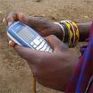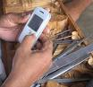

Overview

- Mobile technology provides a catalyst to reaching new areas in a cost effective manner
- Can be provided by either banks, mobile network operators (MNOs) or 3rd party service providers
- Some staggering statistics:

  - In 2001, just eight out of 100 people in the developing world had a mobile phone. Now, nearly 80 out of 100 do.
  - In India, more people have access to mobile phones than toilets, according to a 2010 report from the United Nations University.
  - 97 economies now have mobile phone penetration of over 100 per cent, with over 4 billion mobile subscriptions throughout the developing world.
  - Currently, 93 per cent of Kenyans are mobile phone users and 73 per cent are ‘mobile money’ customers. Additionally, 23 per cent of Kenyans use ‘mobile money’ facilities at least once a day.
  - More than a billion people in emerging and developing markets have cell phones but no bank accounts.
  - About 2.6 billion people in the world do not have access to formal financial services, and yet one billion of them have a mobile phone.

- ‘Mobile Wallets’ offered by MNOs and 3rd party service providers typically offer only product – mobile payments, while bank’s ‘Mobile Banking’ offerings mirror full service bank accounts with services such as deposit insurance protected and interest bearing savings accounts, loans, insurance, remittances and bill pay functionality.
- Mobile payments have been the most widely used product. For agriculture, this means purchase of inputs, or sale of harvests through mobile.
- Expanded services such as agri-lending through mobile is under pilot with a Mercy Corps program in Philippines, or crop insurance through mobile with Syngenta’s Kilimo Salama program in Kenya with MPesa.
- All services rely on well developed “rails” to succeed. The rails are mainly cash in/cash out points (called CICOs or Agents) and mobile network coverage.

Building & Promoting Successful Mobile Products

- Promoting the use of mobile for agriculture financial services does not necessarily depend on the farmers owning a mobile phone. The farmers can simply own a SIM card, which are usually free or a small fee, less than $1.
- The key to success is not always mobile penetration rates, but rather the presence of “pain points”. ie, unsafe or unsecure ways to transport cash, lack of cash in rural areas, high transportation costs to transact, lack of access to financial services, high incidence of crop failure, lack of information, etc.
- Success in promoting usage has been largely observed when sharing ‘channels’. ie working with agricultural service providers to share access to farmers.
- Account activation is, for the most part, much easier than promoting usage and uptake. The value proposition for the farmer must be strong. It must be timely & relevant.

Engaging Marginalized Groups

- The use of agents brings services much deeper in to rural areas than banks have been able to accomplish before.
- Marketing campaigns of MNOs & banks for base of the pyramid market segments are largely centered on mobile and financial literacy.
- Our experience shows that a customer must do 3 transactions before they are able to complete a successful transaction on their own.
- To encourage the agents to teach marginalized people to use the product, additional incentives are paid for the first three transactions, in addition to regular commission for account opening and each transaction.
- For illiterate people, cartoon-type illustrations are developed and used to train groups on how to utilize the menus.
- Remembering PINs and keeping them confidential remains one of the biggest hurdles in reaching marginalized people.

Evidence of Impact

- Still early days, and lots of challenges.
- In Zimbabwe, 20% of farmer income is lost through transaction fees due to lack of cash, high transportation costs, and poor market systems. Using mobile payments to post harvest sales, will reduce costs, and put the money in their hands sooner.
- In Philippines, a pilot is underway to offer agri-lending through mobile in combination with IRRI’s Nutrient Manager application. Bundling the ag services and financial services allows the bank to offer collateral free lending to small holder rice farmers.
- 20,000 farmers in Kenya have crop insurance due to mobile offering of Kilimo Salama.

Challenges

- TECHNOLOGY: Insufficient network coverage and power constraints, Lost SIMS, forgotten passwords, complex product
- CLIENT: Technology, digital and linguistic literacy issues; cost of air time; aging population of farmers, effects of climate change
- MARKET: Remote nature of market, constraints in market access, input access, poor infrastructure, lack of cash, overindebtedness; keeping clients active
- FINANCIAL SERVICES: appropriate products /pricing designed for farmers; low level of banked farmers; savings capacity, core credit risk issues
- TECHNICAL CAPACITY: challenges around scalable capacity building
- MOBILE ECOSYSTEM: Vendor and Cash in/Cash-out agent training and ongoing suppor
- NEW MODEL: New territory with lack of scalable, affordable, sustainable business models, weak business case/customer value for associated products, managing public-private programs/partnerships

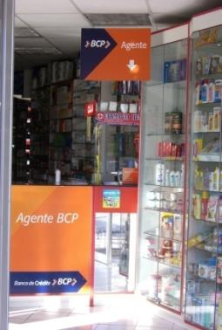

Figure 1: A typical agent in Latin America

Figure 2: Account opening paperwork

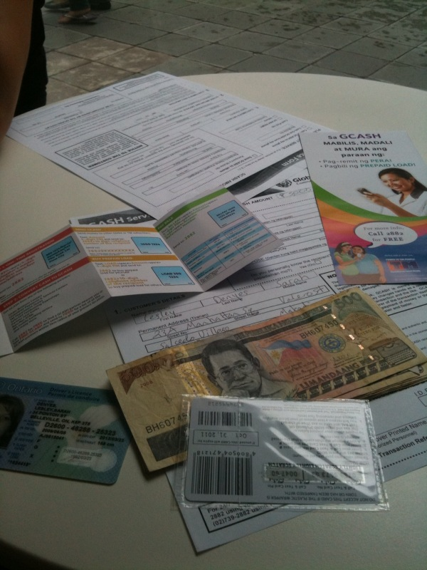

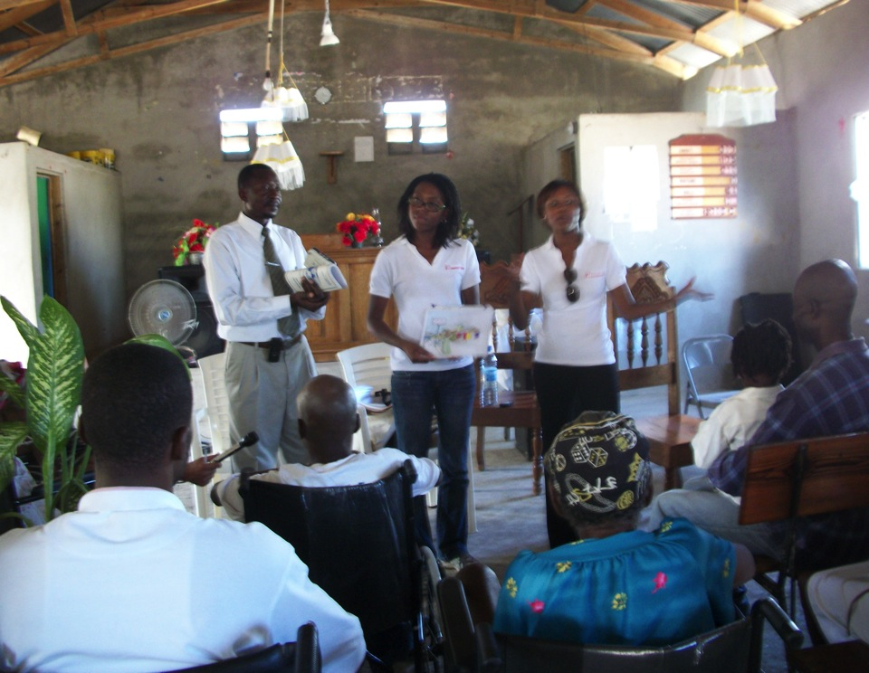
Figure 3: A beneficiary group receives training

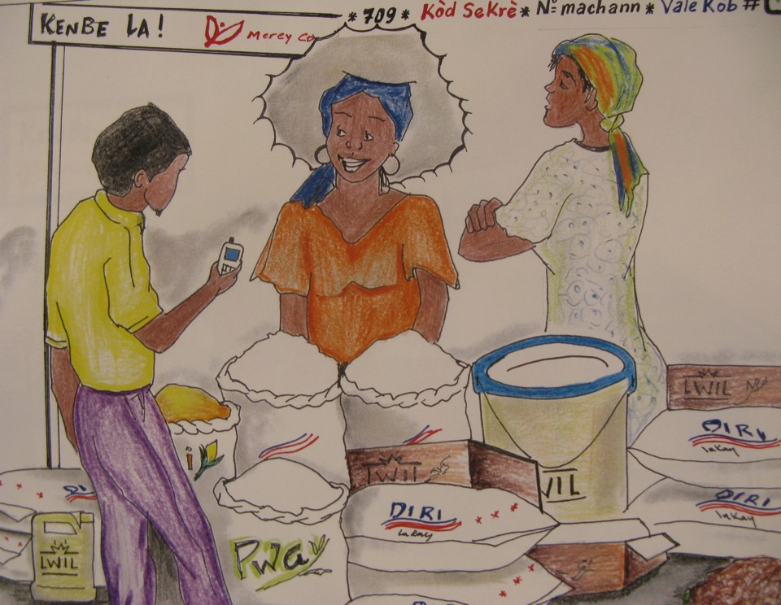
Figure 4: Sample cartoon training material

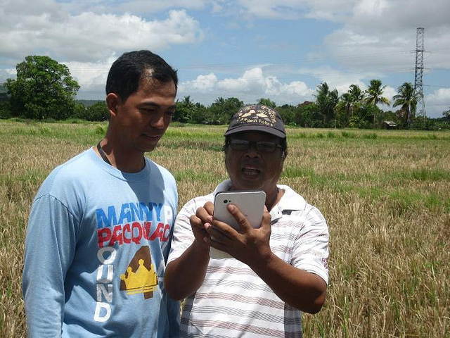
Figure 5: Farmer receives training on a tablet

