The physical inventory is a count of all commodities in the warehouse. The actual amount of commodity counted is the true balance. After commodities are counted and documented, count balances are reconciled with stock cards and warehouse ledgers.
If the physical inventory, stack cards, and ledgers do not reconcile, and there is no justifiable reason for discrepancies, the person who is responsible for the warehouse will be held liable for the value of any differences.
Recommended Procedures for Physical Inventory Count
- Staff not directly connected to the warehousing operation (e.g., project manager, Administration and Finance staff, staff from other projects or agencies) conduct an independent physical count of all commodities at least quarterly, usually in preparation for the quarterly commodity status report. Warehouse staff conduct periodic physical counts of all commodities as part of their commodity management responsibilities.
- To prevent possible diversion, conduct the physical inventory on the same day at all warehouses.
- To facilitate counting, ensure the sides of all stacks are flush (in other words, straight) and the tops are level. For any stack that is not uniform, remove sufficient units until the sides are flush and the top is level.
With the removed units, create a “partial” stack immediately adjacent to the flush and level stack.
- Close and lock all warehouses during the physical inventory.
- If stacks are not interlaced, or if the physical inventory is being conducted as part of a potential loss investigation, stacks must be dismantled and each unit counted. Otherwise, count the number of units in every interlaced stack as follows:
- Climb to the top to observe that the stack is whole and that no units have been taken from the center.
- Count the number of units in two completely interlaced layers-on the face of the stack. (Two completely interlaced layers have parallel sides.)  In the illustration to the right, there are three interlaced units in two layers. |  | 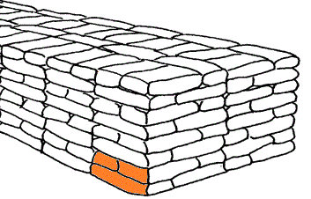
- Count the number of layers from the floor to the top of the stack.
There are eight layers illustrated here.
- Calculate the number of units in one “block” by multiplying the number of units on the face of two completely interlaced layers, times the number of layers.  In the illustration, one block has 3 x 8 = 24 units.  Note: If the number of layers is not even (divisible by 2), the number of units in a block must be calculated manually. |  | 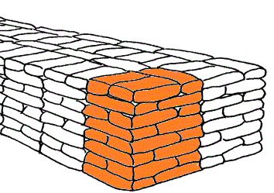
- Determine the number of complete blocks in the stack.
 | There are 16 complete blocks in the stack illustrated here.
- If there is a “partial” block, manually count the number of units in that block.
- Calculate the total number of units in the stack by multiplying the number of units in one block by the number of blocks; then add the total number of units in any “partial” block. The total number of units in the stack illustrated above is:
(24 units per complete block) X (16 blocks) + (0 units in partial block) = 384 units.
- Check the contents of all suspicious units.
- Verify the unit weight for a random sample of bags or containers.
- Record the number of units for each stack, as well as the balance stated on each respective stack card, on a Warehouse Physical Inventory Summary sheet (see template below). Complete separate sheets for each commodity and each shipment number.
Also note any observed problems with the physical condition of the stock (e.g., damaged or leaking containers, signs of infestation, or underweight units).
- Submit all signed and approved Warehouse Physical Inventory Summary sheets to the person designated to conduct reconciliations (usually within the unit that prepares the CSR).
- Ensure all signed and approved Warehouse Physical Inventory Summary sheets (and all supporting documents) are filed and readily accessible for inspection by monitors, auditors, or other persons carrying out warehouse inspections.
- Compare the result of the physical count with the related ledgers (as well as CSRs if appropriate). Reconcile every difference between the physical count and the ledger balance by examining the source documents (e.g., waybills and loss reports) and checking for transcription errors.
- If differences between physical count and ledger balances cannot be reconciled, prepare a loss report. An investigation into the difference may be undertaken. Only when the loss report is approved and returned to the warehouse can the difference (loss or excess) be recorded on the stack cards or in the inventory ledgers.

 | Date of Count: |  |  |  | Warehouse Name:
 | Commodity: |  |  |  | Shipment #: |  |  | Unit Size:
 | Stack Number | Stack Card Quantity |  | Physical Inventory Quantity |  | Difference Between Stack Card and Physical Inventory |  |  |  | Physical Condition
 | TOTAL:
Prepared by:
Signature: |  |  |  |  |  |  | Date:
Verified by:
Signature: |  |  |  |  |  |  | Date:
WH Manager:
Signature: |  |  |  |  |  |  | Date:

