Make Me a Change Agent:
An SBC Resource for WASH, Agriculture, and Livelihoods Activities

PRO-WASH and SCALE
PRO-WASH is an initiative funded by the U.S. Agency for International Development’s (USAID’s) Office of Food for Peace (FFP) and led by Save the Children. PRO-WASH aims to improve the quality of activities, strengthen the capacity and skills of FFP implementing partners in water, sanitation and hygiene (WASH) and improve WASH practices.
SCALE is an initiative funded by FFP to enhance the impact, sustainability, and scalability of FFP-funded agriculture, natural resource management, and off-farm livelihoods activities in emergency and development contexts. SCALE is implemented by Mercy Corps in collaboration with Save the Children.
Disclaimer
This guide is made possible by the generous support of the American people through the United States Agency for International Development (USAID). The contents are the responsibility of the SCALE and PRO-WASH Awards and do not necessarily reflect the views of USAID or the United States Government.
Recommended Citation
Love, A. & Weber, N. (eds.) (2020). Make Me a Change Agent: An SBC Resource for WASH, Agriculture, and Livelihoods Activities. Based on the Make Me a Change Agent resource published by The TOPS Program in 2015. Washington, DC: SCALE Award and PRO-WASH Award.
Cover Credits
Cover was designed by Sujen Buford of TM Design, Inc. Photo by Save the Children.
Illustration Credits
Illustrations were created by Sujen Buford of TM Design, Inc. and Regina Doyle. The Handout 2-3: Drawing a Bug to Practice Listening illustration is based on a similar drawing found in Building Dynamic Groups: Draw a Bug by The Ohio State University Extension.

Contents
Abbreviations and Acronyms vi
Acknowledgments vii
Introduction 1
Note to the Facilitator: Tips for Getting the Most out of the MMCA Guide 2
Lesson 1: Welcome and Introductions 3
Why This Lesson? 3
Advance Preparation 3
Tasks 4
Handout 1-1: Example of a Pre-Test/Post-Test for Make Me a Change Agent 7
Handout 1-2: Sample Training Agendas 9
Lesson 2: Behavior Change through Effective Communication 11
Why This Lesson? 11
Advance Preparation 11
Tasks 12
Handout 2-1: Good Communication 20
Handout 2-2: Listening Role Plays 21
Handout 2-3: Drawing a Bug to Practice Listening 23
Lesson 3: Communicating with Empathy and Respect 24
Why This Lesson? 24
Advance Preparation 24
Tasks 24
Handout 3-1: Four Skills for Improving Empathy 34
Handout 3-2: Showing Respect 35
Lesson 4: Behavior Change through Effective Facilitation 36
Why This Lesson? 36
Advance Preparation 36
Tasks 37
Handout 4-1: Building Blocks for Effective Facilitation 41
Handout 4-2: Adult Learning Principles 42
Handout 4-3: Example Participatory Activities 44
Lesson 5: Negotiated Behavior Change 46
Why This Lesson? 46
Advance Preparation 46
Tasks 47
Handout 5-1: Essential WASH Actions (with Associated Behaviors) 53
Handout 5-2: Example Agriculture Actions (with Associated Behaviors) 55
Handout 5-3: Advantages of Negotiation and Joint Decision-Making 56
Handout 5-4: Role-Play Dialogues 57
Handout 5-5: Illustrated Steps in the Process of Negotiated Behavior Change 66
Handout 5-6: Steps in the Process of Negotiated Behavior Change 68
Handout 5-7: Role-Play Scenarios 69
Handout 5-8: Quality Improvement and Verification Checklist: Home Visits/Negotiated Behavior Change 70
Lesson 6: Storytelling for Behavior Change 71
Why This Lesson? 71
Advance Preparation 71
Tasks 72
Handout 6-1: Closed-Ended Stories 82
Handout 6-2: Open-Ended Stories 84
Handout 6-3: Guidelines for Developing Behavior Change Stories 85
Handout 6-4: Testimonial 87
Handout 6-5: Instructions for Organizing a Guided Testimonial 88
Lesson 7: Learning through Cross-Site Visits 90
Why This Lesson? 90
Advance Preparation 90
Tasks 90
Handout 7-1: Story of a Cross-Site Visit 93
Handout 7-2: Checklist for Planning a Cross-Site Visit 94
Lesson 8: Action Planning 97
Why This Lesson? 97
Advance Preparation 97
Tasks 97
Handout 8-1: Action Planning Worksheet 100
Handout 8-2: Example Action Planning Worksheet 101
Lesson 9: Closing 102
Why This Lesson? 102
Advance Preparation 102
Tasks 102
Handout 9-1: Example Training Feedback Form 104
Advanced Lesson 10: Introduction to Social and Behavior Change 105
Why This Lesson? 105
Advance Preparation 105
Tasks 106
Handout 10-1: Scenarios A and B 121
Handout 10-2: Important Determinants That Influence Behavior 122
Handout 10-3: Additional Selected Behavior Change Theories and Models 124
Handout 10-4: Match the Activity to the Determinant 127
Handout 10-5: Answer Key for Match the Activity to the Determinant 128
Handout 10-6: Stages of Change Exercise 129
Advanced Lesson 11: Understanding Gender and Gender Bias 130
Why This Lesson? 130
Advance Preparation 130
Tasks 131
Handout 11-1: Men and Women and Social Norms 137
Handout 11-2: Photos of Men and Women 138
Advanced Lesson 12: Shared Household Roles and Responsibilities 139
Why This Lesson? 139
Advance Preparation 139
Tasks 139
Handout 12-1: Division of Household Roles and Responsibilities 145
Handout 12-2: Role Play 148
Handout 12-3: Role-Play Practice 149
Advanced Lesson 13: Planning to Facilitate and Train Others 151
Why This Lesson? 151
Advance Preparation 151
Tasks 151
Handout 13-1: Lesson Design 157
Handout 13-2: Template: Lesson Design 158
Handout 13-3: Sample Planning Checklist 159
Advanced Lesson 14A: Quality Improvement and Verification Checklists (QIVCs), Giving and Receiving Feedback 160
Why This Lesson? 160
Advance Preparation 160
Tasks 161
Handout 14A-1: Quality Improvement and Verification Checklist (QIVC) for BCAs’ Facilitation Skills 170
Handout 14A-2: Quality Improvement and Verification Checklist (QIVC) to Evaluate Positive Feedback 172
Handout 14A-3: Role Play Part 1: Education Session 174
Handout 14A-4: Role Play Part 2: Giving Feedback 176
Handout 14A-5: Steps for Giving Feedback to BCAs 177
Advanced Lesson 14B: Creating Quality Improvement and Verification Checklists (QIVCs) 178
Why This Lesson? 178
Advance Preparation 178
Tasks 178
Handout 14B-1: Tips for Developing QIVCs 181
Handout 14B-2: Template for Creating Your Own QIVC 182

Abbreviations and Acronyms
ABO achievement-based objectives
BCA Behavior Change Agent
CLTS community-led total sanitation
FFP Food for Peace (as in USAID’s Office of Food for Peace)
FSN Food Security and Nutrition (as in the FSN Network)
IYC infant and young child
LNRA Learning Needs & Resources Assessment
MMCA Make Me a Change Agent (this curriculum)
NBC Negotiated Behavior Change
NRM natural resource management
ORS oral rehydration solution
PRO-WASH Practices, Research and Operations in Water, Sanitation and Hygiene
QIVC Quality Improvement and Verification Checklist
SBC social and behavior change
SCALE Strengthening Capacity in Agriculture, Livelihoods and Environment
SDA small doable action
TOPS Technical and Operational Performance Support (as in The TOPS Program)
ToT training of trainers
VSLA Village Savings and Loan Association
WASH Water, Sanitation and Hygiene
USAID United States Agency for International Development

Acknowledgments
Make Me a Change Agent was developed thanks to the many individuals who contributed to this work by writing, reviewing, and formatting lessons, as well as participating in the field-testing.
This guide is heavily based on Make Me a Change Agent: A Multisectoral SBC Resource for Community Workers and Field Staff, which was produced in 2015. This adapted version would not have been possible without the original authors’ expertise, time, and effort to write, pilot, and refine the original guide. Special thanks go to Amelia Brandt, Anna Schurmann, Beth Outterson, Bonnie Kittle, Christy Gavitt, Donna Rzewnicki, Fe Garcia, Mary DeCoster, Jennifer Nielsen, Jennifer Weiss, Mesa Somer, Rachel Elrom, Tara Kovach, Terry Laura, and Tom Davis.
Additionally, we thank Aber Mary Fiona, Baby Muzi, Ephrem Kambale, Han Han, Md. Nasir Uddin, Md. Zahidul Islam, Meraz Rahman, Mersha Bogale, Moga Bedassa, and Samprita Chakma for co-facilitating with us while we piloted this version and providing invaluable feedback for improving the exercises, content, and structure of the lessons.
We also thank Andrea Danz, Andrea Mottram, Ashley Aakesson, Caitlyn Bradburn Charlie Davis, Kirk Dearden, Precious Sancho, Rebekah Pinto, Sarah Sahlaney, and Tanya Jackson for their expert reviews of the adapted guide. We thank Nikunja Nepal for providing the gender and social inclusion component of the guide, Michael Klitsch, Maja Persson, and Kim Jurczyk for copyediting and formatting, and Sujen Buford for designing many of the illustrations.
We express sincere gratitude to Bonnie Kittle and Mary DeCoster, who provided constructive reviews of the adapted content, shared excellent ideas and expert feedback, and were always available for a consultation and encouragement.
Finally, we are deeply grateful to all the Behavior Change Agents (community workers and field staff) who have contributed to the development of these materials through the various pilot trainings and who continue to use these skills and techniques to facilitate behavior change.

Abby Love & Nicole Weber

Introduction
This guide is heavily based on Make Me a Change Agent: A Multisectoral SBC Resource for Community Workers and Field Staff, which was produced in 2015. The Technical and Operational Performance Support (TOPS) Program, the Food Security and Nutrition (FSN) Network’s Social and Behavioral Change (SBC) Task Force, and the CORE Group SBC Working Group originally produced the guide. In 2019–2020, the USAID Office of Food for Peace (FFP)-funded Strengthening Capacity in Agriculture, Livelihoods and Environment (SCALE) and Practices, Research and Operations in Water, Sanitation and Hygiene (PRO-WASH) awards collaborated on revising the guide to be a training of trainers specifically for community-level workers focused on interventions related to water, sanitation and hygiene (WASH) and agriculture, and livelihoods. Subsequently, the guide was pilot-tested during trainings in the Democratic Republic of the Congo, Uganda, Bangladesh, and Ethiopia and was revised based on feedback from training participants, facilitators, and reviewers.
These lessons seek to build the skills of community-level workers in order for them to promote behavior change in their communities. Throughout this manual, the term “behavior change agent” (BCA) refers to the wide variety of roles held by workers who promote change. Facilitators may want to replace “BCA” with a title that is appropriate for their audience (such as agriculture extension agent, community health worker, hygiene promoter, etc.).
These lessons include necessary skills that can help a development worker in any sector become more effective as an agent of behavior change. While the lessons are relevant to all sectors, this manual is tailored to WASH, agriculture, NRM, and livelihoods staff. The lessons include examples, role-plays, stories, and behaviors/practices primarily from these sectors.
The Make Me a Change Agent (MMCA) lessons are designed to be conducted individually or as a cohesive curriculum. Most lessons range from a few hours to a half-day. Facilitators can select specific lessons to build certain skills or use the entire curriculum as a week-long training or as a continuing education course. The lessons are arranged in a suggested order, as some build on the skills developed during previous lessons.

Note to the Facilitator: Tips for Getting the Most out of the MMCA Guide
- Select what content is most relevant for your training participants. Each lesson has estimated times, and you can choose among these lessons to develop a training schedule that works best for the participants. You can also select specific subsections of lessons if you feel like these sections address the participants’ needs.
- Most lessons range in duration from a few hours to a half-day. The content can be delivered as a stand-alone training or lessons can be included in already-planned events, such as quarterly reviews, monthly meetings, volunteer trainings, etc. This can help participants develop these skill sets over time and can potentially save time and resources by incorporating the lessons into an event where staff will already be present.
- Some lessons classified here as “advanced” may or may not be advanced for your training participants, depending on their prior training and experience with the content. Take time to read the guide and determine what content best fits your audience. Additional SBC resources are available at www.fsnnetwork.org.
- Use the Word version of the MMCA guide to adapt and customize the training manual based on your context. You can also edit the examples and role-plays to reflect the context in which your participants work and live. Change the vocabulary to match the terms your project uses.
- Edit the pretest/post-test to include only the content that will be included in the training.
- Create an agenda based on the selected learning objectives and the time made available for the training.
- If you are conducting a multiday training, you do not need to start each lesson with the warm-up activity listed at the start of each lesson.
- If you are conducting the MMCA training through an interpreter, work with them to prepare for the training. Allow the interpreter time to look through the content prior to the training to identify appropriate translations for less common terms, such as empathy or testimonial.

Lesson 1: Welcome and Introductions
Achievement-Based Objectives
- By the end of this lesson, participants will have:
- Introduced themselves to the group
- Agreed upon training norms and learning expectations for the training
- Completed a pre-test (optional)
Duration
1 hour to 1 hour, 30 minutes
Materials
- Flip chart paper and markers, masking tape, blank paper (A4 size), note cards, sticky notes or small pieces of paper, colored stickers (optional)
- Name tags, notebooks, pens for participants
- Pre-written flip charts:
- Training Objectives
- Agenda
- Expectations (including results from the Learning Needs and Resources Assessment, if completed ahead of time)
- Parking Lot
- Common Training Norms
- Handout 1-1: Example of a Pre-Test/Post-Test for Make Me a Change Agent (one copy per participant)
- Handout 1-2: Sample Training Agendas

Why This Lesson?
At the start of any training, it is important to allow time for participants to become comfortable with each other and the facilitators. In addition, this lesson introduces the training content so that everyone understands why they are at the training and what to expect from it.

Advance Preparation
Prepare the following flip charts:
- Training Objectives (Task 3)
- Agenda (Task 4)
- Expectations (including results from the Learning Needs and Resources Assessment, if completed ahead of time) (Task 5)
- Parking Lot (Task 5)
- Common Training Norms (Task 6)
Prepare the pre-test. If it is appropriate to administer a written pre-test, you will want to adapt the questions on Handout 1-1: Example of a Pre-Test/Post-Test for Make Me a Change Agent to focus on the content that you are covering during the training. If you are giving a written pre-test, number or letter each participant guide starting at 1 or A; participants can then write this number or letter on their pre-test and post-test. However, a written pre-test is always optional; you may choose not to do one. For example, if you are using only one of the MMCA lessons to conduct a half-day or one-day training, you may not want to take the time to do a pre-test/post-test. You will also not want to do a written pre-test if the group is not comfortable reading and writing. In this case, you may want to pair people up to do the pre- and post-tests or use a group activity, such as a comfort table (See Advanced Lesson 13: Planning to Facilitate and Train Others for an example).
Prepare the agenda. Handout 1-2: Sample Training Agendas has some examples of agendas. An MMCA training can last anywhere from two hours to seven days, depending on the content you choose to cover. Adapt the agenda accordingly and write the agenda on flip chart paper, or provide printed copies for the participants.

Tasks
- Pre-test (20 minutes) (Optional)
  - Welcome participants to the training. Inform them that before starting the lessons, they will first take a pre-test. Explain that the pre-tests are anonymous and are used to help the facilitators refine the training content based on what participants already know, and to measure changes in knowledge before and after the training.
  - Pass out the pre-test. Let participants know that they do not have to write their name on the test. But, they need to write the same thing on the pre-test and post-test so the facilitators can match their papers. Ask participants to look inside the front cover of their participant guide and write the number or letter they see on their pre-test. If participants do not receive a copy of the guide, they should write on their pre-test their birth date, nickname, pet name, or favorite singer. Explain that they will use this same word or number on their post-test.
  - Ask participants to turn in their paper after they finish and to sit quietly until everyone is done. Allow enough time for everyone to finish.
  - Collect pre-tests and put them in a safe place for reference later.
- Getting to Know Each Other: Adjective Name Game (25 minutes)
  - Pass out nametags to participants. Ask them to write on their tags 1) their name and 2) what kind of behavior change maker they are (e.g., water, sanitation and hygiene [WASH], agriculture, gender). They may also add a colored sticker or marker dot on their nametag to represent which sector they are part of (e.g., blue = WASH, green = agriculture, yellow = health/nutrition). If you do not have nametags, you can use small sheets of paper and tape to make nametags.
Once everyone has made a nametag, have everyone stand up and form a circle for the Adjective Name Game. The game goes as follows:
- Person 1 says their name, organization, program, and what type of change maker they are. They then select an adjective that begins with the same letter as their name (e.g., Active Agnes).
- The next person in the circle, Person 2, must repeat the previous person’s name and adjective and then introduce themselves (e.g., Active Agnes, Funny Fatima).
- Person 3 must repeat the name and adjective of Person 1 and Person 2 and add their own information (e.g., Active Agnes, Funny Fatima, Neat Naasir).
- The participants continue introducing themselves in order around the circle until the last person has to repeat the names and adjectives of all participants and facilitators. (If the training group is larger, you can ask participants to repeat the last three names and adjectives rather than all the names).
  - At the conclusion of the activity, ask everyone to return to their seats.
- Objectives (5 minutes)
  - Introduce participants to the objectives of the training by pointing to the Training Objectives flip chart hanging on the wall. Ask a volunteer to read out one of the objectives. Do this until all the objectives have been read aloud. Ask the group if anyone has questions or concerns about the objectives.
  - The objectives may differ slightly based on whom you are training, what the technical focus is, or if there is a focus on a particular skill or lesson. Below are a few examples of objectives:
Sample Training Objectives
- To identify fundamental communication, negotiation, and facilitation skills of WASH, agriculture, natural resource management, and/or livelihoods field staff
- To practice communication, negotiation, and SBC techniques
- To plan how to use skills gained to influence change in your community
Sample Training Objectives (if conducting a training of trainers)
- To demonstrate to others how to facilitate a range of interactive behavior change methodologies and deliver the training to other team members, community members, and local partners
- To develop a personal or program-level action plan for transferring knowledge on negotiation, communication, and facilitation skills
- Agenda Overview (5 minutes)
  - Using the Agenda flip chart, give a brief overview of the plan for the training, explaining that some lessons or timing may change to meet the needs of the group.
  - Explain that the training manual has a variety of lessons that seek to build the skills of community-level workers so they can be more effective behavior change promoters in their communities. Note to participants that not all content in this guide will be covered in the training, but they may use the lessons in the future.
  - Explain that the facilitators will present and model adult learning techniques during the training. Participants will have opportunities to practice these adult education techniques. Allow time for participants to ask questions about the agenda.
- Setting Expectations for the Training (20 minutes)
  - Tell participants that they will now review the training expectations. If you have done a Learning Needs and Resources Assessment (LNRA) prior to the training, present a flip chart with the results, and ask participants if they have additional or different expectations.
  - If you have not done a LNRA, ask participants to pair up and take five minutes to discuss with their partner the following question: What are three things that you want to learn from this training?
  - After a few minutes, ask a volunteer to share their expectations for the training. Write these on a flip chart. Continue asking volunteers to add additional or different expectations they have for the training. Once participants begin repeating expectations or do not have anything new to add, review the list together with participants.
  - Ask participants to look at the workshop agenda and the objectives. Circle or highlight on the flip chart the learning expectations that may not be met, given the scope and objectives of the training.
  - Tell participants that these unmet expectations can be added to the “Parking Lot” flip chart for future discussion.
- Setting Training Norms (10 minutes)
  - Show the prepared flip chart with a list of common norms for training participation and ask participants if they agree with them. If someone does not agree with a norm, facilitate a discussion until there is consensus.
  - Ask participants if they would like to add any other norms. Continue adding norms to the flip chart until there are no additional suggestions. If any norms do not have a consensus within the group, facilitate a conversation as needed to bring the group to a consensus. Once the list is complete, ask if everyone agrees, and make sure there are no outstanding concerns.
Examples of Training Norms
- Be on time.
- Listen when other participants or facilitators are speaking.
- Actively participate in the training.
- Try something new.
- Ask questions if something is not clear.
- Take care of training room and training materials.
- Put computers away once an activity begins.
- Keep phones on silent.
- Step outside the room to take a phone call.
- Take advantage of the breaks to avoid exiting and entering the training room during lessons.
  - Hang this flip chart somewhere in the room where it will be visible throughout the training. Reference it as needed to remind participants of the norms.

Handout 1-1: Example of a Pre-Test/Post-Test for Make Me a Change Agent
Name, Number, or Symbol Pre-Test or Post-Test (circle one)
- Which is not a closed-ended question?
  - You understood everything, right?
  - What are some questions you have on the training materials?
  - Are you satisfied with the training?
  - Did you enjoy the food at the training?
- Which of the following is not a characteristic of a testimony?
  - A testimony is a closed-ended story.
  - A testimony is a true account.
  - A testimony is told by someone who did not experience the behavior themselves.
  - A testimony shames someone into changing their behavior.
- Which of the following is an example of an individual barrier to behavior change?
  - I do not know how to make biopesticides.
  - My mother-in-law says that the children are happier since they started drinking from the protected water source.
  - I know how to make menstrual hygiene pads.
  - I can buy quality seed varieties at the local market.
- A Learning Needs & Resources Assessment (LNRA) can identify all of the following except:
  - Who is a good listener.
  - Why the training is needed.
  - What participants want to learn.
  - What prior experience the participants have with the subject.
- What is the focus of social and behavior change (SBC)?
  - Convincing individuals, households, and communities to adopt new behaviors by telling them that it is good for their health.
  - Telling individuals to adopt new behaviors and hoping they do so.
  - Enabling individuals, households, and communities to adopt and sustain positive behaviors by identifying factors that influence behavior.
  - None of the above.
- Empathy is:
  - Feeling sorry for someone who has lost something.
  - A listening technique.
  - Understanding the perspectives, emotions, and feelings of another person.
  - None of the above.
- When would it be appropriate to use the “listen and rephrase” technique?
  - When you are trying to reinforce a key message.
  - When you are trying to understand someone’s perspective on an issue.
  - When you want the person to know that you understood what he/she said.
  - All of the above.
- Which of the following is NOT one of the steps in Negotiated Behavior Change?
  - Greet the person.
  - Shame the person for not practicing the behavior.
  - Listen to/reflect on what the person says.
  - Make an appointment for a follow-up visit.
- Quality Improvement and Verification Checklists (QIVCs) can be used to:
  - Provide encouragement.
  - Provide motivation.
  - Improve performance.
  - All of the above.
- Small doable actions are:
  - Behaviors that are considered feasible by the individual who is going to practice them.
  - Tasks that can be completed in one day.
  - Tasks that are assigned to people at the end of the meeting.
  - The ideal behaviors.

Handout 1-2: Sample Training Agendas
Example of a half-day training agenda on Lesson 2: Behavior Change through Effective Communication
Time | Activity
9:00–10:00 | Welcome and Introductions (arrival, check-in, introductions, agenda review, setting of norms/expectations, warm-up activity)
10:00–11:30 | Definition of Good Communication , Listening Skills and Practice Listening
11:30–11:45 | Break
11:45–12:45 | Open-Ended and Closed-Ended Questions
12:45–1:15 | Effective Communication Wrap-up , Next Steps and Closing
1:15-2:00 | Lunch
Example of a two-day training on Lesson 2: Behavior Change through Effective Communication, Lesson 3 Behavior Change through Empathy, and Lesson 4: Behavior Change through Effective Facilitation
Time | Activity
Day 1
8:30–10:00 | Welcome and Introductions (arrival, check-in, introductions, agenda review, setting of norms/expectations, warm-up activity, pre-test [optional])
10:00–11:30 | Good Communication and Empathy
11:30–11:45 | Break
11:45–12:30 | Ability to Read Emotions and Appropriately Expressing Emotion
12:30–1:30 | Accepting Differences and Showing Respect
1:30–2:30 | Lunch
2:30–3:15 | Listening Skills and Practicing Listening
3:15–3:30 | Break
3:30–4:15 | Open-Ended and Closed-Ended Questions
4:15–4:30 | Review and Closing for Day 1
Day 2
9:00–9:30 | Recap of Day 1
9:30–10:15 | Lesson 5 Facilitation Warm-Up
10:15–10:30 | Break
10:30–11:00 | Adult Learning Principles and Effective Facilitation
11:00–11:45 | Participatory Activities
11:45–12:00 | Facilitation Self-Assessment
12:00–1:30 | Practicing Facilitation Skills
1:30–2:30 | Lunch
2:30–3:30 | Practicing Facilitation Skills (continued)
3:30–3:45 | Break
3:35–4:00 | Effective Facilitation Wrap-Up
4:00–4:30 | Review and Closing (post-test [optional], certificates, closing circle, group photo)
Each training can be customized based on the audience and the training objectives. An advanced lesson includes Advanced Lesson 13: Planning to Facilitate and Train Others. This is an important lesson if you are conducting a training of trainers.

Lesson 2: Behavior Change through Effective Communication
Achievement-Based Objectives
By the end of this lesson, participants will have:
- Described why a Behavior Change Agent (BCA) needs good communication skills
- Defined good communication
- Practiced three types of listening, including rephrasing
- Given examples of open-ended and closed-ended questions
Duration
2 hours, 50 minutes to 3 hours
Materials
- Flip chart paper and markers, masking tape, blank paper (A4 size), note cards or small pieces of paper, sticky notes, and pencils with erasers (one for each participant)
- Prewritten flip charts:
- Name one communication skill that you feel you do well (optional)
- Name one communication skill that you feel you could improve (optional)
- A drawing of the Listening Bug
- Handout 2-1: Good Communication (one copy per participant)
- Handout 2-2: Listening Role Plays (six copies)
- Handout 2-3: Drawing a Bug to Practice Listening (one large copy or drawing to show participants at the end of the exercise)

Why This Lesson?
Effective communication is one of the most important skills Behavior Change Agents (BCAs) need, but much of their training is on technical content. This lesson will help BCAs improve their communication skills so they can be more effective at facilitating behavior change.

Advance Preparation
If you are doing warm-up activity option A, prepare flip charts as follows:
- Name one communication skill that you feel you do well (Task 1)
- Name one communication skill that you feel you could improve (Task 1)
- A drawing of the Listening Bug (Task 5)
If you are not doing warm-up activity option A, prepare only the last flip chart (to be used in Task 5).
For the Listening Bug drawing, if participants receive a copy of this facilitator manual as part of the training, you will want to change the bug drawing and instructions so they differ from what is in this guide, as they will have already seen the image.
For Task 4, review the three role plays in Handout 2-2: Listening Role Plays. If appropriate, adapt the role plays to fit the topics or issues covered by the participants’ program. Select two participants and give them copies of the role plays in advance so they can practice. Work with the participants so they understand the advantages and limitations of each type of listening. Alternatively, you may want to do the role play directly with a co-facilitator, to ensure that the three types of listening are correctly demonstrated.
For Task 5k, prepare a list of mildly controversial topics that every participant will have an opinion on (for example, men are stronger than women, women are less corrupt then men, behavior change interventions are more important than construction interventions for water sanitation and hygiene [WASH], etc.).

Tasks
- Warm-Up Activity: Option A (15 minutes)
Separate the participants into pairs. Explain that the partners will interview each other using the following prompts and write each answer on a sticky note:
- Name one communication skill that you feel you do well.
- Name one communication skill that you feel you could improve.
- While participants are talking, hang the two flip charts with these questions on the wall.
  - Allow participants about five minutes to talk together, and then ask each person to attach their sticky notes to the appropriate flip charts.
  - When everyone has done so, read the communication skills aloud and ask people what their strengths are or where they can improve.
Note that these lists show the participants are already very familiar with “good communication.” Point out that some people’s strengths are what others would like to improve.
- Facilitate a brief discussion using the following questions: For the skill that you do well, is this a skill that you have always had? If not, how did you gain or improve this skill?
- Which of these skills do you think you could continue to improve?
  - Note that, during this lesson, participants will have an opportunity to learn from the activities and also from each other. Encourage participants to use their best communication skills during the training and to try to learn new skills from other participants.
- Warm-Up Activity: Option B (25 minutes)
  - Tell participants that they will play a game called “telephone,” in two ways. The first time, they will communicate by speaking. Then they will communicate using only nonverbal expressions and body movement.
  - Ask participants to line up next to each other. Whisper a phrase to the first participant in the row. The sentence can be about anything silly or serious, but everyone needs to be able to understand it (for example, “Benson bought four baby goats by the bustling market”). You can also write it on a piece of paper and hand it to the first participant. The first participant will then whisper the phrase to the participant beside them, and so on, until the phrase reaches the last participant. Tell participants that they can only say the phrase once to the next person in line. The last participant will then say the sentence aloud and see if it matches the original.
  - This game can be played a few rounds; if time permits, a new participant may choose the phrase and switch places in line between rounds.
  - Next, tell participants that they will play a similar game but instead of passing a verbal phrase down the line, they will pass nonverbal expressions and body movements.
  - Have participants line up so that they are all facing in one way. Tap the participant at the back of the line on the shoulder. When they turn around, perform a movement (such as waving your arms above your head) or a simple dance move without sound (such as arms to the left, then to the right), along with a facial expression (big smile, frown, silent laugh). That participant will then turn and tap the person in front of them on the shoulder and do their best to imitate the same movement and facial expression. Remind participants not to turn around until they are tapped on the shoulder. Continue until the last participant in the line sees the movement, and then have them demonstrate what they saw to the group.
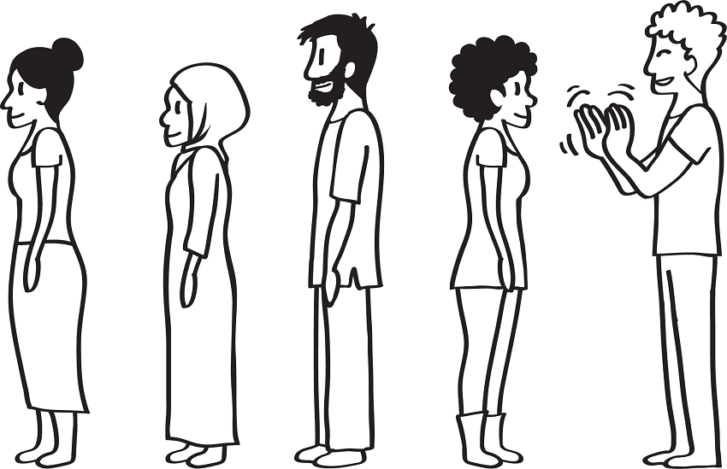
  - Play the silent version for a few rounds; if time permits, let a new participant pick the movement and switch places in line between rounds.
After about 15 minutes, facilitate a brief discussion using the following questions:
- What did you learn about communication by playing this game?
- How was the second exercise different from the first?
- How did you make sure that your message was understood? How did that change from the first exercise to the second?
- How might this lesson apply to your work as a BCA?
- Why are verbal and nonverbal expression important for a BCA?
- Good Communication (15 minutes)
  - If you started with the Option A warm-up activity, ask participants to imagine that the list from this activity is a description of good communication. Ask them if anything is missing. Ask them to think about the type of communication skills needed by a BCA: What else can be added to the list? If you started with the Option B warm-up activity, ask participants to think about the types of communication skills that a BCA needs. Take notes on a flip chart as participants call out answers.
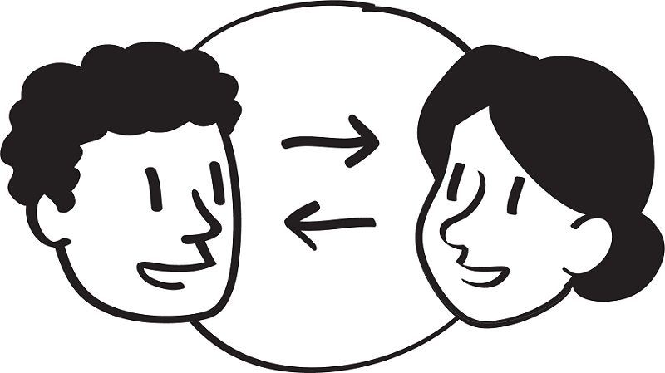
  - Explain that good communication is when one person sends a message and that message is received/understood by another person. Good communication also happens when both parties feel that they have been understood. Ask participants if they would change that definition in any way.
Ask participants to look at Handout 2-1: Good Communication. Continue with a discussion based on the following questions (encourage participants to add items from the flip charts to their handout):
- What differences can you see between the list of skills in this handout and the list on the flip chart?
- Why is it important for BCAs to learn and practice communication skills?
Listen to the group’s responses and add any of the following points if they are not mentioned:
- Good communication builds trust.
- Good communication makes people feel respected and, as a result, more likely to listen to and learn from you.
- Good communication helps ensure that people understand what you are saying.
- Good communication, encouragement, and support build people’s confidence to try new behaviors and skills.
  - Summarize by explaining to participants that communicating well (by listening, showing respect, and being supportive) will help them understand people on a more personal level. As a result, they will better appreciate the difficulties people face in trying new behaviors or practices and will help them find ways to overcome those difficulties. This approach is much more effective and respectful than insisting on behaviors that may be unrealistic. Ultimately, establishing relationships with people makes it more likely that they will adopt and maintain new behaviors and practices.
- Listening Skills (30 minutes)
  - Tell participants that part of being a good communicator is being a good listener. This activity will focus on their listening skills.
Ask the group the following questions and encourage a brief discussion. Potential answers are in italics below each question.
- What is the difference between “hearing” and “listening”?
  - Hearing is involuntary, while listening is voluntary.
  - We always hear things around us, but we do not always pay attention to what we are hearing.
  - Hearing something does not mean that you understand it. When we listen, we are trying to understand.
  - Hearing does not require any effort, while listening well requires effort.
- What do you think you must do in order to listen well?
  - Pay attention to what the other person is saying.
  - Avoid becoming distracted or thinking about other things while the other person is talking.
  - Show that you are listening by looking at the other person, responding to what the person is saying, or asking questions.
  - Avoid thinking so much about your response that you do not truly hear or understand what the other person is saying.
- If you are not paying attention or if you are thinking about how you will respond while the other person is talking, how might this affect communication?
  - You may not understand the person’s specific situation.
  - You might not fully understand what is being said.
  - You might interrupt or frustrate the person.
  - The person may feel that you are not listening to them and will stop sharing information.
- Why is it important for BCAs to listen well when they communicate with families or other community members?
  - BCAs must communicate to help people overcome barriers that prevent them from learning, getting services, and trying new behaviors.
  - BCAs must listen well to be able to understand other people’s problems from their perspective and learn about other people’s realities.
  - Listening is an important part of empathy. You need to understand what someone is saying if you want to understand their perspective.
  - Tell participants that they will watch three role plays demonstrating three different listening techniques, all of which are important to BCAs. Do not tell the group what technique each role play will demonstrate. Explain that during each role play, the listener will demonstrate one listening technique. Remind them to focus on what the listener is doing rather than on what they are not doing.
  - Post three blank pieces of flip chart paper on the wall. Invite the participants whom you selected as role-play actors to come to the front of the room and perform the role plays in Handout 2-2: Listening Role Plays. Limit each role play to a few minutes.
  - After the first role play, ask participants: “What did the listener do during the role play?” Write their responses on the first blank flip chart sheet that you posted, leaving a blank space at the top of the sheet. Remind participants to focus on what the listener was doing rather than on what they were not doing (for example, the listener used eye contact, to encourage the person to continue speaking).
  - Repeat this process with the remaining two role plays.
After all three role plays have been discussed, review each resulting flip chart and write one of the following listening techniques at the top of each sheet:
- Listening without responding
- Asking clarifying questions
- Listening and rephrasing
Ask the following questions, and encourage a brief discussion:
- When would it be most effective to use the “listening without responding” technique? (Answers may include: When someone is very upset or emotional, when someone does not need prompting to continue speaking, and/or when you understand what the person is saying.)
  - Add that, when using this technique, the listener uses only nonverbal communication (making eye contact, nodding the head, assuming an open posture [i.e., positioning their body with the torso leaning toward the speaker], and giving brief verbal responses [“uh huh,” “yes,” “hmm”] to show interest and to encourage the speaker to continue). The listener avoids gestures that communicate boredom or impatience, such as checking their watch or drumming their fingers. This technique encourages the person to speak freely and to express their ideas.
- When would it be most effective to use the “asking clarifying questions” method? (Answers may include: When you are trying to learn something, when you are not sure you have understood everything, when you need more information, and/or when you are trying to help a person to brainstorm solutions to a problem.)
  - Add that when using this technique, the listener asks specific questions to clarify what the speaker is saying. This technique helps the listener gain more information to better understand the speaker. It helps the speaker think more critically about the situation. This technique can help the speaker and listener evaluate alternatives and possible solutions.
- When would it be most effective to use the “listening and rephrasing” technique? (Answers may include: When you are trying to understand someone’s perspective on an issue, when you want the person to know that you understood what they have said, and/or when you want to reinforce a key message.)
  - Add that when using this technique, the listener restates in their own words what the speaker has said. The listener can start rephrasing with statements such as “it seems like you are saying…,” “what I hear you saying is…,” or “so if I understand you correctly...” This technique helps the listener ensure that they understood what the speaker said. It also allows the speaker to clarify anything that the listener did not understand, because they can hear ideas repeated back in summary form. The listener allows the speaker time to correct their understanding if it is incorrect. When using this technique, the listener does not need to repeat word-for-word what the speaker said. They can summarize, so long as they accurately rephrase what the speaker said.
  - Tell participants that while each of these listening techniques may work best at different times, good listeners often switch among all three within one conversation. All three listening techniques are important for a BCA to learn and practice.
- Practice Listening (45 minutes)
  - Tell participants that they are now going to practice their listening skills.
  - Distribute a blank piece of A4 paper and a pencil with an eraser to each participant.
  - Explain to the participants that their task is to listen to the instructions and draw what they hear on the blank piece of paper. They will only listen and draw; they may not ask questions or make comments, and they may not look at anyone else’s drawing.
  - Give participants verbal instructions for drawing the image in Handout 2-3: Drawing a Bug to Practice Listening, line by line (see below). Give detailed instructions so that participants will be able to reproduce the drawing as closely as possible (but do not show them the image). Provide each instruction once only. Do not let participants ask questions or make comments, do not show the image to participants, and do not let participants look at each other’s’ drawings.
Instructions on Drawing the Bug
- The bug is round.
- The bug has eight legs, grouped in pairs, with four legs on the left and four legs on the right. In the pairs, one leg is longer than the other.
- The bug has two eyes on top of the body.
- The bug has two squiggly antennas.
- The bug has two pea-pod–shaped wings.
- The bug has a spot next to each wing.
- The bug has a triangular stinger on the bottom of its body.
- The bug has two feelers on each foot (one longer than the other), both coming from the same side of the leg.
- The bug has a round mouth between its two eyes.
- The bug laid five square eggs to the left of the stinger.
After giving instructions for the drawing, do not show participants the original drawing. Lead a brief discussion by asking:
- How close do you think your drawings are to the original drawing?
- How did you feel not being able to see the original drawing or ask any questions?
  - Invite the participants to ask a few questions to clarify the drawing instructions and to make changes to their drawing, if necessary. Spend about five minutes doing this.
  - When participants have finished improving their drawings, show them the large drawing you prepared. Ask participants to hold up their drawings so everyone can see them. If it is culturally appropriate, you can have people vote on the drawing that most closely matches the actual bug drawing.
Ask participants the following questions, and encourage a brief discussion:
- For people whose drawings were the most similar to the original, how did you do this?
- For everyone else, what helped you the most as you were drawing?
- What was frustrating or unhelpful as you were drawing?
- How did it help to be able to ask clarifying questions?
- What did you learn from this exercise?
  - Tell participants that they have just practiced “asking clarifying questions.” Asking questions for clarification often helps you better understand what someone is saying. Knowing when to pose questions and which questions to ask are also important skills.
  - Tell participants that they will now practice “listening and rephrasing.” Explain that rephrasing is when we repeat in our own words what the other person has said as correctly as possible.
  - Divide the group in half, and ask each group to stand in a circle, so that all group members are able to see and hear each other easily. Explain that both small groups will discuss an assigned topic at the same time. Select one of the mildly controversial topics that you prepared ahead of time. Consider asking some people to take a position opposite to their true opinion, to assure a lively discussion.
  - In each circle, have one person start the discussion by expressing an idea or opinion about the topic. Explain that before a second person can respond or contribute their own idea, they must rephrase what the first person said. Remind participants to avoid simply repeating what the first person said. Rather, they should restate the ideas expressed by the previous person using different words. Encourage participants to start with phrases such as “What I hear you saying is…” or “If I understood you correctly...” The first person must agree that their idea has been rephrased correctly before the second person can contribute their own ideas. If the first person’s ideas were not correctly rephrased, ask the second person to try again. Then a third person rephrases the second person’s idea, then adds their own idea. Continue the discussion in this way until everyone has participated in the discussion or until time is up.
Facilitate a discussion using the following questions:
- What about this activity was challenging for you as the listener?
(Answers may include: I was thinking about my own opinion and not able to listen carefully to the person before me. Once multiple opinions had been shared, I wanted to bring those into my argument as well.)
- What about this activity was challenging for you as the speaker?
(Answers may include: My ideas were not rephrased correctly.)
- How could you use this technique as a BCA?
(Answers may include: To make sure I understood what someone is telling me. To stay focused on what they are telling me. To listen and be open to changing my mind.)
  - Conclude the exercise by bringing everyone back together and telling participants that they have just practiced “listening and rephrasing.” This technique can help ensure that the listener has understood correctly, and it helps the speaker feel heard and understood. Explain that it can be especially helpful when dealing with difficult/controversial topics, settling disputes, or building trust and mutual respect. Thank everyone for participating and sharing their opinions.
- Open-Ended and Closed-Ended Questions (1 hour)
  - Tell participants that in addition to actively listening to others, it is also important for BCAs to ask questions. BCAs who ask questions in a respectful way encourage people to talk with them and share more information.
We commonly use two types of questions: open-ended and closed-ended. Ask participants if they know the difference between these types of questions. Explain that closed-ended questions can usually be answered “yes” or “no,” while open-ended questions are broader and can be answered with original/unique responses from the participants. For example:
- “Do you think you should use organic pesticides?” (closed-ended) versus “What do you think are the benefits of organic pesticides?” (open-ended)
- “Do you think handwashing with soap is a good idea?” (closed-ended) versus “What do you think are some of the advantages of handwashing with soap?” (open-ended)
  - Add further details about open-ended and closed-ended questions, such as:
Question Type | Definition | Benefits/When to Use
Closed-Ended | Questions that can be answered by a “yes” or “no” answer or are limited to a short list of answers  Usually start with “are you…?” or “do/did you…? | Easier and quicker for participants to answer  Good for quantitative data collection  Good for when you want to compare information from different people  Useful when you need very specific information from participants or have a selected number of things from which participants can choose an answer
Open-Ended | Questions that are broad and can be answered with original/unique responses from the participants  Usually start with “how,” “what,” when,” or “where” | Allows the respondent to form a response on their own, which is usually fuller and tells more about the respondent’s opinions  Useful if you want to start a discussion or need more information
  - Tell participants that they are going to practice creating open-ended and closed-ended questions. Pass out a note card or small piece of paper to each participant. Ask participants to write one closed-ended question on their card. Collect the cards and redistribute them. Ask each participant to rephrase the closed-ended question on their card into an open-ended question and write the open-ended question on the other side of the card. When everyone has finished, go around the room and ask a few or all participants to read the closed-ended question and the way they rephrased it. Check that they understand. Example closed-ended questions and their rephrased counterparts are listed in the table below:
Example Closed-Ended Questions | Rephrased Open-Ended Questions
Does your family drink river water? | Where are some places you can get water for your family?
Do you defecate in a latrine? | When you have to defecate, where do you go?
Do you know how to prevent diarrhea? | How can you prevent diarrhea?
Are you using organic fertilizers? | What do you use to fertilize the farm?
Did you regularly check for pests on your farm last season? | How did you monitor pests on your farm last season?
Do you know about Village Savings and Loan Associations? | What have you heard about Village Savings and Loan Associations?
Do you regularly weed your field? | How do you manage weeds on your field?
  - Tell participants that they will now play a game using closed-ended and open-ended questions. Ask the group to stand in a circle, and give each person a notecard and a piece of tape. Explain that each participant is to write the name of an animal, household item, crop type, or famous person (if this is appropriate) on their card (for example, sheep, cat, stove, rock, maize, drum, tube well). Next, they are to tape the card to the back of the person in front of them, so that the receiver of the card does not know what it says. The goal of the game is for each person to ask questions that will help them identify what is written on their card. Encourage participants to be creative in what they write, but to avoid making the word impossible for someone else to guess.
  - For Round 1, have everyone walk around the room and ask only yes or no (closed-ended) questions to try to figure out what is written on their backs (for example, “do I eat grass?”). Explain that each person can ask a maximum of 10 yes or no questions in this round. Encourage people to move around and engage with different people. After about 10 minutes, or when everyone has asked 10 yes or no questions, ask how many people were able to identify the word on their card.
  - For Round 2, have those who still have not identified their word walk around and ask open-ended and/or closed-ended questions (for example, “how big am I compared with a cat?”). Participants who guessed their objects in Round 1 can still participate by answering questions. Each person can ask a maximum of 10 questions in this round. After about 10 minutes, or when everyone has asked 10 questions, ask how many people were able to identify their object in this round. Thank everyone for participating, and invite them to return to their seats.
Facilitate a discussion using the following:
- What kind of information did you get from each person during Round 1?
(Answers may include: The person answered “yes” or “no” only, so I got limited information.)
- What kind of information did you get from other people during Round 2?
(Answers may include: I received more detailed information.)
- When is it useful for BCAs to use closed-ended questions?
(Answers may include: When they need specific answers. For example, during a survey. When they want to know if people are or are not using a certain practice, so they can follow up with more detailed open-ended questions.)
- When is it useful for BCAs to use open-ended questions?
(Answers may include: When they want people to elaborate and provide more details on their practices, when they want to find out how much people have learned, and/or when they want to know people’s feelings or attitudes toward a behavior or practice.)
- Wrap-Up (5 minutes)
  - Wrap up this lesson by asking participants which of these skills they plan to practice during the next month and how they think those skills might impact their work.

Handout 2-1: Good Communication
Which communication skills does a BCA need?
- Show respect for people in the following ways:
  - Be culturally sensitive in how you communicate with people, particularly in relation to age and gender.
  - Listen actively to what people tell you, and show that you understand.
  - Acknowledge people’s ideas/realities, and shape your communication based on this information.
  - Do not scold or lecture people.
- Explain things clearly.
- Ask questions to:
  - Get to know people.
  - Learn about people’s experiences/opinions.
  - Ensure that people understand.
  - Promote dialogue.
- Observe people’s expressions and body language to see how well you are communicating.
- Be honest about what you do and do not know.
- Model the ideal or desired behavior or practice. For example, if you are promoting using biopesticides, you should use biopesticides. If you are promoting handwashing with soap before eating, make sure that you wash your hands with soap before eating. By modeling these behaviors and practices, you can build trust.
  - If you do not yet practice the behavior, demonstrate that you are taking steps to adopt it, and share what the process is like, to encourage others to adopt the behavior.

Handout 2-2: Listening Role Plays
Role Play 1: Listen without Responding
Instructions: Have the two actors sit facing each other. Limit the role-play to 1–2 minutes.
Speaker: Tell the listener about someone you know who was sick, and what happened to them.
Listener: While the speaker is talking, just listen. Do not respond or ask questions, but (if culturally appropriate) maintain eye contact with the speaker in a friendly way. Nod and say things like “uh-huh,” “hmm,” and “yes” (sounds of encouragement), when appropriate.

Role Play 2: Ask Clarifying Questions
Instructions: Have the two actors sit beside each other, close together, but not necessarily face to face. Imagine that the listener is a BCA who has just met a contact in a new community. Limit the role-play to 1–2 minutes.
Speaker (community member): We had agriculture extension agents do demonstration plots here in the past.
Listener (BCA): Who did they work with?
Speaker: Mostly with the school, I think.
Listener: How did it go?
Speaker: Okay. I think the children enjoyed it.
Listener: That’s great. How did the children show they enjoyed it?
Speaker: They had some fruit trees on the plots at the school and learned how to make fruit desserts out of them.
Listener: That sounds like fun. What did the community think of the project?
Speaker: They thought it was nice that someone wanted to work with the school.
Listener: Did any of the community members try what the children were doing on their own fields?
Speaker: Yes, a few community members planted the same types of fruit trees on their fields.
Listener: Who could I talk with at the school if we wanted to do another demonstration at the school or with other people in the community?
Speaker: You could talk with the teacher on Monday or come to the village council meeting next month.
Listener: Okay, great!

Role Play 3: Listen and Rephrase
Instructions: Have the two actors sit beside each other, close together, but not necessarily face to face. The speaker will explain their opinion. The listener will respond by summarizing and restating the speaker’s ideas. Ask the actors to closely follow this script or create something similar. Limit the role-play to 1–2 minutes.
Speaker: I can’t believe what happened today during the community meeting. We were supposed to meet today for a hygiene session at 8:30 a.m., but the hygiene promoter didn’t show up until 10 a.m. It was ridiculous! I have other things to do than wait around for a hygiene promoter.
Listener: It sounds like you had a rough day. What I’m hearing is that you were annoyed that the promoter showed up late, and you could have been doing other things.
Speaker: Yes. Several other women came as well, and there was no hygiene promoter in sight! He didn’t even text us. Finally, around 10 a.m., we got news that the hygiene promoter’s vehicle had gotten stuck in the mud and that he wasn’t able to make it. What a waste of time.
Listener: I understand, you were frustrated because you and other women had to wait a long time. And you didn’t appreciate being made to wait without a text or call, right?
Speaker: That’s right. Now I won’t want to go to the next meeting. What if this happens again? If only they had notified us.
Listener: What I’m hearing is that you wish someone had notified all the women coming for the meeting so you would know not to wait, and that it’s worrisome that this might happen again.
Speaker: That’s right.

Handout 2-3: Drawing a Bug to Practice Listening

Lesson 3: Communicating with Empathy and Respect
Achievement-Based Objectives
By the end of this lesson, participants will have:
- Defined empathy and respect
- Shared an experience of showing or feeling empathy
- Shared an example of a work situation in which empathy was/could have been used
- Practiced naming emotions
Duration
3 hours, 30 minutes
Materials
- Flip chart paper and markers, masking tape, blank paper (A4 size), note cards or small pieces of paper, sticky notes, and pencils with erasers (one for each participant)
- Prewritten flip chart: Definition of Empathy
- Projector (optional) for the empathy video
- Handout 3-1: Four Skills for Improving Empathy (one copy per participant)
- Handout 3-2: Showing Respect (one copy per participant)

Why This Lesson?
Empathy has been found to facilitate behavior change. Developing empathy and showing respect improve a Behavior Change Agent’s (BCA’s) relationship with others and enhances the BCA’s ability to help people address barriers to behavior change.

Advance Preparation
Prepare a flip chart with the Definition of Empathy (Task 2). If you are planning to use the video in Task 3, prepare the projector and video on Empathy: The Human Connection to Patient Care (https://www.youtube.com/watch?v=cDDWvj_q-o8).
For Task 6, write on slips of paper different types of emotions, such as excitement, anger, disgust, happiness, confusion, fear, satisfaction, stress, or embarrassment. Prepare approximately as many slips of paper as there are participants.
For Task 9, make signs reading “Strongly Agree” and “Strongly Disagree.” Prepare a space in the training room where participants can stand in a line or a U-shape.

Tasks
- Warm-Up Activity (15 minutes)
  - Ask participants to form groups of three people who do not know each other well. Explain that they will have about five minutes to talk and discover two interesting things that they all have in common and one thing that is different/unique to each person in the small group. Once they have learned about their similarities and differences, ask each group to share these with the larger group.
Thank the participants for sharing, and facilitate a brief discussion based on the following questions:
- What kinds of questions did you ask to find out your similarities and differences?
- How does exploring these kinds of questions improve our relationships with others?
- Defining Empathy (15 minutes)
  - Explain to participants that this session will focus on skills called empathy and respect. Start the discussion with the following question: What does empathy mean to you? Encourage participants to give their own personal definition or to tell us about other words that remind them of empathy or that are similar to empathy.
  - After several participants share their ideas, summarize and discuss the definition of empathy using the flip chart prepared in advance:
Empathy
Definition | The ability to:  - Understand and share the perspective, emotions, and feelings of another person  - Put yourself in someone else’s shoes (or imagine what it would be like to be in their situation)
WASH Example | I know it is not easy to find the money to pay someone to build a latrine. I had to find money to fix my roof, so I faced a similar challenge.
Agriculture Example | I know how much time and effort it requires to build terraces. We built terraces on my family’s hillside plots.
  - Ask participants to find the local word(s) for empathy and record them on flip chart paper. Post these words (in the local languages or vocabulary) in a visible spot in the room.
  - Optional, if participants ask about sympathy versus empathy. Explain that some people confuse empathy with sympathy. Empathy is a stronger emotional feeling, where the onlooker shares the emotional condition (e.g., pain, sadness, happiness) of the other person as if it was their own feeling. Sympathy is understanding and reacting to an emotional condition or need of another person. Tell participants that knowing the exact differences between sympathy and empathy is not the most important thing. Most important is whether people show empathy or sympathy toward others. (Note: If you have a projector and participants are confused about empathy versus sympathy, you can show the video Brené Brown on Empathy [www.youtube.com/watch?v=1Evwgu369Jw].)
  - During this discussion, some participants may say that they find it difficult to be empathetic toward another person if they have not experienced the same things as that person. Remind them that being honest about what they have or have not experienced is a component of being empathetic. The important thing is to do our best to see things from another person’s perspective and try to understand their situation.
- Exploring Personal Experiences with Empathy (30 minutes)
  - Explain to participants that, now that they have defined the word empathy, they will now see how it applies to our own lives. (Note: If culturally appropriate, you can show all or part of the video Empathy: The Human Connection to Patient Care [www.youtube.com/watch?v=cDDWvj_q-o8].)
Ask participants to think about a time recently when they showed empathy toward someone else or when someone showed empathy toward them. As the facilitator, you may want to first share a personal example that is simple and clear. For example:
- Recently, my sister was nervous because she was going to give a presentation to the village development committee and her supervisor was going to be there at the meeting. I used to get nervous when I had to speak in public, and I know it can be stressful when you want to do well in front of your supervisor. So I talked with her to let her know that I understood what she was going through.
  - After allowing participants a few moments to think, invite them to break into pairs and work with someone they have not worked with already. Ask them to share an empathy experience with their partner.
  - After a few minutes, while the participants are still in pairs, ask them to think of a time recently when someone did not show them empathy, and ask them to share their example with the same partner. Encourage them to choose an example that is personal but that they feel comfortable sharing with the group. Note that the example does not need to be sensitive or private. For example:
- Last week, I had a hard time keeping up at work because I was sick. One of my co-workers did not care that I was sick and was rude to me about not getting all of my work done.
Ask the group to come together and allow participants to share any interesting stories they heard during the activity. If needed, ask:
- How did you feel when someone did not show you empathy?
- How did you react? What did you do in the situation?
- How was that different from the feelings you had when you were shown empathy?
  - Thank participants for sharing their experiences.
- Empathy Role Play (20 minutes)
  - Explain to participants that they are going to watch two short role plays. As they watch, they should think about the definition of empathy and write down which skills the BCA is using (or not using) to show empathy.
Select one of the two scenarios for role plays:
- Scenario 1: Kitchen Gardens
- Scenario 2: Latrine Construction
  - To ensure that empathy is modeled correctly, the facilitation team may want to act these out. If you decide to ask for volunteers to do the role plays, make sure you work with them beforehand to ensure they correctly model empathy.
Scenario 1: Kitchen Gardens
Role Play 1
Setting: Josephine, a farmer, is visited by a BCA who is checking on the status of her kitchen garden.
BCA: Hi Josephine, I’m here to check on your kitchen garden.
Josephine: Okay. But I haven’t done much since you visited last month.
BCA: I hope that’s not the case!
Josephine: Let’s walk to the back of the house to look at it.
BCA: This garden is in bad shape. There are weeds everywhere, the plants look like they haven’t been watered in days, and there is a hole in the fence that hasn’t been repaired. Why aren’t you practicing what we taught you last month?
Josephine crosses her arms, hunches over, and looks down at the ground.
Josephine: Well, as you know the rains are delayed. I must collect water daily for bathing and other household chores. So it is hard for me to collect enough water to also keep the plants healthy.
BCA: Those things are important, but you should prioritize this garden because it can provide food for your family.
Remind participants to write down their thoughts on how the BCA showed (or did not show) empathy toward Josephine. Now go to Role Play 2:
Role Play 2
Setting: Josephine, a farmer, is visited by a BCA who is coming to check on the status of her kitchen garden.
BCA: Hi Josephine, I hope you’re well! How is your family? Is now a good time to check on the kitchen garden we worked on together last month?
Josephine: Sure, we can look at it. But I haven’t done much since you visited last month.
BCA: Okay, well let’s see how it looks and if there is anything we can work on together.
Josephine: As you can see, there are weeds everywhere, the plants haven’t been watered in days, and there is a hole in the fence that hasn’t been repaired.
BCA: Thanks for showing me, Josephine. It’s great that you have taken the initiative to start working on the garden and are aware of the changes that could be made. It seems like it has not been tended in a while. Is there something going on that I can help with?
Josephine crosses her arms, hunches over, and looks down at the ground.
Josephine: Well, as you know the rains are delayed. I must collect water daily for bathing and other household chores. So it is hard for me to collect enough water to also keep the plants healthy.
BCA: Of course, that’s very understandable. It is very hard to collect enough water when the rains are delayed. Are you able to get enough water to support your household’s needs?
Josephine: Yes, thank you. I actually need to go collect some more now so I can start making dinner.
BCA: I am glad you are able to collect enough for your household’s needs. Of course, those are top priority over the garden. Since I know you need to go, would there be a good time tomorrow when I could come back to discuss options for keeping the garden healthy during this dry period?
Josephine: Yes, mid-morning works, as I’ll be back from collecting water.
BCA: Of course. I’ll see you then tomorrow.
Scenario 2: Latrine Construction
Role Play 1
Setting: A father is visited by a BCA who is coming to check on the status of their latrine construction.
BCA: Hi Samuel, I am here to check on your latrine construction.
Samuel: We can go look at it, but I haven’t done much since you visited last month.
BCA: I hope that’s not the case!
They walk to the back of the house to look at the latrine
BCA: Thanks for showing me, Samuel. I can see that a small hole was dug and that you have some wooden slabs to build a superstructure. But it looks like no progress has been made since the last visit. Why aren’t you practicing what we taught you last month?
Samuel crosses his arms, hunches over, and looks down at the ground.
Samuel: Well, this year, the crops are not doing very well. I am worried that we aren’t going to be able to sell enough to get through the winter. So I have been doing some day labor in another town to earn a bit more money for my family. And my wife is visiting family in another village, so I don’t have anyone to help.
BCA: Oh. Earning money is important, but you should prioritize building a latrine, because it can help your family.
Remind participants to write down their thoughts on how the BCA showed (or did not show) empathy toward Samuel. Now go to Role Play 2:
Role Play 2
Setting: A father is visited by a BCA who is coming to check on the status of their latrine construction.
BCA: Hi Samuel, I hope you’re well! Is now a good time to check on the latrine we worked on together last month?
Samuel: Sure, we can go look at it, but I haven’t done much since you visited last month.
BCA: Okay, well, let’s see how it looks and if there are ways we can work together on it.
BCA: Thanks for showing me, Samuel. It is great that you are taking the initiative to build a latrine. I see you have dug a small hole for the pit latrine and that you have some wooden slabs to build a superstructure. But it seems like the building is taking a bit of time. Is there something going on that I can help with?
Samuel crosses his arms, hunches over, and looks down at the ground.
Samuel: Well, this year, the crops are not doing very well. I am worried that we aren’t going to be able to sell enough to get through the winter. So I have been doing some day labor in another town to earn a bit more money for my family. And my wife is visiting family in another village, so I don’t have anyone to help.
BCA: I’m sorry to hear that the crops are not doing well. It has been a tough year.
Samuel: I was able to find some extra work, so we should get through until next year.
BCA: That’s good to hear. I know it can be hard to balance so many priorities, and earning money for your family is really important. Why don’t I come back next week to check in once your wife is back. Then we can discuss if there are ways that I can help you both with the latrine construction.
Samuel: That sounds good; thank you.
BCA: Of course. I’ll see you next week.

Bring the group together and discuss the following questions:
- What was different between the first and second role plays?
(Answers may include: The first BCA wasn’t sensitive to Josephine’s/Samuel’s competing priorities or family situation, wasn’t willing to problem solve with them, and used “you” statements. The second BCA paid attention to body language, used “I” statements, listened effectively, and asked clarifying questions.)
- Are there ways in which the second BCA could have been more empathetic? (Answers may include: The BCA could have shared an example of when they had been in a similar experience. They could have offered to help or to organize neighbors to help.)
- In what ways would showing empathy help a BCA be more effective? (Answers may include: When people receive empathy, they are more likely to listen to suggestions. When a BCA is empathetic, they are more likely to understand the barriers to behavior change and are better able to help the person adopt a new behavior.)
- If a BCA is not empathetic, how will that likely affect their work? (Answers may include: People may not like that BCA. Also, people won’t listen to, trust, or follow the BCA’s suggestions. The BCA may feel frustrated because they don’t understand situations from the perspectives of others.)
  - If time permits, have participants practice the role plays in pairs to reinforce the concept of empathy.
  - Summarize the discussion by reading the following:
Why Is Empathy Important for a BCA?
Developing empathy improves a BCA’s relationship with others and increases their ability to understand and work through barriers to behavior change, while also learning more about why the person might want to change.
- How to Build Empathy (10 minutes)
  - Tell participants that now they are going practice empathy skills.
  - Have participants turn to Handout 3-1: Four Skills for Improving Empathy. Ask volunteers to read aloud each section of the handout.
  - Note that the skills for improving empathy (ability to read emotions, to express emotions, to show respect, and to listen effectively) are all critical if BCAs are to be effective. Explain that for the remainder of the lesson, they will practice these skills, starting with the ability to read emotions. (Note: Effective listening is covered in Lesson 2: Behavior Change through Effective Communication).
- The Ability to Read Emotions (30 minutes)
  - Tell participants that to show empathy and to communicate effectively, they need to be able to understand how someone feels. Choose one of the two options below as a warm-up activity.
Option 1:
Divide participants into two groups, Groups A and B. Place on a table (or put in a box) the small slips of paper with an emotion written on them. Invite one participant from Group A to take the top piece of paper and act out the emotion for Group A without using words. (Alternatively, the facilitator can whisper an emotion into the ear of the person, who will then act it out). Group A participants will have 60 seconds to guess as many times as they can until they correctly identify the emotion or time runs out. If a member of the group guesses the emotion correctly within 60 seconds, Group A receives a point; then it is Group B’s turn to act out an emotion. If the Group A participants do not guess the emotion within 60 seconds, tell them what the emotion was. Group A would receive no points, and then it would be Group B’s turn to act out an emotion. Continue going back and forth between Group A and B until one team has 10 points, everyone has gone, or you run out of time.
Option 2:
Have participants write on a notecard an answer to the question: What is one emotion that you feel during your workday? (Answers may include: stressed, happy, satisfied, or busy.) Collect the cards and then ask a few participants to take a card and silently act out the emotion. Alternatively, the facilitator can read the emotion and whisper it into the ear of the person who is supposed to act it out. As each participant acts out the emotion, encourage the rest of the group to guess what the emotion is. Explain that being able to “read” emotions requires BCAs to pay attention.
Ask participants to name some signs of emotion that help us know what people are feeling. Signs of emotion can be:
- Verbal (spoken), including both the words someone uses and how these words are said.
- Nonverbal (not spoken), including facial expressions and body language. For example, someone with their arms crossed may be feeling defensive or uncomfortable.
  - Ask the group if there are any additional signs that they can look for. Allow participants time to provide some answers.
  - Explain that experienced facilitators often read participants’ body language during a training session to see whether participants are bored, frustrated, interested, tired, etc.
  - Tell the group that an empathetic BCA is alert to both body language and speech and will change their approach based on their interpretation of those signs.
- Appropriately Expressing Emotion (15 minutes)
  - Tell participants that the community members they work with are not the only people who feel a range of emotions. Explain that BCAs are people too and that, to be effective BCAs, they must appropriately express their own emotions.
Ask participants the following questions, and record their answers on a blank sheet of flip chart paper:
- What are some emotions you often feel during your work?
(Answers may include: Happy, frustrated, sad, excited, tired.)
Note: If you did the second warm-up activity, reference some of the emotions that the participants already mentioned feeling during their workday.
- What are some appropriate ways in which to express these emotions?
(Answers may include: Use “I” statements. Take a deep breath, which is helpful because it gives you extra time to relax. Take time before responding when you are feeling angry or frustrated.)
Note: After each new answer to this question, ask the participant to explain why the action is helpful.
  - Ask participants to compare their list to the list in Handout 3-1: Four Skills for Improving Empathy, under “Ability to Appropriately Express Emotions.” Ask them if anything is missing. If any of the items from the handout are missing, add them to the flip chart.

- Respect Wheel (30 minutes)
  - Explain to participants that to communicate well with people and show them empathy, you must be able to make them feel comfortable and respected.
  - Tell participants to take a minute to think individually about a time when they felt respected. What happened that made them feel respected? Ask 1–2 participants to share their experiences.
  - Next, divide participants into small groups of 4–5 people. Give each group flip chart paper and a marker. Explain to participants that they will have 10 minutes for this part of the activity.
  - Explain that for this activity, each group is going to make a “respect wheel.” Ask each group to draw a circle in the center of their flip chart paper and then inside the circle write “I feel respected when…” Tell them that outside of their circle, they should draw lines as if they are the spokes of a wheel.
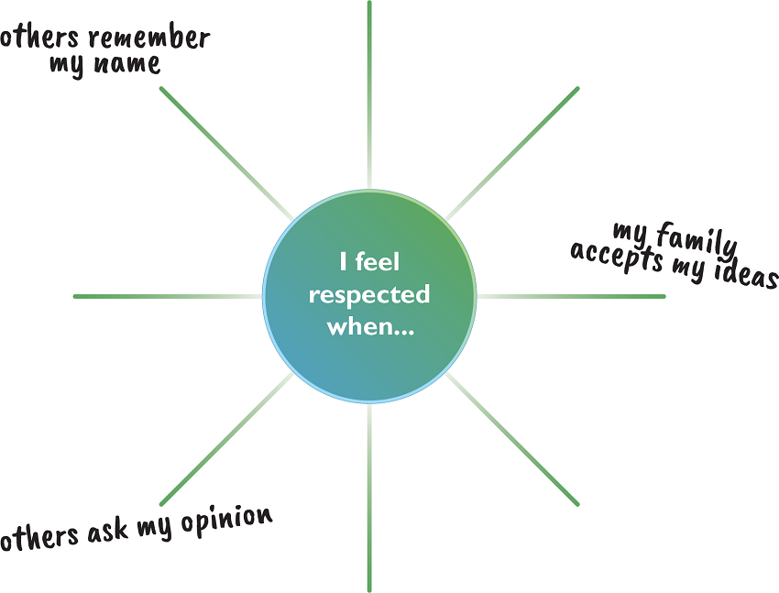
  - Next, ask participants to share with the other members of their group their thoughts on this statement: “I feel respected when…” Explain that, as a group, they should choose short phrases, drawings, or words that represent the group members’ responses to the statement and write these on the lines of the respect wheel.

  - After 10 minutes, ask all groups to hang their respect wheels on the wall. Explain that participants will now walk around and look at the other groups’ respect wheels. Ask each participant to use a marker to draw a smiley face (or other symbol) on any of the wheels next to an example of how they show respect to others and a star (or other symbol different from the first) next to an example of how they would like to show respect to others in the future. Give participants time to circulate around the room to view everyone’s work.
  - Ask participants to return to their seats. Facilitate a discussion based on the following questions:
- How can you show respect to others?
- Were there any answers that were new to you?
- Are there ways for you to ask others to show you respect?
  - Distribute Handout 3-2: Showing Respect. Ask participants to read the handout individually (or ask a volunteer to read the list aloud) and compare the items on the list to the items they wrote on the respect wheels. Ask participants to add things from the respect wheels to the handout to make the list more complete.
  - Tell participants that when a BCA creates a feeling of security and respect with each individual or family they work with, people will feel comfortable sharing their ideas without fear of rejection or disapproval. Respect for the ideas, customs, and rights of others is a key part of being empathetic and should form the basis for all of their interactions.
- Accepting Differences (30 minutes)
  - Tell the group that part of showing respect is understanding and accepting differences. Have participants stand up and form a line in the back of the room. (If the group is large, they can be split into two to three groups). Place the "Strongly Agree" and "Strongly Disagree" signs at opposite ends of the room. Tell participants that during the activity, they will be sharing their opinions. Remind them about the training norms on respect for the opinions of others. Ask participants to be honest but also accepting of differences.
  - Explain that you will read a statement aloud. Participants will then move to the spot along the line that represents their opinion. If they stand at either end of the line, they absolutely agree or disagree with the statement. They may stand anywhere between the two ends, depending on how much they do or do not agree with the statement.
Do a practice statement, such as “Fish tastes better than beef” or “Saturdays are better than Mondays.” After that, ask one of the following prompts:
- Men are stronger than women.
- There would be less corruption if women were engaged in decision-making.
- Job satisfaction is more important than higher pay.
- Women are better caregivers than men.
- For changing behavior, hygiene promotion is more important than infrastructure.
- Women face more gender discrimination than men.
- Men are natural leaders, and women are natural followers.
  - Once participants have moved to the place on the line indicating their agreement or disagreement with the statement, ask a few participants to explain why they chose to stand where they did. Alternate between the two sides, rather than allow too many voices from one side to dominate the discussion. After three or four viewpoints are heard, ask if anyone wishes to move based on the discussion. Encourage participants to keep an open mind. Explain that they are allowed to move if someone presents an argument that changes where they want to stand on the line. Continue the activity using different statements until you think that most or all voices have been heard, making sure that no one person dominates the discussions.
Facilitate a discussion using the following questions:
- How did it feel to have opinions and beliefs that differed from some of your colleagues?
- How did hearing others’ perspectives make you think differently about your own stance on the statement?
- In your work as a BCA, do you ever disagree with the beliefs or practices of others?
  - Close the activity by explaining that it is normal for BCAs to disagree with the beliefs and practices of others. They may come from a different background and have had different experiences than those they are working with. BCAs want to make sure that they always show respect to others and respond professionally, without damaging the relationships they are building. It is important for BCAs to always focus on the behavior or practice that they are trying to change and not pass judgment on other individuals. This is part of being empathetic and understanding the perspectives of other people.
  - Thank everyone for their participation and ask them to return to their seats.
- Wrap-Up (10 minutes)
  - Tell participants that to wrap up this lesson on empathy, you would like to hear ways in which they can show empathy in their work. Give them a few minutes to share answers with the group.
  - Encourage participants to check in with each other over time to see how well they did at showing empathy and if it was helpful.

Handout 3-1: Four Skills for Improving Empathy
- Ability to Read Emotion
Pay close attention to:
    - Words spoken
    - Verbal tone
    - Facial expressions
    - Body language
- Ability to Appropriately Express Emotions
Use “I” statements, not “you” statements. For example: “I feel worried that you haven’t been coming to the clinic,” rather than “You didn’t come to the clinic.”
Pay attention to and adjust your nonverbal expressions when interacting with participants. This can include things such as crossed arms or a bored/upset facial expression, based on the cultural norms of the area.
Recognize negative emotions and use control methods:
    - Take a deep breath and breathe slowly.
    - When you know your advice will create difficulties for participants, begin with an empathetic statement that shows you understand their feelings. Then explain why the change you are suggesting is important. For example: “I realize it’s hard to walk two miles to the clinic. I can understand why you would rather just go to the corner store. But it’s important that you get the medicine at the clinic, because the corner store medicine doesn’t work.”
    - Leave the situation, if necessary. For example, if you feel angry and think you will not be able to express your emotions appropriately at that moment, walk away.
- Accept Differences and Show Respect
Remember that you are trying to change the behavior, not the person.
Explore with people how behavior change is possible while accepting differences of opinion or belief.
Ask questions to understand what could encourage people to change their behavior.
- Ability to Listen Effectively
Use listening and rephrasing skills (e.g., restate or summarize in your own words what you have heard). For example: “So I want to make sure I understand. You are feeling frustrated about this because you don’t have enough time.”

Handout 3-2: Showing Respect
- Get to know the people you are working with.
Learn the names of the people you are working with and get to know the individual members of your team, members of the community, and family members. Allow them to get to know you as well.
Always call people by their name or their respectful title.
Learn about each family’s life, and show your understanding of their difficulties and challenges.
- Practice good verbal and nonverbal communication skills.
Greet people in a culturally appropriate way.
If it is normal for this culture, look at people when you speak with them.
Listen carefully and thoughtfully.
If appropriate and safe, communicate with people one-on-one (not only in large groups).
- Actively listen to others.
Create a safe and open environment to encourage people to share their ideas and opinions.
Give people a chance to discover their answers and insights.
Ask open-ended questions about what people already know about the topic you are discussing.
- Create an environment in which people can be themselves without feeling judged.
Show that you understand and appreciate people’s knowledge and the positive, healthy behaviors they already are using.
When sharing new information, find out what people already know about the topic before adding information.
- Remain humble.
Encourage people to ask questions, and answer these questions to the best of your ability.
Acknowledge when you do not have an answer for a situation.
If you do not know the answer to a question, say that you do not know but will find out.

Lesson 4: Behavior Change through Effective Facilitation
Achievement-Based Objectives
By the end of this lesson, participants will have:
- Described why a Behavior Change Agent (BCA) needs good facilitation skills
- Created a list of the most effective facilitation skills
- Ranked facilitation skills by importance
- Identified the facilitation skills they need to improve
- Practiced effective facilitation skills
- Received and given constructive feedback on a facilitation exercise
Duration
4 to 5 hours
Materials
- Flip chart paper, markers, masking tape, a watch or other device to track time, and index cards
- Pieces of paper with the seven activities listed in Handout 4-3: Example Participatory Activities
- Prewritten flip chart: Instructions for the Practicing Facilitation Skills Exercise
- List of topics for facilitation practice session (one topic for each pair of participants)
- Handout 4-1: Building Blocks for Effective Facilitation (one copy per participant)
- Handout 4-2: Adult Learning Principles (one copy per participant)
- Handout 4-3: Example Participatory Activities (one copy per participant)
- Handout 14A-1: Quality Improvement and Verification Checklist (QIVC) for BCAs’ Facilitation Skills (two copies per participant) (optional)

Why This Lesson?
Effective facilitation skills, used to conduct education sessions and meetings, are one of the most important skills needed by a Behavior Change Agent (BCA) and by a trainer. The typical BCA spends much of their time promoting behavior change by facilitating education sessions (e.g., trainings, meetings, and demonstrations). Unfortunately, much of a BCA’s skill development focuses on technical content for project areas and not on how to facilitate the learning process. This lesson will improve a BCA’s ability to facilitate in a way that more effectively contributes to behavior change. This lesson will also introduce principles of adult education.

Advance Preparation
For Task 1, prepare four separate sheets of flip chart paper, each with one of the following questions at the top:
- What were the characteristics of the facilitator?
- What did the facilitator do to encourage participation?
- How did the facilitator act toward the participants?
- What techniques, methods, or activities did the facilitator use?
For Task 3, prepare seven pieces of paper, each with one of the seven activities and its definition from Handout 4-3: Example Participatory Activities.
For Task 5, prepare a flip chart with the main points from the instructions for the Practicing Facilitation Skills Exercise.
In Task 5, participants will work in pairs to practice leading a 10-minute session on a topic related to their program area. Prepare a list of potential lesson topics that might be relevant to the participants and their programs.
In Task 5, if you plan to use the Quality Improvement and Verification Checklist (QIVC) for the 10-minute session, plan for an additional 25 minutes to explain the QIVC (which is found in Advanced Lesson 14A: Quality Improvement and Verification Checklists (QIVCs), Giving and Receiving Feedback).
Optional Iteration of This Lesson:
If you are not planning to conduct Advanced Lesson 13: Planning to Facilitate and Train Others but you want participants to practice facilitating a lesson out of the Make Me a Change Agent guide, you can adapt Task 5 to do so. Give the pairs a 20-minute lesson out of the MMCA rather than a technical topic. They will need an hour or so to prepare, so build this time into your agenda. Read Advanced Lesson 13: Planning to Facilitate and Train Others to prepare.

Tasks
- Warm-Up Activity (45 minutes)
  - Take the four sheets of flip chart paper you prepared and tape them to different sections of the walls, or lay them on different tables.
  - Divide the participants into four equal groups. Ask them to think of a training or workshop they attended that they really liked. Explain that as they go through this exercise, they should think about the effective facilitator or trainer who led that training or workshop.
  - Ask each group gather at a different flip chart. Start a timer and give each group 1–2 minutes to brainstorm and write down answers to the question on the flip chart. After time expires, have the groups move to the next flip chart. Give them two minutes to read what is written on the flip chart and add new ideas. If appropriate, you can play music and encourage participants to dance from flip chart to flip chart, to add energy to the room.
Once the groups have had a chance to read and comment on all of the flip charts, regroup and put the flip charts in a place where everyone can see the responses. Review the responses to each question. Ask participants to elaborate on their responses. Facilitate a discussion using the following questions:
- What similarities do you notice in the responses to each question?
- Which skills/techniques are you already practicing in your work?
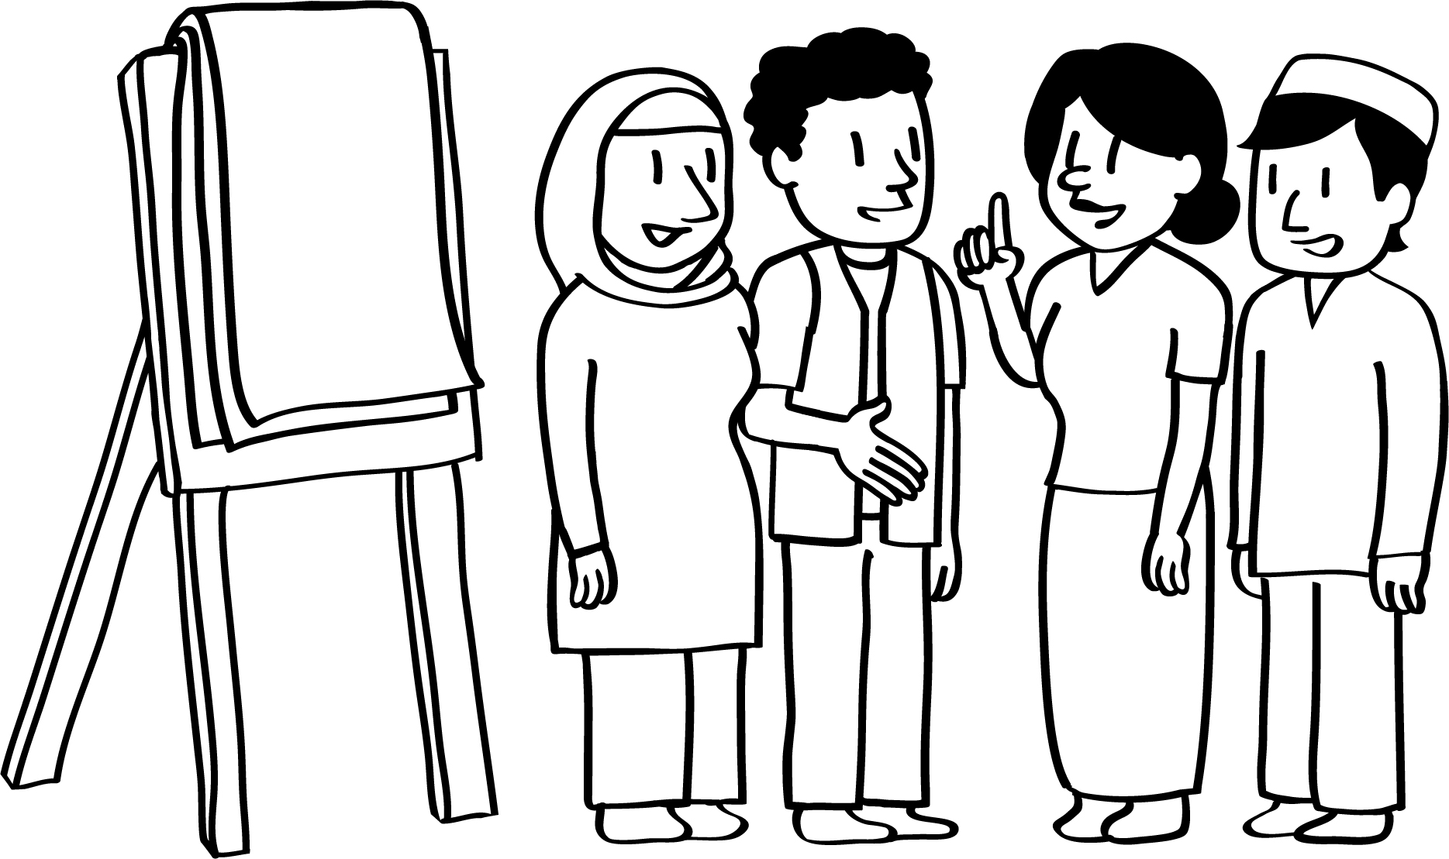
- Which skills/techniques would you like to practice or do you think you need to improve?
  - Explain that effective facilitation skills are central to a BCA’s job: For a person to change their behavior, they often need to gain new skills, acquire new information, or change their attitude. A BCA uses facilitation skills to enable these actions.
- Effective Facilitation and Adult Learning Principles (30 minutes)
  - Explain to participants that the previous exercise identified a number of good facilitation skills. Some responses were related to the activities the facilitator used, some to the characteristics/personality of the facilitator, some to the facilitator's expertise, and some to the planning/preparation of the activities. All of these are very important and relate to the principles of adult learning and tips for effective facilitation.
Ask participants to turn to Handout 4-1: Building Blocks for Effective Facilitation. Go around the room and ask for volunteers to read out the different building blocks. After reading through the handout, ask participants the following questions:
- Is there anything different here than what we discussed in the previous activity?
- Which of these skills are you already practicing?
- Which do you find hard to do when you are facilitating?
  - Explain to participants that this is not a comprehensive list, and that they can add to it.
Explain to participants that in addition to effective facilitation skills, another ability that is critical for a BCA is an understanding of how adults learn. Ask participants to turn to Handout 4-2: Adult Learning Principles. Give participants five minutes to read the handout. After that, ask participants to find a partner and take 10 minutes to discuss the following questions:
- Which of these principles do you agree with as an adult learner?
- Are there any that you do not understand or that you disagree with?
- Do you find any of these principles hard to implement in your work? If so, why?
  - Bring the group back together for a large-group discussion. Ask participants what questions they have about the principles. Did any interesting discussion points arise during the pair work?
  - Summarize the discussion by asking participants if they learned anything new from the handouts and if they think it will be important for their work.
- Participatory Activities (40 minutes)
  - Explain to participants that it takes practice and preparation to become a strong facilitator. Explain that while some of this group may already be skilled and experienced facilitators, others are newer to facilitation. But, everyone can learn from each other and continue to build their skills.
  - Tell participants that they will soon explore using participatory exercises as a facilitation tool. Before getting to that activity, however, they will review a few participatory methods that can be used while facilitating.
  - Divide participants into seven groups. Give each group a piece of paper with one of the seven activities listed in Handout 4-3: Example Participatory Activities, including the definition of the activity. Tell participants that each group will act out their activity and then briefly explain when and how the approach might be used. After they act, the other participants will guess which activity it is. Give groups five minutes to plan how they will act out their activity and read why it is important and when it would be used.
  - Have everyone sit back down and tell them to turn to Handout 4-3: Example Participatory Activities. Invite the first group to come to the front of the room and act out their activity. Ask the other participants to guess which one it is. After people guess the answer, ask the acting group to use two or less minutes to describe the approach and why a facilitator might use. Add anything that they missed and move on to the next group. Once all groups have finished, tell participants that this is not a complete list. There are many more participatory activities that can be used while facilitating, and these are just a few to consider.
  - Ask participants if they are already using these techniques and if any were new to them. Note: You can also ask participants to “vote” by marking with a dot or a marker which techniques they would like to improve and which they feel they are already doing well. Answer any questions they might have. Encourage participants to try using one of these in the upcoming facilitation practice.
  - Note: If you have been training these participants for a few hours or days, you can ask them to think back to when you as a facilitator used these different techniques throughout the training. For example, you could mention that, during Lesson 3 on Communicating with Empathy and Respect, they did a role play related to empathy. Ask participants why they think they used the role-play technique for this topic. Ask participants if they can think of other examples during the training or lesson when these activities were used.
- Facilitation Self-Assessment (10 minutes)
  - Distribute an index card to each participant. Referring to the tips for effective facilitation listed in Handout 4-1: Building Blocks for Effective Facilitation and the participatory activities in Handout 4-3: Example Participatory Activities, ask participants to identify two skills that they would like to improve (or add other skills that have not been mentioned yet) and to write these on the index card.
  - Invite a few participants to volunteer to share one item that they wrote on their index cards. Ask all of the participants to write their names on the top of their card and keep them for later use.
- Practicing Facilitation Skills (2 hours, 30 minutes)
  - Separate participants into groups of two or three and tell them to imagine they are planning a session for a group of people, such as a producer group, a youth group, or a mothers group. Each group is to choose a topic that is relevant to their program or sector (for example, effective organic fertilizer preparation or application, how to treat your drinking water, appropriate planting time and crop spacing for maize production, the importance of water quality monitoring, or how to prepare compost). They will have 25 minutes to prepare a 10–15-minute interactive activity related to their topic. Each member of the group must contribute to the facilitation. Note: Adjust the timing of the preparation and length of the activity, depending on the size of the group and how much time is available. If it works with the training schedule, include a tea break right before the presentations, so that the groups have a few extra minutes to prepare if they need it.
  - Encourage participants to use at least one of the participatory activities discussed in Handout 4-3: Example Participatory Activities and to have fun with this exercise. Remind them that this is an opportunity to experiment and try something new and that each group member must participate in the facilitation. Since they only have 10–15 minutes to present, groups need to carefully plan their time. They do not need to worry about doing long introductions with the group or other things they would normally do in a meeting.
  - If you have completed Advanced Lesson 14A: Quality Improvement and Verification Checklists (QIVCs), Giving and Receiving Feedback, distribute one copy of Handout 14A-1: Quality Improvement and Verification Checklist (QIVC) for BCAs’ Facilitation Skills to each participant. Explain that this will be used to provide feedback during their facilitation.
  - Note: If you have not completed Advanced Lesson 14A: Quality Improvement and Verification Checklists (QIVCs), Giving and Receiving Feedback, review Tasks 3–4 in that lesson to explain to participants the purpose of the QIVC and how it is scored. Tell participants that this checklist can be used to monitor the quality of facilitation. Explain that this QIVC is only one example and that their organization(s) may develop new QIVCs or adapt existing QIVCs to include other skills that the organization considers important. Additional information and instruction on developing QIVCs is available in Advanced Lesson 14B: Creating Quality Improvement and Verification Checklists (QIVCs).
  - After 25 minutes, bring the groups back together. Explain that before each group starts their facilitation exercise, they will share with the group the facilitation skills that they want to improve (previously written on the index cards). If you are using a QIVC to provide feedback, assign 2–3 participants (depending on how many people are in the facilitation group) to fill out Handout 14A-1: Quality Improvement and Verification Checklist (QIVC) for BCAs’ Facilitation Skills during the presentation. There will be one observer for one presenter.
  - Depending on the number of participants/facilitators and amount of time planned for this lesson, have a few groups share their activity with the rest of the participants. If you have two or more facilitators, split the groups evenly and have each small group present.
  - After all of the groups have finished, ask two observers to share one thing that they liked or thought went well. These observers do not have to be the people who completed the QIVC. Next, ask two other observers to make one recommendation each about how to improve the facilitation. Remind participants that constructive feedback consists of concrete suggestions on what to do better and how (e.g., “I suggest that…”). Since this is not the time for discussion, encourage the participants receiving the feedback to say “thank you” when receiving the feedback. Try to keep these feedback sessions to two minutes. If participants completed QIVCs, have them pass their form to the presenter at the end of the feedback.
- Wrap-Up (10 minutes)
  - After all groups have presented, bring everyone back together for a wrap-up.
  - Ask participants to take two minutes to individually write down all of the positive facilitation skills they observed during this lesson.
  - Ask participants to share a few of the positive facilitation skills they wrote down. What did they learn about their own facilitation skills and the use of participatory techniques? What do they hope to continue to practice and improve on?

Handout 4-1: Building Blocks for Effective Facilitation
Actively listen: Listening is the bedrock of good facilitation skills. Effective listening before and during a lesson is necessary to create a tailored and relevant learning process.
Ask questions: Ask questions often during the lesson. This is a critical facilitation skill to move individual and group learning forward. Questions can be framed to accomplish different types of responses, such as to gain or focus attention, solicit information, give information, direct the thoughts of others, and close discussions. See Lesson 2: Behavior Change through Effective Communication for more information on questions.
Be comfortable with silence: Often, questions are met with silence. Participants may need time to process the question, formulate a response, or think of other questions. However, silence can also mean that participants are confused or frustrated. With more experience, you can read nonverbal cues and know how best to address silence.
Be flexible: You never know exactly how a lesson or training will go, who will be there, and what unexpected events will arise. Be flexible and willing to shorten an activity, add important language to a definition, or adapt a lesson.
Stay focused on objectives: Select just one or two practices to focus on during a lesson, so that you can discuss them in more detail. If participant discussions get off-topic, refocus the group by using phrases such as “this is interesting to explore further at another time, but let’s return to the lesson.” It is your responsibility to find the appropriate time to intervene, thank participants, and bring the conversation back to the objective.
Use verbal and nonverbal encouragement: By using verbal and nonverbal cues, you can make participants feel more comfortable with sharing their thoughts and ideas. By nodding your head or agreeing with the participants as they are speaking, they will can feel encouraged to continue sharing. It is also helpful to foster participation of shy or modest participants.
Foster respect among participants: Mutual respect and trust between you and the participants and among the participants nurture the learning process. Effective learning is supported through the constructive and supportive feedback of respected peers.
Use participatory activities: When participants actively engage with others, they build capacities that are more effective, memorable, and easy to apply. Mix activity types so that there are opportunities to work alone, in small groups, and in one large group. Everyone in the room is a student and a facilitator. See Handout 4-3: Example Participatory Activities for more information.
Build in time for reflection: The most effective learning takes place through “real world” experiences, including the opportunity to reflect, identify patterns, draw conclusions, and derive principles that will apply to similar experiences in the future. Allow time for participants to share their experiences and/or to respectfully share others’ experiences.
Build in time for forward planning: Participants need time to practice their new skills, but also to consider ways in which to change their practices going forward. When talking about behavior change, always include time to discuss barriers and enablers.
Note: Adapted from Jane Vella’s 12 Principles for Effective Adult Learning (www.massassets.org/masssaves/documents/12PrinciplesAdultLearning.pdf).

Handout 4-2: Adult Learning Principles
Immediacy: Adults are more engaged when they see the immediate usefulness of what they are learning. If they expect to use something soon, they will work harder to learn it. Facilitators can build immediacy by helping participants to discover opportunities for immediate application and by building opportunities for their immediate application into the session.
Putting It into Practice
- Ask participants to describe when and where they will apply it in the near future
- Invite participants to create action plans to put the new skill into practice (e.g., state early on that they will use this learning in an activity later in the day, so that learners know they will be applying it very shortly).
Respect: Learning is risky for adults, and they need to feel respected to take that risk. Facilitators demonstrate respect when they acknowledge the wealth of knowledge that adults bring to a learning environment, affirm that the adult learners are the key decision-makers in their own learning process, and present content in ways that invite critical analysis, input, and ideas for personal application.
Putting It into Practice
- Do not decide what learners can decide for themselves
- Invite learners to add their experience, examples, and knowledge to new content
- Invite participation rather than call on people by name
- Avoid activities that embarrass people
Relevance: Adults must see a reason for learning new content or they will disengage from the learning process. Good facilitation connects new content with learners’ daily lives and real needs. People will learn faster if the content is significant to them and to their lives.
Putting It into Practice
- Discover what your learners want and need before the event, such as through a Learning Needs and Resources Assessment (LNRA)*
- Use stories and examples related to their context
- Invite them to personalize the content, and ask them to relate it to their work
- Avoid creating sessions where the content is relevant only to a few participants
* Learn more about LNRAs in Advanced Lesson 13: Planning to Facilitate and Train Others.
Safety: Adults will not learn if the environment feels threatening. The perception of threat can trigger changes in the brain that reduce its capacity for critical thinking. The atmosphere in the room, the design of tasks, and the facilitation style need to create a sense of safety so that adults can take increasing levels of risk with their learning.
Putting It into Practice
- Affirm learners’ ideas, questions, and concerns
- Be transparent about why and how the workshop is being run as it is
- Use warm-ups at the beginning of each day to build safety in the group
- Be attentive to power dynamics in the group
Engagement: Adults learn when they are fully and actively engaged in the process of learning and not when they are passive recipients of someone else’s learning.
Putting It into Practice
- Always give learners time to personalize and do something unique with new content
- Use individual, paired, and small-group work to ensure everyone is engaged
- Build in time for feedback from peers
- Keep presentations short, so participants spend less time hearing and more time doing
Inclusion: Adults need to feel included in the learning process, to see that their perspective matters, and to trust that their voice is heard. Facilitators must be sensitive about how the dynamics of gender, age, physical ability, education, culture, religion, ethnicity, and community position (e.g., power) influence participation in any given event. They should watch for the balance of voices and perspectives raised in the group and design/facilitate in ways that intentionally draw on the varied expertise and experience in the room.
Putting It into Practice
- Establish clear training norms for the event
- Intervene with a participant who tends to dominate the discussion or shut others down
- If there is an imbalance of power, less large group work is recommended
- Be aware of your own biases to ensure that you are not disrespecting or excluding any participants

Handout 4-3: Example Participatory Activities
- Role play: A role play is when two or more individuals act out parts in an open‐ended scenario that simulates a real-world experience. Role plays allow participants to apply new technical knowledge and skills in simulated situations in order to learn and improve before applying them in their work and life. Role plays are typically done with a small group of participants and where each participant has a distinct role in the activity. They provide an opportunity for participants to see how others might feel/behave in a given situation. Role plays must be carefully explained and their purpose made clear. The facilitator should debrief and lead a discussion with the group after each role play.
- Demonstration: A demonstration is a step‐by‐step presentation of a practical method for doing something. It is used to teach a specific skill/technique or to model an approach. It appeals to visual learners, as it shows the application of a process; other learners benefit when they have a chance to try the method themselves. This approach requires planning and practice ahead of time. The facilitator needs to set up the space so that everyone can see clearly. Participants need to be given time to try the method and provide feedback.
- 1-2-4 brainstorming: 1-2-4 brainstorming is a tool for generating many ideas within a group of participants. For effective brainstorming sessions, allow time for participants to think individually first. This can prevent a few participants from dominating the session. Start with one minute of silent individual self-reflection on a shared challenge, framed as a question. Next, pairs of participants can take two minutes to generate ideas, building on ideas from their self-reflection. After that, groups of four can take a few minutes to share the ideas they discussed within their pairs and make note of similarities and differences. The facilitator can then bring the whole group back together to share insights, ideas, and takeaways from the smaller group discussions, by asking participants “what is one idea that stood out in your conversation?” Each group can then share one important idea, and the cycle can be repeated as needed.
- Small-group work (2–5 participants): Working in small groups helps encourage trust and familiarity between participants and promotes dialogue. It helps participants share their own experiences, learn from each other, and refine ideas before sharing back to the broader group. Small-group work can begin with individual reflection, to provide time for quieter participants to collect their thoughts. Individual reflection and smaller groups of 2–3 can be helpful for participants who like time to think before they speak and/or who might not get a chance to talk in a large group setting. Small-group discussions should last a few minutes before the groups are brought back to discuss their results. Small-group reporting needs to be carefully planned: If all groups had the same assignment, the reporting out should be additive, with each group contributing a few items until all items are listed; if the groups worked on different tasks, they could present their work on summary flip charts or overhead slides, or post flip charts as a gallery walk where everyone moves around the room and reads what others have done. The task given to the small groups should be very clear and multiple steps provided on flip charts or handouts. Timing must be planned carefully so there is enough time for discussion and the report back.
- Voting: This technique is used when there are multiple options and the group needs to prioritize. Every participant is given the same number of “votes,” which can be a variety of items: stickers, rocks, candy, dried beans, etc. The number of votes that participants get is usually equal to the number of choices that make up a list. For example, if three items are going to be selected, then each person gets three votes. Participants can choose to put all their votes on one statement or spread them out and vote for several statements. The voting can be done privately (e.g., behind a wall, so no one else can see what others vote for) or publicly (by asking everyone to come up and place their votes). After all participants have voted, a discussion can be facilitated based on the responses, with questions such as “why did you choose this over this?” and “what experiences have you had that led you to make this choice?”
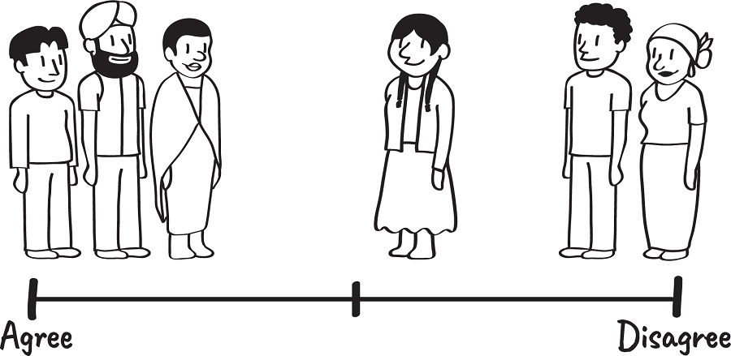
- Take a stand: This technique is also sometimes called “vote with your feet” or “continuum voting,” since participants are asked to stand on a continuum along an “agree” or “disagree” line. While voting requires participants to choose one idea over another, take a stand allows participants to stand between choices to show how strongly they agree or disagree. This technique can be used to discuss difficult issues/controversial topics without forcing people to take one side or the other. It also allows participants to make a personal choice while also learning about the group’s opinions. To use this technique, make it clear to participants which side is “agree” or “disagree” (or “yes or “no”), then read the statement that they are voting on. Participants need time to move to their preferred location. Once they do so, volunteers can be asked to share why they agreed or disagreed with the statement. It is important to choose topics that are not too sensitive when using this technique, as it is a public voting method.
- Using illustrations: Illustrations can be an effective way to demonstrate steps in a process, behavior, or activity, particularly with populations who may not read or write. The illustrations should be drawn clearly, with colors that are easy to see. The facilitator can have participants try to interpret the illustrations first, or the illustrations can be explained to participants, to make sure they understand clearly.

Lesson 5: Negotiated Behavior Change
Achievement-Based Objectives
By the end of this lesson, participants will have:
- Defined the word “negotiate”
- Explained why negotiation skills are useful for a Behavior Change Agent (BCA)
- Identified the steps in negotiated behavior change (NBC)
- Practiced negotiating a behavior change with a familiar scenario
- Provided constructive feedback on a fellow participant’s skills in NBC
Duration
2 hours, 30 minutes, to 3 hours, 30 minutes
Materials
- Flip chart paper, markers, masking tape, envelopes, and scissors
- Prewritten flip charts:
- A list of “ideal behaviors, actions, or practices”
- A list of keywords: Greet, Ask, Listen, Identify, Discuss, Recommend and Negotiate, Agree, Appointment
- Tables with column headers: 1) Decision 2) Who primarily decides 3) Who is consulted and 4) Who is directly impacted
- The Decision-Making Continuum
- Handout 5-1: Essential WASH Actions (with Associated Behaviors) (one copy per participant)
- Handout 5-2: Example Agriculture Actions (with Associated Behaviors) (one copy per participant)
- Handout 5-3: Advantages of Negotiation and Joint Decision Making (one copy per participant)
- Handout 5-4: Role-Play Dialogues (two copies)
- Handout 5-5: Illustrated Steps in the Process of Negotiated Behavior Change (one set for each group of five participants)
- Handout 5-6: Steps in the Process of Negotiated Behavior Change (one copy per participant)
- Handout 5-7: Role-Play Scenarios (one copy, with scenarios cut apart)
- Handout 5-8: Quality Improvement and Verification Checklist: Home Visits/Negotiated Behavior Change (one copy per participant)

Why This Lesson?
In the process of adopting a new behavior, people often encounter challenges. Behavior Change Agents (BCAs) can learn to help their target audience overcome these barriers by learning and applying negotiated behavior change (NBC) skills.

Advance Preparation
For Task 2—if the BCAs promote a set of “ideal behaviors,” “good practices,” or “essential actions” (such as essential nutrition actions or essential water, sanitation and hygiene [WASH] actions) as part of the project/program—list these behaviors on flip chart paper for use with the introduction to ideal behaviors in Task 2a.
For Task 4, prepare a flip chart with a list of the keywords from Handout 5-5: Illustrated Steps in the Process of Negotiated Behavior Change (Greet, Ask, Listen, Identify, Discuss, Recommend and Negotiate, Agree, Appointment).
For Task 4, copy illustrations from Handout 5-5: Illustrated Steps in the Process of Negotiated Behavior Change so that you have one set of illustrations featuring either men or women for each small group of 4–5 participants. Cut out the illustrations and put a set in an envelope for each small group.
For Task 4, choose three volunteers to do a role-play and ask them to practice ahead of time using one of the scripts in Handout 5-4: Role-Play Dialogues. You can also modify the script or write a new one. Option A is on taking a sick child to the health care facility, Option B is on incorporating fish from personal fish ponds into the family diet, and Option C is on sun-drying maize grain before storing it. Make sure that the actors clearly demonstrate each of the eight steps in the process of NBC listed in the subheadings of the dialogues in the role play.
For Task 5, prepare flip charts (one per small group of 4–5 people) for the activity on decision-making behavior. Draw four columns with the headings 1) Decision 2) Who primarily decides 3) Who is consulted and 4) Who is directly impacted.
For Task 5, prepare a flip chart with the decision-making continuum.

Tasks
- Warm-Up Activity (20 minutes)
Ask for four volunteers, then ask two of the volunteers to exit the training room. While they are outside, brief one of the remaining volunteers that when the first volunteer comes back in, they will ask the volunteer to raise their arms in front of them, with palms facing them. They will then start pushing the partner without any explanation toward the opposite side of the room. Instinctively, their partner will resist. Make sure that the volunteer understands what they will do, and then call one of the outside volunteers back into the room. After allowing this pushing for a few minutes, thank the volunteers and ask them to sit down. Note: You can either do this warm-up spontaneously or ask for four volunteers and prepare them ahead of time.
Tell the remaining volunteer who is in the room that when the second volunteer comes in the room, they should ask them kindly to accompany them to the other side of the room. They will give them a reason why and discuss it with the person so that the partner will go willingly across the room without any resistance.
After the demonstration, discuss the following:
- What happened in the first scenario?
(Answers may include: The volunteer pushed the other person, they resisted, and they were not able to get across the room.)
- What happened in the second scenario?
(Answers may include: The volunteer spoke with the person and asked the other person if they were willing to cross the room.)
- What happens when we push or force people to change? What happens when we persuade or negotiate with them?
- Ideal and Next-Best Behaviors (20 minutes)
  - Ask participants to share some of the ideal behaviors that they promote in their work as BCAs. (If the participants work with a program-specific set of “essential actions” or ideal behaviors, share the flip chart list that you prepared in advance). See Handout 5-1: Essential WASH Actions (with Associated Behaviors) for essential WASH actions and Handout 5-2: Example Agriculture Actions (with Associated Behaviors) for example agriculture actions.
  - Ask participants if it is always possible or easy for people to practice the ideal behavior. The participants will likely answer “no.” If they do not, ask them to think of a time when they tried to change their own behavior and if they faced any barriers. Sometimes changing a behavior will have benefits in the long term but may cause short-term costs to the person or the household. For example, constructing a quality latrine can cost a lot of money in the short term. However, it can save money in the long term by preventing diarrhea among family members. Sometimes changing a behavior could put a livelihood at risk. For example, adopting a new seed variety could be risky if the rains are delayed and the farmer does not have insurance.
  - Ask participants for some reasons why community members might not adopt the ideal behavior. (Answers may include: Competing priorities for time, space, or financial resources; no way to get the materials or inputs they need; cultural taboos; fear of bad results; difficulty remembering how/when to do the behavior; religious views; fear of bad effects from doing the behavior; thinking that the danger is not likely to happen to them; or thinking that the danger is not serious.)
  - Ask participants: When community members, such as mothers, fathers, farmers, or youth, have trouble changing their behavior, what is the role of the BCA? (Answers may include: Helping the person find ways to overcome the barriers; or helping them identify ways to achieve the behavior.) Explain that one way to help people overcome barriers is called negotiated behavior change (NBC).
Explain to participants that before you can use the NBC approach, you need to know what the ideal behavior is and what would be a next-best behavior or a small doable action that could lead to the ideal behavior?
- Referring to the flip chart of ideal behaviors, ask participants to write down what they think would be next-best behaviors for each of the ideal behaviors shown on the flip chart.
- Ask participants to share their ideas and discuss. Come to an agreement about the next-best behaviors.
- Add that small doable actions are steps we take on the way to the ideal behavior or are actions that are more feasible from the person’s point of view, given their current situation.
- Definition and Advantages of Negotiated Behavior Change (20 minutes)
  - Ask the group if they have ever heard of NBC. Ask them to think about what this might mean. Read out loud and discuss briefly the below definition:
NBC means that the BCA works together with a person to consider various options that might be realistic and appropriate, considering their current situation. The BCA does not force the person to do something; the BCA listens respectfully to what the other person is saying. In the end, both people will agree with the decision that the other person takes. Remember that this process is a negotiation.
Ask participants to share their experience with working with someone to change a behavior or to negotiate a behavior change:
- When did they negotiate?
- What was the behavior?
- What was the process?
- What happened?
  - Divide participants into small groups of 4–5 and ask them to discuss and make a list of what they think the advantages are of NBC. Give them a few minutes to do this, and then ask each group to share a few examples. Write these responses on flip chart paper.
  - Distribute copies of Handout 5-3: Advantages of Negotiation and Joint Decision-Making to the participants and ask them to compare the advantages list they made to the list found in the handout. Ask them to add to the handout any ideas on their list that they think are important.
  - Explain that there are many opportunities to use their negotiation skills in their day-to-day work. Ask in what types of activities they engage where they interact with others. Answers may include: Farm visits, household visits, meetings with their organization, partner meetings, meetings with local government authorities, and Community Led Total Sanitation (CLTS) triggering events. Add that many of these activities involve building agreement to take actions.
- Naming the Steps in Negotiation (30 minutes)
  - Explain that to negotiate behavior change, it is important to apply social and behavior change (SBC) and effective communication skills. Often, BCAs approach things with a clear idea of what they are promoting or the change they are trying to achieve, but they need to understand what factors make it easier or harder for someone to adopt the behavior. By showing empathy (seeing things from the other person’s point of view), they can build trust, which is required to influence or negotiate behavior change.
  - Divide the participants into small groups and provide each small group with a set of illustrations from Handout 5-5: Illustrated Steps in the Process of Negotiated Behavior Change. Ask each group to arrange the pictures in order, according to the list of steps on the flip chart. Alternatively, you can write the words on pieces of A4 paper and have the group organize themselves by standing in the order of the eight steps. (Note: You may want to cover up the flip chart and, if appropriate, you can make this a competition to see which group can arrange the images or the words first and most accurately).
  - Once participants are done, distribute a copy of Handout 5-6: Steps in the Process of Negotiated Behavior Change to each participant and ask each group to compare their order with that in the handout. Point out that some people find images useful as reminders of the steps in a process. Encourage participants to review the illustrations and/or written descriptions for each step as they continue with this lesson. Show the flip chart list of steps that you prepared in advance (using Handout 5-5: Illustrated Steps in the Process of Negotiated Behavior Change as a guide).
  - Explain to participants that NBC is a process that both parties have to find comfortable. If you are visiting a household or farm and the head of household does not want you to come in or speak with the family, you cannot force the visit. If you feel unsafe or uncomfortable, you can also leave and plan to come back at another time with your supervisor.
  - Explain to participants that they are going to watch a role play showing the steps in NBC. During the role play, they should make sure that they see all of the steps that were on the illustrations or paper and note which steps were covered and which were not.
  - Ask the previously chosen volunteers to perform one of the role plays found in Handout 5-4: Role-Play Dialogues (or the adaptation that was prepared in advance). Make sure that each of the eight steps in the process of NBC, which are listed in the subheadings of the role-play dialogue in Handout 5-4: Role-Play Dialogues, are clearly demonstrated in the role play.
  - After the role play, ask participants what happened first and what happened next. Ask if all eight steps were included.
- Decision-Making Behavior and Joint Household Decision-Making (1 hour, 30 minutes)
  - Ask participants who the people were in the recent role play on NBC. Their answers will depend on the role play but could include a BCA, a person who is making a change in their behavior, or a person that might influence them or act as a barrier to change. The latter are influential figures, such as a husband, a mother-in-law, etc. Explain that the group will now discuss decision-making and why this third person was included in the conversation during the BCA visit.
Ask participants to think about a major decision that was made in their families (by the participant or another family member) or in their community (perhaps something they witnessed). Take notes on a flipchart as you ask 1–2 participants to answer the following questions:
- What was the decision about?
- Who was the primary decision-maker?
- Who was consulted in the process?
- Who did the decision affect directly?
  - Now, explain that participants will be divided into small groups of 4–5 people and that each group will receive a prewritten flip chart with the following headers:
DECISION? | WHO PRIMARILY DECIDES? | WHO IS CONSULTED? | WHO IS DIRECTLY IMPACTED?
  - Ask participants to fill in the table on their flip chart with example decisions that are most relevant to their work. Given the time available, the facilitator can limit the number of items on the list. The table below contains some examples:
DECISION? | WHO PRIMARILY DECIDES? | WHO IS CONSULTED? | WHO IS DIRECTLY IMPACTED?
To use quality seed varieties | Father | Field facilitator | Father, mother, children
Buying household food | Mother | Mother in-law, husband | Father, mother, children, elderly grandmother living with them
To use long-lasting mosquito nets | Mother | Health care provider | Men, women, children
Long-acting birth control | Husband |  | Wife and husband
Who the children marry | Grandfather | Father | Adult children
[ add decision] | [add who] | [add who] | [add who]
  - After about 20 minutes, or when all groups are finished, ask each group to tape their flip chart paper onto the walls of the training room. Ask participants to pick up their notebooks, and give them 10 minutes to walk around the room and look at each display (known as a gallery walk). Ask them to take notes on similarities, differences, and patterns in the work done.
Ask participants what they noted during their gallery walk, such as:
- Who is the primary decision-maker? Explain that, in most patriarchal societies, a man is the head of the household and has primary decision-making power in the household.
- Who are the key implementers of the decisions? Explain that, in many societies, it can be women, because they end up working most of the time implementing decisions taken by their husbands/fathers. For example, men make decisions on which crop to plant, while women plant, weed, harvest, and process those crops. Men make decisions on the location of the water source. Women and children are responsible for water collection and for many of the chores requiring the use of water. Women may make smaller decisions for themselves and around the household, such as small purchases of personal items and items for children for school, what to cook for dinner, when to feed the children, etc.
  - Explain that being the primary decision-maker does not always mean that the person makes the decision alone, without talking to others. It is possible that these decisions are discussed and consulted among spouses and in families. Refer to the flipchart with the continuum of decision-making behavior below to help with this discussion:
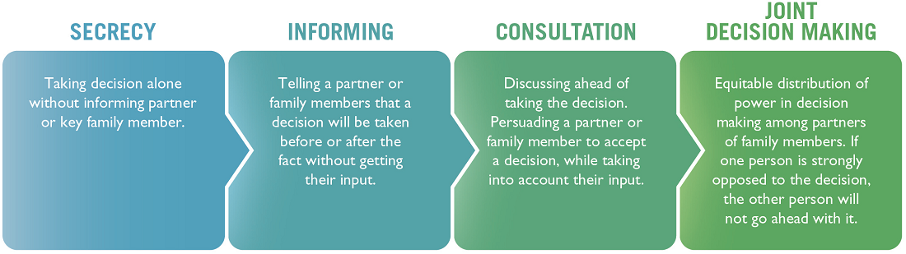
Ask participants the following questions:
- What happens when a person makes a decision in a relationship without consulting the other person?
- What happens when women are not part of the decisions that affect their lives?
- What happens when decisions are made jointly?
  - Ask participants to turn to Handout 5-3: Advantages of Negotiation and Joint Decision-Making. Read the section on advantages of joint decision-making. Ask if anyone has questions or points they want to add to the list.
  - Summarize by explaining that understanding decision-making dynamics within households is helpful when BCAs negotiate behavior change. In many cases, the person they are working with to facilitate behavior change may not be the primary decision-maker about the resources needed to take that action. In these instances, BCAs need to identify influential people and decision-makers to include them in the discussions.
- Practicing Our Negotiation Skills (1 to 2 hours)
  - Explain to participants that they will now practice the NBC process. Distribute Handout 5-8: Quality Improvement and Verification Checklist: Home Visits/Negotiated Behavior Change. Explain that the steps found in the QIVC are the basic steps of NBC and can be used as a guide during this exercise.
  - Divide participants into groups of 3–4. Give each small group a different role-play scenario from the list in Handout 5-7: Role-Play Scenarios, or allow each group to create their own scenario. Explain that they will have 20 minutes to develop a five-minute role play on how to negotiate behavior change. One person will play the role of the BCA, one will play the role of a community member, and the other group members will play the roles of influencing persons (such as a husband, mother-in-law, religious leader, etc.). After 20 minutes of preparation, each small group will perform its role play in front of the larger group.
  - After 20 minutes, ask the groups to come back together. If there is more than one facilitator, if time is short, and/or there are many participants, consider dividing the trainees into two groups and conducting the role plays simultaneously, with one facilitator observing each group. Alternatively, select just a few groups to present their role plays.
Explain that the facilitator will randomly choose two group members to complete the QIVC for the BCA in each role-play. Share the following instructions for using the checklist.
- Check off the steps of the process as they are completed during the role play. When the role play is complete, the participants completing the form will have a few minutes to provide feedback to the BCA. Encourage them to start by asking the BCA “what do you think went well?” before providing additional constructive feedback, if needed. Ask those giving feedback to be encouraging and not critical. Ask those receiving feedback to accept the feedback, saying “thank you” and not arguing or explaining why they did things a certain way.
- If time permits, allow other participants to provide additional verbal feedback.
Ask the first group to come forward and present their role play. Time each role play and stop it after five minutes (even if it is not done). Applaud and thank each group. After all of the role plays are completed, facilitate a discussion based on the following questions:
- How did you feel as the community member?
- How did you feel as the BCA?
- What was difficult? What can you improve? How do you now feel about your ability to make an effective visit?
- Wrap-Up (10 minutes)
Explain that the NBC approach can be used with any behavior in any sector. Remind participants that in the negotiation process, there is often at least one follow-up visit. Ask the following questions to participants.
- What do you think is the purpose of the follow-up visit?
(Answers may include: The purpose is to see if the person has tried the behavior and what the results were. The purpose is to see if the obstacle was overcome and to find other behaviors that the person might need to adopt.)
Note to participants that during the follow-up visit, the BCA follows the same NBC process, only this time the BCA asks about the previously agreed-upon behavior first and goes on from there.
- What might you do if you try negotiation and the person does not change their behavior?
(Answers may include: Take a break and give the person time to think about the change. Ask questions about barriers and motivators. Identify small doable actions with the person or small improvements they can make. Identify and ask for help from an influential person who might encourage the person to change their behavior. Stop the negotiation with that person and focus on other people. Once other people in the project area have changed their behavior, try to negotiate again with this person. Or, have one of the people who changed their behaviors visit the person.)
  - If any of the participants supervise BCAs, mention that part of their job is to help BCAs conduct effective visits, during which they support and assist people in adopting new behaviors. Ask how might they evaluate such visits and, if needed, how do they help them to improve the quality of their visits? (Answers may include: Joining them on a home visit, using a QIVC and providing feedback, and/or arranging for the BCA to accompany an experienced BCA on a home visit.)
  - Ask participants how they might start incorporating NBC into their own work as BCAs.

Handout 5-1: Essential WASH Actions (with Associated Behaviors)
Safe Disposal of Human Feces
- Consistently use improved latrines, including child-friendly latrines and accessible latrines, to encourage all household members to use them. Place all human feces directly into the household latrine.
- Practice age-appropriate actions for safely disposing of infant and young child (IYC) feces, with intermediary steps like diapers, so that all feces end up in latrines.
- Fling any wash water used for cleaning children’s bottoms or diaper materials away from well sites and children’s play areas.
- Promote universal latrine use in the community.
- Participate in efforts to make the community an “open defecation–free community.”
Wash Hands with Soap
- Install two dedicated hand-washing stations with flowing water and soap (such as a tippy tap) within 10 paces of the cooking area and 10 paces from the latrine. Designate responsibility within the family to make sure they are maintained with soap and water.
- Wash hands with soap and flowing water* before preparing food, before eating food, and before feeding young children.
- Wash hands with soap and water after using the latrine/toilet and after cleaning a child’s feces, after handling animals or dung, or after working in the field. Wash children’s hands regularly, especially when they are visibly dirty and before each meal.
Safe Storage and Treatment of Household Drinking Water
- Collect drinking water from the safest, protected source available.
- Treat drinking water with an effective treatment method.
- Store drinking water in a container that is covered and raised off the floor. If possible, use a container with a spigot/tap, a narrow opening, or a narrow neck to encourage pouring while discouraging hands from entering the container.
- Extract water by pouring it into a cup or vessel. If there is no tap, use a dedicated ladle/dipper that hangs on the wall.
- Drink from a clean cup.
- If treated water is limited, prioritize giving safe water to children under two, the elderly, pregnant and nursing mothers, and sick householders.
Hygienic Handling and Safe Storage of Food (Food Hygiene)
- Cook and reheat all hot food until it is boiling or steaming throughout.
- Do not eat food that has been sitting at room temperature without reheating until boiling or steaming.
- Dispose of all food that smells or looks spoiled.
- Store food in the cleanest/coolest location possible and out of the sun. Cover all stored food to protect it from flies and animals.
- Wash foods to be eaten raw with treated water, and prepare these foods on freshly washed surface with clean utensils.
- Wash cooking and serving containers and utensils before use, with flowing water* and soap.

Separating Children from Soil and Animal Feces**
- Separate children from animal feces, keeping a physical barrier as possible between IYC and animals and their feces.
- If children use a play mat, clean and sanitize it weekly or whenever there are visible dirt or feces. Separate livestock/domestic animals and their feces from cooking and sleeping areas/where young children are commonly on the ground.
- Sweep household compound daily or whenever feces are visible, to keep animal feces out of the indoor and outdoor living areas.
- Place any animal feces that will be used as fuel, fertilizer, or building material in a raised area or deep pit, covered and away from the reach of IYC and flies.
- Place animal feces with no future use in a latrine or an isolated rubbish pit.
- Wash IYC toys and play mats weekly or when feces or dirt are visible.
Source: Rosenbaum J and Bery R. 2017. Essential WASH Actions to Improve Child Growth. Research Triangle Park, NC: FHI 360. Available at: globalhandwashing.org/wp-content/uploads/2017/08/Essential-WASH-Actions.pdf.
*Flowing water can run from or be poured from a tap, pitcher, cup, or jug. The key action is to have water rinse over hands or food. Dipping into still water is never acceptable for washing.
**The evidence base for effective means of reducing child exposure to animal feces and soil is not yet established, and the recommended behaviors are based on consultation with area experts, available data, and biological and behavioral plausibility.
Note: Menstrual hygiene management (MHM) is not included in this set of essential WASH actions. Although MHM is clearly essential to a comprehensive WASH initiative, these essential WASH actions are designed to complement the essential nutrition actions and are linked to improved nutrition outcomes. MHM resources are regularly posted on the FSN Network and include: www.fsnnetwork.org/menstrual-hygiene-matters-resource-improving-menstrual-hygiene-around-world, www.fsnnetwork.org/unicef-guidance-menstrual-health-and-hygiene, and www.fsnnetwork.org/menstrual-hygiene-management-emergencies-toolkit

Handout 5-2: Example Agriculture Actions (with Associated Behaviors)
Improving Soil Health and Water Management
- Use compost and/or manure to improve the fertility of the soil.
- Cover soil with mulch to reduce weeds and maintain soil moisture.
- Plant cover crops in between seasons to reduce soil erosion and build soil health.
- Practice water management techniques (such as digging berms, swales, diversion ditches, etc.) to reduce erosion and sink water into the soil.
- Use drip-irrigation or other micro-irrigation technique in land irrigation schemes to reduce water evaporation. Till the soil as little as possible to conserve soil structure.
Gaining Better Access to Inputs
- Check for seed quality by conducting germination tests on seeds before planting.
- Use locally adapted and quality seed varieties.
- Use organic fertilizers to complement/replace inorganic fertilizers.
- Use recommended fertilizer application rates for inorganic fertilizers.
Limiting Pest and Disease Infections
- Monitor fields at regular intervals to identify pests/diseases and the scale of pest/disease outbreaks.
- Use biopesticides to control pest outbreaks. If using chemical pesticides, follow strict safety and application procedures.
- Remove dead plants and other materials from the fields that show signs of disease to limit future crop infection.
Reducing Post-harvest Losses
- Create or find a shady spot in the field to store horticultural crops while they are being harvested. Keep them in the shade post-harvest, if possible.
- Remove moldy grain before storage.
- Dry produce in the sun in an open, well-ventilated space. Keep produce off the ground (for instance, on a raised drying platform) as it dries, so it does not mix with dirt and pests.
- Use hermetically sealed bags (such as PICS Bags) to store grain to prevent mold. If using woven bags, double- or triple-bag grain to provide extra barriers to moisture and pests.
Obtaining Better Value for Marketed Products
- Use cartons, wooden crates, and plastic container to transport produce to prolong the life of products in storage.
- Record business costs, such as input costs, production, and sales, to track revenue and maximize profitability.
- Maintain production records to keep track of planting times for different crops to help plan harvest times for maximum profitability.
- Prevent fruits and vegetables from drying out in open-air markets by shading them, not stacking them too high, and keeping them moist.
Note: Given that there is not a universally accepted or applicable set of essential agriculture actions, as there are for WASH or nutrition, this list is an example list of good agricultural actions with associated behaviors. Facilitators should adapt this list, as relevant to the participant’s implementation context and program objectives.

Handout 5-3: Advantages of Negotiation and Joint Decision-Making
Advantages of Negotiation
- Encourages continued change because it demonstrates how small steps can help people reach bigger goals.
- Forms a bridge between the needs and values of individuals and groups and scientific knowledge.
- Helps BCAs learn what others think, feel, and do by using skills of listening, asking, and negotiating. This information can help the BCA support people as they identify and work around barriers to change.
- Promotes positive approaches in BCAs and encourages a willingness to learn from others, empathy for people in different situations and difficulties, and a better understanding of opportunities for realistic change.
- Builds trust between the BCA and community members, because they have had a chance to express themselves.
- Can identify the best practices possible within a given situation, even if these are not necessarily the optimal practice.
Advantages of Joint Family Decisions | Disadvantages of Individuals Making Family Decisions
- Joint decisions on the family's finances and work-plan could result in improvements in:  - The family's financial situation, leading to prosperity for the family.  - Health of all members of the family.  - Education of the children in the family.  - Harmony in the family, resulting in better care for the children.  - Productivity of families, as the person with expertise in an area will be able to contribute to the decision.  - Women’s ability to participate in family decision-making.  - Addressing misunderstandings and disputes within the family. | Individuals making decisions on the family's finances and work-plan could result in:  - Other members of the family not being aware of the decisions made.  - Others not feeling responsible for the decision.  - More money spent because everyone is making their own spending decisions.  - Less trust in the family.  - Minimal interaction or discussion in the family.

Handout 5-4: Role-Play Dialogues
Option A
Behavior: Bringing children to the hospital in the first 24 hours when they get diarrhea
Scenario: Mary’s baby, Paul, has diarrhea, so she took him to the clinic for treatment, but she waited longer than 24 hours to do so because her husband did not approve.
Actors: Behavior Change Agent (BCA), mother, and mother-in-law
Actor | Dialogue
- Greet the person you are visiting in a friendly manner and introduce yourself to/greet the head of the household (if present). Ask if other members of the family are present who might need to participate in the discussion (influencing groups).
BCA | Good morning, Mary. How are you doing? Did you remember that I was going to visit you today?
Mother | Hi Rosemary. Yes, I remembered. Welcome. Come in.
BCA | Thanks. How is your husband? Is he here now?
Mother | Oh, he is fine. But he is at work now.
BCA | Please tell him I said hello.
Mother | Okay, I will. Thanks.
BCA | Is your mother-in-law at home now? I would like her to join us if she can.
Mother | Yes, she is here. Let me get her.
BCA | Hello, my name is Rosemary. I am here to talk with Mary about what she can do to keep the family healthy. We have been meeting with other mothers in the neighborhood these past few months to talk about this. I think your input will be important in this discussion.
Mother-in-law | Hi, my name is Fancy. Yes, Mary has told me a bit about the meetings. I also think it is important to talk about ways to keep the family healthy.
- Ask the person/people how things are going, with a focus on issues relevant to the BCA’s program.
- Listen and reflect on what the other person is saying.
BCA | How are Paul and Timothy doing?
Mother | Both the kids are doing well now. But last week Paul had diarrhea.
BCA | I am sorry to hear that. Tell me about what happened.
Mother | Well, it started on Monday. He had several loose stools for two days.
BCA | That sounds serious. What did you do?
Mother | Well, the first day I did not do anything, since all children get diarrhea from time to time. Then he got very weak, and I got scared.
BCA | What did you do then?
Mother | I talked with my husband, and we decided to wait another day to see what would happen.
BCA | I see. During this time, what were you giving Paul to eat and drink?
Mother | Well, I remembered the lesson, so I prepared the oral rehydration solution and gave that to him. I also encouraged him to eat, but he refused.
BCA | That is very good, Mary. I am pleased to hear that you prepared the solution. It is also important that children with diarrhea continue to eat. Then what happened?
Mother | As I said, even though I gave him the oral rehydration solution, he got very weak. On the third day, we finally decided to take him to the clinic, where they gave him some medicine and he got better quickly.
BCA | I am glad you decided to take him to the clinic. How do you feel about that decision, Fancy?
Mother-in-law | Well, I wish we had taken Paul to the clinic sooner. The clinic is close, but my son did not approve of this.
- Identify difficulties/barriers.
Optional Step: If this is not the first home visit, review the key points of the last meeting, if relevant to the difficulties/barriers.
BCA | I see. Your son was not in favor of going to the clinic right away. Mary, can you tell me what you remember about the lesson about seeking help at the clinic when a child has diarrhea?
Mother | Well, we talked about how dangerous diarrhea in children can be and that it is important to go to the clinic. So that’s what we did.
BCA | That’s true. Do you remember what we said about when you should take a sick child to the clinic?
Mother-in-law | I think Mary told me that it is important to go right away, during the first day.
BCA | That is right, Fancy. Good memory! If a child passes three loose stools in a day or has blood in the stool, it is very important to go to the clinic immediately. Waiting at home, even if you are giving oral rehydration solution, can be dangerous. A young child can easily die if the diarrhea is bad enough. What prevented you from going to the clinic more quickly?
Mother | Well, my husband thought we should wait. He did not think it was that serious.
BCA | I see. So having permission from your husband to take the child to the clinic is important, and if he does not agree…
Mother | Well, if he does not agree, then we cannot go.
Mother-in-law | Yes, he needs to give Mary the money to buy the medicine.
- Discuss ways the person or people can overcome the difficulties.
BCA | I see. So, in the future, it would be important to make sure your husband understands how serious diarrhea in children can be. How do you think we could help him understand this?
Mother | Well, I can talk to him and tell him the things I learned in the meeting. I could arrange for you to talk to him.
BCA | Fancy, is there anything you can do?
Mother-in-law | Well, I could also talk with him about the importance of seeking health care quickly, and, if this happens again, I can remind him that we should not wait. If he does not agree, then I will try to convince him.
- Recommend and negotiate doable actions, and help select one option/action to try.
BCA | Those are all great ideas! So you could talk with him together, or separately about how serious diarrhea can be and about getting health care within 24 hours of it starting. Or you mentioned that you could have me talk to him. We could also organize a meeting with the fathers of other children who already take them to the health center, so they can talk about why they have decided to do this. Which would work better for you?
Mother | I think I would like for Fancy and me talk to him together about what we learned. Fancy, can you help me?
Mother-in-law | Yes, I can help you.
- Agree to try one or more of the options, and repeat the agreed-upon action.
BCA |  | That sounds like a good plan. I also can lend you the flip charts from the lesson. When do you think you will have time to talk with him?
Mother |  | That would be great. The pictures will help to convince him. I will try to do it this week.
BCA |  | So it sounds like you and Fancy will have time to talk to your husband this week with the flip charts.
Mother |  | Yes, I know I will have time tomorrow after dinner, and Fancy will be around. I will look at the flip charts and me and Fancy can talk to him about why we need to take the kids quickly to the health center when they get diarrhea.
- Make an appointment for the follow-up visit.
BCA |  | That sounds great. Then would it be all right if I passed by in two weeks to see how things went?
Mother |  | Yes, that would be fine.
Mother-in-law |  | Yes, no problem.
BCA |  | Mary, I want you to know that it was great that you remembered to give oral rehydration solution to Paul when he had diarrhea. That really helped him a lot. Keep up the good work. I will see you two weeks from today.
Mother |  | Thanks for the visit, Rosemary.
Mother-in-law |  | Yes, thanks for including me in the discussion. We look forward to seeing you again.

Option B
Behavior: Incorporating fish from family fishponds (aquaculture) into children’s diet.
Scenario: Mother wants to include fish in the children’s diet, but her husband sells all the fish at the market.
Actors: Behavior Change Agent (BCA), Mother, and Father.
Actor |  | Dialogue
- Greet the person you are visiting in a friendly manner and introduce yourself to/greet the head of the household (if present). Ask if other members of the family are present who might need to participate in the discussion (influencing groups).
BCA |  | Good morning, Angela. How are you doing?
Mother |  | Hello. It is good to see you again. Thanks for coming to visit.
BCA |  | How is your family doing?
Mother |  | Everyone is doing well. Thanks for asking.
- Ask the person/people how things are going, with a focus on issues relevant to the BCA’s program.
- Listen and reflect on what the other person is saying.
BCA |  | I hope your fishpond is doing well. Congratulations on the first harvest of fish! I understand it has been about six months since you installed it. How is it going?
Mother |  | Things are going pretty well. We received some training and tried to apply everything that the fishery outreach workers taught us.
BCA |  | That is good to hear. You also had a visit from the local health care worker, right?
Mother |  | Oh, yes. She mentioned that many children are undernourished in our community and that we need to try including other foods in their diet, like fish.
BCA |  | That is true. Fish are an important source of protein. Tell me, how is it going with getting the children to eat more fish?
Mother |  | Well, I have tried, but some things have made it quite difficult.
BCA |  | It can be hard to try to change your family’s diet, but I am very happy that you are trying. Can you tell me about some of the things that have made it hard for you?
- Identify difficulties/barriers.
Optional Step: If this is not the first home visit, review the key points of the last meeting, if relevant to the difficulties/barriers.
Mother |  | Well, my husband does not want me to use the fish from our fishpond in our family meals. He wants to sell the fish because he says we can make more money.
BCA |  | So your husband thinks that making money at the market is more important for the family than including new foods in your children’s diet?
Mother |  | Yes, he feels that our kids look like the rest of the kids in the community and they all seem healthy. I mean, they get sick sometimes, but he says that is just normal.
BCA |  | And what do you think?
Mother |  | Well, in the education sessions, we learned that children should eat different foods to ensure that they grow up big and strong.
BCA |  | This is true. Have you tried to talk to your husband about this?
Mother |  | Yes, but it is hard, and he does not always listen.
BCA |  | Maybe it would help if we talked with him together. Is your husband around? Can he join us?
Mother |  | Yes, he is just outside. I will call him. (Calls the husband to join them).  This is my husband, Cipriano.
- Discuss ways the person or people can overcome the difficulties.
BCA | Hello. I am happy to meet you. Congratulations on your beautiful fishpond. I understand it was a lot of work and that you have finally started harvesting the fish. That is great news.
Father | It is nice to meet you, too. Yes, I am very proud of our fish. It took a while for them to grow but now it is all worth it.
BCA | I understand that you have been selling the fish you harvest at the market to get more money.
Father | Yes, almost everyone in our community enjoys eating fish, and my neighbors are happy to buy from me.
BCA | It is good that people enjoy eating fish. They are a great source of protein, which is important for the body to grow and have energy. Do your kids like to eat fish?
Father | I don’t know. We don’t really feed them fish, because they are so valuable. I sell them all. I know my wife wants to feed the kids fish, but they are so small, they don’t need to eat that much anyway.
BCA | The kids are small at their young age, but they also have the most growing to do. They actually need even more food at this time in their lives, especially food from animals, so they can grow into strong, healthy adults.
Father | Hmm. I never thought of it that way. But the money is important, too.
- Recommend and negotiate doable actions, and help select one option/action to try.
BCA | I understand that you need to make money. But it is also important to make sure that your kids have enough quality food. The food you feed them now will determine how healthy they are later. I would like to make a suggestion. When Angela prepares food, why don’t you help her to include some fish for each of the family members? You will still have fish to sell, and your kids will be getting the nutrients they need. Do you think you can do that?
Father | I don’t think I can afford to keep all those fish for just our family.
BCA | I see that including fish in your household diet every day is a lot to ask. How about trying to add fish to your meals every other day? Angela, can you remind him to save a few fish for you to make with dinner every other day? What do you think of that suggestion?
Mother | What do you think? Every other day would be okay. The kids do love to eat fish.
Father | Well, I guess we can try it out.
- Agree to try one or more of the options, and repeat the agreed upon action.
BCA | Great, why don’t you keep track of how many fish you sell per week and how many fish your family eats? We can even measure the kids now and then measure them again when I come back in a couple months to see how much they have grown.
Father | Ok, I guess we can try it for a couple months.
BCA | Do we agree that Angela will feed everyone in the family fish at least every other day?
Father | Yes.
- Make an appointment for the follow-up visit.
BCA | That’s great. I will plan to come back in two months to see how things are going. Is that okay with you? If anything comes up in the meantime, please just come see me.
Mother | Okay, I will. Thanks for coming by.
BCA | No problem. I am glad the fishpond is working out and that your kids are going to benefit on top of the added income for the family.

Option C
Behavior: Male and female farmers who grow maize sun-dry their grain for at least three days before storing it.
Scenario: The man in the household believes drying requires only one day, and the space around the home to dry maize is limited.
Actors: Behavior Change Agent (BCA), Wife, and Husband.
Actor | Dialogue
- Greet the person you are visiting in a friendly manner and introduce yourself to/greet the head of the household (if present). Ask if other members of the family are present who might need to participate in the discussion (influencing groups).
BCA | Good morning, Mariam. How are you doing?
Wife | Hi, welcome. Come in.
BCA | Thank you. How is your husband, Juma?
Wife | He’s doing well, thank you.
BCA | That’s great to hear. Is he here right now? Might he be able to join us?
Wife | Yes, he is just outside finishing his meal. Let me go ask him to join us.
BCA | Hi, Juma. It is nice to meet you. How are you doing? My name is Agnes, and I’m here to talk with you and Mariam about your grain storage.
Husband | Nice to meet you, Agnes. Mariam has mentioned that you may stop by to talk to us about this.
BCA | Thanks for letting him know, Mariam. We will be discussing ways to keep the grain your family produces safe.
Husband | Okay, that’s fine.
- Ask the person/people how things are going, with a focus on issues relevant to the BCA’s program.
- Listen and reflect on what the other person is saying.
BCA | How is your maize harvest going this year?
Wife | It has been a good year for maize, so we might be able to store some to sell later in the season.
BCA | That’s great to hear. What are your plans for harvesting?
Wife | We started harvesting a few days ago. We harvested about a quarter of our plot already.
BCA | That’s great. What do you do with the harvested maize?
Husband | We put it in the sun for a day before putting it into our grain silo.
BCA | What have you done with previous harvests?
Husband | We did the same thing.
BCA | I see. How is the quality of the grain in the silo when you take it out later to use it?
Husband | Well, usually some of it is rotten, and we have to throw some away.
- Identify difficulties/barriers.
Optional Step: If this is not the first home visit, review the key points of the last meeting, if relevant to the difficulties/barriers.
BCA | I am sorry to hear that. It is hard to have to throw away grain after you work so hard work to produce it. Why do you suppose some of the maize has rotted?
Wife | Maybe because the maize isn’t dry in the silo?
BCA | Yes, exactly. Mariam or Juma, were either of you at the meeting when Samuel, the agricultural extension officer, discussed what makes grain rot during storage? If so, can you tell me what you remember about his talk?
Wife | He said we needed to dry the maize before putting the grain into the silos, which is what we do.
BCA | That’s true, and it’s great that you are drying it some. Do you remember why he said it was important to dry the grain first before storing it?
Husband | I think he said something about how moisture can rot the grain if we don’t dry it. We have been doing that, but we still have some rotted grain.
BCA | That’s right, Juma. Did he suggest how long to dry it for?
Wife | I remember he suggested three days. But I know that the grain can still dry out in the silos, so we thought it was easier to go ahead and put it into the silo after one day. We don’t have that much space in our home to dry the grain.
BCA | Yes, Samuel did recommend three days. That way, the grain is dry enough so that when it is stored, the moisture level is lower, and you will have less rotting later.
- Discuss ways the person or people can overcome the difficulties.
BCA | You mentioned you have limited space to dry the grain. If there was more space for you to dry the grain, would you be able to dry it the full three days?
Wife | Yes, we could definitely try that if we had more space.
BCA | Mariam, do you have any ideas for how to find more space to dry the grain?
Wife | Maybe we can dry it out in the fields right after we harvest? Actually, that would be easier for others to steal. Maybe we can ask a family member or neighbor if we can use the area around their home for a few days to dry the grain.
BCA | I think that is a great idea. Juma, what do you think?
Husband | That might work. But I’m not sure who we can ask.
- Recommend and negotiate doable actions, and help select one option/action to try.
BCA | Am I remembering correctly that your mother lives nearby, Juma? Perhaps she would allow you to use the area around her home to dry your grain.
Husband | True, she is nearby. I’m not sure if she would say yes, but maybe Mariam can go ask her.
Wife | Juma, I think she will be more likely to allow us to put our grain there if we ask her together.
BCA | Juma, would you be willing to talk to your mother with Mariam?
Husband | I guess so.
BCA | Good, I think a first step is for both of you to talk to Juma’s mother together about the space around her home to dry your grain. Then you will hopefully have access to a space to allow it to dry for three days before storing it into the silos.
- Agree to try one or more of the options, and repeat the agreed-upon action.
Husband |  | We will go over to her house tomorrow to ask her.
Wife |  | Maybe we can try to go today, since we are harvesting another batch of maize tomorrow, and it will be good to know if we are able to dry it at her place.
- Make an appointment for the follow-up visit.
BCA |  | That sounds like a good plan. I would like to stop back by in a week or two to check in. Would that be okay?
Husband |  | Yes, that would be fine.
BCA |  | Shall we plan for two weeks from now at this same time?
Husband |  | Yes, that works well.
BCA |  | Great, we will plan to see each other then. It was great to hear you remembered the importance of drying the grain before storage. I hope that you can find more space so that you can dry the full three days. I will see you again in two weeks.
Wife |  | Thanks for the visit, Agnes.

Handout 5-5: Illustrated Steps in the Process of Negotiated Behavior Change
This handout includes two sets of illustrations: one depicting two men chatting and the other depicting two women chatting. Both sets are placed in order of the eight steps of Negotiated Behavior Change.
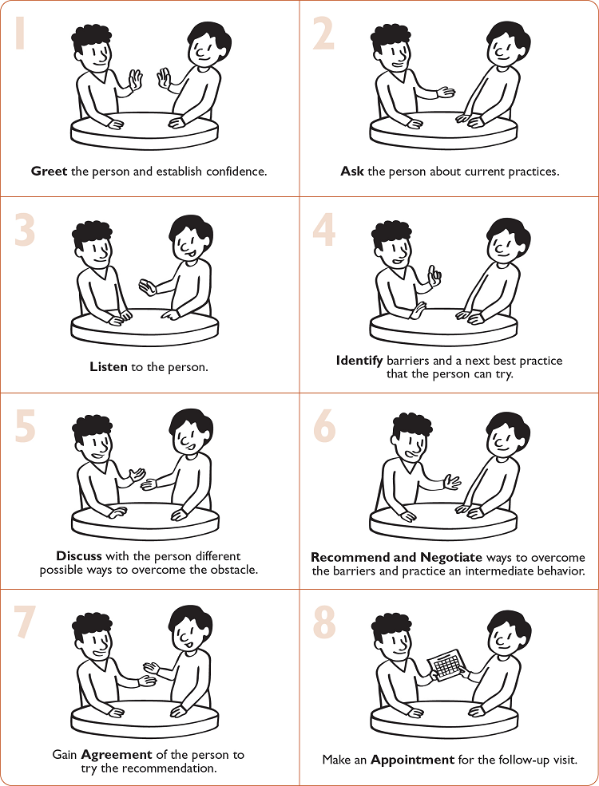
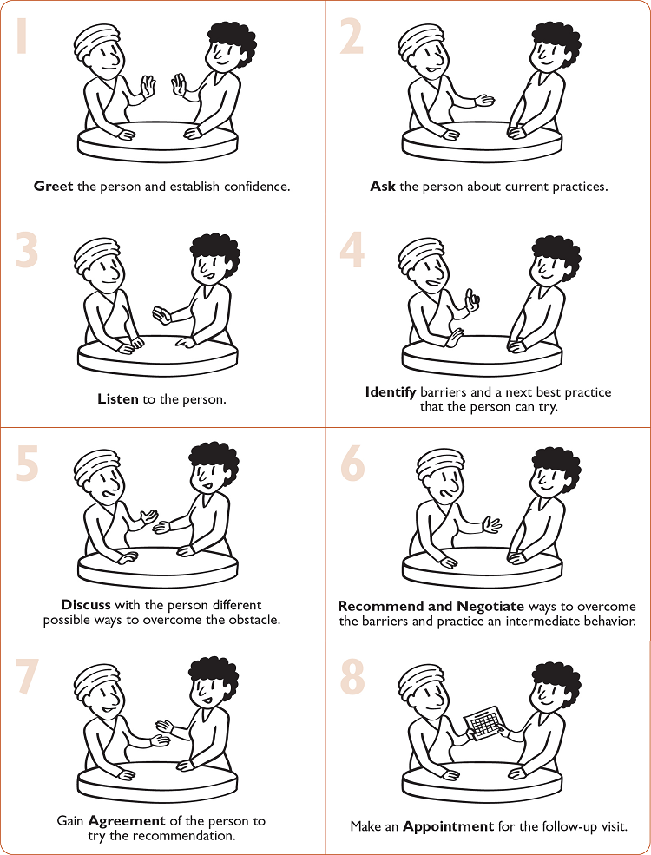

Handout 5-6: Steps in the Process of Negotiated Behavior Change
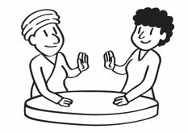 | 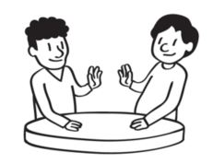 | Greet the person you are visiting in a friendly manner and introduce yourself to/greet the head of the household (if present). Ask if other members of the family are present who might need to participate in the discussion (influencing groups). If the farm is next to the home, ask if you can have the discussion while on the farm.
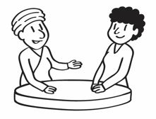 | 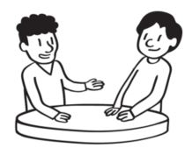 | Ask the person/people how things are going with current and new behaviors, with a focus on issues relevant to the program.
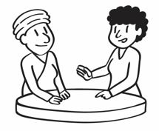 | 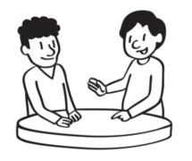 | Listen and reflect on what the other person is saying.
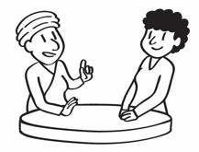 | 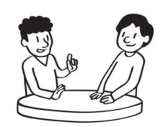 | Identify difficulties/barriers and select one to work on. Optional Step: If this is not the first home visit, review the key points of the last meeting, if relevant to the difficulties/barriers. If there are urgent issues (such as a sick child or pest outbreak), make these a priority.
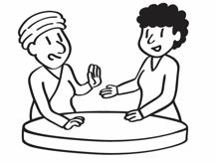 | 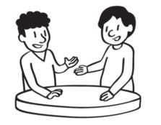 | Discuss ways in which the person or people can overcome the difficulties.
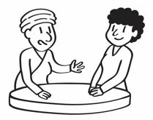 | 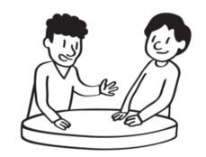 | Recommend and negotiate doable actions and help select one option/action to try.
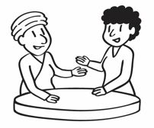 | 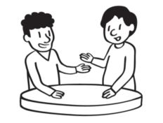 | The person agrees to try one or more of the options and repeats the agreed-upon action.
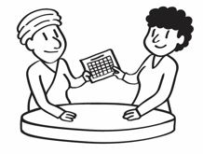 | 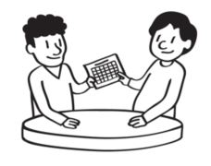 | Make an appointment for the follow-up visit. Congratulate the person on their good work, thank them for making time to talk with you, and remind them when you will be coming back for a follow-up visit.

Handout 5-7: Role-Play Scenarios
- A BCA meets a woman who does not feel that it is important to store her drinking water in a covered container.
- A BCA meets a farmer who does not believe it is important to deworm his animals.
- A BCA finds out that some parents are keeping their daughter home from school to collect water and to do farm chores. She arrives late to school three to four days each week.
- A BCA finds out that herders in the community bring their sheep to the community well used for drinking water. The sheep are not only coming to drink, but they are spending a portion of the day resting in the area around the well. There is another well 5 km away.
- A BCA visits a village and learns that the leader is telling parents that using chlorine tablets to treat their water is dangerous.
- A BCA visits a community and learns that the respected leader is telling farmers to use a banned pesticide on their crops.
- A BCA meets a woman who has two children, a boy and a girl both under 5 years of age, who are both sick with diarrhea. She only gives the ORS to her boy child, thinking that his health is more important.
- A BCA meets a male farmer who is short on field labor and is making his wife work in the fields all day. Her young children are at home by themselves and are not fed during the day.
- A BCA working as a WASH or NRM coordinator supervises a field officer who always turns in expense reports without receipts after travel.

Handout 5-8: Quality Improvement and Verification Checklist:
Home Visits/Negotiated Behavior Change
Name of the person using this list:
Name of the person being evaluated:
Location: Date:
Number of “Yes” boxes checked: Number of questions used:
Present score: % Previous score: %
Calculate the score by counting the number of “Yes” boxes checked and divide by the total number of questions that were applicable to the situation.
Question | Yes | No
- Did the BCA greet the person being visited and establish confidence?
- Did the BCA introduce himself/herself and greet the head of household (if present)?
- Did the BCA ask if other members of the family are present who might need to participate in the discussion (influencing groups)?
- Did the BCA talk with the person being visited about how things are going with current or new behaviors?
- If there were urgent issues (such as a sick child), did the BCA prioritize them and make appropriate recommendations or referrals?
- Did the BCA review the key points of the last (prior) meeting?
- Did the BCA listen to/reflect on what the person being visited said?
- Did the BCA identify difficulties/barriers to behavior adoption?
- Did the BCA discuss realistic options for overcoming the barriers?
- Did the BCA recommend/ask for doable actions?
- Did the BCA ask the person/people to agree to try one or more of the solutions?
- Did the BCA ask the person/people to repeat the agreed-upon action?
- Did the BCA congratulate the person/people on their good work?
- Did the BCA set a date for the follow-up visit?
- Did the BCA thank the person/people for making time to meet?
Comments:

Lesson 6: Storytelling for Behavior Change
Achievement-Based Objectives
By the end of this session, participants will have:
- Articulated the importance of storytelling for behavior change
- Identified the difference between an open-ended story, closed-ended story, and guided testimonial, and in what situations each type can be used
- Practiced writing a story and/or guiding a testimonial
- Provided constructive feedback on their own and their co-participants’ storytelling or testimonial skills
Duration
4 to 6 hours
Materials
- Prewritten flip charts:
- Story Definitions
- Testimonial Definition
- Story diagram
- Adult Learning Cycle
- List of behaviors/practices promoted by the participants in their work
- Handout 6-1: Closed-Ended Stories (one copy per participant)
- Handout 6-2: Open-Ended Stories (one copy per participant)
- Handout 6-3: Guidelines for Developing Behavior Change Stories (one copy per participant
- Handout 6-4: Example of a Testimonial (one copy per participant)
- Handout 6-5: Instructions for Organizing a Guided Testimonial (one copy per participant)

Why This Lesson?
Behavior Change Agents (BCAs) can use stories and guided testimonials to connect with communities and encourage individuals to take action. Stories are entertaining, are easy to remember, and allow people to identify with the characters. Stories can move us to action by inspiring us and can show us solutions to a problem.

Advance Preparation
Prepare the following flip charts:
- Story Definitions (Task 3c)
- Testimonial Definition (Task 4b)
- Draw the story diagram (Task 4f)
- Adult Learning Cycle (Task 7)
Change the names and other details of the stories in Handout 6-1: Closed-Ended Stories, Handout 6-2: Open-Ended Stories, and Handout 6-4: Testimonial so they are appropriate for your training audience. Note: Practice ahead of time and be sure to watch your pace, be animated, and use different voices for different characters. Change the names of the characters to local names to make it feel more familiar to the listeners.
Optional: Develop a list of behaviors and practices that are promoted by the BCAs in their work (If you have taught Lesson 5, you likely will already have this list). In the practical exercises, these behaviors and practices can be assigned to participants as the focus of the stories they develop.
In Task 8, the facilitator demonstrates effective storytelling techniques. You can also choose to prepare two advanced participants to demonstrate the techniques, but make sure that you practice with them and that they correctly demonstrate the techniques. This exercise can be done using a story from Handout 6-1: Closed-Ended Stories, Handout 6-2: Open-Ended Stories, or another story created by the facilitator.

Tasks
- Warm-Up Activity (10 minutes)
  - Tell participants that they will now focus on storytelling for behavior change. They will start with an activity that will help them tap into their creativity. You may want to have the participants stand or sit in a circle. Explain that they will work as a group to make up a story, taking turns to complete the phrases “unfortunately…” and then “fortunately….”
  - For example, the first person starts the story with a sentence, such as “unfortunately, my goat ran away last week.” Then the next person adds “fortunately, it was found by my cousin in the next village over.” The next person continues with “unfortunately, my cousin couldn’t bring my goat back because the goat had begun behaving very strangely…,” and so on. The process continues, alternating between “fortunately” and “unfortunately,” until all participants have had a chance to contribute to the story.
  - Remind participants that they do not have to be serious or realistic during this activity. Encourage them to have fun. The game works best if participants think quickly and do not worry about doing it perfectly. Continue until the story reaches a natural stopping point, everyone is laughing, or time is up.
- Stories for Behavior Change (15 minutes)
  - Tell participants that, in their jobs as BCAs, they are encouraging people to adopt key behaviors and practices. One of the ways they can encourage people to adopt new behaviors is through using stories. Explain to participants that often the stories we love the most are entertaining and also teach us something about ourselves. Despite the amount of detail found in them, stories are one of the easier ways for us to remember important lessons. Stories tend to hold the attention of both children and adults much better than many other educational methods.
  - Ask participants if they have ever worked in a community that tells stories. Are these stories told through speaking, images, dancing, or singing? Have they been able to use storytelling to promote behavior change? If so, how?
  - Explain to participants that teaching through stories is also helpful when they do not want to make someone feel bad about their lack of knowledge or experience. It helps the person think about what needs to happen in a given situation, helping them identify solutions to a problem.
- Definitions and Examples: Closed-Ended and Open-Ended Stories (30 minutes)
  - Ask participants how many of them have recently heard or told a story. What kinds of stories? Where did they hear or tell them?
  - Explain that in this lesson, they will talk about three types of teaching stories: closed-ended, open-ended, and guided testimonials.
  - Display the flip chart that you prepared in advance with the story definitions (below) and explain the definitions of closed-ended and open-ended stories.
Story Definitions
Closed-Ended Story: An account of an event (true or imaginary) that promotes a specific behavior to solve a particular problem.
Open-Ended Story: An account of an event (true or imaginary) that tells about a problem but does not explain what to do about it. Listeners are asked to generate many possible solutions to a complex problem.
  - Explain to participants that you will now read a closed-ended story. Distribute Handout 6-1: Closed-Ended Stories. You can choose to read Option A: Bloodworms or Option B: Male Caregiver. Read the story with the participants. Discuss the story in small groups or in plenary by posing the questions for whichever story you read:
Option A: Bloodworms
- What was the main problem in the story?
(Answers may include: Bloodworms, schistosomiasis)
- What happened to the two brothers after bathing in the water? What symptoms did they have?
(Answers may include: Belly pains, blood in urine)
- What did they think caused their illness?
(Answers may include: The townspeople were poisoning them.)
- What did their neighbors and the chief tell them?
(Answers may include: Each family had their own well, the history of the problem, and how the community solved it.)
- What was the solution to the problem?
(Answers may include: Stopped urinating in river, dug wells for drinking, got treatment for disease, and stopped bathing in contaminated water.)
- What did we learn to do from this story?
(Answers may include: Construction and use of latrines, construction and use of wells for drinking/washing water, and treatment of disease.)
- Do you know anyone in your community (or country) who has ever had problems while sing river water? Could they solve the problems by doing something similar to this story?
- What would you do in this scenario?
Option B: Male Caregiver
- What were the main problems in the story? What went wrong? (Answers may include: Flood, loss of property, Martin’s sense of shame in his wife’s earning an income and his doing household work, and increased work burden for Joy because of his embarrassment.)
- How did Joy solve these problems?
(Answers may include: By reinforcing Martin’s positive traits, giving an example from her home village where men look after babies, and getting her neighbors to come with them.)
- How can we prevent or propose solutions to this problem?
(Answers may include: By including men more in community programs targeted to women, increasing awareness about gender equality, monetizing the work done and seeing it as savings, and bringing role models.)
- Do you know anyone in your community who has ever had these kinds of problems?
- What would you do in this scenario?
  - Explain to participants that you will now read them an open-ended story. Some people also call it a “problem story,” since it explains a problem but does not reveal what to do about it. After the story, the listeners are asked to propose their own solutions to the problem.
  - Distribute Handout 6-2: Open-Ended Stories and read either Option A: The Watering Hole or Option B: The Broken Pump. Read through the story with the participants. Discuss the story in small groups or in plenary by posing the questions for whichever story you read:
Option A: Watering Hole
- What were the main problems in the story? What went wrong?
(Answers may include: There is not enough water for all the community animals to use. It is a longer walk to the other watering hole. Simon thinks that because Leila has a livestock herd three times bigger than anyone else in the village, she should use the larger watering hole that is further away. Leila has many other chores she needs to do so she cannot walk far.)
- How could these problems have been prevented?
(Answers may include: Community resource planning and management, community dialogue on shared resources.)
- Have people in your community ever had these kinds of problems?
- How can we prevent this problem?
Option B: The Broken Pump
- What were the main problems in the story? What went wrong?
(Answers may include:The community doesn’t have clean water. The community was not consulted before the project started. The community believes that accessing water should be free. The cost of the technology was too expensive based on how much the community can afford to pay to maintain the infrastructure.)
- How could these problems have been prevented?
(Answers may include: Identifying and addressing barriers to contributing money to maintain the water point, providing social and behavior change (SBC) activities to target the behavior, paying to maintain water point access, and discussing the full cost of the pump with the community before the installation.)
- Have people in your community ever had these kinds of problems?
- How can we prevent this problem?
(Answers may include: Operations and maintenance of the water point, meetings with households in the village, community contributions, and SBC.)
Ask participants when they might want to use a closed-ended story and when might they want to use an open-ended story. Allow participants time to answer. Summarize the discussion with the following answers:
- Use closed-ended stories when you want to promote a specific behavior or set of behaviors to solve a problem (for example, if you are promoting specific behaviors like exclusive breastfeeding, use of latrines, hand washing, and other key actions). Do not use closed-ended stories when you want to generate many ideas and alternative ways of dealing with a problem.
- Open-ended stories are used when you want to generate discussion and identify many possible solutions to more complex problems. When there is not a clear strategy to tackle a particular problem, consider using an open-ended story. Do not use an open-ended story when people already have decided what action they will take to resolve a problem or when there is really only one good way to resolve a problem.
  - Ask if anyone has additional questions about the differences between open-ended and closed-ended stories.
  - Distribute Handout 6-3: Guidelines for Developing Behavior Change Stories. Ask participants to read the guidelines aloud.
  - Ask participants if they have any questions. Tell participants that they will have the option to practice writing stories during the practical exercise.
- Testimonials (25 minutes)
  - Explain to participants that open-ended and closed-ended stories can be based on true events or they can be fictional, meaning that the storyteller can make them up. One type of story that we can use based on only true events is called a testimonial.
  - Ask participants if anyone has heard of testimonials. What are they? Listen to their responses, then reveal the following definition written on a flip chart:
Testimonial Definition
A testimonial is when someone tells a true, personal story about their own experience with a product or behavior. Testimonials are given to influence another person’s opinion about the benefits or value of that product or behavior and to show how barriers to behavior change were overcome.
Some examples of testimonials are:
- A farmer explaining to a group why she terraced her land and the benefits that she saw from that in terms of soil conservation.
- A father explaining to a group why he always gives his kids clean drinking water.
- A mother explaining to other women in her church why she decided to have her cows and goats vaccinated.
- A youth explaining over the radio the benefits of checking his field for pests.
- A child explaining to other children that she always washes her hands before eating dinner.
Ask for a volunteer to give a testimonial about a behavior that they have changed in their life. If there are no volunteers, ask a volunteer to read aloud Handout 6-4: Testimonial. After listening to the testimonial, facilitate a discussion around the following questions:
- What were the main problems in the story? What went wrong?
(Answers may include:Their guardian became older, which made it harder for them to stay awake and protect the home. Thugs started roaming the streets and taking advantage of innocent people. They had Break-ins and guards were injured while defending the property of their employers.)
- What were some of the beliefs that the person had about dogs?
(Answers may include: They thought it would cost a lot to maintain the dog. They thought that dogs were dirty and smelly.)
- Why did the person decide to try the new behavior?
(Answers may include: Someone offered them a guard dog. They felt very vulnerable. They were not being guarded by anyone. Someone broke into their house at night and stole their new radio.)
- What were some of the benefits that the person noticed once they had a dog?
(Answers may include: They felt happy. The dog was happy to see them. They felt secure at night. They had not been robbed. The mother-in-law was happy.)
- Have people in your community ever had these kinds of problems with safety and security? Would anyone be willing to try this behavior of having a guard dog?
- What else could be added to a testimonial to make it even more compelling?
  - Ask participants if a testimonial is an example of a closed-ended or open-ended story. (Answer: closed-ended, as it is a story to promote a specific behavior to solve a particular problem)
  - Show participants the story diagram you prepared in advance to see the differences and similarities between open-ended and closed-ended stories and testimonials.
  - Tell participants that often companies will hire known people, such as football stars, comedians, or actors to give a testimonial or endorsement for their product. Ask if they have ever heard these testimonials, sometimes called endorsements, on the radio or television. Ask who gave the testimonial, and for which products or services. How did it make you feel?
Ask participants to think of some reasons why testimonials might be powerful in their work. You can add the advantages listed below to the reasons generated during the discussion.
- Testimonials are first-hand, meaning that the storyteller describes their own experience.
- Testimonials often reach people on an emotional level. While the person presents facts, they also explain how they feel about it. If a father has given oral rehydration solution (ORS) to his child and has seen positive effects, other fathers are more likely to use it.
- If a group has trust and respect for the person giving the testimonial, this makes it easier for others to believe in and try what the person is sharing. Sometimes, people will try something they expect not to work just because they respect or trust the person who recommended it.
- If a person has heard a testimonial and decides not to try the behavior, they might think it could hurt their relationship with the person giving the testimonial. On the other hand, someone who does try the behavior may have a better relationship with the person giving the testimonial.
- When a member of the community gives a testimonial, people think that they are honest because they have not been paid to give the testimonial. The same is not always true of a paid BCA, as some people may believe that the BCA must promote the behavior/practice as part of their job.
- People who live in communities where it is important to be seen as “one of the group” or “not outside the norm” are strongly motivated by whether someone else they trust and respect in their community practices or approves of a behavior. In communities like this, showing that other people practice or approve a behavior can be a powerful tool. BCAs can use social norms (the desire to do what the community approves of) in their guided testimonials to promote behavior change.
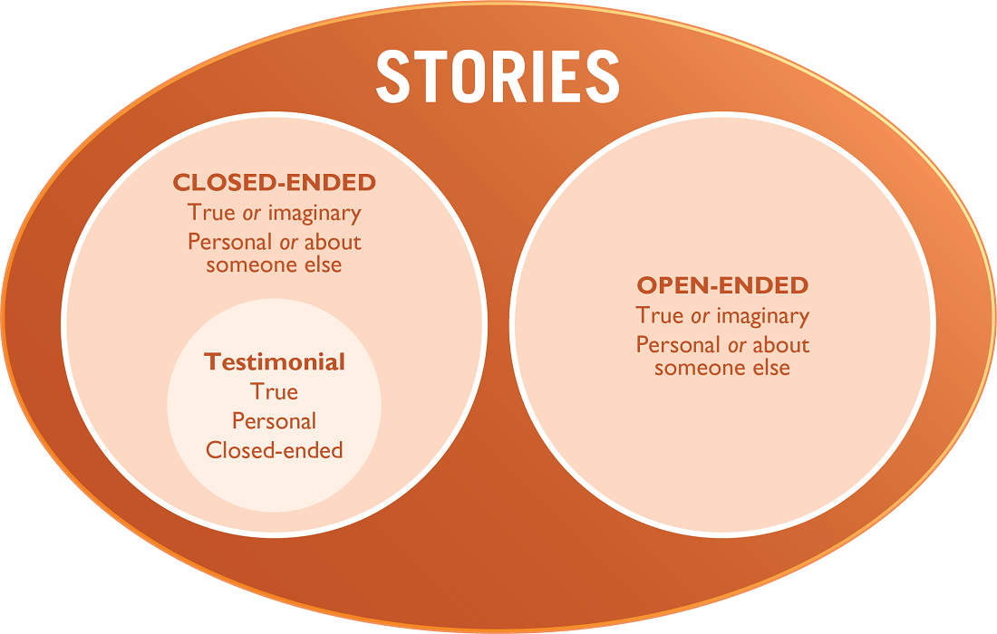

- Guided Testimonial (20 minutes)
  - Explain that one type of testimony that is very powerful is a guided testimonial. This is when a BCA assists another person to prepare and deliver a testimonial.
  - Ask participants if any of them have asked someone to share a testimonial to promote behavior change. If yes, ask one or two participants to describe the process they used to organize the testimonial.
  - For testimonials to have the greatest impact, it is not enough to ask someone to talk about their experience. An effective testimonial needs to be well-prepared. Distribute Handout 6-5: Instructions for Organizing a Guided Testimonial.
  - Note to participants that this handout describes a very specific process. Ask participants to read aloud the handout and identify the eight different elements that are included in a testimonial. Take any questions.
  - Summarize that the difference between a guided testimonial and a testimonial is that during a guided testimonial, the BCA helps someone to tell their own story. Ask: Why might you want to help someone tell their own story instead of you, as a BCA, telling their story? Explain that the story will be more powerful if it comes from the person who experienced it.
- Developing Discussion Questions for Stories (20 minutes)
  - Ask participants to think back to the different story examples. What did we do after each story? (Answer: We discussed the story.) How does a discussion make the story more effective? (Answer: It helps people imagine the situation happening in their own life, and it can help to identify new, locally appropriate solutions.)
  - Explain to participants that it is very important to have a discussion right after a story. This allows the listeners to reflect what they just heard and how it applies to their own lives.
  - Ask participants what types of questions would be useful to discuss a story or a guided testimonial? (Answers may include: Questions that review what happened in the story, how it applies to their life, if they have encountered similar challenges, and what solutions they might apply in their own life.)
Review the list below for examples of questions asked after stories. Ask participants to add other questions.
- What were the main problems raised in the story?
- How did people try to resolve the problems? What happened? How did they finally resolve the problem?
- How could the people in the story have prevented the problem?
- In terms of health (or another sector, depending on the story), what were the most important practices mentioned in this story?
- Whom do you identify with in this story? What would you do?
- What did you learn from this story?
- Have you seen this problem in your community?
- Do you know people who might identify with the characters in the story?
- Would it be possible for people in your community to resolve problems in the same way as the people in the story? How might you resolve the problems presented in the story? What might the challenges be? What would be easy to implement?
- What do we need to do to encourage people in your group to adopt this behavior? How could we begin that work?
  - Tell participants that it is extremely important to let people discover the meaning of the story for themselves rather than telling them the meaning. Use questions after a story to highlight the bad things that can happen when people do not practice the behavior and the good things that can happen when people do practice the behavior. Tell participants that they will have the option to practice guiding testimonials during the practical exercise.
- Optional Advanced Discussion: Adult Learning Cycle (20 minutes)
  - If time permits and this advanced discussion is appropriate for your participants, post the flip chart that you prepared in advance showing the Adult Learning Cycle (below).
Tell participants that according to this theory, effective learning takes place when an individual goes through all four stages of the cycle: experience, reflection, conceptualization, and application. Explain that this is just one theory of adult learning. It is a useful reference for helping participants learn from stories. Explain that hearing a story is a kind of experience. When you listen to a story, you are learning from the experience of others. Then, through a facilitated discussion, a BCA can walk participants through the next few stages of the cycle.
- Experience is when an individual experiences something or encounters a new situation. Stories allow people to hear an experience.
- Reflection occurs when an individual reflects on an experience. Through facilitated discussion, participants can reflect on the experience of those in the story.
- Conceptualization/Generalization is the stage in which an individual thinks about how the experience applies more generally in their life. Through facilitated discussion, participants can conceptualize how the experience of those in the story applies to their own life.
- Application is the point where the individual feels able to take action when they have a similar experience, based on what they learned. Participants can take action based on what they learned from the story.

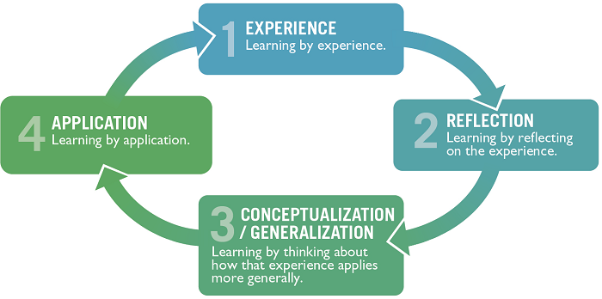

  - Give some examples of discussion questions (below) that BCAs can use with participants after sharing a story to take participants through the four stages of the adult learning cycle.
Stages | Example Discussion Questions
Reflection | - What were the main problems raised in the story?  - What issues were not talked about directly in this story that might have contributed to the problems?  - How could the people in the story solve the problem? Or how did people try to resolve the problems? What happened? How did they finally resolve the problem?  - How could the people in the story have prevented the problem?  - How would you describe the reasons for the problem in this story to a friend?  - In terms of health (or agriculture or another sector, depending on the story), what were the most important practices mentioned in this story?
Conceptualization/ Generalization | - Who do you identify with in this story? What would you do?  - What did you learn from this story?  - Have you seen that problem in your community?  - Do you know people who might identify with the different characters in the story?  - Would it be possible for people in your community to resolve problems in the same way as the people in the story, or how might you resolve the problems presented in the story? What might the challenges be? What would be easy to implement? Can we do that?
Application | - What are the ways in which we could have prevented that problem (or could solve it) in this community?  - What do we need to do to encourage people in this community to adopt this behavior? How could we begin that work?
- Techniques for Telling Stories (15 minutes)
  - Explain to participants that now that they have learned about a few different types of stories (closed-ended, open-ended, testimonials, and guided testimonials), they are going to look at what it takes to be a good storyteller.
  - Use one of the stories from this lesson or another short example to practice storytelling. Tell participants that they will hear the same story twice. Tell them to note the differences they hear. Note: Prepare the volunteers ahead of time to ensure that they know how they are supposed to read the story.
  - Ask the participant you have prepared ahead of time to “tell” the story in a boring way. Ask the second participant to “tell” the same story with changes in tone/ volume and with enthusiasm.
  - After both participants have told the story, ask participants to identify the differences between the two. Explain that a story can be well written, but if it is not delivered well, it will not capture and hold the attention of the listener.
  - BCAs can work with storytellers to make sure they captivate the audience. They can use eye contact, body language, changes in the tone, volume and/or pace of their voice to enhance the story. Tell participants that during the practical exercise, they will apply these techniques and coach others on using these techniques while listening to the stories.
- Practicing Storytelling or Guided Testimonials (1 hour, 30 minutes to 3 hours)
Note: The facilitator can decide based on the training objectives and the time allotted to the section to do Option A: Writing Open-Ended Stories (1 hour, 30 minutes), Option B: Guided Testimonials Practice (1 hour, 30 minutes), or both exercises.
  - Option A: Writing Open-Ended Stories (1 hour, 30 minutes)
    - Have participants turn to Handout 6-3: Guidelines for Developing Behavior Change Stories.
    - Divide the participants into pairs and ask each pair to review the stories in Handout 6-1: Closed-Ended Stories and in Handout 6-2: Open-Ended Stories. Give the pairs 10–15 minutes to try to fit each story into the seven steps of a behavior change story (see box on Handout 6-3: Guidelines for Developing Behavior Change Stories). Select 2–3 pairs to share what they did. Did both stories have all of the steps? Why or why not?
    - Assign each pair a behavior (see Advance Preparation), such as daily cleaning of the latrine, paying water user fees, using quality seeds, etc. Explain that they will have 15–20 minutes to work with their partner to develop a short, open-ended story that promotes the assigned behavior. Ask the pairs to develop 3–4 discussion questions to use after the story.
    - Combine the pairs that developed stories into small groups of four. Using the stories that the pairs wrote for this lesson, ask each person to practice telling their story to the others in their group, using their best storytelling skills. The facilitators should circulate and observe the groups, giving feedback when appropriate. Encourage the listeners to share two positive observations and one thing to work on, using phrases such as “what if…?” After the story, the pair should ask their discussion questions.
    - After everyone has had a chance to tell their story, ask each small group to select one person from their group to present their story to the larger group. Listen to one story from each small group. After each story, ask the larger group to share the following:
What they liked about the story
What they think could be done to further improve the story
  - Option B: Guided Testimonials Practice (1 hour, 30 minutes)
    - Tell the participants that they will now practice preparing someone to give a testimonial. Divide the participants into pairs and ask each pair to review the testimonial in Handout 6-4: Testimonial. Give the pairs 10–15 minutes to see if the testimonial has included all of the points from the box Points to Include in a Guided Testimonial, from Handout 6-5: Instructions for Organizing a Guided Testimonial. Select 2–3 pairs to share what they did. Did the testimonial have all these points?
    - Now, ask each pair to decide who will be the person who tells their story (the testifier) and who will be the BCA who guides the testifier.
    - Explain that the testifier needs to name a practice (behavior) that they adopted in their own life during the past five years (e.g., getting vaccines for their animals, using oral rehydration solution, stopping smoking, starting to exercise, terracing land, etc.). Note: It is possible to give a testimonial about a product, but for this lesson, the testimonial is about a behavior. Also, it is important that this is a change the person made in their own life, not one that they saw someone else do.
    - Tell the participants that once the testifier has chosen a behavior, they must get approval from the workshop facilitator before moving ahead with that behavior for this exercise.
    - Ask participants to return to their pairs. Explain that the BCA will encourage the testifier to tell their story by following the steps and prompts in Handout 6-5: Instructions for Organizing a Guided Testimonial. The testifier should take notes during the process. Explain that after 20 minutes, they will practice giving the testimonial to the BCA. The volunteer should include the same information that they mentioned when the BCA asked questions, but put it into a short speech about the practice they will promote with the testimonial. The pairs should also develop 3–4 discussion questions to use after the testimonial.
    - Remind the volunteer testifier that it is important to include details when sharing the testimonial and to look interested in what they are saying (e.g., smiling, maintaining eye contact, using other culturally specific cues to show their excitement).
    - Tell participants that as the volunteer is practicing the testimonial, they can refer to their written notes to remember the key points to make.
    - Once the volunteer finishes practicing the testimonial, the BCA should share what they liked about the testimonial and suggest ways to improve the content and/or the delivery. Tell them that if the volunteer needs more practice, they can give the testimonial again; The BCA should try to offer fewer prompts/less coaching the second time.
    - After both testimonials have been given, ask the small groups to select one testifier and one BCA from their group to present their testimonial to the larger group. After each testimonial has been presented, ask the larger group to share the following:
What they liked about the testimonial
What they think could be done to improve the testimonial
- Wrap-Up (10 minutes)
  - Generate a discussion around the following questions:
- What opportunities exist in your project for using storytelling and guided testimonials to promote behavior change?
- If community members already use storytelling, how can you build upon that norm to promote behavior change?
- What steps would you take to get ready to tell a story and make sure the story will work well before telling it to others?

Handout 6-1: Closed-Ended Stories
Option A: Bloodworms
There were once two brothers named Fernando and Hernando who moved to a new village. Each day, they would walk to the river each day to bathe, and they talked about how surprising it was that hardly anyone else frequented the river. They asked their neighbor, Mr. Tufo, about the situation, and he told them that each family had their own well. Fernando looked at Hernando and frowned, but said nothing. Later, the two brothers talked about how strange it was for each family to have their own well instead of gathering at the river like they used to do in their old village.
After one month, both brothers began having belly pains and started noticing blood in their urine. Hernando grabbed his brother by the arm, looked him in the eyes in panic, and said, “Brother, the townspeople are poisoning us! They do not like us here!” They went to the village chief to complain.
Upon explaining their troubles to the chief, the brothers were told that, years ago, many of the people in the village had belly trouble and blood in their urine. One of the tribes in the community began to argue with the other tribe, and neighbors accused each other of putting curses on their households. The smaller tribe of people planned to leave and move to another village when a health worker advised them that the disease came from tiny creatures living in the river where people bathed. These baby worms went through people’s skin and traveled through the blood to their bellies. The villagers also learned that the eggs of the worms were passed in people’s urine/feces and could be washed into the river by rain.
Both tribes, upon the advice of the health worker, began to use shovels to bury their feces, built latrines, and stopped urinating in the river. They also dug wells to draw water for drinking and washing. Soon, no one in the village complained of belly pain and bloody urine. The two tribes began to get along with each other again.
The two brothers followed the example of the rest of the villagers and soon became healthy again. After that, whenever they had a problem, they were sure to discuss it with their neighbors to see what they could learn from them.
Option B: Male Caregiver
Joy and Martin were a happy young couple. One night, their village flooded in the middle of the night. They had just enough time to lift their 10-month-old daughter from her crib and run to the local school to take shelter. When the flood water went back down, they returned to their house to see the damage. Their crops, their main source of income, were completely destroyed. Joy started crying when she saw the damage to the fields and house. Martin wanted to cry, but he didn’t, so Joy would not worry. They inspected all of the damage. By some miracle, a few items, including Joy’s sewing machine, were safe, as they were on higher shelves.
In the following days, Joy and Martin cleaned their house and started discussing what they could do to earn money. It would be a long time before the field could be planted again. Martin talked about emigrating to a neighboring country to find work temporarily, but they did not have the money to travel or the paperwork.
Suddenly, Joy remembered the sewing machine on the shelf. She proposed that with part of the relief money they received from the government, she would go to the market, buy some fabric and thread, and start sewing. “Everyone will need new clothes!” she said. Martin thought this was a good idea and decided that they could go to the market the next day. At first, Joy sewed clothes for some neighbors for free and sewed children’s clothes out of sacks, since there was limited fabric. Slowly, people started coming in with small orders, and Joy started earning money.
As Joy became busy with sewing, Martin needed to help out in the kitchen and help take care of their daughter. Martin seemed happy to help out when they were alone, but as soon as there were people around, he would leave. At those times, the burden of dealing with her clients and looking after their daughter fell entirely on Joy. In addition, some relief organizations were giving baby food to families with small children, but Joy had no time to get the baby food. One night, after a meal that Martin had cooked, Joy asked him why he disappeared when there are people around. Joy said, “I need help from you so that I can sew. Now that there are so many orders, there’s a chance to make good money.” Martin finally confessed that he thinks providing for the family is a man’s job. When he is in front of other people, he feels like a failure, because she is earning for the family. In addition, he is afraid that if he goes to collect the baby food, his neighbors will laugh at him.
Joy thought for a moment. This had never occurred to her. In her own village, men took care of children and cooked. She told this to Martin and said that he should not feel ashamed. She told Martin what a good cook and a good father he was. If he showed these qualities of himself, he would be a great role model for the community, and other men might join him. Joy proposed that she and Martin go together to get the baby food. She would ask their neighbors, Lucy and James, to join them. That way, there would be less attention to Martin. Martin thought this was a good idea.
The four of them, along with their babies, reached the distribution center the next day. The people there were very happy to see fathers with their babies. They acknowledged Martin and James in front of everyone and invited them, along with the mothers, to attend a short training on keeping water safe after floods. Martin told Joy that he would attend the training, and Joy could go home and continue with her sewing.

Handout 6-2: Open-Ended Stories
Option A: The Watering Hole
Every morning, Simon leaves his house with his small herd of goats and walks the one-kilometer path to the watering hole. Along the path, he passes a number of his neighbors’ homes, all of whom use the same watering hole for their animals. As he passes Leila’s home, a neighbor he has known for many years, he notices that she has already left for the morning. This means her large herd of goats and sheep (which is three times larger than those of other households in the village) will already be at the watering hole.
It is nearing the end of the dry season, but no one can predict when the rains will come. The water level at the watering hole is getting lower every day, and the other watering hole is two kilometers in the other direction. It is a bigger watering hole with more reserves, but neighbors come to this one because it is closer.
When Simon arrives at the hole, he is angry with Leila for bringing her large herd to this watering hole, since it is drying more every day. He asks her to consider taking her herd to the other watering hole, since he believes that is fairer to the rest of the community. Leila disagrees, saying that this is a shared resource and that all community members should be allowed to use it, regardless of the size of their herd. She also mentions that she has more household chores than he does, so she cannot spend the time walking to the watering hole that is farther away.
Option B: The Broken Pump
Fimi has lived in Kujija for her whole life, and she has a husband named John. Together, they have a small child named Olivier. Olivier is often sick with diarrhea from drinking river water, which worries Fimi and John. She and her husband walk far to the river to collect water. This takes up a lot of their time. Fimi often wishes that there were a well in her village, because then Olivier would not get sick and they would have more time to take care of their fields and animals.
Fimi decides to get involved in the local development committee. She and the committee are able to partner with the local government authorities and a nongovernmental organization to install a well with a hand pump in their village. Fimi, her whole family, and the entire village are overjoyed to finally have clean water. Olivier is no longer sick, and the family spends more time in their fields and has a great harvest.
One day, the pump breaks down. Fimi calls the pump mechanic, but he says that he will not come to fix the pump without being paid. Fimi and the village do not have money saved for repairing the hand pump. Ever since the hand pump broke, people have been drinking from the river water, and Fimi is worried because Olivier is sick again.

Handout 6-3: Guidelines for Developing Behavior Change Stories
- Use a closed-ended story when you are trying to promote a specific behavior. Clearly identify the specific behavior that someone did in the story and repeat the behavior throughout the story.
  - For example, it would be better to say “Martine persuaded her relatives to help her build a hand-washing station at their home” than to say “Martine decided she wanted to have better cleanliness and hygiene at her home.” Another example could be to say “Marianne began checking her field for Fall Armyworm regularly by inspecting 10 to 15 maize plants in five random locations on her plot” rather than “Marianne began looking for Fall Armyworm on her maize plot.”
- Use an open-ended story when you want to start a discussion about many possible solutions to a problem.
- Give names to the people and the setting in your story, or mention their profession instead of calling them “the man” or “the youth.” That makes it easier for people to remember the story.
- Use place names that sound familiar and believable, but do not use the name of a real place (to avoid stigma).
- Make sure that the situation in the story looks like something that could be true. In some cultures, a real situation can be acted out in the story by animals or other characters who represent certain personalities or meanings.
- Make the story simple and clear.
- Focus the story on a specific behavior change and not just on receiving information or learning about a new practice.
- Limit the story to no more than five minutes to keep people’s attention. This timing does not include the questions that are discussed after the story.
- Include enough detail to make the story interesting, but not so much that the important messages get lost.
- Be descriptive and dramatic about important parts of the story. Let the reader know what people’s emotions were at different parts of the story. Help the reader visualize what is happening in the story, as if they were watching it happen.
  - For example, instead of saying, “The promoter found that Felipe had a fever,” you could say “Andrea, the promoter, noticed that beads of sweat were forming on Felipe’s forehead as he struggled to breathe. She quickly took his temperature, and gasped when she found that it was already 41 degrees!”
- At times, humor or jokes can be used in a story, so that people will remember the story and want to tell it to others. BCAs must keep their objectives in mind, however, and make sure that humor does not become the central focus of the story.
- Traditional knowledge or beliefs, when relevant, can be included in stories. If so, BCAs should be careful not to make local/traditional practices or people look bad. If the weakness of a local custom is included in the story, the storyteller may want to mention that people have good reasons for what they did in the past, but sometimes circumstances change or people learn new information and practices change over time.
- Draw comparisons in the stories.
  - For example, a family who took their sick baby to the health facility for treatment can be compared with a family who did not. A story may start with a description of someone’s life before they learned a new behavior and then describe how their life changed after they adopted the new behavior.
- If the project has done formative research on the behavior being encouraged, incorporate that information into the story and show a way to overcome the barriers.
Step to Include in a Story
- Although stories are flexible, most have the following seven steps:
- There was a time when __________
- And every day ___________
- Until one day __________
- And because of this __________
- And because of this ___________
- Until finally __________
- And ever since that day ___________
Note: Brian McDonald, the author of Invisible Ink: A Practical Guide to Building Stories that Resonate, suggests several of these steps as a guide to writing a better story.

Handout 6-4: Testimonial
Good morning, everyone. I’d like to share my story about why I decided to get a guard dog. For a long time, a man from our neighborhood was our guard. But, over time, he got older, and it became harder for him to stay awake during the night, which is when we really needed him. Also, during that time, things changed in our neighborhood. The youth became bolder, and things became more dangerous as thugs started roaming the streets, stealing from innocent people. There were many break-ins, and guards were injured while defending the property of their employers.
When Joshua became too old, we decided to get a guard dog. We had heard from friends that people in rural areas use dogs as protection and that they were very effective. At first, I didn’t like the idea, because I have never liked dogs, and I thought it would cost a lot to maintain a dog. I also thought the dog would be dirty and smelly. However, when someone offered me a guard dog, I decided to accept it, since we felt very vulnerable not being guarded by anyone, especially at night. In fact, before we finally got the dog, someone broke into our house and stole our new radio. That incident really motivated me.
I had to build a shelter for the dog to keep it out of the sun and the rain. We just built a small lean-to, so that was easy. Then I had to figure out what to feed the dog. At first, I thought dogs need to always eat meat and that I would have to buy expensive food. But my friends told me that dogs eat almost anything, so as it turned out, he was fine to eat the scraps from our meals. I only have to feed him a decent meal about once a week. This costs less than what we paid Joshua. Then I had to figure out what to feed the dog. Then we had to train the dog to recognize the family members. Of course, he immediately liked me, because I’m the one who feeds him. The rest of the family played with him and, after a week, he knew everyone in our family. I also soon learned that dogs kept in families aren’t dirty or smelly.
What I didn’t know would happen is that he’d make everyone feel happy! Even though this was a guard dog, he was very friendly, and he greeted us when we came home. We also felt very secure when he was guarding the house at night. Where I live, people are typically afraid of strange dogs, so they naturally stay away. But our dog is very alert to strange sounds, especially at night, so when people walk too closely to our gate, the dog jumps up. If he feels there is a threat, he begins to bark.
Everyone in the house is so happy with my decision to get a guard dog. We feel so much safer, and we sleep soundly. In fact, ours is one of the few houses in our neighborhood that hasn’t been robbed since we got the dog a year ago.

Handout 6-5: Instructions for Organizing a Guided Testimonial
- Identify the behaviors with low adoption rates that you are promoting. You might start by promoting the new behavior with a small group and then use guided testimonials after some people have adopted the behavior.
- Identify people who have experience with practicing the behavior and who know its benefits. Choose a person to give the testimonial after talking with multiple people who practice the behavior. Make sure that the person is respected in the community, can relate to the group to whom you are promoting this behavior, and is excited about the product or behavior you are promoting.
- Ask them questions to help them state what barriers they overcame to be able to practice the behavior and the positive results of practicing the behavior. Ask if they would like to share their story with others to promote others to adopt the behavior.
- If they agree to share their story, explain when/where you will need them to speak, what to include in the testimonial (see list below), how long they will have to give their testimonial (usually less than 5 minutes), how much information/detail to include, and the need to show enthusiasm for the behavior/practice.
Points to Include in a Guided Testimonial
- Name the product or practice (behavior) being discussed.
- Explain how you learned about the product or practice.
- Share your initial reaction to the product or practice.
- State how and when you first tried the product or practice.
- Explain how you worked through any barriers.
- Explain the advantages you discovered.
- Share who supported your decision to use the product or practice (e.g., wife, husband, mother, father).
- Explain why you decided to keep doing the practice or using the product.
- During preparation, ask the testifier prompting questions to formulate the testimonial, such as:
  - How did you learn about this practice/behavior?
  - What was your initial reaction when someone suggested that you do it?
  - When did you first try it?
  - Who supported your decision? What did they say to you about it that encouraged you to try? (Prompt for specific people who may have supported them: What did your mother think? Your husband? The field agent?)
  - How did you first try it? What did you do, specifically? (Make sure the testifier gives details on this. The testifier should explain it in a way that you can see in your mind exactly what they did.)
  - Did you encounter any barriers when you tried it? How did you work through those barriers?
  - Why did you adopt this practice?
  - What are the benefits or results of the practice that you adopted?
  - What are the main reasons you decided to continue doing the practice?
- Ask the person to practice telling you the testimonial at least twice; if you have the option, record the testimonial on tape or video. Coach the person to include all of the important parts of a testimonial (included in the list above) and to leave out anything that is not useful or that might discourage other people.
- Give the person some time (e.g., a few days to a week) to prepare what to say and to practice their testimonial.
- When the person can give the testimonial with enough details without notes and you think they are ready to address a group, invite them to give the testimonial.
- Have the person give the testimonial to a group (e.g., a farmers’ association, a mother’s club, etc.) that you are regularly meeting with to promote behaviors. Do not interrupt the person while they are giving the testimonial. When the testimonial is finished, ask questions so they can include any details that they may have left out of the testimonial. Discuss the product, technique, or behavior being promoted by referring back to what was said in the testimonial.
- Get a commitment from the group. Ask the group, “how many of you would be willing to try out what [name] tried out?”
- Tell the group that you want to hear someone else’s testimonial the next time you meet (if the product or behavior is something that can be tried out before the next meeting). Choose the person who will give the next testimonial by talking with people informally after the meeting. Assure that the person selected is someone who can give a positive testimonial. Subsequent testimonials after the first can be more natural and may not require as much coaching. However, if there is less practice and coaching, you may have to ask future presenters more questions after they give their testimonials.
General Guidelines for Testimonials:
- Include a problem solved (or a barrier that is overcome).
- Include many examples or specific details in the testimonial, which makes it more real and easier to understand and imagine.
- Target testimonials to the specific audience you have in mind, and have people give testimonials to a group of people “like them” (e.g., fathers giving testimonials to other fathers, youth giving testimonials to other youth).
- Use “live” (in-person) or video testimonials rather than written ones, where possible. Radio is another medium that can be used to share testimonials.

Lesson 7: Learning through Cross-Site Visits
Achievement-Based Objectives
By the end of this lesson, participants will have:
- Identified the qualities that make a cross-site visit a valuable learning experience
- Reviewed steps for planning a cross-site visit
- Created a cross-site visit itinerary to meet the needs of the learners
- Discussed how to use cross-site visits to promote behavior change
Duration
1 hour, 30 minutes
Materials
- Paper, pencils, and markers
- Handout 7-1: Story of a Cross-Site Visit (one copy per participant)
- Handout 7-2: Checklist for Planning a Cross-Site Visit (one copy per participant)

Why This Lesson?
There are many ways in which Behavior Change Agents (BCAs) can promote changes in behaviors/practices. One way is to have members of one group visit members of a nearby group to learn how they solved a problem. Households can also visit other households in their community. In this lesson, we will learn how to plan and carry out a cross-site visit to promote behavior change.

Advance Preparation
For Task 3, if you know one participant has conducted a cross-site visit in the past, you can ask them ahead of time if they would like to share their experience with the group. Alternatively, you can adapt the terms and topic of the Handout 7-1: Story of a Cross-Site Visit to match the interests of your participants and the focus of their project area(s).

Tasks
- Warm-Up Activity (30 minutes)
  - Divide participants into four groups. Give each group a piece of paper and pens/pencils/markers. Ask them to imagine that they are going to live on a deserted island for five years. (Or the facilitator can pick some other isolated location, such as the Moon, a boat, a mountaintop, etc.). Explain that they can only take five items with them to this place. They must decide, as a group, which five items they would like to take. Ask each group to sit far enough away from the other groups so that they cannot hear what others are discussing. They can write out their list or make drawings of the five items.
  - After about 10 minutes, explain that each group will now have an opportunity to choose a representative to visit another group, see which items they have selected, ask a few questions, then report back to their own group. Each group will then have a few minutes to make changes to their own list, based on any new ideas gained from other groups.
  - Ask each group to switch representatives (for example, the representative from Group 1 visits Group 2, and vice versa). Allow about two minutes for the representatives to review the items and ask questions of the group members.
Instruct the representatives to return to their original groups and allow five minutes for the groups to discuss and make changes to their lists, if desired. Invite each group to present its list. After all groups have done so, facilitate a discussion based on the following questions.
- How did you decide on the five items to bring along? What difficulties did you have in coming to an agreement? How did you work through this?
- How did your list change after you learned about another group’s list? If you made some changes, what inspired you to do so? If you did not make changes, what made you decide to stick with your original plan?
- What did you think of sending a representative to visit another group? What would have been different if everyone could have seen the other lists for themselves? Would it be helpful to be able to visit multiple groups or to choose which group to visit? Why?
- After learning about each group’s list, what other changes might you make to your own lists?
  - Thank the participants for their creativity and explain that, as BCAs, one of their responsibilities is to support community members to figure out how to solve problems through new behaviors or practices. Because neither a BCA nor a single community has all of the answers, we can consider bringing together households or communities to help them learn from each other through an approach called cross-site visits.
- Group Discussion about Cross-Site Visits (10 minutes)
  - Ask participants to reflect for a moment on a cross-site visit (sometimes referred to as a field or exchange visit) they have participated in or organized. This could have been when a few households visited other model households in the community or when members or staff from one location visited another location with the intent to learn. If participants have had no prior experience with cross-site learning, ask them to think of a time when they learned from and were inspired by seeing how others were solving a problem or using a new/different practice.
Explain that during a cross-site visit, both the people visiting the new site and the people who are visited benefit from learning. Facilitate a discussion based on the following questions. Note: if none of the group members have participated in a cross-site visit, ask participants to imagine what would be helpful about visiting and hosting a cross-site visit.
- For those of you that have visited another site, what worked well about the visit? How did seeing the technique or practice first-hand help you learn?
(Answers may include: While some people learn best in a classroom, I like to see the solution in action, because then I will have a chance to try it for myself. It is more believable and realistic to see other people doing the practice. I can learn how to do the same thing in my own community by talking with others and asking questions. It is nice to know that there are other people I can rely on for help/advice if I decide to try it.)
- For those of you who hosted visitors, how was that helpful for you?
(Answers may include: I felt proud of how well our project was going. I felt motivated to continue after seeing how what we were doing could help others. I liked being able to share our mistakes and solutions so that others don’t need to waste their own time.)
- Planning a Cross-Site Visit to Enhance Learning and Behavior Change (35 minutes)
  - Emphasize that for all the reasons just shared, a cross-site visit can be a fun and inspiring way to encourage behavior change.
  - Note that for community members to get the greatest benefit, the visit needs to be well organized. Ask participants for some thoughts about how a poorly organized visit might affect community members’ experience. (Answers may include: They might focus on the frustration of waiting or wasting time, instead of the benefits of the new practice. Their frustration could make them feel less motivated to try the new behavior. They might lose trust in the BCA and the other community.)
  - Emphasize that these frustrations can be avoided through advance planning. Explain that they will now review the steps for planning a site visit. They will then practice completing a checklist they can use to help plan their next cross-site visit.
  - Ask one participant to share an example of a successful cross-site visit they conducted. If no one volunteers their experience, ask for a volunteer to read the example of a cross-site visit in Handout 7-1: Story of a Cross-Site Visit.
  - Ask the participants how they think this visit was helpful to both the visitors and the hosts. Ask them why they think the visit was able to go so smoothly.
Distribute Handout 7-2: Checklist for Planning a Cross-Site Visit. Explain that this tool can be used to ensure that cross-site visits are as effective as possible.
- Ask them to imagine that they are the BCA who prepared the visit they just heard about. Read through the checklist as a group, verbally completing each section using the example that you just read out loud.
- For example, for “what do we want to learn?” ask participants to imagine what topics/questions/concerns the BCA wrote down as part of the planning process. Ask the participant who planned it if they wrote down any topics/questions/concerns. If using the story from the handout, answers may include: steps of the process, costs, materials needed, problems and solutions, benefits for families, etc.
- Emphasize the importance of the “After the Visit” section. These questions help community members and BCAs plan tangible next steps following a cross-site visit. Ask participants to imagine that they have just come back from this very inspiring cross-site visit. Is there anything else on the checklist that they would need to encourage them to change their behavior?
- Action Planning (20 minutes)
  - Now ask participants to think of a site that their community members (or BCAs) could visit sometime during the next few months. This could be staff or community members visiting staff or community members in another location. Or, this could be arranging for household members to visit model households in their own communities. Encourage the group to be realistic and to use this opportunity to practice preparing as if for an actual site visit. Ask them to work individually to complete as much of the checklist as possible.
  - After 10 minutes, ask a few participants to share their plans with the larger group. If there are multiple people from the same team in the training, ask the other team members if they have anything to add or change about their colleague’s cross-site visit plan.
Facilitate a brief discussion based on the following questions:
- How else can you use cross-site visits in your work?
- How might your community benefit from hosting visitors? How could you make this happen?
  - Ask participants if they have any questions, or if they have anything else to add.
- Wrap-Up (5 minutes)
  - Remind participants that the BCA doesn’t always have to have the solutions to a problem. Some solutions can be found by learning from what other households, communities, or organizations have done. Well-organized cross-site visits can be very powerful learning experiences, especially if BCAs plan and support the implementation of an action plan after the visit.

Handout 7-1: Story of a Cross-Site Visit
A group of 10 farmers from a village association wanted to learn more about aquaculture. They worked with their local BCA to arrange a visit to a nearby community where people had been doing fish farming for several years. They took a bus to the nearby community and were greeted by John, a community leader who had helped arrange the visit.
After a brief introduction, the visitors went to the pond of a farmer named Michael, who was just starting his fishpond. He showed them how he was digging the pond and some of the tools and materials he was using. The visitors asked questions about planning, costs, and the time involved.
Then they visited another farmer named Mary, who had been maintaining her ponds for some time. She demonstrated to the visitors the different ways of feeding and caring for the fish. The visitors had an opportunity to observe and practice catching, checking, and feeding the fish. They talked with Mary about problems she had experienced and how she dealt with them.
Finally, they met with Esther and Martin, who showed the visitors how they harvest, package, and store the fish. They talked about how they have added the fish to their meals and how they sell some of the fish.
The fish farmers and their families demonstrated how they cook the fish. The visitors had brought some vegetables and other food to share. They all ate a meal together and talked more about their families, their communities, and the projects they were working on for the next year.

Handout 7-2: Checklist for Planning a Cross-Site Visit
Why and Where Will We Visit?
- Who is leading the cross-site visit? Name and phone:
- Where are we going?
- What do we want to learn?

- Who can teach us about this? Community contact person:
- Community contact person phone number:
Other community members we’d like to meet with (who has been involved and can teach us the different steps?):

- What questions do we want to ask? What would we like to see?
Email, message, or talk with the hosts about these questions and interests before the visit. Confirm arrangements to meet with people who can provide answers and demonstrate the practices, techniques, or behaviors.
Questions:

Things to see/observe/practice:

What Other Information Do We Need Before the Visit?
- How long will it take to get there?
- What mode of transportation will we take?
- How do we get there? (directions to the site):
- At what time will we arrive?
- How long will we stay?
- What is the schedule? (use the form below as a guide)
- Does the community agree to the schedule? YES / NO
- Will we plan to meet with local officials? YES / NO
- List of items to ask participants to bring (water, rain boots, hat, closed-toe shoes, etc.)
Things to Take
- Letter of introduction or invitation to show to authorities (if needed)
- Refreshments or box lunches/food to share with hosts and participants (if needed)
- Cameras (if photos or video are wanted/needed)
- Appropriate clothing for the weather (rain gear, etc.) and terrain (closed toe shoes, boots)
- Notebooks and pencil/pens for note taking (if the group would like to assign a recorder, who?)
After the Visit
- Discuss the visit and lessons learned with other participants. Sample questions include:
    - What was your favorite part of the visit? What made that special for you?
    - What surprised you?
    - What would you like to try out for yourself? What are the first steps you will take? What other resources or information do you need to take these steps? How can we work together to do that?
    - What do you think you might do differently? What are the first steps you will take to try it this way? What projects or practices in this community might you like to share with others?
  - Discuss the visit and lessons learned with your supervisor. Identify opportunities to improve the next cross-site visit (logistics, content, discussion etc.).
  - Whether you recommend visits to this site in the future, share lessons learned from the cross-site visit with your team.
  - Prepare a cross-site visit report with the date, itinerary, participants’ names, and contact information for the people at the other site, as well as learning objectives, important lessons learned, and follow-up action steps.
  - Create an action plan for utilizing the lessons learned from the cross-site visit. What can you put into action next week or next month? What do you want to put into action that will require time? What steps can you take to get there?
Sample Cross-Site Visit Schedule
Name and number of lead:
Name and number of contacts in host community:
Name and number of logistics (lunch, bus etc.):
Arrival time/Location:
- Meet with hosts/introduction activity.
- Discuss ground norms (e.g., show respect, allow time for demonstration, then share questions/answers, give constructive feedback, no cell phone use, get photo consent if needed, etc.).
- Review the schedule.
First Presentation/Demonstration
- Name:
- Topic:
- Start time:
- End time:
Second Presentation/Demonstration (optional)
- Name:
- Topic:
- Start time:
- End time:
Add additional presentations/demonstrations, as needed.
Discussion/Final Questions and Answers
- Time:
- Questions to ask:

Thank You/Conclusion Time:
Departure Time:

Lesson 8: Action Planning
Achievement-Based Objectives
By the end of this lesson, participants will have:
- Created an action plan for how they will use what they have learned in the MMCA lessons
- Practiced giving and receiving feedback
Duration
1 hour, 30 minutes
Materials Needed
- Flip chart paper, notecards, A4 paper, and markers
- Prewritten flip chart: traffic light
- Handout 8-1: Action Planning Worksheet (one copy per participant)
- Handout 8-2: Example Action Planning Worksheet (one copy per participant)

Why This Lesson?
It is easy to leave a training, go back to the routine tasks of a job, and forget to put the skills learned during the training to use. This lesson will help BCAs plan for how they will use the information they have learned at the training and/or train others on the content.

Advance Preparation
For Task 1, draw the traffic light on a flip chart ahead of time.

Tasks
- Warm-Up Activity (15 minutes)
Hang up the traffic light flipchart. Explain that as they near the end of the training, participants should think about how they will continue to apply these skills after the training. Explain that the traffic light represents a plan for themselves following the training:
- What participants want to stop doing in their behavior change activities as a result of this training (red light)
- What they want to do less of (yellow light)
- What they want to continuing doing or do more of (green light)
  - Hand each participant a piece of A4 paper. Ask each participant to draw their own traffic light on their piece of paper.
  - Once they draw their light, ask them to write down what they want to stop doing, do less of, or do more of after the training. Remind them that “red” on their traffic light represents one thing that they personally want to stop doing as it relates to the skills and competencies within MMCA. For example, “I want to do more active listening.” Yellow represents one thing that they want to do less off. For example, “I want to use less closed-ended questions.” Green represents one thing they want to continue doing, or do more of. For example, “I want to use more negotiated behavior change techniques.” Allow five minutes for participants to write at least one answer for each color.
  - After five minutes, ask participants to share their traffic light answers with the person sitting next to them.
  - Bring the group back together once everyone has shared with their partner. Ask for a volunteer to share something they will do more of and why. Ask another participant to share something they will do less of and why. Finally, ask another participant to share something they will stop doing and why.
  - Thank the participants for sharing. Encourage them to check in with each other after the training to see how they are progressing.
- Reviewing What Was Learned (25 minutes)
  - Explain to participants that now that everyone’s personal plans have been reviewed, they will review what they learned this week and make a plan for how to take these skills forward into their work. Ask participants to call out the topics, approaches, techniques, or skills they have learned. Examples may include effective facilitation, effective communication, empathy, guided testimonials, storytelling, etc. Write these on a flip chart. Add any additional points, and ask if there are any changes to be made.
  - Ask participants to take 2–3 minutes to answer the following question: “What are the top three things you feel are most applicable to your work, starting as early as tomorrow?” Ask them to silently reflect and to write their answers on a piece of paper. Remind participants to consider what is happening in their projects and communities at this time (e.g., work plans, harvest season, upcoming holidays and celebrations, etc.) when they think about their answers.
  - If this group will be training others on MMCA, ask participants to take another 2–3 minutes to answer the following question: “What are the top three lessons that you think are most important to share with your colleagues or frontline staff?” Ask them to silently reflect and to write their answers on a piece of paper.
  - After participants individually reflect, ask them to get into small groups based on their teams, sectors, or other appropriate groupings.
  - Invite participants to share in their groups what they wrote on their cards. Tell them to share why they prioritized these lessons and to discuss if there are differences in priorities between people on the same team and why that may be.
  - Once everyone in the group has shared and discussed any differences, ask participants to select one skill or technique for which they want to make an action plan.
- Action Planning (30 minutes)
  - Action planning can be done in the same groups used in Task 2 or can be done individually, depending on what is most useful for participants. Give participants a copy of Handout 8-1: Action Planning Worksheet. Explain that they can adjust the action-planning template in the future to fit their needs. Tell participants that they can reference Handout 8-2: Example Action Planning Worksheet as an example.
  - Ask them to work individually or in groups and to spend about 10 minutes to identify next steps for their priority actions.
  - If participants are working individually, after 10 minutes, put them into small groups of 4–5 people.
  - In their groups, ask participants to go in a circle and share their plans with their peers. Ask the other group members to listen and provide constructive feedback. Encourage them to ask questions such as: “When will you do these steps? What could be a barrier to your practicing this? Can any of us help hold you accountable?” Encourage participants to remember what they learned about giving and receiving feedback in this activity, so that everyone is being respectful. Ask participants to update their plans as they talk to their peers and receive feedback/additional ideas.
If the group is planning to train others, you can pose additional questions for discussion, such as:
- How will we conduct the training? (e.g., all at once, lesson-by-lesson at our monthly meetings, etc.)
- Who do we need to talk to within the next week about planning the training?
- Wrap-Up (15 minutes)
  - Bring the entire group back together and thank everyone for writing their plans.
  - Ask if one or two participants would like to share their plans with the rest of the group. Ask participants if anyone has questions for the volunteers or suggestions for improving the action plans. Thank the volunteers for sharing and encourage a round of applause.
  - Tell participants that they can do this exercise for any of the skills, lessons, or techniques they want to use in their work. Encourage them to sign and date their plan and to schedule a meeting with their supervisor to discuss their next steps.
  - Thank all participants for their commitments. Have everyone share a round of applause for their hard work during the training.

Handout 8-1: Action Planning Worksheet
Behavior Change Agent Name
Date
What skill/technique do you want to practice when you return to work?
Where do you have the opportunity to practice this?
How will you measure your progress?

What steps will you take to practice this skill/technique? Be as specific as possible. |  | What resources are needed to take this step? | When will this take place? | Who can hold you accountable?
Step 1
Step 2
Step 3
Step 4
Step 5
Step 6
Step 7

Your Signature: Date:

Supervisor’s Signature: Date:

Handout 8-2: Example Action Planning Worksheet
Behavior Change Agent Name | Martin Ele
Date | 12 March 2020
What skill/technique do you want to practice when you return to work? | Using open-ended questions
Where do you have the opportunity to practice this? | At the next Farmer Field School meeting
How will you measure your progress? | Ask supervisor to come to the next meeting with a QIVC and specifically look at how I use open- and closed-ended questions.

What steps will you take to practice this skill/technique? Be as specific as possible. |  | What resources are needed to take this step? | When will this take place? | Who can hold you accountable?
Step 1 | Draft questions to pose based on behavior we are discussing in the group (proper weeding techniques). | My time to draft the questions | Tuesday,  15 April | Galina
Step 2 | Practice asking the questions to a colleague and ask for feedback. If questions do not lead the conversation where I hoped it would go, I will change how I am asking the question. | Galina’s time to listen to me practice | Wed-Thurs 16-18 April | Galina
Step 3 | At the next group meeting, use a few of the questions I have prepared. | My time at the group meeting | Friday,  19 April | Me
Step 4 | Actively listen to answers and continue to pose additional questions as needed. | My time at the group meeting | Friday,  19 April | Me

Your Signature: Date:

Supervisor’s Signature: Date:

Lesson 9: Closing
Achievement-Based Objectives
- By the end of this lesson, participants will have:
- Completed the post-test
- Received certificates
- Given feedback to the facilitators
- Committed to a next step after the training
Duration
1 hour
Materials Needed
- Blank flip chart paper and markers
- Flip chart with Day 1 expectations
- Participant certificats (one per participant)
- Handout 1-1: Pre-Test/Post-Test for Make Me a Change Agent (one copy per participant)
- Handout 9-1: Example Training Feedback Form (one copy per participant)

Why This Lesson?
This lesson will provide an opportunity to review the achievement of the workshop objectives through a group discussion, workshop evaluation forms, and a comparison of the results of the post-test with those of the pre-test. Participants will also be recognized for their attendance at the workshop.

Advance Preparation
Find the Expectations flip chart from Lesson 1 Task 5 and bring copies of the pre-test. Print out post-tests and an evaluation form for each participation. Write the names of the training participants on the certificates.

Tasks
- Review Expectations (5 minutes)
  - Tell participants that they have come to the end of the training. Put up the flip chart with the “list of expectations” from Lesson 1 Task 5 on the first day. Review the list with the group and ask them to reflect on the training and how it met or did not meet their expectations.
  - Take comments and criticism with grace. If possible, discuss why some expectations were unable to be met. Brainstorm ideas about where they can look for support for the remaining expectations.
- Post-Test (15 minutes) Optional, if a pre-test was completed
  - Ask participants to put away all notes. Make sure that all of the flip chart sheets from previous days of the training are not visible.
  - Pass out the post-test, found in Handout 1-1: Example of a Pre-Test/Post-Test for Make Me a Change Agent (consider reordering the questions on the post-test). Ask participants to write their name or the same identifier they used on their pre-test (e.g., number on their training manual, their birth date, nickname, pet name, favorite singer, etc.).
  - Ask participants to turn over their paper once they are done and to sit quietly until everyone has finished. Allow enough time for everyone to finish.
  - Collect post-tests. Share answers to the pre-test/post-test with participants.
- Training Evaluation Feedback (10 minutes)
  - Hand out the evaluation feedback form, such as Handout 9-1: Example Training Feedback Form or another that you created. Ask participants to complete the form and add any suggestions they have. Tell participants that they can modify Handout 9-1: Example Training Feedback Form and use it in future trainings.
- Training Certificates (15 minutes)
  - Give closing remarks encouraging the participants in their work. Hand out the certificates and call each participant by name. Alternatively, hand out the first certificate. Next, have that certificate recipient call the name of the next person and be the one to hand them their certificate. Continue until everyone has received their certificates.
- Closing Circle (10 minutes)
  - Stand or sit in a circle. Ask volunteers to share one thing that has impacted them from this training or one sentence on how they will use what they learned at the training within the next month.
- Final Closing (5 minutes)
  - If relevant, invite an appropriate guest, such as a representative of the hosting organization, to say a few words to close the training.
  - Acknowledge and thank participants and other contributors/organizers. Thank them for their energy, valuable contributions, and dedication. Stay available in the training room to ensure that you say good-bye and answer any final questions.

Handout 9-1: Example Training Feedback Form
- Please rate the training in terms of its usefulness in the following areas, using the scale below. Circle the numbers that apply to your opinions.
1 = Not useful at all 3 = Somewhat useful 5 = Very useful
Area | Rating
Overall assessment of the training | 1 | 2 | 3 | 4 | 5
Useful in your daily work | 1 | 2 | 3 | 4 | 5
Increased your ability to organize and hold meetings | 1 | 2 | 3 | 4 | 5
Increased your ability to supervise or conduct household or farm visits | 1 | 2 | 3 | 4 | 5
Increased your ability to facilitate and train others | 1 | 2 | 3 | 4 | 5
- Which topics or aspects did you find most interesting or useful?

- Please comment on the organization of the training (from 1 = insufficient to 5= excellent)
1 | 2 | 3 | 4 | 5
- Was an appropriate amount of material covered during this training? If not, was too much material covered or too little? (circle one)
Too little | Just right | Too much
- How would you recommend changing this training before it is used in another setting?

- Any additional comments or suggestions, including activities or initiatives you think would be useful:

THANK YOU!

Advanced Lesson 10: Introduction to Social and Behavior Change
Achievement-Based Objectives
By the end of this lesson, participants will have:
- Discussed personal experiences with behavior change
- Examined a list of determinants of behavior change
- Defined social and behavior change (SBC)
- Practiced applying the stages of change to examples in their lives
- Defined a small doable action (SDA)
- Developed SDAs using examples from their own life or work
Duration
5 to 6 hours
Materials
- Small ball, flip chart paper, markers, blank printer paper (size A4), and masking tape
- Prewritten flip charts:
- Definition of SBC
- Definitions of determinants, enablers, and barriers
- The socioecological model
- The Stages of Change Model
- Definition of small doable actions (SDAs)
- Instructions for SDA group work
- Handout 10-1: Scenarios A and B (one copy for the facilitator)
- Handout 10-2: Important Determinants that Influence Behavior (one copy per participant)
- Handout 10-3: Additional Selected Behavior Change Theories and Models (one copy per participant)
- Handout 10-4: Match the Activity to the Determinant (one copy per participant)
- Handout 10-5: Answer Key for Match the Activity to the Determinant (one copy per participant)
- Handout 10-6: Stages of Change Exercise (one copy for the facilitator)

Why This Lesson?
Daily, most field staff use both technical skills and social and behavior change (SBC) skills to do their tasks. For example, an agronomist needs to know how to control a pest outbreak. A sanitation construction engineer may need to know how to build a latrine. These staff also organize community meetings and encourage behavior change, such as uptake of good pest management, handwashing with soap and water, or cleaning the latrine regularly. This lesson provides a broad overview of SBC for staff to promote change more effectively.

Advance Preparation
Note: If participants have prior SBC experience, you can use a Learning Needs and Resources Assessment (LNRA) to ask participants: 1) What are their prior experiences with SBC? 2) What has worked well? and 3) What are their main challenges? This lesson can then be adapted based on their responses. If you are unable to do a LNRA ahead of time, you can use these questions to start the discussion for this lesson.
Prepare the following flip charts:
- Definition of SBC (Task 3)
- Definitions of determinants, enablers, and barriers, (Task 4)
- The socioecological model (Task 5)
- The Stages of Change Model (Task 7)
- Definition of small doable actions (SDAs) (Task 9)
- Instructions for SDA group work (Task 10)
For Task 2, if you have results from formative research in your project, you can adapt Scenario B to be based on significant responses to determinants identified during your research.
For Task 5, prepare six signs (on A4 paper) each with one of the following words: Pre-contemplation, Contemplation, Preparation, Action, Maintenance, and Relapse. Hang them up around the room, as far apart as possible.
For Task 10, decide if you will have the training participants complete Option 1 or Option 2. Option 1 focuses on a personal change. Option 2 focuses on a change within the project.
Note that Handout 10-3: Additional Selected Behavior Change Theories and Models provides a brief overview of other commonly used behavior change theories and models. If you are using one of these theories or models in your organization/project, you can also adapt the lesson to incorporate that information.

Tasks
- Warm-Up Activity (10 minutes)
  - Introduce this lesson by telling participants that a Behavior Change Agent (BCA) supports individuals through the process of changing their behaviors. Explain that they will do a quick activity to review some of the changes they would like to see in their communities.
  - Ask participants to form a large circle. Toss a ball to one participant and ask them to share an action, behavior, or practice that they would like to see more of in their community (for example, more farmers using compost). Ask that participant to toss the ball to someone else, who will then share an action, behavior, or practice that they would like to see less of (for example, cutting down fewer trees). Ask that person to toss the ball to another, who will share another “more” behavior (for example, more weekly maintenance of the water source). Continue in this way, alternating between “less” and “more” statements, until all participants have shared an action, behavior, or practice.
  - Thank participants and ask them to take their seats. Note to participants that during today’s lesson, they will be discussing how to help others adopt and sustain the “more” behaviors and practices.
- Understanding Change (1 hour)
  - Ask participants to take three minutes individually to remember a change they made (or tried to make) in their own lives. The change could be in their workplace, in their community, or at home. Ask them to try to recall the things they did to make and maintain that change. Who was supportive of this change? Who was not supportive? Finally, reflect on whether that change was successful.
Next, interview 1–2 people about their reflection, using the following questions:
- What was the change you made/tried to make?
- What motivated you in the first place to want to adopt a new behavior?
- How easy or difficult was it?
- What made it easier/more difficult?
- Who supported the change?
- Who did not support the change?
- How long did it take you to make this change?
- Were you successful in making the change? Why? Why not?
- Were you successful in maintaining this change? Why? Why not?
  - Explain to participants that when we reflect on our own process of behavior change, we can help others to adopt new behaviors. Reflecting on what makes it hard/easy to adopt a behavior, what the benefits/disadvantages are, and who might support or not support the behavior are all elements of behavior change.
  - Explain to participants that helping people change their behavior can be very rewarding, but it can also be very hard and frustrating. Just like changes we try to make in our own lives, it is not always straightforward for others to make changes. Ask the participants to raise their hands if they ever have been frustrated or disappointed by people not adopting a new, more productive, healthier behavior.
Ask each participant to think back to the behaviors or practices they talked about during the warm-up, specifically the “more” behaviors. Then ask them to think of a time when an individual or a group of people did not practice one of these behaviors or did not continue practicing the behavior that they initially adopted. Ask participants to think of how they felt about the person or people who did not change. Share these two examples:
- Ruth, a farmer who has learned about the benefits of intercropping (growing one crop alongside another), agrees that it is helpful. However, after several months, she still has not used it. A BCA’s reaction to Ruth not intercropping might be frustration and anger.
- John, a young man who has received education about drinking water treatment, insists that he is not going to use chlorine tablets. A BCA’s reaction to John not using chlorine tablets might be confusion and disappointment.
  - Ask each participant to tell their neighbor about one frustrating experience they had with promoting a behavior. Give participants five minutes to discuss this with each other, and then ask a few participants to share their behavior change experience and their reaction with the larger group.
  - Ask participants for their thoughts on why they sometimes feel frustrated when people do not change. (Answers may include: We feel disrespected when people do not want to listen to what we provide as advice. We believe that changing the behavior can improve health, well-being, or harvests/yields. We worry that not changing the behavior can cause harm. We want to meet our program goals, and we feel stressed when people will not change.)
  - Note that a BCA may find a person’s behaviors and decisions confusing or frustrating when they have their own ideas about the “right” choice. Sometimes it seems that people do not think through their actions logically, their actions do not match their values or goals, they do not take information or facts seriously, or they say one thing but then do another. Culture and traditions can also influence actions.
  - Emphasize to participants that frustration, anger, disappointment, and wanting to give up are common reactions when someone you are trying to help seems to be making unhealthy or unhelpful choices. It is normal to feel this way when you believe in the benefits of the behavior change and/or feel pressure to meet program goals. When knowledge is shared or a new method taught and it is not used by the community member, this can lead to feelings of disappointment in that person and in oneself.
  - Suggest to participants that people have very good reasons for acting as they do and that we can learn a lot from an honest discussion with a person about their reasons. For example, Ruth, the farmer, might have excellent reasons for not intercropping. Remind them that Ruth has been farming for decades and is an expert in which farming methods work best for her.
  - Ask the participants to imagine that they are a BCA conducting a home visit to Ruth, the farmer, or John, the young man who will not use chlorine tablets. Both have their own personal life experiences from before they met the BCA. Explain that they going to imagine visiting John in two different scenarios. Read aloud Handout 10-1: Scenarios A and B with the two stories, or ask for volunteers to play the parts of Oumar and John.
Ask participants the following questions:
    - What are the differences between Scenario A and Scenario B?
(Answers may include: In Scenario B, Oumar asks John about the tablets before giving him more information and listens to him intently. Oumar and John have a conversation. Oumar takes one of the reasons that John does not want to use the tablets and proposes a way for them to try this behavior together.)
    - What are the benefits of asking John questions?
(Answers may include: Oumar can understand the reasons why John is not practicing the behavior. Oumar can work with him to suggest concrete actions to overcome these issues. Oumar can tailor what he is saying to John.)
    - How might John feel when we ask questions rather than making assumptions?
(Answers may include: He feels respected, that his opinion is valued, and that he is a valued member of the community.)
  - One of the responsibilities of a BCA is to learn why some people are not practicing a behavior. Asking questions and listening actively are two very important skills that a BCA needs and are the focus of Lesson 2: Behavior Change through Effective Communication.
- Introduction to SBC and Priority Groups (15 minutes)
  - Explain that asking questions and listening are keys to social and behavior change. Display the prepared flip chart with the definition of Social and Behavior Change and read it aloud:
Social and Behavior Change
A process involving individuals, communities, or societies that enables them to adopt and sustain positive behaviors. It does so by identifying the various factors that influence people’s behavior and addressing these by using those approaches that are most likely to be effective.
  - SBC looks at a behavior and considers factors that contribute to why a person might or might not change their behavior. Many years of program implementation and research have shown that increasing knowledge or awareness of, or changing attitudes about, a particular behavior without addressing other factors that influence behavior does not always result in people changing their behavior.
  - Explain to the participants that SBC helps us identify more effective strategies for working with our Priority Group toward changing a practice or behavior. The Priority Group is the group of people that are being encouraged to adopt the behavior, as well as those people who ensure that someone else (such as a child) practices the new behavior. For example, the Priority Group
might be caregivers of children under 5, if the targeted behavior is for children to wash their hands with soap before eating.
Priority Group
A group of people who are being encouraged to adopt a behavior, as well as those people who ensure that someone else (such as a child) practices the new behavior.
Explain that different behaviors might have different Priority Groups. Ask participants the following questions:
- Who might be the Priority Group for menstrual hygiene behaviors? (Answer: Menstruating girls and women.)
- Who might be the Priority Group for applying homemade biopesticides to kitchen gardens? (Answer: Female farmers.)
  - Note that for many WASH activities, the Priority Group is mothers of children under 5 years of age, because often the problem being addressed is childhood diarrhea. This is true where mothers are the primary caregivers and spend the most time with the child. For agriculture activities, the Priority Group may be male or female farmers in the household, depending on the problem that is being addressed (e.g., market access or dietary diversity through garden production) and the context.
Ask participants to think back to the warm-up activity and consider the following questions:
- What is a behavior that they are promoting?
- Who is the Priority Group for this behavior?
  - Explain that once a priority group has been identified, it is important to understand why they are or are not practicing the behavior.
- Determinants of Behavior Change (45 minutes)
  - Ask participants how their project determines why a Priority Group is or is not practicing a certain behavior. Allow time for a few answers, which might include the project asking the Priority Group questions, observing the Priority Group, and/or conducting formative research.
  - Explain that formative research, such as a Barrier Analysis, can be conducted among the Priority Group to identify the most significant reasons why someone is or is not practicing a behavior. These are called determinants of behavior change.
  - Determinants of behavior change are categories of factors that influence whether the Priority Group practices a given behavior. Within these categories of determinants, the Priority Group may identify things that they perceive as making it easier for them to practice a certain behavior (called “enablers”) or things that they perceive as making it harder for them to practice the behavior (called “barriers”). Knowing this can help BCAs in influencing groups, by being aware of which people are perceived as encouraging or discouraging a behavior.
Determinants: Factors shown to motivate or prevent adoption of a behavior for a given group of people
Enabler: Something that makes it easier to practice the behavior
Barrier: Something that makes it harder to practice the behavior
  - Explain that there are 12 determinants of behavior change. Ask participants to turn to Handout 10-2: Important Determinants that Influence Behavior. Read the list of determinants popcorn-style, and ask participants what questions they have. Explain that it may help to think of determinants as 12 train cars, each labeled as a separate but connected determinant. We need to inspect each train car (using formative research) to see what is inside and which of those elements is the key reason why people do not practice the behavior.
  - Ask participants why we have the word “perceived” in front of many of the determinants. Explain that it is the Priority Group’s perception of the risk, positive consequences, etc., that influences their decision.
  - Remind participants that it is important to understand people’s perceptions, even if they are not always scientifically accurate or if they differ from our own perceptions.
Explain that social scientists have discovered that among all determinants, four are more commonly found to influence behavior change for health and WASH behaviors:
- Perceived self-efficacy/skills
- Perceived social norms
- Perceived positive consequences
- Perceived negative consequences
  - Ask participants to underline or star these four determinants on their handout. Tell participants that while these 12 determinants likely apply to health and WASH behaviors, there are not enough data to say which ones apply to agriculture or natural resource management behaviors, education behaviors, or behaviors linked to gender equity.
  - Ask participants to revisit Handout 10-1: Scenarios A and B. Explain that they will have 15 minutes to read through Scenario B and underline the different determinants of behavior change that they see in the story.
Note: You may want to do one example as a group to make sure that all participants understand the instructions. For example, John is worried that the treated water will taste bad. This is a perceived negative consequence. Remind participants that determinants can be enablers or barriers and to underline both.
  - After 15 minutes, bring the group back together and ask participants what categories of determinants are in the story. (Answers may include: Taste is a perceived negative consequence. Waste of money is a perceived action efficacy. Water at source is already good is a perceived risk. Keeps kids healthy is a perceived positive consequence. Kids being healthy is a perceived action efficacy. Adding just the right amount is a perceived self-efficacy. My wife approved is a perceived social norm.)
  - Ask if there are any questions on the exercise.
- Enablers and Barriers (20 minutes)
  - Explain to participants that once they understand the determinants of their Priority Group, they can also understand if these determinants are enablers or barriers and if they are at an individual, social, or environmental level.
Show participants the prepared flip chart of the image of the socioecological model and explain the differences between individual, social, and environmental barriers and enablers:
- Individual barriers and enablers are what the person thinks, feels, and wants, such as their personality, habits, skills, knowledge, attitudes, and beliefs. These can be influenced by factors such as a person’s age, gender, religion, literacy level, goals, and dreams.
- Social barriers and enablers include what friends, family (husband, wife, mother, father, sister, etc.), and neighbors say or do (for example, the local shopkeeper, church pastor, hygiene promoter, etc.). This category can also include local customs and social norms.
- Environmental barriers and enablers are the services, resources, and policies that exist where the person lives (for example, a mainly agricultural economy, the availability of clinics in the village, national or regional policies on water and sanitation, seed certification policies, the availability of agricultural extension services, etc.). This category also includes market systems such as supply chains and what products are available in the local markets.

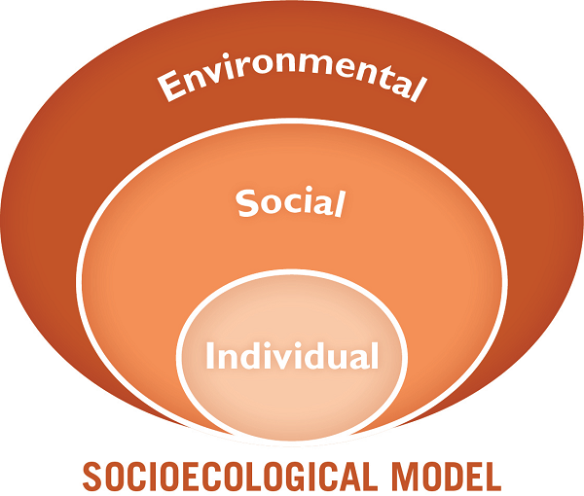

  - Explain that there are many models, such as the socioecological model, that can help us understand human behavior. When we understand if determinants are at an individual, social, or environmental level, we can better adapt our interventions. More theories and models are briefly covered in Handout 10-3: Additional Selected Behavior Change Theories and Models.
  - Explain that while this training does not focus on how to do formative research (such as a Barrier Analysis), understanding the Priority Group’s determinants can help a BCA identify the most significant barriers for why people are not practicing a behavior and enablers that may facilitate adoption of a behavior.
Explain that there is an adaptable, standard questionnaire that can be used to identify what members of a Priority Group view as enablers and barriers for a particular behavior. The results can help BCAs develop a more effective behavior change strategy. Some examples of questions are:
- What makes it hard for you to [insert action or behavior being promoted]?
  - Example: What makes it hard for you to wash your hands with soap before eating?
  - Example: What makes it hard to for you to use quality seeds?
- What would make it easier for you to [insert action or behavior being promoted]?
  - Example: What would make it easier for you to keep your drinking water container covered at all times?
  - Example: What would make it easier for you to plant two complementary crops in the same field?
- Who approves of you [insert action or behavior being promoted]?
  - Example: Who approves of you paying for drinking water?
  - Example: Who approves of you selling extra produce from your garden at the market?
- Who disapproves of you [insert action or behavior being promoted]?
Example: Who disapproves of you paying for drinking water?
Example: Who disapproves of you selling extra produce from your garden at the market?
Ask participants the following questions:
- How does knowing the barriers to behavior change help to promote change? For example, if I know that a barrier for my Priority Group (e.g. mothers of children under 5) is that their husbands do not approve of the behavior, I know that the determinant of perceived social norms is important. Then I can start thinking about an SBC strategy that can be used in husbands’ groups to address this barrier. (Responses should include: It allows us to work on removing the barriers.)
- How does knowing the enablers to behavior change help us to promote change? (Responses should include: It allows us to highlight the enablers that make the change more attractive.)
- SBC Determinants Activity (25 minutes)
  - Explain that it is important to collect information from the Priority Group systematically over time to see if barriers or enablers have changed. For example, access to water may have been a barrier to irrigation and handwashing. However, perhaps this barrier has been addressed through improvements in water infrastructure. If irrigation and/or handwashing rates have not increased, then other barriers may be preventing the uptake of this behavior/practice. Tell participants that while conducting this research requires a specific skill set outside of this training, they will briefly play a matching game about selecting or designing activities. Note: Design activities only after formative research has been completed.
  - Distribute Handout 10-4: Match the Activity to the Determinant to each person. Ask participants to work individually to match the determinants that best correspond to the activities.
  - After 10–15 minutes, or once everyone has completed the exercise, ask participants to share what they have done with a neighbor. Check answers using Handout 10-5: Answer Key for Match the Activity to the Determinant, and take any questions.
  - Discuss with participants what other programmatic decisions they might make once they know the Priority Group’s important determinants and their perceived barriers and enablers to adopting a behavior. (Answers may include: Tailoring a training curriculum to the specific needs/barriers of the Priority Group, creating visual aids, etc.)
  - Ask participants if they have any remaining questions on determinants.
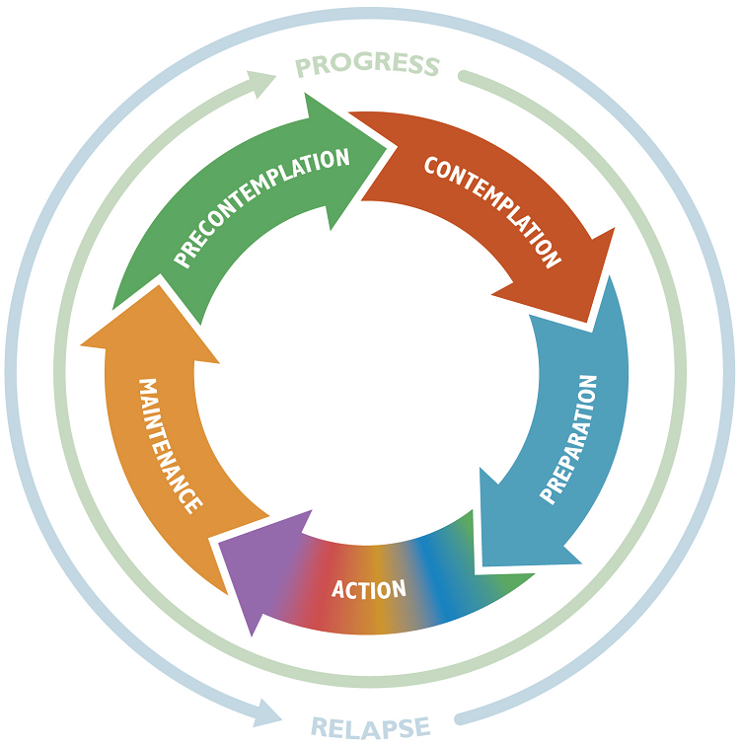
- Stages of Change (20 minutes)
  - Explain to participants that now that they understand more about Priority Groups, determinants, and barriers and enablers to change, they will learn about the stages of change. This SBC model can help us understand where our Priority Group is located along the process of change.
  - Post the prepared flipchart showing the Stages of Change model.
  - Explain that the Stages of Change model describes behavior change as a process and has multiple steps. Change in behavior, especially habitual behavior (such as latrine use or handwashing with soap and water), occurs continuously through a cyclical process.
  - Ask participants to read the table below aloud to review the definition of each stage and give WASH and agriculture-related examples. Alternatively, the facilitator can give examples verbally while pointing to the Stages of Change model.
Description | Agriculture Example | WASH Example
Precontemplation  I do not intend to take action in the near future. I may be unaware that my behavior is problematic or produces negative consequences. I may underestimate the pros of changing behavior and place too much emphasis on the cons of changing behavior. | I am a farmer, and I do not know what mulch is or the advantages of using mulch in my fields. | I do not wash my hands after using the toilet, and I do not think that is a problem.
Contemplation  I intend to start the behavior in the near future. I recognize that my behavior may be problematic and undertake a more thoughtful and practical consideration of the pros and cons of changing the behavior, with equal emphasis placed on both. I may still have mixed feelings about changing my behavior. | I learned that mulch helps keep soil moist and reduces weeds. I am thinking about starting to use mulch in my fields. | I learned that dirty hands can make me and my family sick. I think we might need to start washing our hands with soap.
Preparation  I decide that I am going to change my behavior, and I am getting ready to take action. I start with small steps and make plans to change my behavior. I believe that changing my behavior can lead to improvements and that this is the time to act. | I found out what local materials my neighbors are using for mulch. I decided to use mulch on half of my field, and I figured out how much mulch I would need and where I can collect it. | I spoke to a few friends who have built tippy taps and learned what material they used to build it. Before building the tippy tap, I discussed it with my wife, and we decided to build one together.
Action  I recently changed my behavior, and I intend to move forward with that behavior change. I show this by modifying my problematic behavior or acquiring new improved behaviors. | I tried the mulch on half my field, and the results were great. Now I choose to use mulch on all of my fields. | I started washing my hands with soap and water almost every time I leave the latrine and before eating.
Maintenance  I have sustained my behavior change for a while (defined as more than six months), and I intend to maintain the behavior change going forward. I am working to prevent relapse to earlier stages. | I always make sure there is mulch on my fields to protect the soil. It is now a habit. | I wash my hands every time before eating and after washing. It is now a habit.
Relapse  I have returned to practicing my previous behavior. Relapse is normal, and this can be expected when I try to change a behavior around something that I have been doing for a long time. | I used to use mulch in my fields, but now I do not do it anymore. | I used to wash my hands with soap all the time, but now I do not do it anymore.
Ask participants the following questions:
- Imagine that you are working with a Priority Group that has been certified as “open defecation free” during a community-led total sanitation intervention in the past. However, the members of the Priority Group have started defecating in the open again. What stage is the Priority Group in?
(Answers may include: Relapsed into contemplation or preparation, if they are considering using the latrines.)
- What might happen if we assume the Priority Group members are starting from a precontemplation stage?
(Answers may include: We will not be able to address the factors that contributed to their relapse; participants won’t be interested in the content; they will be bored; and time and resources will be wasted.)
- Imagine that you are working with a Priority Group of farmers who have relapsed and are no longer covering their soil with mulch. What might we want to do?
(Answers may include: Ask questions to understand why they stopped using mulch; and work with them on an action or a step toward using mulch again.)
Ask participants to consider a change they have made in their own lives by reflecting on the following questions:
- How does the Stages of Change Model reflect your experience with changing behaviors?
- How does it differ?
  - Explain that BCAs can design and implement activities based on the stage where people are and help them progressively move toward action and maintenance. Once you understand which stage your Priority Group is in, it is easier to see where they need to move next. Many programs (and program staff) assume that their Priority Group is always at the precontemplation stage, and therefore they focus on awareness-raising. This can cause them to overlook the fact that people are often aware of a behavior’s importance but find it difficult to overcome barriers to practicing it. At the same time, keep in mind that the Stages of Change process is not one-way: People might move back and forth between preparation and action, stop at a particular stage, or revert to the previous one.
  - As a group, read the table below:
If your Priority Group is largely in this Stage of Change | Focus on the following:
Precontemplation  People do not think that their behavior poses a problem, and they have no intention/interest in changing it. For example, a person defecates in the open and thinks that it is no problem. | Raise awareness about the problem and reduce barriers.
Contemplation  People are aware of the problem related to their behavior and are considering taking action, weighing the pros and cons. For example, a person defecates in the open despite being concerned about the health risks it poses. | Highlight a behavior’s benefits, increasing social pressure and helping people to make plans.
Preparation  People are motivated to change their behavior, solve the problem, see the benefits, and plan to take action. For example, a person is convinced of the benefits of a latrine but lacks the materials for its construction. | Reduce barriers that make the behavior more difficult, such as lacking knowledge or high costs.
Action  People started practicing the behavior, experiencing its benefits as well as its costs (such as time, effort, money, and opinions of others). For example, a person started using a low-cost latrine that requires regular maintenance. | Assist with solving problems, providing feedback on results, and facilitating social support.
Maintenance  People practice the behavior, requiring some effort to continue in the long term. For example, a person is comfortable with using the latrine and disagrees with defecating in the open. | Ensure preconditions for sustainability reminders and reinforcement.
Relapse  People might have some or even many small lapses, or even relapses (periods when they go back to their previous behavior). | Evaluate reasons for relapse, provide one-on-one support to reassess motivations and barriers, and plan stronger coping strategies.
  - Your Priority Group’s stage of change can be identified through your baseline survey by assessing people’s awareness (are they aware of the problem?), attitudes (have they considered adopting the promoted behavior?), practices (are they already practicing the behavior?), and the factors that make sustaining the behavior either difficult or easy. This can help BCAs understand their Priority Group’s readiness to change.
- Stages of Change Activity (15 minutes)
  - Explain that one way to practice and become familiar with the Stages of Change model is for participants to think about where they are with different behaviors in their own lives.
  - Place six prepared signs around the training room (spaced apart) representing a stage in the Stages of Change process (precontemplation, contemplation, preparation, action, maintenance, and relapse). Ask participants to stand in the center of the room. Explain that you will read a number of phrases and that each person will move to the stage where they currently find themselves related to their own behavior.
  - Give an example, such as “I wash my hands with soap before eating.” The facilitator can pick 4–5 phrases from among the example phrases in Advanced Lesson Handout 10-6: Stages of Change Exercise, or they can choose different ones customized to the context.
  - After the exercise, ask participants to reflect on this activity and how it might apply to their work. Ask why it would be helpful to know the stage of change the Priority Group is in and how to get this information (Answers may include: Yes, we can plan activities based on where a person is in the process of change. For example, during precontemplation, we may want to focus more on knowledge and information. However, if the person is in preparation, it is about working with them on barriers and enablers. We can get this information using reports, evaluations, and observation and by asking questions.)
  - Summarize by reinforcing that the change process is rarely linear and time-bound (e.g., people may jump from precontemplation to action, or they may remain at one stage for a long time), people start at different stages, and it is common to skip around or even repeat stages.
  - Explain to the participants that they can use the categories of determinants (enablers and barriers), the socioecological model, and the stages of change during all steps in a project. Explain that during the design of a project, they can find out about the barriers and enablers by doing different types of formative research, such as trials of improved practices, interviews, focus group discussions, or a Barrier Analysis study. During a household visit, they also can identify perceived enablers and barriers through a one-on-one discussion with a household member.
  - Ask if anyone has any remaining questions about the socioecological model or the stages of change. Thank participants for their active participation.
- Small Doable Actions (20 minutes)
  - Tell participants that, now that they have talked about social and behavior change, they will consider how this applies to their work as a trainer/facilitator. Ask participants about their project goals. (Answers may include: Reducing malnutrition, improving access to food, or reducing childhood deaths.)
  - Explain that when they organize a cross-site visit, a testimonial, a training event, or a community meeting or when they conduct a home visit, they are conducting an SBC activity. With each activity, they are promoting different behaviors related to the overall goal of the project.
As a BCA, their goal is to increase the number of people who are practicing the desired behavior. To do this, they can:
- Make the ideal or desired behavior or practice easy to do.
- Make the ideal or desired behavior or practice desirable.
- Facilitate people’s access to the knowledge, incentives, skills, time, resources, and social support needed to adopt and maintain ideal or desired practices or behaviors.
  - Explain that it is often difficult for people to change their behavior completely. As discussed in the section on the Stages of Change approach, behavior change is a process. A behavior that might be easy for one person to change might be hard for another person to change.
  - Even when there are many barriers to adoption, we can make the behavior easier to adopt by starting with small doable actions (SDAs). Post the prepared flipchart on SDAs and read the text aloud.
Small doable action (SDA)
A behavior that, when practiced consistently and correctly, will lead to personal and/or life improvement. It is considered feasible by the individual, from their point of view, considering their current practices, the available resources, and the particular social context. Although the behavior may not be an ideal practice, it can be the next best behavior that more households are likely to adopt, because it is considered feasible from their point of view. SDAs can also be effective in the behavior change process as part of the stages of change. An SDA can be a step along the way to adopting the ideal behavior.
Here are some examples of the difference between an ideal practice and an SDA:
- Ideal Practice: Use a 20-liter jerry can with a cap to store drinking water.
SDA: If not possible, use a container with a small neck and cover with the best option available.
- Ideal Practice: Use a hermetically sealed bag to store dried cereals.
SDA: If not possible and using woven bags, double- or triple-bag them to provide extra barriers to pests.
- Ideal Practice: Install a permanent handwashing station that is routinely supplied with soap.
SDA: If not possible, wash hands using a pitcher with a basin and water and soap.
SDA: Use soapy water (OMO mixed with detergent) instead of bar soap.
  - Explain that SDAs can also be shown as illustrations. Here are a few examples on safe water handling and rainwater harvesting.
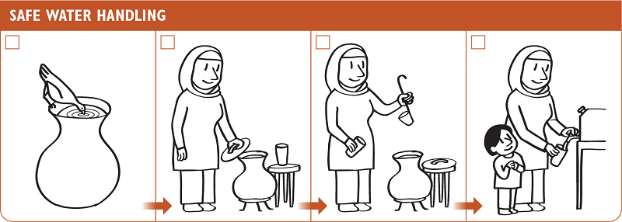

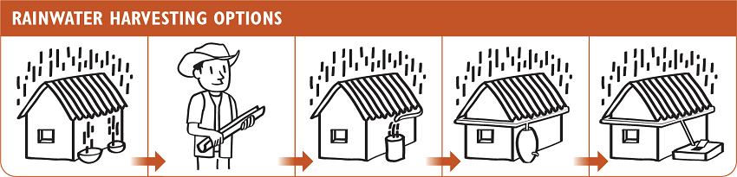
Note that once SDAs are identified, community agents can negotiate with members of the Priority Group to continue to move along the continuum toward the ideal practice. This could include a BCA working with a Priority Group member to assess current practices and to identify agriculture- or WASH-related improvements and supporting the member to identify and overcome barriers to make the SDA easier. This can also include working with a community member to identify preparatory behaviors or behaviors that need to happen before the ideal behavior can be successfully practiced. For example:
- Before practicing handwashing with soap, people need to collect water, buy soap, prepare a handwashing station, and walk to the handwashing location. These are all preparatory behaviors that help get to the ideal behavior.
- Before farmers can use compost to improve their soil, they need to collect food scraps and dried grasses or leaves, turn them periodically to help it decompose, and transport compost to their field. These are all preparatory behaviors that help them get to the ideal behavior.
  - Explain that Lesson 5: Negotiated Behavior Change focuses on negotiating about ideal behaviors or SDAs. Remind participants to be supportive and nonjudgmental when someone is doing something other than the ideal behavior.
- SDA Group Exercise (45 minutes)
  - Divide participants into small groups. Explain that they will have 20 minutes to work together on an SDA exercise. Display the prepared flipchart with the instructions for the SDA group work.
Option 1 (45 minutes)
    - Ask each member of the group to think of a behavior or practice that they are trying to change in their own life (for example, I am trying to arrive to work on time [by 8 a.m.] each day). Discuss the options as a small group and choose one member and their behavior to focus on for the activity.
    - Tell participants to use the questions below to learn more about the group member and the behavior they would like to practice:
    - What makes it hard for you to [insert action or behavior being promoted]?
    - What would make it easier for you to [insert action or behavior being promoted]?
    - Who approves of you [insert action or behavior being promoted]?
    - Who disapproves of you [insert action or behavior being promoted]?
    - Explain that they should then discuss SDAs that are feasible from the point of view of the person in your group who is trying to change their behavior and write or draw ideas on flip chart paper (see example below). After 15 minutes, ask participants to hang the flip charts on the wall. Have a gallery walk and allow participants to ask questions and provide feedback on each flip chart. Alternatively, you can have small-group presentations and discuss these in plenary.
Example for Option 1
Ideal behavior: John arrives to work every day by 8 a.m.
Barriers: Bus is always late, he is tired in the morning because he goes to bed late, and he has to collect water in the morning for bathing.
Enablers: He could choose to take an earlier bus, and his sons are now old enough to help collect water for bathing.
Who approves of the behavior: John’s supervisor and co-workers
Who disapproves of the behavior: Wife
SDAs: John can ask his sons to help collect water in the morning; John can discuss with his wife the importance of arriving at work on time.
Option 2 (45 minutes)
- Divide participants into small groups. If you have multiple sectors (WASH, agriculture, NRM, etc.), group participants with others who work in the same sector.
- Ask each group to pick a behavior or practice that they are promoting in their project and tell them to record the answers to the following prompts on flip chart paper:
    - Choose two reasons (according to their formative research) for why the Priority Group is not adopting this behavior or practice.
    - Brainstorm ways their project could support behavior change by addressing these specific factors or reasons.
    - Define two SDAs that are on the way to the ideal behavior or practice.
- After 15 minutes, ask participants to hang the flip charts on the wall. Have a gallery walk and allow participants to ask questions and provide feedback on each flip chart. Alternatively, you can have small-group presentations and discuss these in plenary.
Example for Option 2
Ideal Behavior: Mothers of children under 5 in the Priority Group wash their hands with soap and water.
Barriers: Priority Group thinks there is not enough time to wash hands, kids are impatient, and/or handwashing is a waste of water.
Enablers: Priority Group thinks soap smells nice, there is enough soap at the house, and/or there is a belief that handwashing protects against disease.
Who approves of the behavior: Other mothers, husband, and children
Who disapproves of the behavior: Mother-in-law
SDAs: The Priority Group creating a tippy tap to use less water when handwashing; the Priority Group creating a small sign next to the toilet to act as a reminder for handwashing
- Wrap-Up (10 minutes)
  - Remind participants that it is important to understand who they are working with and to look at situations from their point of view. Sometimes it is hard to understand why people decide to do things that might not seem “right.” By asking people questions and trying to understand the situation from their point of view, BCAs can develop more effective SBC activities. Encourage participants to see themselves not as experts who share information or give advice, but rather as helpers who promote behavior change among people who already have a lifetime of personal experience and knowledge.
  - The Stages of Change model can help us determine our SBC activity. If our Priority Group are already in action, then they likely have the knowledge and skills to do the behavior and do not need to receive more information or assistance on that topic. The Socioecological model helps us understand at what level the barriers and enablers are influencing our Priority Group and can help us think through activities targeting change at the individual, social, and environmental levels. Explain that when planning activities, BCAs work on maximizing the enablers and reducing the barriers. Acknowledge that they may face many individual, social, and environmental barriers to behavior change in their work. They alone cannot tackle all of the social and structural changes that need to happen to improve food security, decrease poverty, and address negative beliefs held by others.
  - The MMCA training teaches skills that focus on partnership, acceptance, and recognition of existing strengths. These techniques can help them work with individuals and communities to make small changes. Comment that participants are probably already practicing many of these skills every day in their projects.

Handout 10-1: Scenarios A and B
Scenario A
Narrator: Oumar arrives at John’s house and knocks on his door. John opens the door.
Oumar: Hi John, how are you?
John: I’m good, how about yourself?
Oumar: I’m good, as well. Just wanted to stop by and say hi. Have you been using those chlorine tablets?
John (frustrated): Look, Oumar. I appreciate your time, but I don’t want to use them.
Oumar (surprised): But, John, they are good for your health. You need to keep yourself healthy and keep your family healthy.
John: Thanks for the advice. Have a nice day. See you soon.
Narrator: Oumar walks away, uncertain about whether or not John will start using the chlorine tablets.
Scenario B
Narrator: Oumar arrives at John’s house and knocks on his door. John opens the door:
Oumar: Hi John, how are you?
John: I’m good, how about yourself?
Oumar: I’m good as well. How are those chlorine tablets? Have you been using them?
John (frustrated): Look, Oumar. I appreciate your time, but I don’t want to use them.
Oumar (nodding his head): I understand that people may have reasons why they don’t use chlorine tablets. Do you mind if I come in and we chat?
John: Sure.
Narrator: John and Oumar sit down together in the house.
Oumar: Now, tell me a little bit about why you aren’t sure about using these tablets.
John: When we were at the demonstration, I heard that the water tastes funny, and I am worried that I will not like the taste. I also feel that it’s a waste of money, because I know that the water we use is fine for us. I don’t even know where I am supposed to buy these tablets.
Oumar: Do you think there would be any reason to use them?
John: Well, I know they keep the kids heathier. My neighbor James started using them and his family was healthy all through the cholera times. But I’m still unsure.
Oumar: Well, how about next time I bring some tablets and together we can try a drink of treated water at the right dosage? People usually complain about the water when they add too much chlorine. We’ll add just the right amount, so the taste isn’t so strong.
John (pauses to think): Sure, bring those tablets with you next time. In any case, I know my wife wants to use them.

Handout 10-2: Important Determinants That Influence Behavior
Always explore the first four determinants in formative research. These four are commonly found to be the most important for health/nutrition behaviors. Access is also very important for some WASH behaviors.
- Perceived self-efficacy/skills
- An individual's belief that they can do a particular behavior given their current knowledge and skills.
- The set of knowledge, skills, or abilities necessary to perform a particular behavior.
- Perceived social norms
- The perception that people important to an individual think they should do the behavior.
- Norms have two parts: who matters most to the person on a particular issue, and what the person perceives those people think they should do.
- Perceived positive consequences
- The positive things a person thinks will happen as a result of performing a behavior.
- Asking participants questions related to positive consequences may reveal advantages (benefits) of the behavior, attitudes about the behavior, and perceived positive attributes of the action.
- Perceived negative consequences
- The negative things a person thinks will happen as a result of performing a behavior.
- Asking participants questions related to negative consequences may reveal disadvantage of the behavior, attitudes about the behavior, and perceived negative attributes of the action.
- Perceived action efficacy
- The belief that, by practicing a behavior, they will avoid the problem (e.g., if I sleep under a mosquito net, I won’t get malaria). Sometimes talked about as part of perceived positive consequences.
- Access
- Access has many different facets, including the degree of availability of the needed products (e.g., fertilizer, soap, condoms) or services (e.g., veterinary services, immunizations) required to adopt a given behavior.
- Includes barriers related to cost, geography, distance, linguistics, cultural issues, and gender.
- Perceived susceptibility/risk
- A person's perception of how vulnerable or at risk they feel about a particular problem (e.g., the possibility that their crops could have cassava wilt).
- Perceived severity
- Belief that the problem (which the behavior can prevent) is serious (e.g., a farmer may be more likely to plant trees if he thinks soil erosion is a serious problem).
- Cues for action
- The presence of reminders that help a person remember to do a particular behavior (such as handprints on a handwashing station outside of a latrine) or the steps involved in doing the behavior (such as memory aids).
- Key powerful events that trigger a behavior change in a person (e.g., a brother-in-law dying of cholera, which leads to a person washing their hands regularly).

- Policy
- Laws and regulations (local, regional, or national) that affect behaviors and access to products and services (e.g., the presence of good land title laws making it more likely for a person to take steps to improve their farmland).
- Culture
- The set of history, customs, lifestyles, values, and practices within a self-defined group. This may be associated with ethnicity or lifestyle and often influences perceived social norms.
- Perceived divine will
- A person’s belief that it is God’s will (or the gods’ wills) for them to have the problem and/or to overcome it.
- Includes the Priority Group’s perception of what their religion accepts/rejects and perceptions about the spirit world or magic (e.g., spells, curses).
- Numerous unpublished Barrier Analysis studies have found this determinant to be important for many behaviors (particularly for health and nutrition behaviors).
Note: Universal motivators are factors that motivate most people, irrespective of other variables. They are usually used in mass media activities (e.g., billboards, posters, public service announcements). Universal motivators include love, security, comfort, recognition, success, freedom, social acceptance, status, and power.
This list of determinants is from Kittle, B. 2017. A Practical Guide to Conducting a Barrier Analysis (2nd ed.). New York: Helen Keller International. Available at: www.fsnnetwork.org/sites/default/files/final_second_edition_practical_guide_to_conducting_barrier_analysis.pdf. This handout was adapted from materials originally developed by AED and from the Food for the Hungry Barrier Analysis Manual.

Handout 10-3: Additional Selected Behavior Change Theories and Models
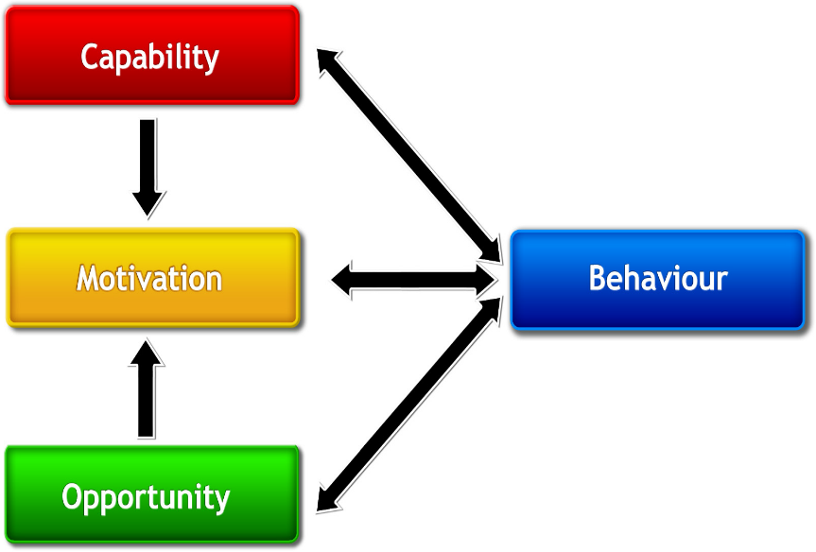
COM-B Model
The COM-B model is useful because it captures most of the common elements across a range of existing behavior change models. The model states that a person will practice a behavior (e.g., adopt an agriculture practice) if they have sufficient capability, opportunity, and motivation at the right time and place. If any of these elements are not present or are insufficient, the person will not practice the behavior.
When applying the model, project designers can determine which specific aspects of each element are relevant to a specific practice among a target group in a given context. Designers and implementers can better ensure that project interventions effectively increase capability, motivation, and opportunities to practice a behavior and, through that, facilitate adoption and maintenance of the practice.
Source: USAID Advancing Nutrition, ANH meeting presentation, June 2010
Diffusion of Innovations
Diffusion of Innovations seeks to explain how new ideas, practices, or products that are perceived as new are taken up by different groups in a population. Diffusion of Innovations considers what qualities make an innovation spread, the importance of peer networks, and what different groups of users’ needs are. This model, which has often been associated with “technology transfer” approaches, reflects that some groups are early adopters of new practices or technology because of different capability, motivation, and/or opportunity, while others wait until they see their peers benefiting from innovations before they adopt those innovations themselves.
Current applications of this model to SBC design emphasize that adoption of new techniques and technologies is not always top-down. They may be local solutions that are scaled up. Most people who “adopt” a new technology “adapt” it to make it easier and more beneficial to them. Programmers should continually try to capture these adaptations to see if they can improve the technique or technology overall and prove useful to others who can benefit from adoption.
Source: Rogers, E. M. (2003). Diffusion of Innovations. New York: Free Press.
IBM WASH Model
The Integrated Behavioral Model for Water, Sanitation and Hygiene, a multilevel, multifactor ecological model, is for designing and evaluating behavior change interventions involving:
- Frequently repeated health behaviors (e.g., washing hands with soap or using a latrine).
- Use of enabling technologies (e.g., handwashing station, latrine, safe food cover, and/or cook stove).
It can help improve our understanding of the factors that influence water, sanitation and hygiene practices in infrastructure-constrained setting.
Integrated Behavioral Model for Water, Sanitation and Hygiene Model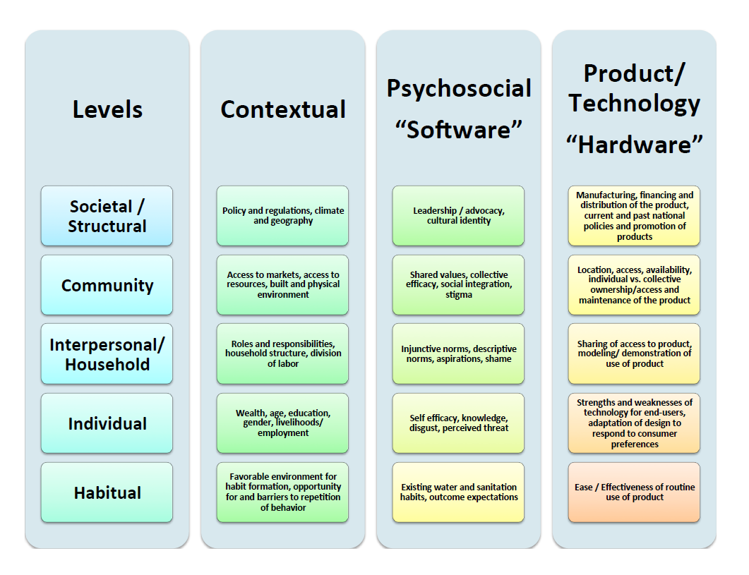
Source: Dreibelbis R et al. (2013) The Integrated Behavioural Model for Water, Sanitation and Hygiene: a systematic review of behavioural models and a framework for designing and evaluating behaviour change interventions in infrastructure-restricted settings, BMC Public Health Oct 26;13:1015. doi: 10.1186/1471-2458-13-1015

RANAS (Risk, Attitudes, Norms, Ability, and Self-Regulation) Model
The RANAS model draws from different theories of social and health psychology, such as the theory of planned behavior and the health action process approach. The RANAS model provides a tool to analyze the different determinants of behavior based on quantitative data.
Behavior A
Intention
Use
Habit
Behavior B
Intention
Use
Habit
Attitude factors:
Beliefs about costs and benefits
Feelings
Norm factors:
Others’ behavior
Others’ (dis)approval
Personal importance
Ability factors:
How-to-do knowledge
Confidence in performance
Confidence in continuation
Confidence in recovering
Self-regulation factors:
Action planning
Action control
Barrier planning
Remembering
Commitment
Risk factors:
Health knowledge
Vulnerability
Severity
Persuasive behavior change techniques
Norm behavior change techniques
Infrastructural, skill & ability behavior change techniques
Planning & relapse prevention behavior change techniques
Information behavior change techniques
Social context
Physical context
Personal context

Source: Contzen, N., & Mosler, H.-J. (2015). The RANAS approach to systematic behavior change. Methodological Fact Sheet 1. Dübendorf, Switzerland: Eawag, Swiss Federal Institute of Aquatic Science and Technology.
Note: More resources can be found at: www.thecompassforsbc.org/sites/default/files/strengthening_tools/SBCC%20Theory%20PowerPoint_August%202011.pdf

Handout 10-4: Match the Activity to the Determinant
Instructions: Match the determinant in the right column with the appropriate programmatic activity in the left column.
Examples of WASH and Agriculture/NRM Activities
Example of Activity | Determinant
- Demonstrate what happens when you leave food uncovered near a pile of feces. | - Perceived self-efficacy
- Show mothers pictures of their babies before and after the program. | - Perceived social norms
- Advocate for controls and regulations on pesticides that limit the import of illegal products. | - Perceived positive consequences
- Tie soap from a string next to the tippy-tap. | - Perceived negative consequences
- Survey farmers regarding the percentage who suffer land erosion problems. | - Access
- Conduct community monitoring to show the high percentage of children who are malnourished. | - Cues for action/reminders
- Persuade local shops to sell seeds. | - Perceived susceptibility/risk
- Weigh babies at the end of the two-week health education session. | - Perceived severity
- Demonstrate and have hands-on practice on applying new skills, such as tree planting, installing drip irrigation, etc. | - Perceived divine will
- Convene discussions with older women about how mothers used to carry their babies with them everywhere, to remind current mothers of the “old ways.” | - Policy
- Work with religious leaders to help farmers realize that crop rotation and “resting the land” is in line with recommendations in their holy scriptures. | - Culture
- Orient village elders and farmers’ husbands to the benefits of adopting the new practices. | - Perceived action efficacy

Handout 10-5: Answer Key for Match the Activity to the Determinant
Example of Activity | Determinant
- Demonstrate what happens when you leave food uncovered near a pile of feces. | d) Perceived negative consequence
- Show mothers pictures of their babies before and after the program. | c) Perceived positive consequences
- Advocate for controls and regulations on pesticides that limit the import of illegal products. | j) Policy
- Tie soap from a string next to the tippy-tap. | f) Cues for action/reminders
- Survey farmers regarding the percentage who suffer land erosion problems. | h) Perceived severity
- Conduct community monitoring to show the high percent of children who are malnourished. | g) Perceived susceptibility/risk
- Persuade local shops to sell seeds. | e) Access
- Weigh babies at the end of the two-week health education session. | l) Perceived action efficacy
- Demonstrate and have hands-on practice to apply new skills, such as tree planting, installing drip irrigation, etc. | a) Perceived self-efficacy
- Convene discussions with older women about how mothers used to carry their babies with them everywhere, to remind current mothers of the “old ways.” | k) Culture
- Work with religious leaders to help farmers realize that crop rotation and “resting the land” is in line with recommendations in their holy scriptures. | i) Perceived divine will
- Orient village elders and farmers’ husbands to the benefits of adopting the new practices. | b) Perceived social norms

Handout 10-6: Stages of Change Exercise
The facilitator can pick four to five examples from this list to use during the exercise or use other appropriate examples for the training context:
- Wash my hand with soap and water before eating
- Identify barriers and enablers in behavior change
- Practice active listening
- Exercise 30 minutes a day
- Treat my colleagues with respect
- Ask open-ended questions
- Eat at least three servings of fruits daily
- Eat at least three servings of vegetables daily
- Make decisions jointly with my partner
- Treat my water before drinking
- Drink water from a protected source
- Keep my drinking water container covered at all times
- Wash all fruits and vegetables before eating them
- Reheat cooked food before eating it
- Show up to work on time
- Submit my work reports by the deadline
- Get eight hours of sleep a night
- Use quality seed varieties in my fields
- Use quality improvement and verification checklists in my work
- Use a Learning Needs & Resources Assessment when developing a training

Advanced Lesson 11: Understanding Gender and Gender Bias
Achievement-Based Objectives
- By the end of this lesson, participants will have:
- Differentiated between sex and gender
- Defined gendered social norms and behaviors, patriarchy, and gender equality
- Reflected on their own biases relating to gender
Duration
3 hours
Materials Needed
- Flip chart paper, markers, sticky-notes (four different colors), and colored pens
- A stack of A4 blank paper (four half sheets per participant)
- A few pictures of men and women who have performed nontraditional gender roles and succeeded (locally relatable is better, but some suggestions are provided in this manual)
- Prewritten flip charts:
- Definitions of Sex and Gender
- Women must…
- Women must not…
- Men must…
- Men must not…
- Definition of Patriarchy
- Handout 11-1: Men and Women and Social Norms (one copy per participant)
- Handout 11-2: Photos of Men and Women (one copy)

Why This Lesson?
Societies all over the world have assigned certain behaviors, rules, and assumptions based on gender. For BCAs, it is important to understand these “unwritten” gender rules in the communities in which they work, because these rules create (intentionally or unintentionally) discriminatory social practices, especially against women. As a result, women cannot participate fully and actively in activities and decisions that affect their lives. In addition, BCAs need to be aware of gender biases and prejudices they themselves hold, to ensure that their programs are as inclusive and as participatory as possible.

Advance Preparation
Prepare the following flip charts:
- Definitions of Sex and Gender (Task 2)
- Women must… (Task 3)
- Women must not… (Task 3)
- Men must… (Task 3)
- Men must not… (Task 3)
- Definition of patriarchy (Task 4)
For Task 1, cut sheets of A4 paper in half so that each participant will have four pieces of paper.
For Task 2, collect two culturally appropriate photos, one that looks traditionally male and one that looks traditionally female. You can collect these during a community visit, on the internet, or by asking your organization for a few photographs. If desired, collect pictures of locally relevant photos and examples of men and women who working in nontraditional gender roles to use in Task 4 (instead of the pictures in Handout 11-2: Photos of Men and Women).

Tasks
- Warm-Up Activity (15 minutes)
  - Give each participant four half-sheets of A4 paper. Ask them to draw one of the following on each separate piece of paper: a pilot, a teacher, a politician, and a caregiver. Tell participants to give each person they draw a name. Tell the participants that the drawing can be quick and does not have to be perfect. Give participants about 15 minutes, and then collect the drawings for use in Task 4.
  - If there is more than one facilitator, have someone tally the number of male- and female-named pictures that are drawn for each profession. If the facilitator is not familiar with male and female names, ask a participant to help clarify. Put the drawings and tally aside for an exercise in Task 4.
- Understanding Sex and Gender (30 minutes)
  - Show the two culturally appropriate photos you collected before the lesson, one male and one female. Ask participants whether the people in the photos are male or female. Ask them why they are male or female (i.e., what basis they have for telling the difference). Participants may mention nonbiological things such as clothes, jewelry, or shoes. They may also mention physical features like having a beard or moustache, having long hair, or having breasts. Write all responses on a flip chart.
  - Explain to participants that, based on our cultures, we have ideas of what females and males look like (for example, the clothes they wear or how they style their hair). We are deciding from these photos (just based on what we can see on the outside) whether these people are male or female. What we cannot see, however, are the biological differences that define their sex or how they define their gender.
  - Ask participants if they know the difference between sex and gender. Ask volunteers to share their answers.
  - Explain the differences between gender and sex by showing the below definitions on a flip chart:
Definitions of Sex and Gender
Sex: Biological differences between female and male bodies, hormones, and organs
Gender: Traits or characteristics that society, culture, or communities have defined as male or female (such as norms, roles, and relationships of and between groups of women and men)
(Note: The definition of gender is from the World Health Organization, at www.who.int/gender-equity-rights/understanding/gender-definition/en/.)
  - Ask participants to look at the following table. You can discuss each point as a group, encouraging participants to provide local and relatable examples to develop a common understanding.
Sex | Gender
- Biological differences between female and male bodies, hormones, DNA, and organs (such as the female vulva and uterus and the male penis and testicles).  - Cannot be changed without medical intervention.  - Universal and does not vary according to geography, race, caste, ethnic group, tribe, or culture.  - Does not change depending on location and time.  - Most people are assigned male or female. | - Traits or characteristics that society, culture, or communities have defined as male or female (such as norms, roles, and relationships of and between groups of women and men).  - Includes how society expects you to speak, dress, and behave, based on your sex.  - Can be changed  - Varies according to time, place, race, caste, and community.  - Not all individuals follow established gender norms and may not fit into male or female gender categories.
  - Thank participants for contributing to the discussion. Ask them what remaining questions they have about the differences between sex and gender.
  - Tell participants that these terms will be used throughout the lesson, and they will discuss their own perceptions and biases related to gender and how that affects their work as BCAs.
- Understanding Gender Discrimination (45 minutes)
  - Take participants through the Option 1 or Option 2 activity below. If you are also doing Advanced Lesson 12: Shared Household Roles and Responsibilities, you may want to do Option 2, for activity variety.
Option 1: Women and Men “Must” and “Must Not”
    - Hang up the four flip chart you made with the headings: “Women must…,” “Women must not…,” “Men must…,” and “Men must not….”
    - Have participants separate into pairs. Give each pair four sticky notes of different colors. Assign one color to one of the titles above (for example, blue is “Women must…,” red is “Women must not…,” green is “Men must…,” and yellow is “Men must not…”).
    - Based on their understanding of gender roles and the local practices in their community, ask the pairs to write one sentence to complete each of the four phrases (for example, “Women must cook” or “Men must not touch menstruating women”).
    - Give the pairs 5–7 minutes to write their four sentences on sticky notes. Once finished, ask them to stick the notes onto the appropriate flip charts. As participants bring their notes up, group the responses based on similar sentences. (Note: You can also do this activity verbally, with participants sharing their answers aloud instead of writing them.)
    - Read aloud some of the answers from each flip chart. Ask participants:
    - What do they notice about what was written under the “must” category for both men and women?
    - What do they notice about what was written under the “must not” category for both men and women?
    - Tell participants that much of what men and women are expected to do based on cultural norms can affect their access to work and to services in the community. Ask participants:
    - What kind of work holds the most status in your community? (Answers may include: Earning a wage, harvesting cash crops, having a political position.) Who mostly does that work? Are there any answers in our must/must not responses that prohibit women from engaging in this work?
    - What kind of work provides the most opportunities to meet people and exchange information? (Answers may include: Working at a shop, holding a political position.) Who mostly does that work? Are there any answers in our must/must not responses that prohibit women from engaging in this work?
    - What kind of work sustains people in their day-to-day life? (Answers may include: Cooking, cleaning, collecting water, caregiving.) Who mostly does that work? Are there any answers in our must/must not responses that assign women this work?
    - Summarize this discussion by noting that our cultural norms and perceptions of what men and women must/must not do lead to differences in access and opportunities for women.
Option 2: Man Box and Woman Box
    - Divide participants into same-gender groups of four to five people. Ask half the groups (including at least one all-male group) to discuss “acting like a man” and half (including at least one all-female group) to discuss “acting like a woman.”
    - Ask the groups to discuss and write discussion points on sticky notes. Ask the “men’s group” to discuss and answer the following question:
    - What are examples of messages that men/boys are given when they are told to “act like a man”? (For example, they must be strong.)
    - Ask the “women’s group” to discuss and answer the following question:
    - What are examples of messages that women/girls are given when they are told to “act like a woman”? (For example, they must be polite to everyone.)
    - After 10 minutes, bring the groups back together and have them put the sticky notes on one of two flip charts (one flip chart paper for the men’s groups and one for the women’s groups). Invite them to look at the messages posted by all groups.
    - Bring the group together and ask how the messages create barriers for women and men or harm women and men.
    - Explain that these messages can be seen as social rules about how women and men should act. We can think of these rules as “boxes” that we are supposed to live within. Draw a box around the messages for the men’s groups and another box around the messages for the women’s groups. Call these boxes “The Man Box” and “The Woman Box.”
    - Ask participants:
    - What happens to men and women/boys and girls who do not conform to the messages inside the box?
(Answers may include: They are not accepted by their community, their families punish them for not acting a certain way.)
    - What tools, strategies, and techniques do others use to keep men and women/boys and girls inside the box?
(Answers may include: They do not have equal access to education, employment opportunities, limiting mobility, saying things like this is how it has always been done.)
    - Summarize the activity by noting that our perceptions of what men and women should/should not do (our “boxes”) lead to differences in access and opportunities, particularly for women.
- Understanding Gender Discrimination and Patriarchy (30 minutes)
  - Ask participants to form pairs with someone of their same gender and turn to Handout 11-1: Men and Women and Social Norms. Read the list and add any additional norms that relate to the community they are from or work in. After five minutes, bring the groups back together and ask a few volunteers to share the additional norms they listed.
  - Explain how these norms result in women working more than men, having less control over decisions that affect their lives, and having fewer opportunities to receive an education and earn an income.
  - Ask participants how they learned the “must” and “must not” rules (or the contents of the “man box” and the “woman box”) from the previous activity. Encourage participants to share experiences from their past when they were instructed about appropriate gender roles. (Answers may include: From family members, from religious leaders, by observing others, or through radio, television, or advertisements.) Thank participants for sharing their responses.
  - Explain that our collective belief in patriarchy is what fundamentally puts men above women. Post the flip chart with the definition of patriarchy and read it aloud:
Definition of Patriarchy
The system that promotes the belief that men and boys are better, stronger, more powerful, and more intelligent than women and hence are considered more valuable than women and girls.
  - Explain that most communities around the world follow patriarchal rules. Both boys and girls are born into patriarchal communities, and they grow up learning the rules and cultural norms related to patriarchy. This means that both men and women can have patriarchal beliefs. Having these beliefs can lead to actions by both women and men that discriminate against girls and women. For example, in many communities, women discriminate against girls and women. Mothers decide to feed their sons and husbands better than their daughters or themselves. They may do this because they believe that the work their sons and husbands do is more labor intensive, dangerous, or important than their own.
  - Ask participants if they have seen other ways in which men or women discriminate against girls and women in their communities. (Answers may include: Women not being allowed to work outside the home, and parents deciding to send their sons to school over their daughters.) Ask why they think that is the norm. Collect answers on a sheet of flip chart paper.
  - Ask participants if they also see patriarchal beliefs that lead to discrimination against boys and men in their communities. (Answers may include: Boys and men are discouraged from showing emotions even when they are hurt or lose a loved one, and men feeling pressure to be the main provider for their household.) Collect answers on a sheet of flip chart paper.
  - Explain to participants that patriarchal beliefs in our communities lead to the norms that discriminate against women and men, girls and boys in different ways. Men and women may have different roles and responsibilities in the household or community. However, patriarchal beliefs lead us to value one gender’s work over another’s. Historically, communities value the work of men more than they value the work of women.
  - Explain to participants that gender equality is when women and men enjoy the same rights, resources, opportunities, and protections. Gender equality is therefore the equal valuing by society of the similarities and the differences of men and women and the roles they play. Gender equality is based on women and men being full partners in the home, community, and society and should never be understood as a fight between men and women. Gender equality is a fight against strong patriarchal beliefs (which both men and women can hold) and a fight for strong gender equality beliefs.
  - Note to participants that BCAs may not be able to change all the social norms and beliefs in the communities they work in. However, there are behaviors that can be promoted to encourage gender equality (for example, encouraging mothers to ask their older sons to fetch water). Ask if participants can think of behaviors they are promoting or could promote that work toward gender equality, without putting boys, girls, men, or women at risk. Write these on a flip chart, and thank participants for sharing.
  - Ask if there are any remaining questions related to patriarchy and gender discrimination. Note that as BCAs, it is important that they understand the gender discriminations, roles, responsibilities, and norms in our communities. Knowing these helps promote behaviors that work toward gender equality.
- Examining Our Own Gender Bias (30 minutes)
  - Project the pictures from Handout 11-2: Photos of Men and Women (or other locally relevant photos that have been collected). If there is not a projector, pass around the printed versions. For each picture, ask a few volunteers to guess what the person’s job is. Once participants answer, ask them to explain their response. For example, if someone says Picture 1 looks like a doctor, ask them why. Record the answers for each picture on a sheet of flip chart paper.
  - Bring out the pictures drawn by all of the participants during Task 1. Show the tally on a sheet of flip chart paper and tell participants how many pictures were drawn male and how many were drawn female for each profession. Ask participants if they see any trends. (Answers may include: We had more male numbers for pilots and politicians and more female numbers for teachers and caregivers.) Ask participants what made them assign a male name or a female name to their drawings. Invite a few participants to share their responses.
Tell participants about the people in pictures in Handout 11-2: Photos of Men and Women:
- Picture 1: Arunachalam Muruganantham is pioneer of technology for making low-cost sanitary pads for women in rural India. One of the most well-known trainers for making sanitary pads.
- Picture 2: Clark Gayford is fiancé of New Zealand Prime Minister Jacinda Arden. He is a former radio broadcaster and current homemaker and primary caregiver for their daughter.
- Picture 3: Ramdevi Shrestha is a retired driver of the former Royal Family of Nepal.
- Picture 4: Ayesha Farooq is the first female fighter pilot of the Pakistan Army.
  - Ask participants if they notice any differences in what they thought the person’s job was and what it really is. Why do you think we have those perceptions?
  - Explain to participants that this activity is an opportunity to think about our own gender biases, meaning our own ideas of men’s and women’s abilities to do certain things. Note how our gender bias may have influenced our drawings and the names we assigned to the different professions.
  - Clarify to participants that we have these biases because of socialization, which is the process by which, after birth, social and cultural influences start to create boys and girls/men and women. Differences in cultural treatment, clothing/toys, and responsibilities given to boys and girls gradually lead to differences in their socialization.
  - Because most of our societies are patriarchal, all of us develop some bias toward what we think women and men should do. We tend to assign responsibilities that we think are more powerful, important, or intellectual to men and those that are considered weak, soft, or nurturing to women.
Ask participants why it is important for BCAs to be aware of their gender biases. Allow time for responses. If participants do not mention the following, note that being aware of their own gender bias will help BCAs to:
- Think of participatory, inclusive, and innovative solutions for behavior change (for example, ensuring that men and women are equally represented in trainings and community meetings, that women actively participate in decision-making processes, that information is disseminated and discussed with both husbands and wives during home visits, etc.). Consider gender norms as they relate to behavior change goals, such as how handwashing by children can be encouraged by all members of the family, not just by the mother.
- Recognize the potential ways men and women can act outside of their gendered roles (for example, discussing possibilities as to how women can participate in activities typically done by men, such as construction or mechanization of agriculture, or how men can be part of activities normally done by women, such as cooking, cleaning, or caregiving).
- Ensure that the practices they are promoting do not discriminate against or marginalize a group of people. For example, selecting only women to participate in nutrition initiatives reinforces the role of women as primary caregivers. In addition, promoting new agriculture initiatives without understanding the amount of work involved might be adding work to women’s already heavy work burden.
  - Invite participants to share examples from their work.
- Wrap-Up (10 minutes)
Summarize the discussion by asking the following questions:
- As BCAs, what is your role in understanding gender and gender bias?
- What from this lesson will you take forward into your work?
- What remaining questions do you have around patriarchy, gender biases, or the other topics covered in this lesson?

Handout 11-1: Men and Women and Social Norms
Women | Men
Perform tasks considered “small,” such as cooking, cleaning, weeding, fetching water, etc. | Perform tasks considered “big,” such as plowing, harvesting, getting an education, having a job, etc.
Work is unpredictable and continuous, with no rest (such as caregiving). | Work has a predictable schedule, with some rest (such as seasonal work).
Work is less visible and not celebrated/acknowledged (such as household chores or agricultural work, like weeding). | Work is visible and celebrated/acknowledged (such as earning a salary, harvesting, and bringing food home).
Put themselves last (such as women serving everyone else before eating). | Put themselves first (such as prioritizing men’s needs when they are the primary provider in the family).
Perform community support work (such as weddings, funerals), but have little social status in relation to community political work. | Mostly do community political work, which gives them social status.
Have limited mobility and stricter rules on where, when, and whom they can associate with. | Have more freedom to move around as they wish.
Have limited decision-making power in the household, such as in areas of education, marriage, or income earning. | Have main decision-making power.
Must follow many social rules in terms of their clothing, food and alcohol choices, and behavior toward others. | Follow fewer social rules and have more freedom over their clothing, food and alcohol choices, and behavior toward others.
Additional norm: | Additional norm:
Additional norm: | Additional norm:
Additional norm: | Additional norm:
Additional norm: | Additional norm:
Additional norm: | Additional norm:

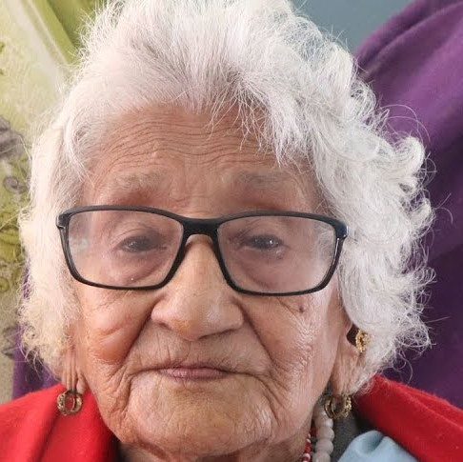
Handout 11-2: Photos of Men and Women
Picture 4: shorturl.at/ixzTU
Picture 3: shorturl.at/ikEJ8
Picture 2: shorturl.at/oDN35
Picture 1: shorturl.at/hkKO2
Picture 2
Picture 3
Picture 4

Advanced Lesson 12: Shared Household Roles and Responsibilities
Achievement-Based Objectives
At the end of the session, the participants will be able to:
- Describe how household roles and responsibilities are divided along gender lines
- Define the four types of gender roles
- List advantages of sharing of household work among family members
Duration
3 hours (including discussion and exercise)
Materials
- Flip chart paper, markers, sticky notes, tape, a pillow or other prop that can be used as a baby, a bucket or water can
- “The Impossible Dream” video, laptop, projector, and screen (if using video)
- Prewritten flip charts:
- What women mostly do…
- What men mostly do…
- Handout 12-1: Division of Household Roles and Responsibilities (one copy per participant)
- Handout 12-2: Role-Play Example (three copies)
- Handout 12-3: Role-Play Practice (one copy per participant)

Why This Lesson?
All over the world, to different degrees, women are primarily responsible for unpaid work such as household chores and caregiving, while men are primarily responsible for paid work or earning for the family. Women work more hours than men do on a daily basis, which affects their health and the time available for them to participate in community, educational, and income-earning activities. Additionally, women’s work is mostly confined in and around the household, which limits their mobility and exposure. This lesson will help BCAs understand the impact that this division of roles and responsibilities has on different members of the household and how to consider a range of factors when facilitating behavior change.

Advance Preparation
Prepare two flip charts titled what “What women mostly do…” and “What men mostly do...”
Get the required props for the skit (a cushion/folded blanket and a bucket/water can). Gather locally relevant examples of women’s burden of household work and of couples who share household work for use in Task 2.
Before this lesson, identify two volunteers (preferably one male and one female) to act out the role play in Task 4.

Tasks
- Warm-Up Activity (10 minutes)
  - Explain to participants that they will be discussing daily activities in the household and community.
  - Ask for a female volunteer from among the participants. Ask her to imagine that she is a man (for example, someone from her household, such as her husband, father, or brother). Ask her to describe, step-by-step, a typical day for that man, using “I” statements (for example, “I wake up at 6 AM, and I go to the bathroom. Then I bathe, using the pot of water that my wife heated up. Then I…”). Encourage the volunteer to use “I” statements, as this will elicit laughter and help participants relax. After the volunteer has finished, thank her and ask her to sit down.
  - Next, ask a male volunteer to do the same exercise, imagining that he is a woman from his family (mother, wife, sister). Ask him to describe, step-by-step, a typical day for that woman, using “I” statements (for example, “I get up at 5 AM, and I go outside and collect water to heat up for my husband’s shower. Then I go to the chicken coop and collect eggs. Then I…”). After the volunteer has finished, thank him and ask him to sit down.
  - If the training participants are all men or all women, ask one volunteer to share what happens, step-by-step, in a woman’s day and ask one volunteer to share what happens in a man’s day.
  - Ask participants what they noticed about how the man and the woman in this activity spent their day. Do you agree/disagree with this representation? Is there anything you would change or add? Explain that during this lesson, we will be talking about roles and responsibilities in the household.
- Understanding Household and Community Roles and Responsibilities (45 minutes to 1 hour)
  - Optional: If there is time and you have a projector, show a short video as an introduction: The Impossible Dream (www.youtube.com/watch?v=t2JBPBIFR2Y&frags=pl%2Cwn).
  - Hang the two flip charts titled “What women mostly do…” and “What men mostly do…” on the wall in the front of the room. Explain that each participant is to write one activity that women mostly do and one that men mostly do. Ask participants not to repeat an activity that is already written. Explain that the reason for writing “mostly” is because we are trying to discuss what is the norm, not the exception. Encourage participants to think of activities related to household tasks, community work, agriculture, WASH, and relaxation/leisure. Give every participant a chance to write on each of the flip charts. Note: You can also have participants get into small groups and act out the activities that “men mostly do” and “women mostly do.” In this adaptation, the facilitator can write a list on the flip chart.
  - After everyone has finished, look at the list and add any roles that are missing (e.g., if participants focus mainly on the household roles, you may need to add community roles). Explain to participants that there are four types of gender roles: productive, reproductive, community management, and community political roles.
Explain each of the following roles. Ask participants to share examples of each kind of role after you explain it.
- Productive roles: These are roles done by men and women for payment in cash or in kind, such as production, trade, and labor wages. Because these activities are usually more visible and earn an income, they are often seen as more important. Many people think that men should be active in and lead productive roles.
- Reproductive roles: These roles include household activities, such as cleaning, cooking, caring for children and the elderly, and giving birth. These activities are often not valued as highly as productive roles because they do not generate income. Generally, the women and girls in the family do reproductive work. However, besides giving birth and breastfeeding, all other work could also be completed by men.
- Community management roles: These are roles done for the benefit of the community. They include helping out during emergencies, births, weddings, and deaths, as well as contributing labor for important construction work, helping repair and maintain important public resources, and being active in religious or cultural activities. These activities do not necessarily provide monetary returns or much respect. Men and women are typically both involved in community management roles.
- Community political roles: These roles include local government and political activities, distribution of resources and opportunities, and leadership of projects and events for community benefit (for example, water committee leaders or village chiefs). While these activities do not provide a direct economic benefit, they provide respect and political opportunities. These roles can also provide an opportunity to enter national politics. Men are typically more involved in these roles than women are.
  - After this discussion, refer back to the list of activities that women and men mostly do. With participants calling out the answers, mark each activity as productive (P), reproductive (R), community management (CM), or community political (CP) by writing the initials next to each activity.
  - Allow participants to ask questions and provide more examples, if needed.
  - Ask participants why it might be important to understand the different types of roles in their community. (Answers may include: It is important to understand these because the roles carry different weight and power in our communities. This can affect how we engage with community members and facilitate behavior change.) Note to participants that they will discuss after the next activity their role as BCAs in challenging these gender roles, norms, and power structures.
- Comparing Levels of Household Roles and Responsibilities (1 hour)
  - Divide participants into groups of 5–6 people. Pass out a copy of Handout 12-1: Division of Household Roles and Responsibilities to each participant. Explain to participants that this exercise is to get them thinking about household roles and responsibilities in their communities and how much work different household members do. They will have 20 minutes to read the list of roles and, for each one, fill in the chart together.
  - Ask the group to think of who normally does each task (men or women) in their community. If they want, groups can get more specific than men/women by writing the role within the household (e.g., mother-in-law, father, etc.) but ask them to also note the gender of the person. Explain that the tasks/roles listed are suggestions. Participants can add, remove, or change the tasks. Ask them to focus mostly on tasks related to agriculture and WASH when they prepare this table.
  - After 20 minutes, bring participants back together. Ask participants to look at the “responsibility,” “time,” and “frequency” columns for Section 1. Were there any trends you noticed for “responsibility” in Section 1? How about for the “time” or “frequency” columns? Allow participants time to share information, and see if any groups had different answers.
  - Ask participants to look at Sections 2 and 3. What trends do they notice for “responsibility,” “income generating,” or “time” in these sections?
  - If it does not come up in discussion, note to participants that Section 1 likely demonstrates that women do more household-related tasks on a daily basis than men do. Sections 2 and 3 demonstrate that men are more likely to have opportunities for rest and relaxation, personal development, capacity building, networking, and access to information. Explain that globally, women perform the majority of unpaid care work. If paid and unpaid work were combined, women work longer hours than men each day in almost every country.
Facilitate a discussion with participants on the following questions:
- Why do men typically get more opportunities in terms of networking, socialization, and personal development?
(Answers may include: Social norms, and patriarchy values men’s time and experience more than women’s.)
- Does this impact your work as a BCA? If so, how?
(Answers may include: Men have more time for trainings; men are in leadership positions, so that is who we usually engage with.)
- As a BCA, what do you see as your role in addressing these norms and working toward more opportunities for women?
(Answers may include: Invite women to trainings; ensure childcare during trainings; consider the needs and wants of both men and women; collect monitoring data by gender; and hold activities at a time and place that are both comfortable and safe for men and women.) Note to participants that they must be careful to do no harm as they promote these activities. For example, they do not want to increase women’s labor burden or increase the likelihood of gender-based violence.
Explain that BCAs have a critical role to play in promoting gender equality, in how they interact with community members, how they create space for women’s participation in activities, and how they facilitate community dialogue. Note that BCAs can use many resources and guidance materials to promote gender equality when they design their WASH and agriculture activities. For example:
- The Gender and WASH Monitoring Tool (2014), developed by Plan International Australia and Plan Vietnam, helps users to explore and monitor relations between men and women through facilitated community dialogue.
- The CLTS Knowledge Hub offers advice for practitioners wanting to apply approaches to WASH programming that promote gender equality.
- CARE International’s Social Analysis and Action Toolkit and CARE Ethiopia’s food and nutrition security version help BCAs use participatory tools to transform gender and social norm barriers in agriculture and food and nutrition security programming.
  - Ask if any participants have used these resources, or others, to design agriculture or WASH activities that promote gender equality. How were these activities different from their typical WASH or agriculture activities? Thank participants for sharing, and ask if anyone has additional questions.
  - If the video was shown in Task 2a, ask the participants how they felt about the division of work as they watched the video. Thank participants for their answers, and note that soon they will discuss strategies for helping men and women share household responsibilities.
- Sharing of Household Roles and Responsibilities (20 minutes)
  - Ask the two volunteers you have identified for the role play to come forward. Give each volunteer printed copies of Handout 12-2: Role Play. Assign the role of Sani (the husband) to the male volunteer and Rabi (the wife) to the female volunteer. You will need something to use as a prop for the water container. The facilitator can play the role of the “narrator,” or another participant can play it.
After the participants have watched the role play, ask them the following questions:
- What did you notice about the gender roles in Rabi and Sani’s household?
(Answers may include: Women were supposed to carry water and cook; boys and men were supposed to work in the fields.)
- In general, which roles can be shared by men and women in a household (based on gender) and which roles cannot (based on sex)?
(Answers may include: Giving birth cannot be shared; carrying water can be shared.)
  - Explain that BCAs can ask community members to think about work from the point of view of gender rather than sex, as a strategy to help men and women consider sharing workloads. Using local examples can further motivate people. Ask participants if they saw this strategy used in the role play. (Answers may include: When Rabi mentions other traditions that have changed, like where she gets the water.)
  - Thank participants for their comments and ask if they have any other reflections on the role play.
- Role-Play Practice (40 minutes)
  - Divide participants into groups of three and pass out Handout 12-3: Role-Play Practice. Ask each group member to pick a character and do the role play in their small groups. Alternatively, select three volunteers to present the role play to the larger group.
After 10 minutes, bring participants back together for a group discussion. Ask the following questions:
- Who received the information/training?
- Who had the most use for that information/training?
- Why couldn’t Claire attend the full training?
- What was the main factor behind the lack of behavior change in this case (making the pesticide and applying it)?
- What was the role of the BCA? Who came up with the solutions?
- Does a BCA have to have all of the solutions to all of the problems?
Note to participants that the division of household work is directly related to outcomes of development programs (in this case, gardening). The BCA in the example used some techniques to encourage Claire’s participation in the discussion. Ask participants to share what techniques they noticed the BCA using. Answers may include:
- Refusing the offer of tea, but requesting that Claire stay, giving her time to participate in the discussion.
- Listening to Martin and Claire regarding their concerns.
- Not taking responsibility for finding solutions, but rather encouraging the couple to find their own solutions.
- Emphasizing the importance of both husband and wife attending the training.
Discuss how BCAs can apply this knowledge to their work. For example, if a program is encouraging adult women and men to collect drinking water from the safest source available, a BCA may ask questions such as:
- Who collects water in the household normally?
- Where is the closest safe and protected source?
- Why is the household not collecting water from the protected source?
- Is it because of the distance and time involved?
- How can these factors be addressed in the household?
Or if a program is encouraging farmers to plant saline-tolerant seeds every season, the BCA might ask questions such as:
- Who in the household got the training on how to use saline-tolerant seeds?
- Who does most of the planting?
- How do they procure seeds?
- If it is the market, who goes to the market?
- Wrap-Up (5 minutes)
End the lesson by asking participants the following questions:
- How does knowing answers to the information above help a BCA negotiate behavior change?
- Is there additional information that would be helpful to know?

Handout 12-1: Division of Household Roles and Responsibilities
Section 1: Domestic Work
The tasks/roles included here are examples and can be removed or revised to be more culturally relevant.
Task | Primary Responsibility  (who in the family has the primarily responsible for doing this task) |  | Time Taken  (average) | Frequency (how often the task is done) | Does this activity generate an income?
 | Men | Women
Housecleaning
Cooking
Fetching water
Livestock care
Child care
Purchasing daily necessities (tea, oil, soap, etc.)
Buying clothes for the family (school uniform, shoes, etc.)
Buying inputs (seeds and fertilizer)
Transporting produce
Selling produce
Additional tasks:

Section 2: Personal Development, Capacity/Skills Development, and Rest
The tasks/roles included here are examples and can be removed or revised to be more relevant.
Task | Primary Responsibility  (who in the family has the primarily responsible for doing this task) |  | Time Taken  (average) | Frequency (how often the task is done) | Does this activity generate an income?
 | Men | Women
Reading and writing
Household discussions
Community discussions
Entertainment
Exercise/sports
Meeting friends
Participation in trainings
Rest
Additional activity:

Section 3: Social Networking and Opportunities for Exposure and Information
The tasks/roles included here are examples and can be removed or revised to be more relevant.
Task | Primary Responsibility  (who in the family has the primarily responsible for doing this task) |  | Time Taken  (average) | Frequency (how often the task is done) | Does this activity generate an income?
 | Men | Women
Contributing labor for construction
Discussing community development
Participating in cultural, social, or religious organizations
Participating in savings groups
Holding leadership positions in community groups
Participating in major community meetings
Participating in celebrations
Additional activity:

Handout 12-2: Role Play
Narration: Sani and his wife, Rabi, live together in the village of Mountsere with their two sons, Laminou (age 12) and Bakar (age 9). Every day, Rabi goes to the well to fetch water for the family.

Sani: Rabi! Rabi! Where are you? It’s lunch time, and I’m hungry.

Narration: Sani looks around the house and finds his wife just returning from the well with a container of water.

Sani: Why isn’t my lunch ready? You know that I’ve been working hard all morning. I provide for you, and all I ask is that my meals be ready on time. What have you been doing all morning?

Rabi: I’m sorry, but there was a long line at the pump today, and it took much longer than usual to fetch water.

Sani: You need to plan better in the future. I am the only man in the village going hungry right now!

Rabi: Well, other families have daughters who can fetch water and we don’t! So you’ll just have to be patient and wait while I prepare your meal.

Sani: It’s not my fault that we only have sons. You should be proud of that. Besides, they can help me in the fields.

Rabi: I am happy we have sons, but I need help at home. I think Laminou is old enough and strong enough to help fetch water.

Sani: What? A boy carry water? That’s not how things are done here! It’s not our tradition.

Rabi: I know it is unusual, but many traditions have changed over the years, and we have benefited from those changes. For example, before the well was dug, we got water from the river. Now, we have fewer cases of diarrhea. It’s time we made some changes. Girls and women can’t continue to do all of the household work. Men and boys should start to help.

Sani: I don’t know where you’re getting all these strange ideas, but I do know that I’m hungry.

Rabi: Well, if you don’t want to be hungry again, then I think we can ask the boys to start collecting water and maybe help with other household chores. I’ll speak to my friend, Maya, and see if she will ask her sons to help out, as well. That way the boys can all go together, and it won’t seem so strange.

Narration: Sani thinks awhile about Rabi’s idea.

Sani: OK, we can try this out and see how it works. Anything to get fed on time!

Handout 12-3: Role-Play Practice
Behavior: Gardeners apply homemade garlic-chili pesticide to their garden.
Actors: Norman (nutrition BCA), Martin (husband, farmer, and gardener), and Claire (wife, homemaker, and gardener).
Actor | Dialogue
BCA approaches the house
BCA | Good morning, Claire. How are you doing? How is your family?
Wife | Hi Norman, I am very well. How about you? It’s nice to see you here. Please come in.
BCA | I am on my follow up rounds after the last training on the new gardening techniques. Can I have a short chat with you?
Wife | Oh, of course. But I left the training early. With all the work at home, I don’t have time for these things. Martin stayed, but he is not home at the moment. He will be back any time now from his fields.
BCA | Did Martin tell you anything about the training after he came home?
Wife | Well, he didn’t tell me much, except he said something about pest control.
BCA | Oh, that was key information shared during the training.
Wife | Well, we do have a lot of insects in the garden, but I’m not sure what to do about them.
Martin enters
Husband | Hello, Norman. Nice to see you here. How are you?
BCA | Hi Martin, I am doing very well. I was just telling Claire that I am following up on the training. But I realize that she didn’t attend the full training. But you did, right?
Husband | Yes, of course I did. What will an uneducated woman like Claire learn at the training? She can’t even write. There is enough for her to do at home. (speaking to Claire) Claire, go get Norman some tea while we chat. (speaking to Norman) Go ahead. What did you want to ask?
BCA | Oh no, I have just had my tea before I left home. Could Claire stay for this conversation? She also helps with the garden, right? I will keep it short.
Husband | Okay, if you say so.
BCA | Thanks, Martin. Claire was just telling me that she heard that we talked about ways to control insects in the garden.
Husband | Yes, that’s true. I mentioned the garlic and chili pesticide you told us about, but she hasn’t made it yet.
Wife | I can’t make this new pesticide if I don’t know how to make it. And where will I get garlic and chili?
BCA | Hmm…those are some serious challenges. Let’s discuss if we can find some solutions.  Martin, do you remember the recipe for the homemade pesticide?
Husband | Let’s see…I think it was, for every half liter of water, mix in 10 cloves of garlic and four hot chilies. Was that it?
BCA | Very good. Do you remember how to prepare it?
Husband | Hmm…I think we are supposed to crush up the garlic and chili and soak them in the water for a day or overnight.
BCA | That’s right. Claire, is that something you can make and apply to your garden to get rid of insects?
Wife | But where will I get the garlic? I have chilies left over from last year’s garden, but I don’t have garlic.
BCA | Martin, do you have any ideas?
Husband | I think our neighbors have some garlic. Why don’t we trade something with them to get the garlic? We can offer them some produce from our garden.
BCA | Claire, how does that sound?
Claire | Yes, I can speak with my neighbor and propose we trade. They are reasonable people. But who will make it and put it on the garden? I already do so many other household chores.
BCA | Martin, do you have any suggestions?
Husband | Well, if Claire can get the ingredients and crush the garlic and chilies, I can mix it up and apply it before I go to the fields in the morning.
BCA | Claire, how does that sound?
Wife | That sounds like a good plan.
BCA | Great, it looks like you have found some solutions.
Husband | Perhaps, this year, we’ll have a bigger yield from our garden.
BCA | I’m glad you we were able to figure this out. I need to get home now. However, we learned a lot during the training, and I hope, Martin, that you will share what you learned with Claire. Next time there is a training, it would be great if both of you could attend. Martin, you saw there were several people who couldn’t write at the last training, both men and women. You don’t need to know how to read or write to learn. So Claire could also benefit if she came with you.
Wife | I would love to attend the training, but I also have a lot of work at home.
Husband | Maybe the children and I can help you finish some of the chores so we can go together. You and I can talk about it later.
BCA | That would be nice if Claire could get some help with her housework. If the work is done before the training, she will be able to focus instead of worrying about the work at home. In any case, I hope you will find a good solution.
Wife | Goodbye, Norman. Thank you for the visit.

Advanced Lesson 13: Planning to Facilitate and Train Others
Achievement-Based Objectives
By the end of this lesson, participants will have:
- Described how a Learning Needs and Resources Assessment (LNRA) can be used
- Practiced writing achievement-based objectives (ABOs)
- Used a lesson design template to create a lesson
- Facilitated the lesson they created (if time permits)
Duration
2 to 5 hours (if facilitating lesson)
Materials
- Flip chart paper, markers, masking tape, blank paper (A4 size), note cards or small pieces of paper, and pencils with erasers (one for each participant)
- Speaker and music for warm-up activity
- Prepare music for the warm-up activity (optional)
- Prewritten flip charts:
- Instructions for Group Work
- LNRA Tips
- Workshop Flip Chart Comfort Table
- ABO Exercise
- Handout 13-1: Lesson Design (one copy per participant)
- Handout 13-2: Template: Lesson Design (one copy per participant)
- Handout 13-3: Sample Planning Checklist (one copy per participant)

Why This Lesson?
This lesson will help BCAs improve their planning and preparation skills for learning activities, workshops, and trainings, by providing them with guidance and templates that they can use for future activities. This lesson includes resources that are adapted and used with permission from Global Learning Partners, Inc. (www.globallearningpartners.com). This lesson builds on Lesson 4: Behavior Change through Effective Facilitation, which is recommended to be facilitated before starting this lesson.

Advance Preparation
Prepare the following flip charts:
- Instructions for Group Work
- LNRA Tips
- Workshop Flip Chart Comfort Table
- ABO Exercise

Tasks
- Warm-Up Activity (15 minutes)
  - Have participants stand and form one large circle. Ask them to count off as 1 or 2 to divide into two even groups. If the number is uneven, facilitators may participate so that each person has a partner. Ask the 1s to form a small circle facing outward. Ask the 2s to form a larger circle around them facing inward. Line up the circles so that each person has a partner and participants are positioned at a comfortable conversational distance.
  - Pose a question about facilitation and lesson planning for participants to discuss (sample questions below). Ask them to take turns so that both partners answer the question. Give the partners two minutes to discuss each question.
Sample Questions
- Speak about a training that you organized that you are proud of.
- Discuss what steps you take prior to a training or meeting that you are facilitating.
- Talk about tools or templates you use before a training or meeting to help you prepare.
  - After each question, tell the outer circle to move two people to their right so they are partnered with someone different each time. Alternatively, if you have music, play it and tell them to keep moving until it stops. When the music stops, whomever they are facing is their new partner. Once they have their new partner, give partners a new question to discuss, following the same guidelines as with the first question. Depending on time, ask two or three questions.
  - Have participants reform into one large circle. Ask a few people to share how they felt about the activity and the topics they discussed.
- Preparing to Be a Facilitator (10 minutes)
  - Explain to participants that during the warm up, they discussed some of the tools and techniques they already use while facilitating. As a BCA and as a facilitator, their job is to help participants determine if they will change a particular behavior or practice. This behavior change can be related to anything, from changing how they communicate with local leaders to how they plant their crops to how often they wash their hands, etc. Together with the participants, the facilitator’s job is to help them look at why they do these practices, to examine some of the consequences of doing them, and to look at alternatives and steps to change their behaviors.
  - Facilitators might also be negotiating behavior change by asking questions, listening to participants, helping examine some of the barriers, motivating them to share their experiences, and offering alternative solutions.
  - Explain to participants that to be an effective facilitator, there are steps they can take before the activity even starts to be more effective at negotiating behavior change during facilitation.
- Lesson Design (50 minutes)
  - Explain that today they will use a template to help design a lesson that they could facilitate in the near future. Explain that they will talk about lesson design, Learning Needs and Resources Assessments (LNRAs), and achievement-based objectives (ABOs), all to help them prepare for future trainings and workshops. Note: If the participants will be training others on MMCA, they can use the template to design an MMCA lesson.
  - Divide the participants into pairs. Assign each pair a topic relevant to their program area, or tell participants that they can propose an additional topic idea. If participants will be training others on MMCA, assign each pair a different component of an MMCA lesson and ask them to use this as a basis for their lesson planning. Explain that they are planning a 20-minute lesson that they will facilitate in the near future. Note: You can adjust the amount of time for each lesson from 15–30 minutes, depending on your agenda.
  - Ask participants to look at Handout 13-1: Lesson Design, and give them a few minutes to read the 10 categories. Alternatively, go around in a circle and ask volunteers to read aloud each category and the definition.
  - Tell participants to imagine that they are planning a lesson based on the topic they were assigned. The first step in lesson planning is to explain the “why.” The “why” explains the current situation and the reason this training or learning opportunity is needed. For example, if BCAs do not treat community members with respect, a training could be planned around building respect.
Hand out to each participant Handout 13-2: Template: Lesson Design. Explain that the pairs will have 15 minutes to talk and fill out the first five steps in the handout. Explain that their answers are to be based on the lesson that they are imagining that they will deliver based on their assigned topic.
- Why?
- Who will facilitate?
- Who will attend?
- When and how long?
- Where will the training be held?
  - After 15 minutes, bring the group back together. Ask participants to share out in the larger group.
- Content (45 minutes)
  - Explain that many times, when BCAs organize learning events, they (as experts in the subject area assume that certain content needs to be covered in a training. Other times, they choose content because specific topics have been listed in the project work plan.
  - Explain that there is a tool BCAs can use to better understand their participants and their expectations. This is called the Learning Needs and Resources Assessment (LNRA).
Ask the group to imagine that they are tasked with creating a training for community health workers or agricultural extension workers on communication, negotiation, and facilitation skills. Tell them to separate into groups of 4–5 people and jot down their thoughts to the following questions:
- What do you already assume about these learners?
- What would you like to discover about them before holding the training?
- What or who could you ask, study, or observe to make that discovery?
  - After five minutes, bring the groups back together and ask to hear ideas from each group.
  - Explain that an LNRA can be used to understand the needs, knowledge, and expectations of participants. An LNRA can be conducted before the workshop to help design the content or during the training to focus the material. The LNRA can provide guidance on adapting exercises to the learners and offering a more tailored learning opportunity.
  - Ask pairs to regroup to develop an LNRA based on their lesson topic. Show the prepared flip chart with tips for LNRAs. Pairs will determine what they need to know about the learners and write 4–5 questions for the training participants. Ask participants to focus questions on measuring knowledge, feelings, and behaviors. After five minutes, ask each pair to find a partner pair and present their questions for feedback. Encourage them to modify the questions as they receive feedback. After five minutes, bring everyone back together and ask for a few volunteers to present 2–3 questions.

Tips for Learning Needs and Resources Assessments
- Provide a simple introduction that explains the purpose of the LNRA.
- Use simple, easy-to-understand language.
- Use primarily open-ended questions.
- Avoid using jargon, abbreviations, or terminology that may be difficult to understand.
- Write the deadline for responses on the LNRA.
- Provide an email address or location for respondents to submit the LNRAs.
  - Explain that even if they are unable to ask people ahead of time to do a LNRA, they can still collect information at the beginning of a workshop, training, or meeting. Facilitators can ask learners to note their comfort level with different topics by completing a “Comfort Table” like the example below. Facilitators can put this on a flip chart and ask learners to use adhesive dots or markers to note their comfort levels as they enter the room at the start of the workshop. They can then repeat this exercise at the end of the workshop to check for progress. The comfort table can also be used as an alternative to a pre-test.
Example: Workshop Flip Chart Comfort Table
Skills Area | Pre-Workshop  Comfort Level |  |  |  |  | Post-Workshop  Comfort Level
 | 1 | 2 | 3 | 4 | 5 | 1 | 2 | 3 | 4 | 5
Conducting a farm or household visit
Facilitating a meeting or workshop
Using a quality improvement and verification checklist
Developing a quality improvement and verification checklist
Writing testimonials for behavior change
Scale: 1 = not comfortable, 2 = a little comfortable, 3 = moderately comfortable, 4 = comfortable, 5 = very comfortable
- What For? (25 minutes)
  - Explain that as part of the design process for the “what for,” achievement-based objectives (ABOs) can be set. ABOs help participants understand what they will accomplish during each training while the facilitator is present.
  - Each ABO objective starts with a statement about “when.” Since BCAs cannot control what people do after they leave the training, a phrase similar to “at the end of the training….” Is usually included. Then “for whom” (usually the participants) is usually added (for example, “at the end of the training, the participants…”).
The verb is then added. Explain that the verb is written in the future perfect tense (will have + verb) (for example, will have practiced, will have used, will have selected, etc.). Encourage participants to use active verbs when writing ABOs. Ask participants for examples of a passive verb and an active verb.
- Passive verb examples include expose, know, learn, and understand. Avoid phrases such as “by the end of the training, participants will have understood the lesson design template.”
- Active verb examples include identify, define, practice, share, and discuss. Use phrases such as “by the end of the training, the participants will have practiced using the lesson design template.”
  - Ask participants to look at Bloom’s Taxonomy of Verbs, which is a list of verbs they can use to help them write their ABOs.
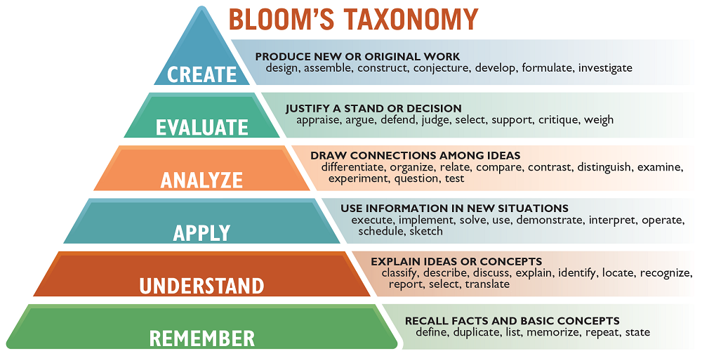
  - Ask participants what they notice about how the verbs are classified. Answer may include the following: Verbs are increasingly more complex as you move from the bottom of the pyramid to the top of the pyramid. Explain that as you move up the pyramid, participants are moving from recalling facts to analyzing information. Encourage participants to think about how they may use some of the verbs higher up the pyramid in their ABOs.
  - Explain that now what is needed is the “what,” which is the content of the training. This could be anything such as writing ABOs, conducting home visits, writing LNRAs, building a latrine, etc. For example, “at the end of the training, the participants will have practiced writing ABOs.”
  - Provide some examples of ABOs from the ongoing training. Write examples on the flip chart and underline and write the different parts of the ABO:
When | For whom | Verb (future perfect) | What
By the end of the lesson | participants | will have distinguished | precontemplation from contemplation.
By the end of the lesson | participants | will have used | the lesson design template to create a session for their work.
  - Ask participants to take 10 minutes in their pairs to write 2–3 ABOs for the lesson they will facilitate. If the practical exercise is not being done, give them 10 minutes to work in pairs to write a few ABOs on another topic.
- The “How” and “With What Resources” (25 minutes)
  - Explain that they are now going to talk about the “how.” Similar to this guide, the “how” lists step-by-step instructions for implementing each activity. Include sufficient details in the “how” so that any facilitator could follow the steps for doing the activities. The “how” can draw on participatory techniques used in the MMCA guide, such as storytelling, testimonials, role plays, group exercises, and warm-up exercises.
  - The “how” may also help participants to list out what materials need to be budgeted or acquired for a training. Handout 13-3: Sample Checklist for Planning can be used as a guide to think through additional steps for planning a workshop or training.
- Exercise (45 minutes to 3 hours)
  - Tell participants that they are now going to practice designing a lesson. Ask the pairs to use Handout 13-2: Template: Lesson Design to design their lesson. Remind participants to look at Handout 4-1: Building Blocks for Effective Facilitation and Handout 4-3: Example Participatory Activities as they design their lessons. Give pairs an additional 30 minutes to finalize their lesson plan and prepare to facilitate the lesson. Note: The time needed can vary based on the agenda. If participants practice delivering their lesson to the group, they may need 1–2 hours to prepare the lesson. In this case, be sure that they have adequate time in the agenda for preparation.
  - If groups are practicing facilitating:
    - Once groups have prepared their lessons, bring everyone back together. If you have multiple facilitators, break the pairs into groups so that each facilitator has one group. This way, the lessons take less time to share.
    - Remind participants that they will have exactly 20 minutes (or however long their lessons were assigned to be) to deliver their lesson. Whether or not they have finished, stop them at 20 minutes and then move to feedback.
  - During facilitation, assign one person to fill out a QIVC for each facilitator, using the QIVC template in Handout 14A-1: Quality Improvement and Verification Checklist (QIVC) for BCAs’ Facilitation Skills. If time permits, you can have those that fill out the QIVC practice provide feedback in private to the facilitator after the session and have the facilitator practice receiving feedback.
  - If groups are not practicing facilitating:
    - After 25 minutes, bring everyone back together. Ask participants which steps they felt most comfortable with, and which steps they would like to practice.
    - Explain that lesson planning can be difficult and will take time/practice. Emphasize that over time, it can help them plan a better training, meeting, or workshop.
- Closing (5 minutes)
  - Thank everyone for participating in the lesson planning and for practicing facilitating.
  - Ask what remaining questions participants have about lesson planning.

Handout 13-1: Lesson Design
- Why this lesson? | The current situation | A description of the situation or problem that is calling for the event.
- Who will facilitate? | The facilitators | Who will lead the learning activity?
- Who will attend? | The participants | Who is the learning activity for?
- When and how long? | The time and timing | When will this learning event, training, or meeting take place? How long will this lesson last? How much time is needed for each task/activity?
- Where? | Location (in-person or virtual) | Where will the training take place (includes in-person or online)?
- Learning Needs and Resources Assessment (LNRA) | Questions to ask participants | What questions do you need to ask participants to understand their learning needs on the topic, and what do they already know?
- What content? | The content | Based on the Learning Needs and Resources Assessment, what will be covered in this learning event, training, or meeting? What are the skills, information, and perspectives to focus on in the learning?
- What for? | The achievement-based objectives (ABOs) | A specific description of what learners will do during the program with each piece of priority content, in order to learn it.
- How? | Methods | What methods, activities, exercises, and demonstrations will be used?
- With what resources? | Resources needed to carry out the activity | What materials (e.g., flip charts, markers, and demonstration material), funds, and human resources are required to carry out the lesson?

Handout 13-2: Template: Lesson Design
- Why this lesson?
- Who will facilitate?
- Who will attend?
- When and how long?
- Where?
- Learning Needs and Resources Assessment questions |  | - What content?
- What for? At the end of the training, the participants will have… (achievement-based objectives)
- How? What activities will the participants do?
- With what resources?

Handout 13-3: Sample Planning Checklist
Name of the event: Date of the event:
Location of the event: Focal point:
Participants: ____________________________
Task | Who | When | Status
Before the training/event
Write activity terms of reference
Create a budget and get approvals
Ensure that the facilitators are available
Request permission from the authorities/leaders
Reserve the meeting room and meals
Create a participant list and send invitations
Confirm participants
Arrange tickets, hotel rooms, and/or transport
Print training guides, workshop materials, pre-/post-tests, evaluation, certificates for participants, attendance sheets
Buy required supplies, such as notebooks, pens, flip chart paper, markers, and nametags
Do a logistic check each morning and evening
Do a daily short evaluation to collect feedback
Use participatory methods during the activity
Do pre-/post-tests and workshop evaluations
After the training/event
Write report and include what went well and how you can improve in the future.
Share documentation with others, as needed.
Note: All tasks may not be relevant for all trainings, workshop or meetings. Adapt as needed.

Advanced Lesson 14A: Quality Improvement and Verification Checklists (QIVCs), Giving and Receiving Feedback
Achievement-Based Objectives
By the end of this lesson, participants will have:
- Defined performance
- Reviewed two quality improvement and verification checklists (QIVCs)
- Observed a simulated use of the QIVC
- Reviewed the steps for giving positive feedback
- Practiced giving and receiving feedback (optional)
Duration
2 hours, 15 minutes
Materials Needed
- Flip chart paper, markers, and pencils
- 10 small balls (or crumpled pieces of paper), a plastic bag, and a shoebox or similarly sized container or box, blindfold/scarf
- Handout 14A-1: Quality Improvement and Verification Checklist (QIVC) for Behavior Change Agents’ Facilitation Skills
- Handout 14A-2: QIVC to Evaluate Positive Feedback (one copy per participant)
- Handout 14A-3: Role Play Part 1: Education Session (two copies)
- Handout 14A-4: Role Play Part 2: Giving Feedback (two copies)
- Handout 14A-5: Steps for Giving Feedback to BCAs (one copy per participant)
- Prewritten flip charts:
- Purposes of a QIVC
- How to Score the QIVC

Why This Lesson?
Behavior Change Agents (BCAs) can benefit from effective supervision to improve the quality of their ongoing work. This lesson is designed to be used by BCAs and their supervisors to give and receive feedback that can help BCAs become more effective agents of change. The QIVC, developed by Food for the Hungry, is a tool that has been found to help improve the performance of workers. Note: Advanced Lesson 14B: Creating Quality Improvement and Verification Checklists can be completed as an Advanced Lesson to practice developing activity-specific QIVCs.

Advance Preparation
Prepare the following flip charts:
- Purposes of a QIVC (Task 3)
- How to Score the QIVC (Task 5)
For the activity in Task 1, locate a shoebox or similarly sized container or box, 10 small balls or pieces of paper crumpled into a ball shape, a blindfold/scarf, and a bag in which to place the balls. For Task 5, prepare to present one of the two options from Handout 14A-3: Role Play Part 1: Education Session. Option A describes a handwashing demonstration, and Option B is on improved fodder demonstration. The facilitator can pick one of the options or replace this example with a demonstration that is more relevant to participants’ program area(s).
If there are two facilitators, it would be best if they did the role play in Task 5 together, with one facilitator playing the role of the BCA and the other playing the role of the supervisor. If there is only one facilitator, choose an experienced participant to play the role of the BCA. Practice the role play ahead of time. A few participants will also have to play the roles of the people who are attending the education session.
With your co-facilitator or experienced participant, review the following:
- Handout 14A-1: Quality Improvement and Verification Checklist (QIVC) for BCAs’ Facilitation Skills
- Handout 14A-2: Quality Improvement and Verification Checklist (QIVC) to Evaluate Positive Feedback
- Handout 14A-3: Role Play Part 1: Education Session
- Handout 14A-4: Role Play Part 2: Giving Feedback
- The instructions in Task 5
These materials will help the person playing the BCA know what things to do well. Work together to choose 2–3 things for the BCA to do wrong on purpose. That way, the person playing the supervisor will be prepared to give appropriate feedback.
Ask the person playing the BCA to not try to entertain the audience by acting silly or making purposeful errors during the skit. This learning activity is to provide realistic examples of effective and ineffective techniques of how the supervisor works with the BCA. Also, make sure you have practiced giving appropriate feedback before training others.
In many cultures, supervisors are more prone to mark “no” for tiny faults. Mark “yes” if the facilitator in general completed the given task. Be sure to model how the QIVC is a tool to compassionately encourage and improve the ability of workers. It is not a tool used to discourage workers or to try to shame them into change.

Tasks
- Warm-Up Activity (20 minutes)
  - Explain to participants that the lesson will start with a quick activity to get them thinking about today’s topic, which is giving feedback. Ask a volunteer to come to the front of the room and face the rest of the participants. Explain that they will be blindfolded, and ensure that they are comfortable with that. If not, select another volunteer.
  - Explain that the goal of the activity is to see how many balls or crumpled pieces of paper the volunteer can throw into a waste bin, basket, or box while blindfolded. Explain that there will be three rounds. During Round 1, the volunteer has to try to throw the balls into the bin with no feedback from the other participants (i.e., with no talking). During Round 2, the other participants can only give one-word feedback, such as “closer,” “left,” “backwards,” “farther,” etc. During Round 3, participants can give as much feedback as they want to the volunteer, such as “throw the ball one meter further and a little to the left,” and the volunteer can ask clarifying questions. Ask if anyone has any questions before the activity begins.
  - Ask the volunteer to put on the blindfold and face the front of the room. Quietly place the basket somewhere in front of them, so they do not know the exact location. Place it in a location that is not impossible for the person to reach while throwing the ball.
  - Round 1: Hand the volunteer a bag with 10 balls. Remind everyone that they cannot give any feedback in this round, even if the ball goes into the basket. Tell participants to pay attention in case the volunteer accidentally throws the ball at them. After this round, ask a participant to count how many of the balls made it into the basket and tell the group. Collect the balls and give them back to the volunteer.
  - Round 2: Remind everyone that, during this round, they can give one-word feedback. After each throw, choose one participant who wants to provide one-word feedback. Keep going until all of the 10 balls have been thrown. After this round, ask a participant to count how many of the balls made it into the basket. Collect the balls and give them back to the volunteer. Note: If played correctly, the number of balls in the basket should increase with each round.
  - Round 3: Remind everyone that during this round, they can give detailed feedback. Additionally, the volunteer can ask clarifying questions, such as “was that throw closer?” After each throw, choose one participant who wants to give feedback. The volunteer can then respond with a clarifying question before throwing their next ball. If needed, remind participants of the importance of being supportive when giving feedback. After this round, ask the volunteer to take off their blindfold and have everyone sit down. Ask a participant to count how many of the balls made it into the basket.
Thank everyone for helping with the activity. Facilitate a brief discussion based on the following questions:
- What was challenging about this exercise? What went well?
- How did providing detailed feedback change the outcome from round to round? How did dialogue effect the game? How did using positive comments help the conversation?
- How did practicing/gaining experience during this exercise change the outcome?
- Has anyone ever felt like this in your work (e.g., you are trying to reach a goal, but you are not sure whether you are on the right track)? What examples can you share?
- The Importance of Monitoring and Evaluation (10 minutes)
  - Explain to participants that it takes a lot of practice and support to become an effective BCA, but continually working to improve is worth the effort. Even if a certain behavior change strategy has been proven very effective, it might not work if it is not presented or shared well. That is why programs do monitoring and evaluation.
  - Note that looking at both quantity and quality data helps when tracking a program’s progress. Ask participants what measurable things they usually monitor in their program. Answers may include: How many trainings were conducted, how many demonstration plots were established, how many people attended education sessions, how many latrines were constructed, etc.
  - Tell participants that the amount of work done is important, but it is equally important to know the quality of the programs, how well a session was facilitated, and how engaged the community members were in the program. To do a good job of monitoring, we need to measure how well tasks are completed, especially tasks that are repeated multiple times during the project. If these tasks are not done well, the project may not be successful. Many activities, such as trainings, home visits, farm demonstrations, and health and nutrition demonstrations, require BCAs to repeatedly organize and conduct quality activities and demonstrate performance.
- The Quality Improvement and Verification Checklist (QIVC) Tool and How It Is Used (10 minutes)
  - To focus our attention on how well tasks and activities are done, Food for the Hungry developed a tool called the quality improvement and verification checklist (QIVC).
Explain that QIVCs have three main purposes. Post the prepared flip chart and review the three purposes of a QIVC:
- To encourage
- To monitor
- To improve performance/how well someone does a task or job
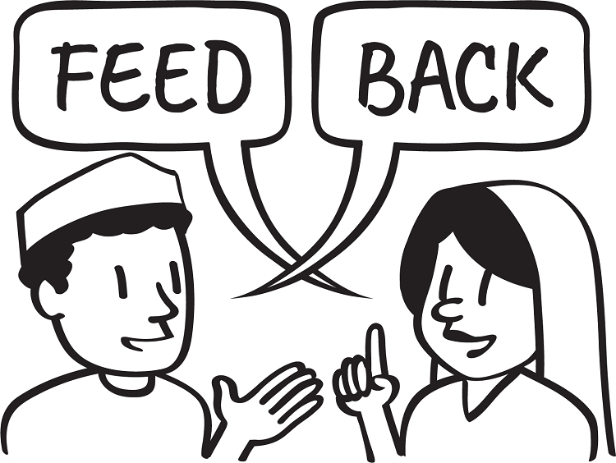
  - Tell participants that the QIVC can be used with each team member in a program responsible for facilitating a learning experience to encourage, monitor, and improve their performance or how well a task or job is done. Ask participants what they think these activities might be. Answers could include: a household visit, a farm visit, training, meetings, a CLTS triggering event, a VSLA meeting, etc. Explain to participants that the QIVC rapidly increases performance, and small improvements in performance can cause large changes in impact.
  - QIVCs help provide real-time feedback to BCAs. Often, during projects, a large amount of data is collected (for example, a baseline, surveys, and an endline). However, it may take a long time to analyze and share these data with project staff. QIVCs help provide feedback directly to the BCA soon after activities are completed.
- Review the QIVC (15 minutes)
  - Refer participants to Handout 14A-1: Quality Improvement and Verification Checklist (QIVC) for BCAs’ Facilitation Skills and Handout 14A-2: Quality Improvement and Verification Checklist (QIVC) to Evaluate Positive Feedback. Explain that while these two QIVCs will be used during this session, there are many other QIVCs focused on other tasks. Such QIVCs, created by Food for the Hungry, can be found here (www.caregroupinfo.org/docs/QIVC_Files.zip).
  - Note: If you are doing Advanced Lesson 14B: Creating Quality Improvement and Verification Checklists (QIVCs), you can say that they will practice designing their own QIVCs later on.
  - Review each point on Handout 14A-1: Quality Improvement and Verification Checklist (QIVC) for BCAs’ Facilitation Skills with participants. Make sure that they understand what each question means.
  - Explain to participants that most questions on the QIVC have a “yes” or “no” answer. This is to reduce the influence of subjective opinion in the review. That means the monitoring is based on observations rather than on personal perspectives, feelings, or opinions. After reading a question, they should decide if the answer is “yes” or “no” and mark the corresponding box.
If the question is not relevant for a particular training, then they should draw a line through the “yes” or “no” boxes. For example:
- In Question 13, if the agricultural extension worker is doing a hands-on demonstration on how to construct an A-frame and is not using flip charts or cards, they may not have captions to read to the participants. In this case, the scorer would mark a line through the yes or no like this.
- In Question 14, if the topic was on consistently using improved latrines, the facilitator would have a difficult time demonstrating this activity. It is possible for the facilitator to demonstrate an improved latrine, but using the latrine at all times is not something that needs to be demonstrated during the lesson. The scorer would mark a line through the yes or no like this.
  - Tell participants it is important to adapt QIVCs to fit the culture and design of different programs. After using the QIVC for 3–4 months, staff and volunteers should meet together to discuss the checklist. If specific questions are not appropriate or applicable to their situation, the QIVC should be adapted or revised as needed. The e QIVC is designed to ensure that participatory teaching methods and effective facilitation are used in each lesson; users should make sure their final version continues to reinforce these key principles.

- QIVCs in Action (40 minutes)
  - Explain to participants that they are going to watch a role play of the BCA facilitating an education session. The role play will be done in two parts: In the first part, a BCA facilitates a meeting and the supervisor, who has come to watch, uses the QIVC; in the second part, the supervisor gives feedback to the BCA and the BCA receives the feedback.
  - Distribute a copy of the Handout 14A-1: Quality Improvement and Verification Checklist (QIVC) for BCAs’ Facilitation Skills to participants. Explain that the person filling out the QIVC does so directly after the event, not during it. This is so they can pay attention during the activity and not be distracted.
  - Perform the role play (Option A, Option B, or a locally relevant example) found in Handout 14A-3: Role Play Part 1: Education Session. Make sure that the BCA teaches the audience how to do something, such as handwashing or using fodder.
  - After completing the role play, ask each participant to fill out and score their copies of Handout 14A-1: Quality Improvement and Verification Checklist (QIVC) for BCAs’ Facilitation Skills. Show the prepared flip chart with instructions on How to Score the QIVC(below).
How to Score the QIVC
- Count the number of “yes” responses.
- Divide the number of “yes” responses by the total number of answered questions (questions answered with either a “yes” or “no” response).
- Do not count the questions that are not applicable (those that are crossed out).
  - Ask participants sitting at each table to compare scores and come to a consensus. Then ask each table to share the scores they gave.
  - Give each participant a copy of the Handout 14A-2: Quality Improvement and Verification Checklist (QIVC) to Evaluate Positive Feedback. Tell participants they will now watch a role play of the supervisor giving feedback from the QIVC to the BCA. Ask participants to carefully observe how the supervisor gives feedback and how the BCA receives this feedback.
  - Use Handout 14A-4: Role Play Part 2: Giving Feedback to guide giving feedback during the role play. Once the role play is completed, give participants a few minutes to score Handout 14A-2: Quality Improvement and Verification Checklist (QIVC) for Giving Feedback. Ask participants to discuss their scoring at their tables and agree on a score. Discuss how the scores between participants varied, and explain that while the checklist is meant to be objective, we can still have different perceptions based on our personal experiences.
Ask participants the following questions, based on what they saw during the role play (potential answers are in italics):
- What does the supervisor say to the BCA when they visit the activity and plan to use a QIVC?
  - Don’t worry. This is not a test, but a tool to help you improve. Teach as you normally do.
- What comments does the supervisor make during the educational lesson?
  - None, the supervisor only observes and does not interrupt or make comments to the facilitator. The supervisor only speaks to the facilitator if there is an immediate safety concern or if the BCA explains an important concept wrong in a way that could hurt the listeners (for example, if the BCA does not correctly explain the ratio of ORS to water).
- Where/when does the supervisor talk about the QIVC with the BCA?
  - In private (not in front of other people), after the activity is completed.
- Why does the supervisor explain the checklist to the BCA?
  - Because it is a method for improving and encouraging the worker’s performance. All workers should know exactly what is expected of them.
- How does the supervisor speak to the BCA?
  - The supervisor needs to be compassionate when providing feedback so the BCA does not feel shame. Even if the BCA did very poorly on the checklist, the supervisor emphasizes areas where they have shown some improvement. Ask the BCA which areas they want to work on.
- How are QIVCs different from other approaches?
  - This approach is more structured and focuses on the positive aspects of someone’s performance.
- How might QIVCs improve performance?
  - Many people believe that pointing out mistakes will eliminate failures and improve performance. However, studies have shown that the opposite is true, especially when it comes to learning new tasks. This approach also helps BCAs stay motivated.
- How often can you use QIVCs?
  - It depends on the program design, objectives, resources, etc. The facilitator can also provide the below example.
How Often Should QIVCs Be Used?
How often QIVCs are used depends on a BCA’s performance and on the resources available for supervision. Some general guidance includes:
- Use QIVCs monthly until scores significantly improve for BCAs with unacceptable scores (e.g., those less than 80%).
- Use QIVCs every 3–6 months for BCAs with acceptable scores (e.g., those over 80%).
- Use QIVCs once or twice a year for BCAs with high scores (e.g., 95% or higher).
- Using Results from the QIVCs (15 minutes)
  - QIVCs can help improve performance at the individual level or project level. They can also help identify where capacity-strengthening and supervision efforts need to be concentrated. It can be helpful to compile all QIVC results in a database and look at the results per question. An example of a QIVC worksheet/database that can be used to compile results from different QIVCs can be found here (www.fsnnetwork.org/sites/default/files/EXAMPLE_worksheet_%20Quality%20Checklist _database.xls).
The QIVC can help answer questions, such as:
- What problems do most BCAs have with the steps in the activity?
- What parts of the activity need to be restructured?
- On what parts of the activity do BCAs need to be retrained?
- Which BCAs are having the most challenges with the activities?
- Who needs additional training or supervision?
  - Examining the data by BCA score over time can indicate whether performance is improving, both on average and by BCA. This can help identify BCAs who might need more supervision and coaching, as well as BCAs whose performance is improving. Note: QIVCs are programmatic tools and are not designed to replace tools used by human resources, such as annual performance reviews that determine raises and salaries.
  - Remind participants that QIVCs are a structured and systematic way for supervisors to provide feedback on a BCA’s work. While each program can decide how to use QIVCs, these tools are meant to help focus training and supervision efforts.
  - Show participants the graph below (either write it on a flip chart, or ask them to turn to this page in their guidebook):
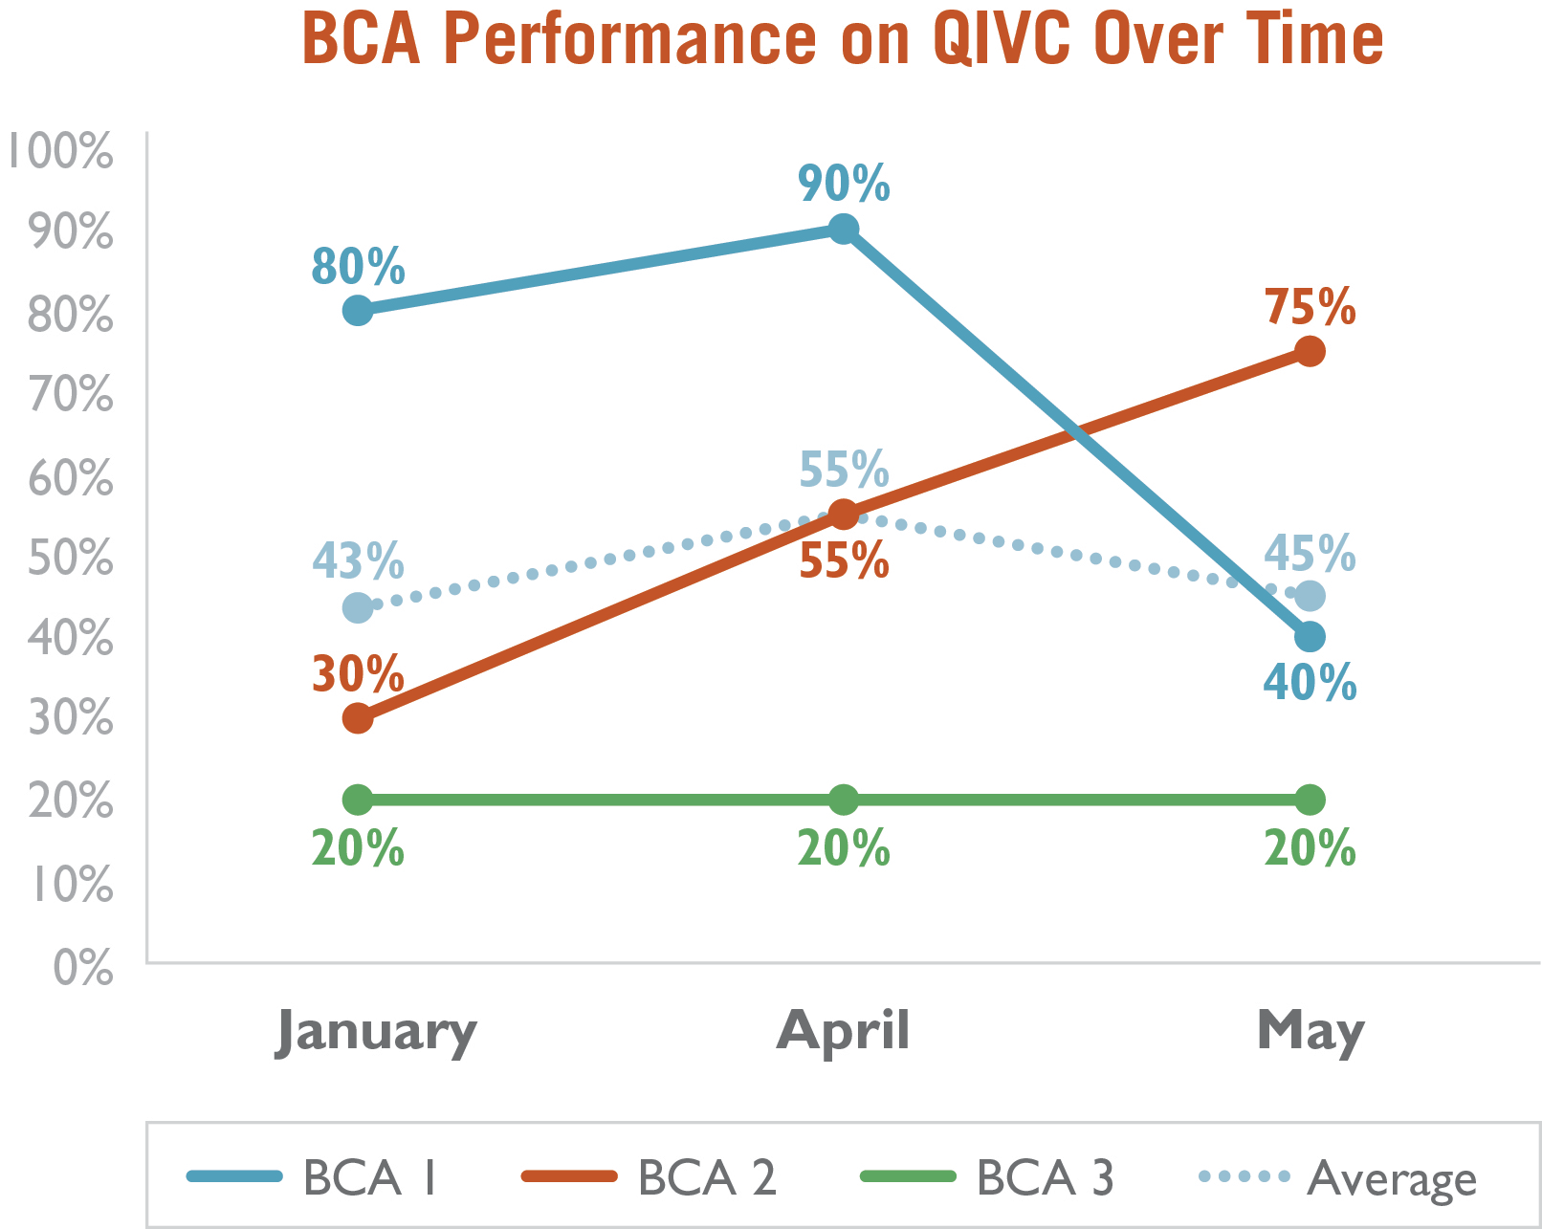
Ask participants the following questions:
- What do you notice about this graph?
(Answers may include: BCA 1 is going down in performance. BCA 2 is improving. BCA 3 is staying consistent, and the average of all BCAs slightly increased in April and then declined.)
- What might you do if you had these data?
(Answers may include: Provide extra supervision to BCA 1. Work with BCA 1 and BCA 3 to provide additional training.)
  - Explain to participants that they can also look at data by question. Ask participants to look at the graph below:
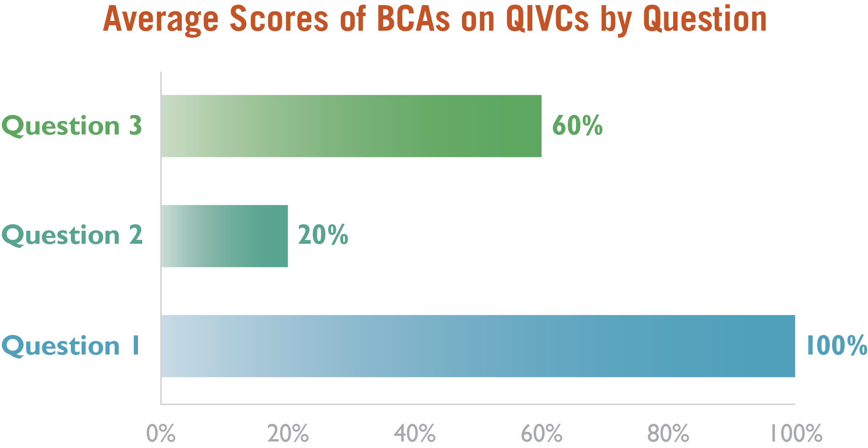

  - Ask participants what they would do if they saw these results from the QIVCs?
(Answers may include: Provide more training/support on what needs to be done to get a “yes” on Questions 2 and 3.) Note to participants that it can be helpful to look at these data every month or quarter.
  - Explain to participants that if they supervise multiple BCAs, they can see if there are common/frequent challenges as they attempt to change behaviors. For example, if being seated at the same level as the participants and looking them in the eye is challenging for multiple BCAs, then this can be addressed during the next supervisory meeting and all BCAs can practice the challenging behavior.
  - Explain to participants that QIVCS can be used by different members of the team. In the example below, the program manager uses QIVCs with the supervisors, who use them with the promoters, who use them with the volunteers. This allows many people to receive feedback without overburdening one team member.

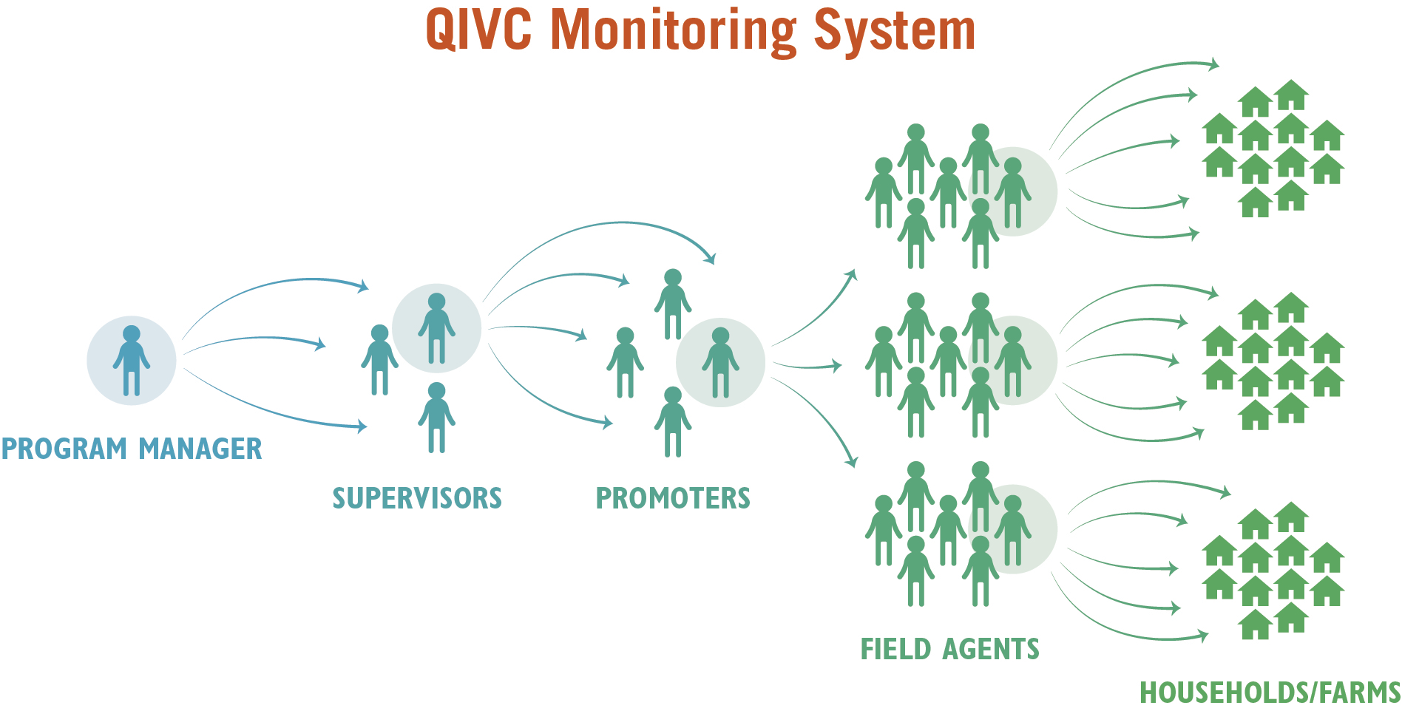

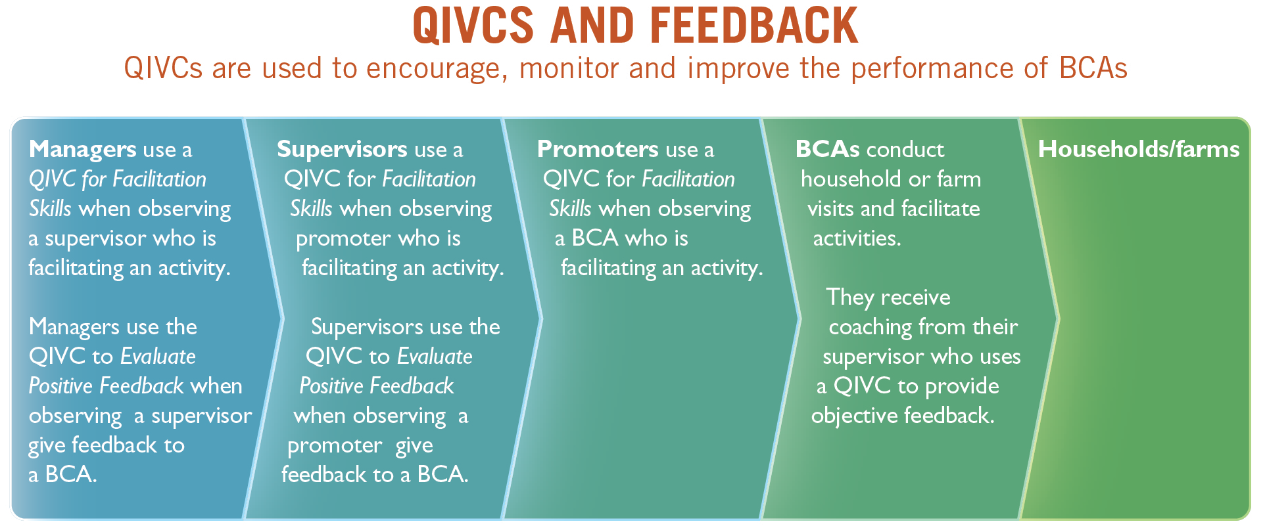

- Giving and Receiving Feedback (25 minutes or 55 minutes, if optional exercise is completed)
  - Explain to participants that giving and receiving feedback is important for BCAs. As a BCA, they also might receive feedback from direct reports, peers, managers, community health volunteers, agriculture extension agents, etc. Many people are uncomfortable with giving and receiving feedback. Refer participants to Handout 14A-5: Steps for Giving Feedback to BCAs.
  - Add that in addition to giving feedback, many receive feedback in their day-to-day jobs.
Ask participants what things are important to consider when receiving feedback. Answers may include:
- Listen to the entire comment/suggestion without interrupting.
- Thank the person who provided feedback. Feedback is an opportunity to benefit from the experience of others.
- Before responding, ask questions to make sure you understand clearly what the person is saying. Try to restate in your own words (or paraphrase) what you have understood them to say.
- Try not to get defensive and justify your actions. At times, you simply need time to consider what the other person said. Sometimes you may disagree with the feedback, but it can be beneficial to hear a different perspective. If the person providing the feedback asks why you did something, you can respond.
- Help the person providing the input to be specific. For example, you could ask the one providing feedback to give examples of behaviors they would like to see improved.
- Set goals for improvement.
- Follow up to get additional feedback once you have made progress.
- Ask for feedback frequently.
Ask participants:
- Which of these steps have you already used? Which steps are new to you?
- How might using these steps for giving and receiving feedback help in your work?
- Giving and Receiving Feedback: Optional Practical Feedback Exercise (30 minutes)
  - Note to facilitator: This is an optional exercise to have participants practice giving and receiving feedback. Each person can play each role one time (giver, receiver, and observer), or you can do one round and discuss the exercise in plenary.
  - Separate participants into groups of three. One person will start as a feedback giver, one person will start as a feedback receiver, and one person will be the observer. The feedback giver has five minutes to provide feedback to the receiver, using the Handout 14A-5: Steps for Giving Feedback to BCAs. The giver will offer feedback to their partner related to something that they have seen the person do during the training (a role play, brainstorm, discussion, or other participatory activity). The receiver receives the feedback, keeping in mind the tips above on receiving feedback. The observer fills out Handout 14A-2: Quality Improvement and Verification Checklist (QIVC) to Evaluate Positive Feedback.
  - Bring the groups back together after five minutes. Ask participants what it was like to give feedback to their partners/hear feedback from their partner. Acknowledge any awkwardness and defensiveness, explaining that this skill may require time to build.
  - If time permits, switch roles so that the giver becomes the receiver, the receiver becomes the observer, and the observer becomes the giver. After five minutes, discuss the exercise and switch roles again.
- Wrap-Up (10 minutes)
Facilitate a brief discussion by asking the following questions:
- How do you think you can use these tools in your work?
- Can someone provide a specific example of how they plan to incorporate the QIVC?
- Can someone provide an example of when they will practice giving feedback? How about receiving feedback?
  - Note that throughout this training/workshop, they have been practicing how to give and receive feedback. Refer participants to Advanced Lesson 14B: Creating Quality Improvement and Verification Checklists (QIVCs) to create project-specific QIVCs.

Handout 14A-1: Quality Improvement and Verification Checklist (QIVC) for BCAs’ Facilitation Skills
Name of the person filling out QIVC:
Name of the person being evaluated:
Location: Date:
Number of “Yes” boxes checked: Number of questions used: _________
Present score: % Previous score: %
Feel free to add or delete questions based on your SBC strategy and what works for your project.
Calculate the score by counting the number of “Yes” boxes checked and dividing by the total number of questions that were applicable to the situation.
Question | Yes | No
Set-Up of Activity
      - Did the BCA seat people so that they could see participants’ faces?
      - Did the BCA sit at the same level as the other participants (if appropriate)?
      - Did the BCA introduce the topic well?
      - Did the BCA ask questions to relate the topic to the participants’ experiences?
      - Did the BCA ask about the current practices of the participants?
Comments:
Methods of Activity
      - Did the BCA speak loud enough so that everyone could hear?
      - Did the BCA change the intonation of their voice?
      - Did the BCA speak slowly and clearly?
      - Did the BCA make appropriate eye contact with everyone?
      - Did the BCA encourage comments by nodding, smiling, or other actions to show they were listening?
      - Did the BCA always reply to participants in a courteous and respectful way?
      - If using visual aids, did the BCA explain the meaning of each picture?
      - If using visual aids, did the BCA read each caption aloud to the participants?
      - Did the BCA demonstrate any skills that they were promoting?
      - Did the BCA use a participatory method (game, skit, song, exercise, etc.)?
      - Specify:
      - Did the BCA use examples/terminology that were culturally appropriate?
      - Did the BCA ask about the current practices of the participants?
      - Did the BCA give participants adequate time to answer questions?
      - Did the BCA ask participants if there were barriers that might prevent them from trying the practice?
      - Did the BCA encourage discussion among participants to work around the barriers mentioned?
      - Did the BCA suggest other strategies to overcome barriers?
      - Did the BCA encourage comments by paraphrasing what people said? (Repeating statements in their own words)?
      - Did the BCA ask participants if they agreed with other participants’ responses?
      - Did the BCA prevent one or two people from dominating the discussion?
      - Did the BCA encourage timid participants to speak/participate?
      - Did the BCA summarize the discussion?
      - Did the BCA reinforce statements by sharing relevant personal experiences or by asking others to share personal experiences?
Comments:
End of Activity
      - Did the BCA summarize the essential points of the lesson?
      - Did the BCA verify that people understood the main points, using open-ended questions?
      - Did the BCA ask the participants to commit to try the new behavior?
      - Did the BCA finish the session within the allotted time?
Comments:
Content of Activity
      - If using a lesson plan/facilitation guide, did the BCA follow the plan in the curriculum/guide?
      - Was the content of the educational messages on topic?
1 2 3 4 5
Poor Excellent
      - Was the content of the educational messages correct?
1 2 3 4 5
Poor Excellent
      - Was the content of the educational messages complete?
1 2 3 4 5
Poor Excellent
Comments:
Note: For questions 35, 36, and 37, if the score per question is 4 or above, count it as YES. If the score per question is 3 or less, count it as NO.

Handout 14A-2: Quality Improvement and Verification Checklist (QIVC) to Evaluate Positive Feedback
Name of the person filling out QIVC:
Name of the person being evaluated:
Location: Date:
Number of “Yes” boxes checked: Number of questions used: _________
Present score: % Previous score: %
Calculate the score by counting the number of “Yes” boxes checked and dividing by the total number of questions that were applicable to the situation.
Question | Yes | No
Content
      - Did the evaluator explain that the purpose of the QIVC is to improve and measure work quality?
      - Did the evaluator tell the person evaluated not to be afraid, that this is not a test and is something to help them improve?
      - Did the evaluator advise the person being evaluated not to say anything to the evaluator while being observed?
During the Observation
      - Did the evaluator avoid making comments to the person evaluated during the lesson?
      - Did the evaluator mark all the questions (yes or no) right after the observation?
Feedback
      - Did the evaluator give the feedback in a private place?
      - Did the evaluator ask the person evaluated to take notes on their comments?
      - Did the evaluator discuss each positive point on the form?
      - Did the evaluator encourage the person evaluated about the things they did correctly?
      - Did the evaluator use positive body language when providing positive feedback to the person?
      - Did the evaluator use encouraging words (e.g., excellent, very good) when providing positive feedback to the person?
      - Did the evaluator avoid mixed comments such as, “That was excellent, but you should…”, when providing positive feedback to the person?
      - Did the evaluator always respond to the comments from the person evaluated in a courteous and respectful manner?
      - Did the evaluator mention the area(s) where the performance of the person evaluated was better than the majority of other people?
      - Did the evaluator discuss each negative point on the form?
      - Did the evaluator ask the person evaluated to discuss the negative points in their performance before providing an opinion?
      - Did the evaluator use examples to explain the correct manner of performing the parts of the process that were done incorrectly?
      - Did the evaluator maintain control of the evaluation process in an appropriate manner?
      - Did the evaluator help the person evaluated find solutions to the problems they had, where possible?
      - Did the evaluator keep the attention of the person evaluated?
      - Were the evaluator’s suggestions appropriate for the context of the person being evaluated?
      - Were the evaluator’s suggestions complete?
      - Were the evaluator’s suggestions specific?
End
      - Did the evaluator ask the person evaluated to give a summary of what could be improved/what was done correctly?
      - Did the evaluator complete this list if the person evaluated could not remember what could be improved/what was done correctly?
      - Did the evaluator ask the person evaluated to indicate their commitment to improve these things?
Comments:

Handout 14A-3: Role Play Part 1: Education Session
Introduction to Role Play 1: Handwashing
Read the following introduction aloud to participants:
The BCA is preparing an education session with a women’s group about children and diarrhea. During the lesson, she will demonstrate the technique for proper handwashing. She is arranging the soap, handwashing pitcher, and basin. She has prepared a space for all participants to sit in front of her in a semi-circle, so all the women can see each other. As the BCA is getting ready, her supervisor arrives, and they have the following discussion.
Role Play 1: Handwashing
Supervisor: Good morning, Maria. How are you doing?
BCA: Welcome! I’m fine. It’s good to see you.
Supervisor: I’ve come to pay you a visit and to observe your meeting. During this visit, I will be completing the Quality Improvement and Verification Checklist. [She shows the QIVC to the BCA.] Remember, the QIVC will help improve your work as a facilitator. It’s not a test, so there’s no need to be nervous. We have used this same form before.
BCA: Yes, I remember. I was just getting ready to show the women how to practice handwashing. The women will be joining me soon. Since you are here, if I have any questions or problems, I’ll be sure to ask for your help.
Supervisor: Actually, I’ll just be watching during the meeting. Just carry on as if I wasn’t here. Afterward, we will talk about how the meeting went.
The BCA sits down and calls the participants to join her. The supervisor sits to the side, holding the QIVC. One woman arrives late and sits behind everyone else, a little outside the group. The BCA asks two participants to volunteer to demonstrate washing their hands with clean water and soap. Everyone but the woman sitting a little outside the group has a chance to participate. The BCA does almost everything well. However, she does not ask the participants if they have any experience using soap for handwashing, and she does not ask open-ended questions during the session to check for understanding. She was also impatient with one of the participants and did not treat her respectfully. The demonstration ends, and the BCA thanks the participants for coming.

Introduction to Role Play 2: Improved Fodder Demonstration
Read the following introduction aloud to participants:
The BCA is in the middle of a meeting with community members about using improved fodder crops. He has already taken attendance and guided a farmer through her testimonial of how the health of her cows changed after feeding them improved fodder. Now, during the break, he is preparing to introduce a few indigenous fodder species and to demonstrate how, when, and where to plant them. He is arranging the different seedlings and cuttings for demonstration. He has arranged the demonstration under a shaded tree so it will not be too hot for the community members. As the BCA is getting ready, his supervisor arrives, and they have the following discussion.
Role Play 2: Improved Fodder Demonstration
Supervisor: Good morning, Jean. How are you doing?
BCA: Hello, Galina! I’m doing well.
Supervisor: I’ve come to observe your community meeting. During this visit, I will be completing the Quality Improvement and Verification Checklist for Education Session Facilitation. [She shows the QIVC to the BCA.] Remember, the QIVC will help improve your work as a facilitator. It is not a test, so there’s no need to be nervous. We have used this same form before.
BCA: Yes, I remember. I was just getting ready to meet the community members to show them the different fodder species and their different characteristics.
Supervisor: Great, I’ll just be watching during the meeting. Just carry on as if I was not here. Afterward, we will talk about how the meeting went.
Jean stands near the tree trunk and calls the community members to join him. Galina sits to the side, holding her QIVC. Everyone crowds around to try to get into the shade and be able to see the demonstration. Jean briefly points to the different fodder types and discusses their characteristics. He hands out a card with photos and short descriptions of each one written in the local language. He asks if anyone currently plants any of these types of fodder and asks follow-up questions of those who do (about where they learned about it, what changes have they seen in their animal’s milk production, etc.). He asks if anyone has questions and waits to see if anyone answers. Jean ends by asking everyone to share if they plan to plant any of the improved fodder. The demonstration ends, and Jean thanks everyone for coming. The BCA does pretty well, but he did not let everyone sit on the same level, nor did he ask if there were any barriers for why people may not be able to plant improved fodder. He also acted frustrated and impatient with one participant.

Handout 14A-4: Role Play Part 2: Giving Feedback
Giving Feedback for Role Plays
The BCA and the supervisor privately discuss the education session. The supervisor uses the following outline to discuss the BCA’s performance:
- Ask the BCA “how do you think you did?”
  - Agree with positive points and mistakes the BCA mentions, as appropriate. Probe as needed by asking questions, such as “What things do you think you do well?” and “What things could you have done differently?”
  - Review everything marked “yes” on the quality improvement and verification checklist (QIVC).
- If not mentioned earlier, ask the BCA about areas that you marked “no.”
  - For example, “Tell me about the woman who came in last. I thought she seemed left out of the group.”
- Reinforce things that the BCA says that could help them improve in these areas. Do not concentrate too much on what the BCA did wrong, but rather what they did well.
- Help the BCA come up with ways to strengthen areas that needed improvement.
- Ask the BCA to summarize the things that you discussed today, both positive things and areas to improve.
- Give the BCA their score, and summarize anything that was missed.
- Ask them to commit to changing these things. If there are several things that need work, ask them to commit to working on one or two priority items.
- Thank the BCA.

Handout 14A-5: Steps for Giving Feedback to BCAs
- Share the evaluation tool with the BCA ahead of time.
- Remind the person of the purpose of the evaluation.
- Give feedback in private and as soon as it is appropriate after the activity.
- Ask the person being evaluated to take notes.
- Keep the BCA’s attention, and maintain control of the evaluation.
- Use positive body language, and respond to the worker in a courteous and respectful manner.
- Ask the BCA to tell you what went well before giving your opinion.
- Discuss each positive point.
- Mention things the worker does especially well and encourage the BCA.
- Ask the BCA what things could be improved.
- Discuss each negative point on the form that the BCA did not already mention. If there many negative points, focus on a few priorities
- Do not make confusing, mixed comments that are partly positive and partly negative, such as “you spoke clearly, but I couldn’t hear you.”
- Offer several examples to explain the correct manner of performing the tasks where the BCA received a “no” on the QIVC.
- Help the BCA find solutions to problems, when possible.
- At the end of the evaluation, ask the BCA to summarize the things they will improve.
- If they forget any areas, remind them what you discussed.
- Ask the BCA to make a commitment to improve these issues.
- Ask the BCA to give a summary of the things they did well.
- Add to the summary if the BCA forgot any positive areas.

Advanced Lesson 14B: Creating Quality Improvement and Verification Checklists (QIVCs)
Achievement-Based Objectives
By the end of this session, the participants will have:
- Practiced creating quality improvement and verification checklists (QIVCs)
- Provided feedback to a colleague on their QIVC
- Received feedback on their QIVC
Duration
I hour to 1 hour, 15 minutes
Materials Needed
- Pens and paper
- Handout 14B-1: Tips for Developing QIVCs (one copy per participant)
- Handout 14B-2: Template for Creating Your Own QIVC (one copy per participant)
- Prewritten flip chart: How to Score the QIVC

Why This Lesson?
Programs implement many different activities, which means there is no “one size fits all” quality improvement and verification checklist (QIVC). Many existing QIVCs are available online, but participants may want to create or adapt one to best fit their program’s activities. In this lesson, participants will practice creating QIVCs that they can use in their own program. This lesson is based on Food for the Hungry training materials, developed by Tom Davis.
Note: Teach this lesson after Advanced Lesson 14A: Quality Improvement and Verification Checklists (QIVCs), Giving and Receiving Feedback.

Advance Preparation
If participants have already created new QIVCs for their activities, you may want to collect these ahead of time and use as examples during the lesson.
Prepare the flip chart How to Score the QIVC.

Tasks
- Warm-Up Activity (5 minutes)
  - Tell participants that today they will be working on creating their own quality improvement and verification checklists (QIVCs). Ask participants to write down three outreach or education activities that they or their team do regularly as part of their project activities. Provide a few examples, such as a farm visit, oral rehydration solution (ORS) demonstrations, seed distribution, etc.
  - Ask participants to share their answers while you take notes on a flip chart. Discuss answers in the group. Answers may include: Team meetings, field visits, household visits, farm visits, participatory theater performances, children’s hygiene sessions, meetings with agricultural extension agents, or a farm visit to teach a farmer about seedling spacing, etc.

- When Do We Create Our Own QIVCs (10 minutes)
Ask participants to look at the master list of activities generated during the warm-up activity. For each activity, ask the following questions:
- Is this a regular program activity done by a staff member or by a volunteer? Does it require facilitation?
- Does this activity have multiple steps?
- Can these steps be monitored through watching or listening?
  - Tell participants that if an activity meets these three criteria, they might want to consider developing a QIVC. Ask participants if it is possible to create a QIVC for the following examples, and ask them to explain their answers to make sure that they understand.
Example | Answer
A field facilitator’s ideas about problems in the community | No, we cannot observe someone’s ideas. Questions can be added to a QIVC such as, “Did the field facilitator ask the participants about problems they face in their community?” or “Did the field facilitator ask the participants about barriers they face when practicing this behavior?”
Teaching a farmer about seedling spacing | Yes, this is observable, and there are multiple steps.
Community consultation about a borehole deep tube well or water point | Yes, this is observable, and there are multiple steps.
Production levels for producer groups | No, this is not something that a facilitator does or that is observable. This type of data would be found in the group’s records. Questions can be added to a QIVC such as, “Did the field facilitator ask participants about their current practices related to production?”
Number of children with diarrhea | No, this is not something that a facilitator does or that is observable. For this type of question, consult clinical records or do a household survey. Questions can be added to a QIVC such as, “Did the BCA ask about the health of the children and other family members during the household visit?”
  - Tell participants that today they will practice making their own QIVCs.
  - Ask participants to think about the QIVCs that they saw in the previous lesson: What are some components of a QIVC to always include? Write their answers on a flip chart. Answers may include: name, date, location, etc.
  - Ask participants to look at Handout 14B-1: Tips for Developing QIVCs. Ask them to read the list to themselves or go around in a circle and read line-by-line down the list.

- Creating Our Own QIVCs (1 hour)
Tell participants that now that they have read some tips on creating QIVCs, they will look at a few examples. Ask participants to assess if the following points are appropriate to include in a QIVC:
- The volunteer laughed at participants when they asked a question.
  - Answer: No, the statement needs to be rephrased so that “yes” is the correct behavior. For example, “the volunteer did not laugh at participants when they asked a question.”
- The promoter studied the materials last night so she could explain things.
  - Answer: No, whether the promoter studied the previous night is not something that can be observed. This point can be phrased as “Is the promoter able to conduct the lesson without reading the guide word-by-word?” or “Does the promoter have all of the material for the demonstration?”
  - Explain that after looking at a few examples, the participants will take time to create their own QIVC. Separate participants into small groups (by sector or by project). Ask each group to pick an activity that they commonly do in their work from the master list of activities created during the warm-up. Encourage participants to create a QIVC for an activity that has not already been discussed (e.g., try not to use a general community meeting or training as an example).
  - Explain that the small groups will have 20 minutes to create a QIVC that they could use in their project with between 20 to 30 questions. Note: If you have less time available, ask participants to brainstorm five questions that they would include on a QIVC.
  - Note that Handout 14B-2: Template for Creating Your Own QIVC provides a model for such a form. Alternatively, if each small group has a laptop, they can edit a QIVC based on those found here (www.fsnnetwork.org/quality-improvement-verification-checklists-online-training-module-training-files-slides-qivcs-etc).
  - After 20 minutes, ask the small groups to swap their QIVC with another group. Have the groups take 5 minutes to read each other’s draft QIVCs and note where they see opportunities for improvement. For the next 10 minutes, ask the groups to share their feedback with each other. Walk around to the small groups and make sure that participants are giving and receiving respectful and thoughtful feedback on the QIVCs.
Bring the group back together. Ask participants the following questions:
- How was the experience of creating your own QIVC?
- Did you have any challenges doing so?
- Wrap-Up (5 minutes)
  - Encourage participants to take their draft QIVC back to their project and further develop it with their supervisor and supervisees for use in their project. Reiterate that it is always good to ask a colleague to review a QIVC before piloting it, because it could be useful to hear a different perspective.

Handout 14B-1: Tips for Developing QIVCs
- Create QIVCs for commonly done project activities that have multiple steps.
- Do not base QIVCs only on activities that are being done poorly. Provide opportunities for people to succeed and to receive positive feedback.
- Develop the QIVCs jointly with co-workers.
- Limit QIVCs to two pages.
- Make each question something that can be monitored (seen or heard).
- Make each question detailed enough to identify specific challenges or things being done well by the person being evaluated.
- For questions that can be answered “yes” or “no,” “yes” should always be the positive behavior (e.g., “did not make fun of the mother”).
- Most questions will be “yes” or “no,” but you can use some questions that require the person filling in the form to grade performance using a scale.
- Order the questions based on their order in the process. For example, put questions that are about greeting participants at the beginning of the checklist.
- If there are parts of the process that are not always done, separate them out into a separate section on the QIVC.
- Make sure that each line is a separate question.
- Number each question.
- Include a space at the end of the QIVC for comments.
- Use pictures for each question if working with illiterate or low literacy populations.
- Take time to experiment and pilot new QIVCs.
- Regularly review and modify each QIVC. Change the steps of the activity based upon what is working well and what is not working.
Adapted from: Davis, T. 2012. Quality improvement & verification checklists: Online training manual, training files, slides, QIVCS, etc. Presentation posted at www.fsnnetwork.org/quality-improvement-verification-checklists-online-training-module-training-files-slides-qivcs-etc.

Handout 14B-2: Template for Creating Your Own QIVC
Title of the QIVC (Activity):
Name of the person using this list:
Name of the person evaluated:
Location: Date:
Number of “Yes” boxes checked: Number of questions used:
Present score: % Previous score: %
Calculate the score by counting the number of “Yes” boxes checked and divide by the total number of questions applicable to the situation.
Question | Yes | No
Comments:

Note: The number of questions on a QIVC is flexible. Include sufficient questions so that they are specific enough.

The FSN Network and CORE Group. 2015. Make Me a Change Agent: A Multisectoral SBC Resource for Community Workers and Field Staff. Washington, DC: The TOPS Program.
If you distribute the lesson to participants, consider changing the drawing and instructions to prevent participants from seeing it before the lesson.
Clark, B.J. et al. 2013. Facilitators and barriers to initiating change in medical intensive care unit survivors with alcohol use disorders: A qualitative study. Journal of Critical Care 28(5): 849–856. doi: 10.1016/j.jcrc.2013.06.011. Epub 2013 Jul 19. Available at: www.ncbi.nlm.nih.gov/pubmed/23876701.
Adapted from: www.trainingcoursematerial.com/free-games-activities/communication-skills-activities/guess-the-emotion.
Adaptable copies of QIVCs and related training slides and videos are available at www.fsnnetwork.org/quality-improvement-verification-checklists-online-training-module-training-files-slides-qivcs-etc.
This continuum is adapted from the Household Dialogue Toolkit, developed by Mercy Corps’ BRIGE program in Nepal (2017) and available at: www.mercycorps.org/research-resources/gender-resilience.
This diagram is based on David Kolb’s Experiential Learning Theory.
Adapted from: Deutsche Gesellschaft für Internationale Zusammenarbeit (GIZ). 2019. Social and Behaviour Change Insights and Practice: Practitioner’s Guide. Bonn.
Other subjects that SBC draws on may be familiar, including behavior change communication, social psychology, human-centered design, anthropology, behavioral economics, health communication, social marketing, and other behavioral sciences. Many organizations have different tools, techniques, and ways of identifying determinants and incorporating SBC into their work. For example, some organizations use barrier analysis, RANAS, IBM-WASH, Trials of Improved Practices (TIPS), ABCD, etc.
Adapted from: GIZ. 2019. Social and Behaviour Change Insights and Practice: Practitioner’s Guide. Bonn.
Definition from: Kittle, B. 2017. A Practical Guide to Conducting a Barrier Analysis. New York: Helen Keller International.
Definition from: Kittle, B. 2017. A Practical Guide to Conducting a Barrier Analysis. New York: Helen Keller International.
For a full description of Barrier Analysis, see Kittle, B. 2017. A Practical Guide to Conducting a Barrier Analysis. New York: Helen Keller International.
For a full description of Barrier Analysis, see: Kittle, B. 2017. A Practical Guide to Conducting a Barrier Analysis. New York: Helen Keller International. Barrier Analysis is typically a five-day training on how to design and implement this approach.
Adapted by the American Society on Aging and the American Society of Consultant Pharmacists Foundation from DiClemente, C. C., and Prochaska, J. O. 1998. Toward a comprehensive, transtheoretical model of change: Stages of change and addictive behaviors, in W. R. Miller and N. Heather, eds., Applied Clinical Psychology. Treating Addictive Behaviors, pp. 3–24. New York: Plenum Press. https://doi.org/10.1007/978-1-4899-1934-2_1.
The Stages of Change model is also known as the Transtheoretical Model.
Table adapted from: Schmied, P. 2017. Behaviour Change Toolkit for International Development Practitioners. Prague, Czech Republic: People in Need.
Adapted from: The TOPS Program and CARE International. 2017. REALIZE: Social and Behavioral Change for Gender Equity and Diversity. Washington, DC: The TOPS Program.
WASHplus. 2015. Small doable actions: A feasible approach to behavior change. WASHplus Learning Brief. Washington, DC: FHI 360. Accessed at: www.washplus.org/sites/default/files/sda-learning_brief2015.pdf.
Examples from: Helvetas, 2016. Behavior change workshop – Session 2. Available at: https://www.fsnnetwork.org/behavior-change-manual-wash-projects.
International Labour Office (ILO). 2018. Care work and care jobs for the future of decent work. Geneva: ILO. Available at: www.ilo.org/wcmsp5/groups/public/---dgreports/---dcomm/---publ/documents/publication/wcms_633135.pdf.
The framework for gender analysis and planning was developed from the work of Caroline Moser, who explains the concepts on an International Labour Office web page: www.ilo.org/public/english/region/asro/mdtmanila/training/unit1/groles.htm.
International Labour Office (ILO). 2018. Care work and care jobs for the future of decent work. Geneva: ILO. Available at: www.ilo.org/wcmsp5/groups/public/---dgreports/---dcomm/---publ/documents/publication/wcms_633135.pdf.
Plan International Australia. 2014. Gender and WASH monitoring tool. Melbourne. Available at: https://www.plan.org.au/~/media/plan/documents/resources/gwmt-march-2014.pdf.
Mercer, E. 2019. Nine ideas for gender transformative WASH programming. Community-Led Total Sanitation. Available at: www.communityledtotalsanitation.org/blog/nine-ideas-gender-transformative-wash-programming.
CARE USA. 2018. Social analysis and action global implementation manual. Atlanta, GA. Available at: www.fsnnetwork.org/sites/default/files/SAA_Toolkit_FINAL.pdf.
CARE Ethiopia. 2018. Social analysis and action in food and nutrition security programming. Addis Ababa. Available at: www.care.org/sites/default/files/documents/saa_in_fns_december_2018_1.pdf.

