Acknowledgments

The Reference Materials on Key Practices: Community Workers would not have been possible without the contributions of many individuals, agencies, and institutions. The evolution of the Essential Nutrition Actions (ENA) Framework had been influenced over the years by USAID’s generous funding to the BASICS project, and to the LINKAGES project, the Africa’s Health in 2010 project, and the Food and Nutrition Technical Assistance Project (FANTA) project, all managed by the Academy for Educational Development and FHI 360. The African Regional Center for the Quality of Health Care, the West African Health Organization, the East, Central and Southern African Health Community, and UNICEF each played key roles as well, especially in Liberia and Niger, as did the Carter Center in Ethiopia and the Essential Services for Health in Ethiopia (ESHE) project funded by USAID and managed by John Snow Incorporated (JSI). National training partners in a number of countries have also been central to the development of the ENA framework, as well as to related training and behavior change communication materials.

The 2014 revision of the generic ENA materials was initiated by JSI Research & Training Institute Incorporated and Helen Keller International, with the support of the CORE Group and the Food-for-Peace Technical and Operational Performance Support (TOPS) Project. Revisions include work from Helen Keller International, the USAID-funded Strengthening Partnership, Results, and Innovations in Nutrition Globally (SPRING) project in Bangladesh and Nigeria, the USAID/Peace Corps West Africa Food Security Partnership (WAFSP), and Peace Corps Benin. Illustrations are from SPRING/Nigeria and SPRING/India adapted from UNICEF and URC/CHS: *The Community Infant and Young Child Feeding (IYCF) Counselling Package* 2013, and from the USAID/Suaahara project in Nepal.

The revised materials were tested during the joint CORE Group, JSI and HKI Training of Trainers, funded by USAID TOPS project in December 2014.

Citation

Guyon A. MD.MPH[1], Quinn V. PhD[2], Nielsen J. PhD[3], Stone-Jimenez M.MSc, IBCLC[4], Essential Nutrition Actions and Essential Hygiene Actions Reference Materials on Key Practices: Community Workers**.** 2015.

Photo Credits:  
Top photo: Agnes Guyon, JSI Ghana; Middle Photo: Victoria Quinn, HKI Nepal; Bottom Photo: Victoria Quinn, HKI Nepal

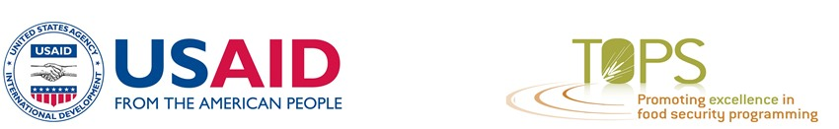

This guide was made possible by a grant from the USAID Technical and Operational Performance Support (TOPS) program. The TOPS Micro Grant Program is made possible by the generous support and contribution of the American people through the United States Agency for International Development (USAID). The contents of the materials produced through the TOPS Micro Grants Program do not necessarily reflect the views of TOPS, USAID or the United States Government.

Contents

Contents i

Acronyms and Abbreviations iii

Global Nutrition Efforts 1

About the Essential Nutrition Actions Operational Framework 2

The Essential Nutrition Actions 3

The Framework to Integrate, Communicate and Harmonize 6

2015 updates, compared to ENA 2010 7

Reference Documents 8

About the Reference Materials on Key Practices 9

About Adapting the Reference Materials on Key Practices 9

The Life Cycle Approach 10

Practice 1. Nutrition for Adolescent Girls and Non-Pregnant Women 10

Practice 2. Nutrition for Pregnant Women 12

Practice 3. Preventing Anemia and Malaria During Pregnancy 13

Practice 4. Using Iodized Salt 14

Practice 5. Early Initiation of Breastfeeding 15

Practice 6. Exclusive Breastfeeding From Birth Up to Six Months of Age 16

Practice 7. Positioning Your Baby Correctly for Breastfeeding 17

Practice 8. Nutrition for Lactating Mothers 18

Practice 9. Introducing Complementary Feeding 19

Practice 10. A Varied Diet 20

Practice 11. Feeding Frequency and Quantity for Children Aged Six Up to 12 Months 21

Practice 12. Feeding Frequency and Quantity for Children Aged 12 Up to 24 Months 22

Practice 13. Feeding Sick Children During and After Illness 23

Practice 14. Nutritional Care of Infants and Children with Diarrhea or Moderate Malnutrition 24

Practice 15. Importance of Vitamin A 25

Practice 16. Preventing Anemia in Children 26

Practice 17. Keeping the Environment Clean 27

Practice 18. Hand washing 28

Practice 19. Washing a Child’s Hands Before Feeding 29

Practice 20. Washing Your Hands Easily Using Minimum Water 30

Practice 21. Keeping Food and Food Containers Clean 31

Practice 22. Growing Diverse Crops and Raising Small Animals for a Varied Diet 32

Practice 23. Diversifying Crops for a Varied Diet 33

Practice 24. Importance of a Varied Diet for Pregnant and Breastfeeding Farmers 34

Practice 25. Raising and Eating Fish 35

Practice 26. Producing and Consuming Small-Animal Products 36

Practice 27. Taking Care of Poultry 37

Practice 28. Composting 38

Practice 29. Water Management and Mulching 39

[Practice 30. Farmers’ Role in Providing a Varied Diet to Their Pregnant and   
Breastfeeding Wives, and Young Children 40](#_Toc415043495)

Annex 1. Galidraa Negotiation Checklist 41

Acronyms and Abbreviations

ANC antenatal care

ARV antiretroviral

BF breastfeeding

BMI body mass index

CV community volunteer

EBF exclusive breastfeeding

EHA Essential Hygiene Actions

ENA Essential Nutrition Actions

FADDUA frequency, amount, density, diversity, utilization, active feeding

GALIDRAA Greet, Ask, Listen, Identify, Discuss, Recommend, Agree, set follow-up Appointment

GMP growth monitoring and promotion

HFP homestead food production

IDD iodine deficiency disorder

IFA iron–folic acid

IMAM integrated management of acute malnutrition

IMNCI integrated management of neonatal and childhood illnesses

IPT intermittent preventive treatment

ITN insecticide-treated mosquito net

IU international units

IYCF infant and young child feeding

LAM lactation amenorrhea method

MAM moderate acute malnutrition

MTCT mother-to-child transmission (of HIV)

MUAC mid-upper arm circumference

OTP outpatient therapeutic program

PMTCT prevention of mother-to-child transmission (of HIV)

RUTF ready-to-use therapeutic foods

SAM severe acute malnutrition

SBCC social behavior change communication

SFP supplementary feeding program

STI sexually transmitted infection

TOT training of trainers

TT tetanus–toxoid

Global Nutrition Efforts

Around the world **some 162 million children under five were stunted in 2012**. ‘At current trends, the number of stunted children under five is projected to be 128 million in 2025, against a target of 100 million. The current prevalence of anaemia in women of reproductive age is 29.4%, against the 2025 target of 14.7% (WHO, 2014)”.[5] Beyond the scourge of the lack of food is the even more pervasive problem of “hidden hunger,” or deficiencies in key micronutrients like vitamin A, iron, zinc and iodine. Children affected by stunting and micronutrient deficiencies are more susceptible to sickness, fare poorly in school, enter adulthood more prone to non-communicable diseases, and at work often earn less than non-stunted coworkers. Children suffer, families suffer and nations suffer.

The world community is reacting with increasing urgency to the gravity of this situation and its effects for the long term, focusing on global undernutrition, especially among pregnant women and children under two years of age. It is also aligning and increasing resources and building partnerships to combat suffering caused by undernutrition. Since 2010, more than 100 government, civil society, and university groups have endorsed the framework and roadmap for the Scaling-Up Nutrition (SUN) Movement. There is also broad recognition that a well-defined set of essential nutrition actions has proven effective in combating malnutrition during the critical first 1,000 days.[6]

The landmark *Lancet Series on Maternal and Child Undernutrition* published [in 2008](http://www.thelancet.com/series/maternal-and-child-undernutrition) and updated [in 2013](http://www.thelancet.com/series/maternal-and-child-nutrition)[7] [8] [9] estimates that maternal and child undernutrition is the cause of 45 percent of under-five deaths.1 These series reviewed global data from randomized control trials and confirmed that if implemented at scale during the window of opportunity (from conception up to 24 months of age) this package of nutrition-specific and nutrition-sensitive interventions can significantly reduce mortality and related morbidity and disability.

In 2013, the World Health Organization (WHO) released a guide entitled, *Essential Nutrition Actions: improving maternal, newborn, infant and young child health and nutrition[10],* which also draws on the findings of systematic reviews such as those of the Lancet to highlight the proven actions that need to be taken to scale within the health sector.

About the Essential Nutrition Actions   
Operational Framework

The **Essential Nutrition Actions (ENA) framework** was originally developed with the support of USAID, WHO and UNICEF, and has been implemented across Africa and Asia since 1997.[11] **The full ENA framework** is an approach for managing the **advocacy, planning and delivery** of an integrated package of interventions to **reach near universal coverage** (>90%) in order to achieve public health impact.

It promotes a **“nutrition through the life cycle”** approach to deliver the right services and messages **to the right person at the right time** using all relevant program platforms. It provides an **operational framework** for reducing “missed opportunities” both within[12] and outside the health system for delivering nutrition messages and services.

The recommended practices are multiple and potentially complex. However, over years of experience the program has evolved to distill the most important and practical aspects, and to **organize delivery mechanisms** that refresh and reinforce the knowledge of implementers. In addition, in each setting users can select priority elements from the full package for their context, and/or phase in components over time to avoid overloading health agents, community workers and other cadres helping to roll out nutrition strategies.

The Essential Nutrition Actions

Women’s Nutrition

**For adolescents and women:** the importance of the healthy timing and spacing of pregnancy, consumption of diversified diet and/or of fortified foods (commercial and/or in-home fortification).

**During pregnancy and lactation:** increased protein, caloric and micronutrient (Vitamin A, Iron, Calcium, Zinc) intake, dietary change to increase iron absorption, rest during pregnancy, and the lactation amenorrhea method (LAM) of contraception.

Breastfeeding

Early initiation of breastfeeding (immediately after birth), exclusive breastfeeding for the first 6 months, continued breastfeeding with complementary foods up to 2 years or beyond, and HIV and infant feeding.

Complementary Feeding

From 6 months (age-appropriate frequency, amount, density, diversity, utilization) with continued breastfeeding for up to two years or beyond, consumption of fortified foods (commercial and/or in-home fortification), responsive feeding, food hygiene.

Nutritional Care of Sick and Malnourished Children

Feeding more during and after illness, provision of vitamin A, and treatment of diarrhea with low-osmolarity ORS and zinc supplements, and the integrated management of acute malnutrition (IMAM) for moderate and severe acute malnutrition.

Prevention and Control of Anemia

**Among women:** increased dietary intake of iron-rich or enhancing foods, iron-folic acid supplementation during pregnancy, post-partum and more routinely by women of childbearing age, intermittent preventive treatment (IPT) for malaria and de-worming treatment during pregnancy, use of insecticide-treated bed nets (ITNs), and delayed cord clamping at birth.

**Among children:** delayed cord clamping at birth, implementation of the Integrated Management of Neonatal and Childhood Illness (IMNCI) algorithm and integrated Community Case Management (iCCM) of malaria, diarrhea, pneumonia, anemia and acute malnutrition, use of ITNs, de-worming from age 12 months, increased dietary intake of iron-rich or enhancing foods from age 6 months, and iron supplementation where indicated.

Prevention and Control of Vitamin A Deficiency

**Among children and women:** through breastfeeding, high dose supplementation of children ages 6-59 months and of women post-partum where appropriate, low dose supplementation during pregnancy where indicated, and promoting the regular consumption of vitamin A-rich, fortified or bio-fortified foods.

Prevention and Control of Iodine Deficiency

**Among children and women:** through promotion of iodized salt or through supplementation in the absence of scaled up iodized salt programs.

In addition, mounting evidence suggests it is necessary to give more emphasis to the **ESSENTIAL HYGIENE ACTIONS** previously embedded within complementary feeding and feeding the sick child. These actions include: household treatment and safe storage of drinking water (such as utilizing chlorine solution and storing water in closed container with tap), hand washing at five critical occasions (after defecation; after cleaning child who has defecated; before preparing food; before feeding child; before eating), safe storage and handling of food, the safe disposal of feces through the use of latrines and promotion of open defecation free communities, and creating barriers between toddlers and soiled environments and animal feces.

The ***2013 Lancet Maternal and Child Nutrition*** series emphasized that nutrition*-sensitive* programs, such as those shown in the box below, can improve nutritional outcomes by addressing many of the underlying determinants of malnutrition especially those related to food security, caregiving practices and adequate health services, water and sanitation. These nutrition-*sensitive* programs also offer an opportunity to integrate nutrition-*specific* interventions, such as the Essential Nutrition Actions (ENA) and Essential Hygiene Actions (EHA), which in turn leads to their increased coverage and effectiveness. As the Lancet authors note, *“…nutrition-sensitive programs can help scale up nutrition-specific interventions and create a stimulating environment in which young children can grow and develop to their full potential*”.[13]

The ENA & EHA training materials aim to provide skills on how to effectively implement *nutrition- specific* ENA & EHA interventions during the first 1,000 days, as well as emphasizes how to integrate these into a range of *nutrition-sensitive* programs including health services and community level interventions in other sectors.

|  |
| --- |
| Nutrition *Sensitive* Interventions  Health and Family Planning Services  Family planning  Adolescent and women health  Immunization   * Management of childhood illnesses   Food Security and Livelihoods  Agricultural interventions  Addressing seasonal food insecurity  Early warning and resilience  Social protection and safety nets  Conditional and unconditional cash transfers   * Dietary quality and diversity   Water, Sanitation and Hygiene (WASH) interventions  Environmental enteropathy  Promotion of hygiene behaviors and practices  Hygienic and sanitary environment  Drinking water – quality, distance and source  Improved sanitation facilities   * Reduction and elimination of open defecation   Early Childhood Development (ECD) and Positive Caregiving  Women’s Empowerment and Gender Equality  Maternal Mental Health  Child Protection  Classroom Education |

The Framework to Integrate, Communicate and Harmonize

The ENA Framework includes ensuring that priority messages and services from this comprehensive list are integrated into all existing **health sector programs**, in particular those that reach mothers and children at critical contact points in the first thousand days of the life cycle: maternal health and prenatal care; delivery and neonatal care; postpartum care; family planning; immunizations; well child visits (including growth monitoring, promotion and counseling); sick child visits (including facility and community IMCI and CCM); and IMAM.

The appropriate messages and services are also integrated to the greatest extent possible into programs **outside the health sector**: agriculture and food security activities; education (pre-service for health, primary and secondary schools for general education) and literacy programs; microcredit and livelihoods enhancement; and water, sanitation, and hygiene (WASH). ENA messages and behavior change communications are also delivered and reinforced by **community groups.**

Implementing the ENA framework entails building the widest possible network of partnerships across sectors so that interventions, practices and messages are harmonized and all groups use similar materials and jobs aids. Ideally, ministries and partners are brought together at the regional and/or national levels to agree on these harmonized approaches. Such fora can also serve as a platform for **advocacy** with policy leaders on the importance of nutrition to the nation’s economic as well as social development.

Implementing the ENA Framework Entails Three Interconnected Strategies

Develop **a multi-channel social and behavior change communication** (SBCC) plan to promote and support the adoption of “small do-able” actions. Special emphasis is given to **interpersonal counseling** (supporting individual mothers, especially in the context of their daily routines, to adopt optimal practices) reinforced by **group discussions**, **mass media, community festivals** and other **social mobilization events**. Health workers, other agents, and community workers are trained to employ the counseling technique of “negotiation for behavior change,” to help mothers anticipate and overcome barriers to carrying out new practices. Health workers can use these approaches with clients at clinics, while community workers apply them during home visits or at community meeting places (markets, chores, women groups meetings, etc.).

**Tailor a capacity building strategy** to enable program managers, health workers, other agents (agriculture extension workers, teachers, credit groups, etc…) and community workers to acquire knowledge and skills in delivering services and counseling through all relevant existing platforms and contacts, therefore decreasing missed opportunities to deliver ENA and EHA.

**Strengthen delivery systems** (health, agriculture, water & sanitation, education, finance) to secure the **regular supply** of nutrition related products, to include the **monitoring** of nutrition actions into information systems, and to incorporate nutrition into supportive supervision and quality improvement schemes.

2015 updates, compared to ENA 2010

The updated ENA-EHA training builds on the ENA 2010 training Trilogy keeping the overall format of the materials. The 2015 revised version also:

Includes the latest **ENA recommendations from WHO[14]** across the life cycle; in particular, nutrition for adolescents, non-pregnant and non-lactating women, revised micronutrient protocols, and the importance of working beyond the health sector.

Serves as **an operational and practical** tool for translating 2013 Lancet recommendations and SUN aspirations into action on the ground

Gives central focus to moving **beyond nutrition education to promotion of social and behaviour change**. Includes exercises throughout to build participants’ skills in counselling and negotiation to support caregivers to adopt improved practices, including role plays, field practicums, using illustrations to animate group discussions and individual counselling, facilitating community support groups, and applying these skills across both ENA and EHA.

Equips health workers at health facilities to **better deliver nutrition services** and messages at each health contact.

Guides **nutrition managers** through practical exercises to **build their training skills** and provides them with a tool to train **community workers across all sectors** to promote high impact nutrition and hygiene.

Includes the promotion of the **Essential Hygiene Actions** as inextricably linked to improved nutrition, going beyond hand washing to food hygiene, animal hygiene, safe water, and introduction to simple hand washing stations.

Incorporates suggestions for ways that **Homestead Food Production** can contribute to improved nutrition and how agriculture in general can be made nutrition-sensitive.

Reference Documents

Lancet References (2008 -2013)

[Lancet Series on Maternal and Child Undernutrition (2008)](http://www.thelancet.com/series/maternal-and-child-undernutrition) [Lancet Series on Maternal and Child Nutrition (2013)](http://www.thelancet.com/series/maternal-and-child-nutrition)

WHO References (2013)

WHO Essential Nutrition Actions Guide

ENA Training Materials (2015)

[ENA & EHA Training Guide - Health Workers](http://www.coregroup.org/storage/Nutrition/ENA/IIA._HW_Training_Guide_complete.pdf) and Nutrition Managers

[ENA & EHA Reference Manual - Health Workers and Nutrition Managers](http://www.coregroup.org/storage/Nutrition/ENA/IIB._HW_Training_Handouts_complete.pdf)

[ENA & EHA Training Guide - Community Workers](http://www.coregroup.org/storage/Nutrition/ENA/III._CV_Training_Guide_complete.pdf) (all sectors)

* ENA & EHA Reference Materials on Key Practices - Community Workers (all sectors)

ENA State of the Art Training for Managers (English & French, 2006)

Includes nine modules on rational for the essential nutrition actions and large scale implementation

Technical Capacity Assessment tools (JSI, 2013)

These tools are designed to help an organization assess its ability to implement various nutrition programs, looking holistically at personnel, documents, and systems in place at the organizational and implementing partner levels.

Essential Nutrition Actions Framework within the Health system

Community-based Management of Acute Malnutrition

* Essential Nutrition Actions Framework within the context of HIV & AIDS

Quality Assessment of Nutrition Services-A How-To Guide (HKI. [jnielsen@hki.org](mailto:jnielsen@hki.org))

Surveying Nutrition-Related Services Offered to Pregnant Women, Postpartum Women, and Caregivers of Children Under Five in Health Facilities

Supportive Supervision Tools

[Quality Improvement Verification Checklists](http://www.fsnnetwork.org/resource-library/social-and-behavioral-change/quality-improvement-verification-checklists-online-tra) [Partnership Defined Quality (Save the Children)](http://www.coregroup.org/our-technical-work/initiatives/diffusion-of-innovations/83) Integrated MNCH Supportive Supervision (JSI) Supportive Supervision at key health contact points (JSI)

Care Group Guidance for Community

[Care Group Difference: Guide to Mobilizing Community-Based Volunteer Health Educators (World Relief/CORE Group, 2004)](http://www.coregroup.org/storage/documents/Diffusion_of_Innovation/Care_Manual.pdf)

* [Training Manual for Program Design and Implementation (Food for the Hungry, 2013)](http://caregroupinfo.org/docs/CG_Manual_Final.pdf)

Formative Research Tools

ProPAN 2.0 (PAHO, CDC, 2013)/Optifoods Focused Ethnographic Study Guide (GAIN, 2012)

Designing for Behavior Change (CORE Group & Food Security & Nutrition Network, 2013)

About the Reference Materials on Key Practices

The goal of the Reference Materials is to support the delivery of nutrition and hygiene practices and to improve counseling that targets individuals using negotiation to promote the adoption of improved practices that are feasible and realistic for those individuals. It provides messages and additional information for each of the ENA and EHA practices as well as a brief introduction on how Homestead Food production (HFP) can be developed to improve household dietary quality and diversity.

Toward these ends, the Reference materials on key Practices:

Provides key background information explaining how the recommended practices will improve the nutrition and health of women and children.

* The selection and wording of messages might change from one setting to another; however the science behind the recommended practices remains the same.

The specific nutritious foods suggested for enriching the diets of women and young children need to be adapted to the context of the countries and regions, and seasonal variability needs to be taken into consideration.

Gives simple tips on ways to promote optimal behaviors by mothers, husbands, mothers-in-law, and other household members.

Provides discussion topics for counseling sessions and group meetings, with illustrations and details.

* The proposed illustrations are representative to show examples that can be used during counseling and negotiation. They can also be used as sample for adaptation of potential local illustrations.

Countries and/or projects might also already have validated illustrations, health cards, and/or posters that can be used in place of those included here

About Adapting the Reference Materials on Key Practices

Two training guides have been developed to strengthen the nutrition capacity of health workers and community workers. Both include sessions introducing **technical content** while also enabling the **practice of counseling and negotiations skills** through role plays and field practice and guiding providers in how to deliver nutrition and hygiene through **existing contacts using a life cycle approach**.

While the content of the training guides remain generally fixed, the approach for communicating the rationale and benefits of the practices may need to be adapted through **formative research or testing of the messages** to ensure they fit specific country and regional cultures and contexts. Such research will identify key behavioral determinants to be addressed, local terms and social norms to be taken into account, and other strategies to tailor the general training modules and communications strategies to the specific needs of each unique area. Similarly, protocols related to micronutrient supplementation and treatments will have to be aligned with country recommendations.

The Life Cycle Approach

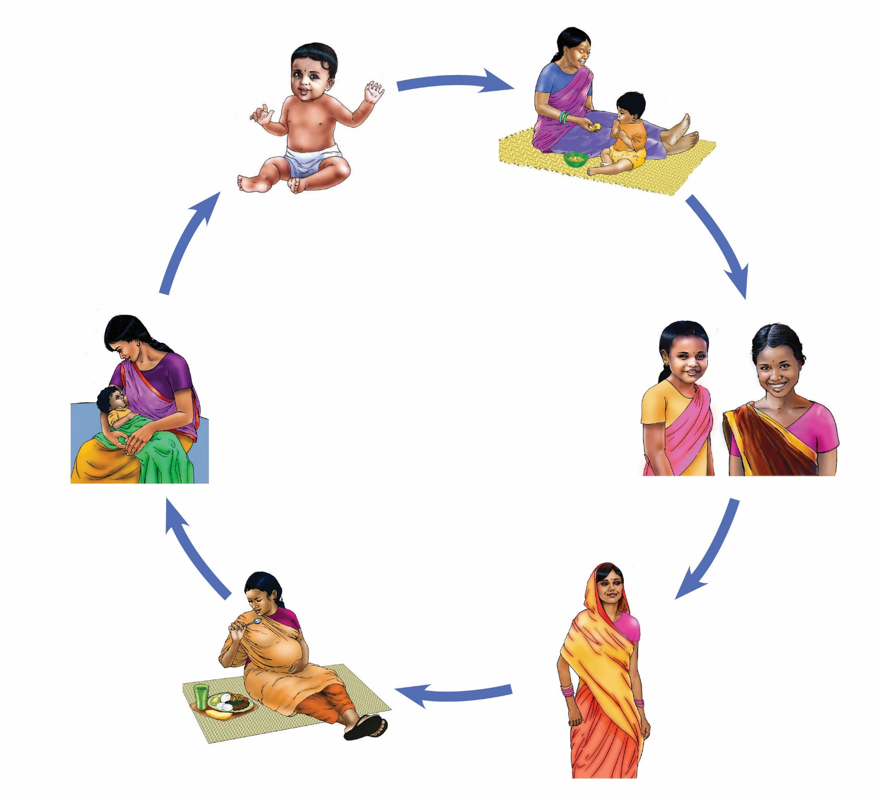Practice 1. Nutrition for Adolescent Girls and   
Non-Pregnant Women

What do you see in this picture? How can we help adolescent girls eat what they need? In your community, do parents or teachers advise adolescent girls to eat additional diversified foods? Why or why not? *[Discussion.]*

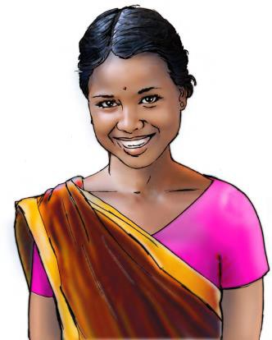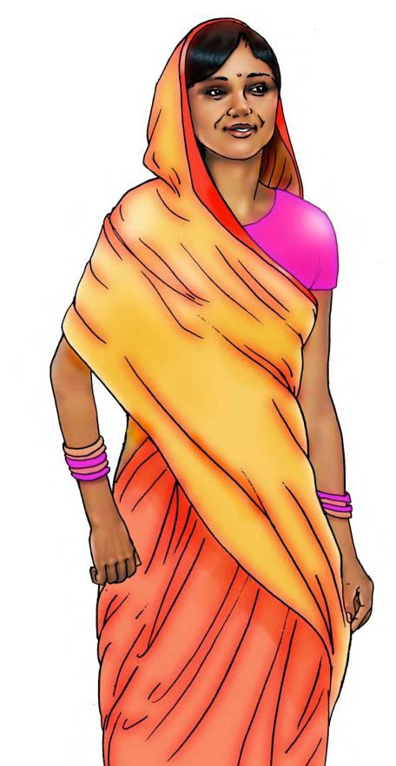

Messages

**Give at least three meals to your daughter daily, each with different types of colorful food. At least one meal includes fish, chicken, eggs, or meat. This extra food will make her strong and healthy to prepare her for future motherhood.**

**Give weekly iron-folic acid (IFA) supplementation and de-worming medicine twice a year to prevent anemia or weak blood**

More Information

Between the ages of 10 and 20 a girl is experiencing an important growth spurt and needs different types of food together with IFA supplements for her body to develop.

An adolescent girl and a non-pregnant woman need to eat many different types of colorful foods: amaranth and red amaranth, country bean, yard-long bean, soybeans, peanuts, black beans, orange-flesh sweet potato, pumpkin, moringa, okra, papaya, and spinach.

Eating fish, chicken, eggs, or meat at least once a day will make an adolescent girl strong and help her develop as a healthy adult.

IFA and de-worming medications are available at schools or at health facilities.

To allow the full development of her body and to have a strong baby, an adolescent must delay her first pregnancy until she is 20 years old.

To allow the body to rest, pregnancies need to be spaced by a minimum of three years.



Practice 2. Nutrition for Pregnant Women

What do you see in this picture? How can we help pregnant women eat what they need? In your community, do husbands advise their pregnant wives to eat additional food? Why or why not? *[Discussion.]*

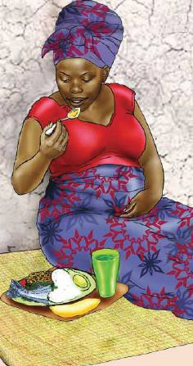Message for Mothers

If you are pregnant, eat one extra bowl of food every day to be healthy and active, and to give birth to a strong baby. This extra food will not make the baby too big—just strong and healthy.

More Information

To be strong and get vitamins, a pregnant woman needs   
to eat many different types of colorful foods: amaranth   
and red amaranth, country bean, yard-long bean, soybeans, peanuts, black beans, orange-flesh sweet potato, pumpkin, moringa, okra, papaya, and spinach.

Eating fish, chicken, eggs, or meat at least once a day   
will make a pregnant woman strong and help her have   
a healthy baby.

When you are pregnant, you need to eat one extra   
meal per day.

When you are pregnant, you need to rest and avoid  
 carrying heavy loads.

* Go to the health facility to get calcium from the health workers

Message for Husbands, Mothers in Law

If your wife or daughter-in-law is pregnant, make sure that she has one extra meal each day, she rests adequately, and she does not carry heavy loads or do strenuous household chores so that she can deliver a strong and healthy baby.



Practice 3. Preventing Anemia and Malaria During Pregnancy

What do you see in this picture? In your community, do pregnant woman get iron-folic acid (IFA) supplementation and treatment for malaria and other parasites from the health facility? *[Discussion.]*

Message for Mothers

When you know you are pregnant, go to your health facility to get IFA tablets to take daily to maintain your strength and health during pregnancy, and to prevent anemia.

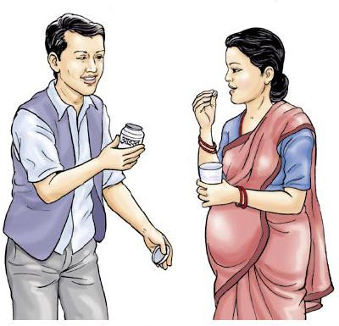More Information

Anemia is a condition where the amount of blood in your body is too low, so that you feel sick and very weak.

As a pregnant woman, you need plenty of iron to avoid becoming anemic.

IFA tablets are important to stay strong.

Ask a health worker for a new supply of IFA tablets   
at each visit.

Ask about preventive treatment against malaria   
at each visit.

Ask about deworming medicine at each visit.

Take IFA once a day as soon as you know you are pregnant, and continue taking it daily for three months after delivery.

Take it with food to prevent nausea and drink lots of water to avoid becoming constipated.

* Fish, meat, eggs, liver, and dark green leafy vegetables are good sources of iron.

Message for Husbands and Fathers

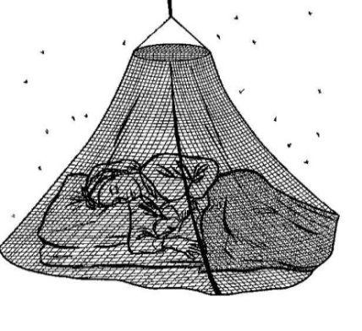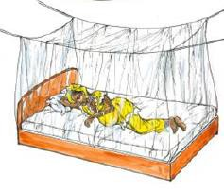

To prevent malaria, make sure that your family sleeps under an insecticide- treated mosquito net (ITN), especially pregnant women and children. Make sure your wife starts antenatal visits as soon as you know she is pregnant.

More Information

Malaria causes anemia, which will make family members unwell and very tired.

Family members with a fever need to be treated immediately at a health facility.

Practice 4. Using Iodized Salt

What do you see in the picture? Why is it important to use iodized salt? Can you find it in your community? *[Discussion.]*

Message for Mothers and Caregivers

When cooking for the family, make sure to use iodized salt so that family members remain healthy.

More Information

Iodized salt is available almost everywhere.

Pregnant women need to use iodized salt to ensure the health of their babies. Iodine is important for the baby’s brain development.

Adults need iodine to prevent goiter.

Add the iodized salt at the end of the cooking.

Store iodized salt in a tightly sealed dark container.

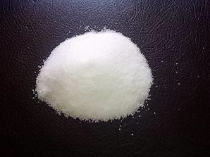

Practice 5. Early Initiation of Breastfeeding

What is happening in the picture? Do mothers in your community start breastfeeding immediately after birth, even before expelling the placenta? *[Discussion.]*

Message for Mothers

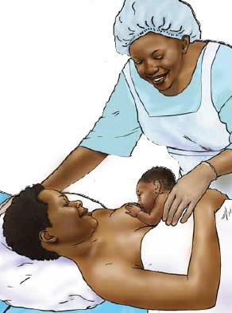Put your baby on the breast immediately after birth, even before expelling the placenta, to stimulate your milk production and prevent hemorrhage.

More Information

The first yellow milk (colostrum) does two important things, it helps to protect the infant from illness, and it helps the infant to expel its first dark stool.

Putting the baby on the breast immediately after birth will help expel the placenta and reduce postpartum bleeding.

Feeding the baby sugar water, honey, water, powdered milk, cow’s milk, or goat’s milk—rather than breastfeeding—may interfere with establishing good breastfeeding practices and could lead to diarrhea, pneumonia, or other illness in the baby.

* If you have nipple or breast problems, see a health worker for care right away.

Practice 6. Exclusive Breastfeeding From Birth Up to   
Six Months of Age

What do you feed a baby who is less than six months of age? *[Discussion.]*

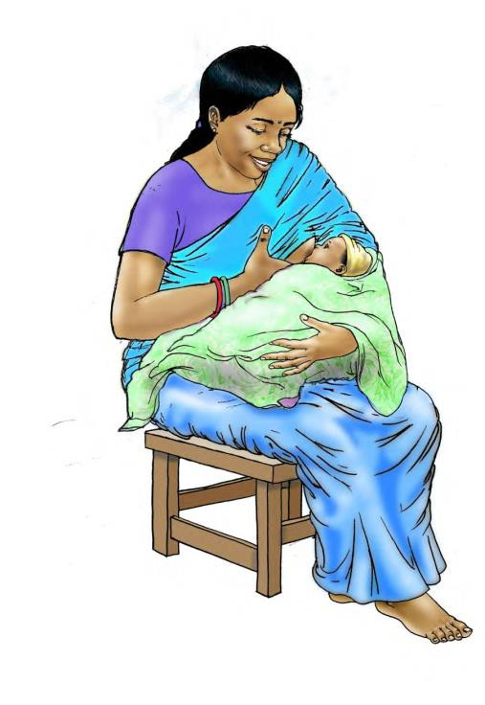Message for Mothers

For your baby to grow healthy and strong, give only breast milk—and no water or other liquids or food—for their first six months of life. Breastfeed as often as your baby wants to eat —*at least* eight to 12 times over a 24 hour period—to help you produce enough milk and give your baby enough food to grow healthy and strong.

More Information

Breast milk provides the best possible nourishment for babies, builds their ability to fight illness and protects them from diarrhea and respiratory infections.

During your baby’s first six months, even in hot weather, breast milk is enough to satisfy their thirst. Remember: If you give your baby water or other liquids, he/she will suck less on the breast and will not grow as well.

Frequent breastfeeding helps milk flow and ensures your baby’s growth.

Empty the first breast before you switch to the other. That way, your baby will receive all the nutrients and fat in the breast milk.

Never use a bottle to feed your baby. Bottles are hard to keep clean and may become contaminated and cause illness.

Practice 7. Positioning Your Baby Correctly for Breastfeeding

Do new mothers in your community have any problems with breastfeeding? Do they know how to hold their babies correctly so that they take in the most nourishment possible? What were your personal challenges? *[Discussion.]*

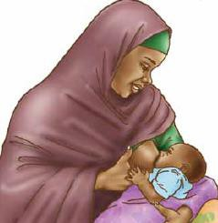Message for Mothers

When breastfeeding, sit comfortably and draw your baby toward you. Take care not to lean down over your baby.

More Information

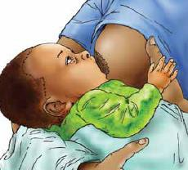When you breastfeed, your infant is able to look up at your face. Hold him close to you, his stomach against your stomach, his head, back, and buttocks in a straight line, and his nose pointing straight toward your breast. Let one arm of your baby extend behind your back.

Be sure to support your baby's whole body, not just her head and shoulders.

Hold your breast with your fingers in a C shape, the thumb above the dark part of the breast (the areola) and the other fingers below.

Do not put your fingers in a scissor hold around your nipple (with two fingers on either side of it); this puts pressure on the breast and can stop your milk flow and pull the nipple out of your baby’s mouth.

* To stimulate the infant to open his mouth wide, tease their lower lip with your nipple.

Signs of Proper Attachment

Tease the infant’s lower lip with the nipple, in order for the infant to open his mouth wide. The infant’s chin s touches the breast.

The infant’s lower lip is turned outward.

* The infant’s mouth covers a large part of your areola, with more of the areola showing above the nipple than below.

Signs of Efficient Suckling

Sucking is slow and regular, with one swallow following each two sucks.

Your infant’s sucks are slow and deep, with occasional pauses.

Sucking is comfortable and pain free for you.

You hear your baby swallowing.

Your breast is softened after the baby has finished feeding.

Practice 8. Nutrition for Lactating Mothers

What is happening in the picture? In your community, do you give additional meals to mothers who are breastfeeding? *[Discussion.]*

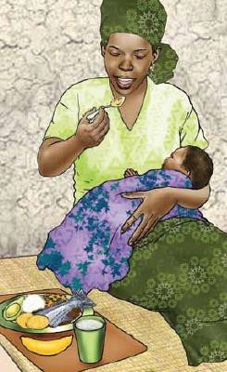Message for Mothers

Every day when you are breastfeeding, eat two extra bowls of food to maintain your baby’s and your own strength and health, and to receive enough vitamins. Be sure to eat many different types of foods.

More Information

To be strong and get vitamins, a breastfeeding woman needs to eat many different types of colorful foods: amaranth and red amaranth, country bean, yard-long bean, soybeans, peanuts, black beans, orange-flesh sweet potato, pumpkin, moringa, okra, papaya, and spinach. Eating fish, chicken, eggs, or meat at least once a day will help make you strong. When you are lactating, you need to drink plenty of clean water.

Continue taking IFA supplements for three months after delivery.

Message to Husbands

Make sure your wife eats different types of food every day to be strong and get vitamins.



Practice 9. Introducing Complementary Feeding

What is happening in the pictures? When should children start eating food other than breast milk? What kinds of food should they start with? *[Discussion.]*

Message for Mothers and Fathers

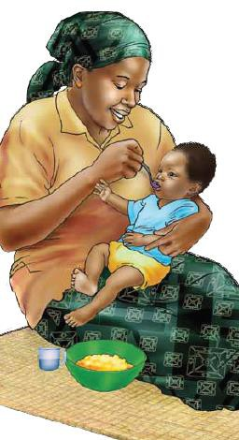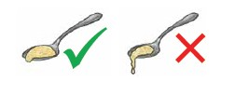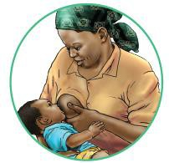

For your baby to grow and stay healthy and strong, introduce pureed or mashed food twice a day when she is six months old, but also continue breastfeeding until she is two years or older.

More Information

At six months, breast milk alone is no longer enough to keep your baby growing. Begin to give your baby rice, dark green leafy vegetables, fish, meat, and eggs every day, in addition to breast milk.

Porridge can be made from local foods, such as rice, plantains, corn, sorghum, cassava, sweet potatoes, yams, eddo, or others, and then enriched with a wide variety of ingredients.

Mash and soften the food you give to your baby so he can easily chew and swallow it. Keep the baby’s food thick enough that it falls slowly off a spoon. It should not be watery. Food can be thicker as your baby grows older, but make sure it is not too thick to swallow easily without choking.

Porridge made with milk is much better than porridge made with water: porridge with water does not provide enough nutrients for your child to grow strong and healthy. If you can, use breast milk or milk to cook the baby’s porridge; it will be more nutritious.

Use iodized salt whenever possible in family foods.

Clean ingredients well and cook food thoroughly before   
giving to your baby.

Wash your hands before feeding your baby.

Help your baby learn to eat by feeding him patiently, encouraging him to eat all the food you offer. Force feeding or  
 stuffing your baby discourages him from eating and can be harmful.

Do not add pepper or chili to food, it ruins your baby’s appetite.

Breast milk remains an important source of nutrients for babies and protects them from allergies, diarrhea, pneumonia, and other diseases. Keep breastfeeding as often as your baby wants to eat, at least through their second year.

Practice 10. A Varied Diet

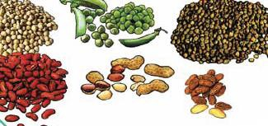What do you see in this picture? How can you enrich the food you feed your baby or child to prevent malnutrition? *[Discussion.]*

Message for Mothers

At each meal, to help your baby grow and get strong, enrich the food you give them with two to three different types of colorful food.

More Information

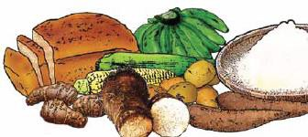Add colorful foods to enrich your baby’s diet: vegetables and fruits that are orange and red, such as carrots, orange-fleshed sweet potatoes, and ripe mango and papaya; dark green leafy vegetables such as kale and chard; and avocado, beans, eggs, peanuts, and peas or lentils.

Add animal-source foods such as fish, eggs, chicken, liver, and other meat and milk whenever available. Animal-source foods are especially important to help babies and children grow healthy and strong.

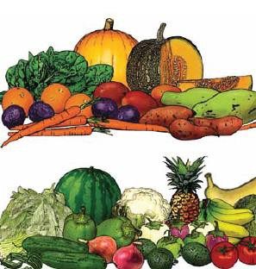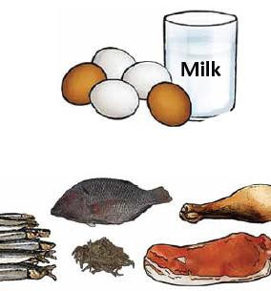

Add a little butter, spoon oil, palm oil, vegetable oil, sesame seed or peanut paste to your baby’s food.

Every day, give your baby a little fruit, including those above, or banana, butter pear, mangoes and plums, or watermelon. Make sure the fruit is well washed, and for younger babies, well mashed or squeezed into juice.

Mash and soften other family foods to make them easy for your baby or child to chew and swallow.

Keep breastfeeding until your child is 24 months or older, as often as your child wants to eat or drink.

Message for Fathers

When you go to the market, buy nutritious food for your young child, such as eggs, liver, mangos, or papayas. These foods can also make healthy snacks.

Practice 11. Feeding Frequency and Quantity for Children Aged Six Up to 12 Months

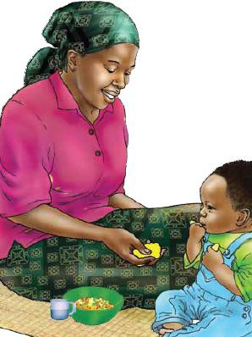What do you see in this picture? How many times do you feed your baby when he is six to 11 months old? *[Discussion.]*

Message for Mothers

Between the ages of six and 11 months, make sure that your baby keeps growing healthy and strong by feeding her two to three times each day plus one or two nutritious pureed or mashed snacks.

More Information

Babies have small stomachs and need to be fed often to grow healthy and strong.

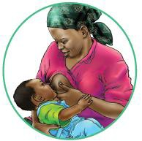Start by giving six- to eight-month-old babies half of a 250 ml. bowl of colorful food twice daily—three times daily as the baby gets older.

Whenever available, include animal-source foods (i.e., fish, eggs, chicken, liver, and other meat, and milk).

Serve your baby’s food in their own bowl so you can see how much she is eating.

One or two times daily, in addition to meals, give a nutritious snack such as ripe papaya and mango, banana, or jackfruit; boiled white potato or sweet potato; and fried sweet gourd, green banana, or potato.

By eight months, your baby should be able to begin eating with his hands.

Give small pieces of soft ripe fruit or soft cooked vegetables.

Continue breastfeeding. Feed breast milk eight to 10 times every day.

Before feeding your child, to avoid diarrhea, wash his hands and your own.

Use iodized salt to prepare food for the whole family, including the child.

Be patient. Play and sing to encourage your baby to eat, as it may take her  
awhile to adapt to foods other than breast milk.

Force feeding or stuffing babies discourages them from eating.

Avoid Bottle Feeding

Feed your baby using a clean bowl or cup and never a bottle. Bottle feeding may cause your baby to get diarrhea.

Practice 12. Feeding Frequency and Quantity for Children Aged 12 Up to 24 Months

What do you see in this picture? In your community, how many meals are given to a child 12 to 24 months of age? Or, how many times do you yourself feed your child when they are that age? *[Discussion.]*

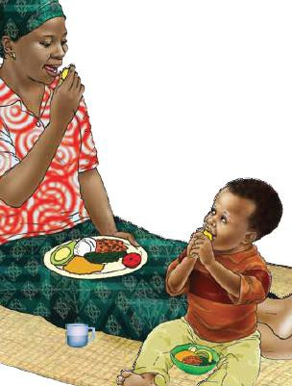Message for Mothers

At least three to four times a day when your child is between 12 and   
24 months of age, feed him family foods plus one or two snacks—  
also solid food—to ensure healthy growth.

More Information

Young children have small stomachs and can eat only small amounts at each meal. Feed your child frequently throughout the day to help her grow healthy and strong.

Give a 250 ml. bowl of family food three times every day.

Make sure that family meals include a variety of colorful foods: orange and red vegetables and fruits, green leafy vegetables, and eggs, beans, lentils, or peanuts.



Whenever available, include animal-source foods (i.e., fish, eggs, chicken, liver, and other meat and milk), which are the most important for growth.

Serve your child’s food on his own plate—separate from the family plate—so you can see how much he is eating.

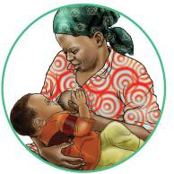At least twice a day, in addition to meals, give a nutritious snack such as ripe mango and papaya, avocado, banana, boiled potato, orange-fleshed sweet potato, other fruits and vegetables, and fresh and fried bread products. Before feeding your child, to avoid diarrhea, wash her hands and your own.

Use iodized salt to prepare food for the whole family, including the child.

Be patient and play with your baby to encourage her to eat, as   
she may be more interested in exploring her world than sitting still to eat.



Practice 13. Feeding Sick Children During and   
After Illness

What do you see in this picture? What do you do when your baby or child gets sick? *[Discussion.]*

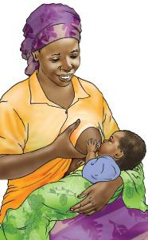Message for Mothers

When your child is sick, breastfeed more often. Offer children aged six months and older additional food to help them recover faster. For two weeks after your child aged 6 to 24 months has recovered from illness, give one additional meal of solid food each day to speed recovery.

More Information

*For all infants and young children up to 24 months:*

When your baby is sick and afterwards, breastfeed more often and for longer each time to help him recover faster and lose less weight. Breastfeeding also comforts a sick child.

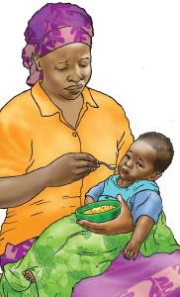Continue breastfeeding during illness —ideally, more frequently than usual in order to comfort the child and restore strength.

* Continue breastfeeding even when you yourself are sick.

*For infants six months and older:*

A sick child’s appetite will fall off because of illness. Be   
patient in encouraging her to eat and offer favorite foods.

Give her food in small quantities throughout the day.

Keep feeding family foods to a sick child to maintain her strength and prevent weight loss, especially after recovery when appetite returns.



Practice 14. Nutritional Care of Infants and Children with Diarrhea or Moderate Malnutrition

Moderate Malnutrition

What do you see in the picture? Zinc helps your baby recover much faster from diarrhea. *[Discussion.]*

Message for Mothers

If your child is sick, with diarrhea or is malnourished, breastfeed more often. In addition, if your child is older than six months, also provide one more bowl of food each day in addition to any supplementary food you’ve been given.

More Information

*For all infants and children up to 24 months*

Breastfeed a sick child more frequently. It will help her recover faster.

If your child has moderate malnutrition, give him one additional meal each day until he recovers.

After diarrhea, give your child an additional meal for two weeks to help her recover faster.

If your child over six months has diarrhea, give her an oral rehydration solution (ORS) so that she does not become dehydrated. For a child under six months who is very sick and dehydrated, ORS is also recommended.

To help your baby recover more quickly from diarrhea, ask your health worker to give you zinc and follow instructions for its use. Give zinc for the exact time period specified—usually between 10 and 14 days.

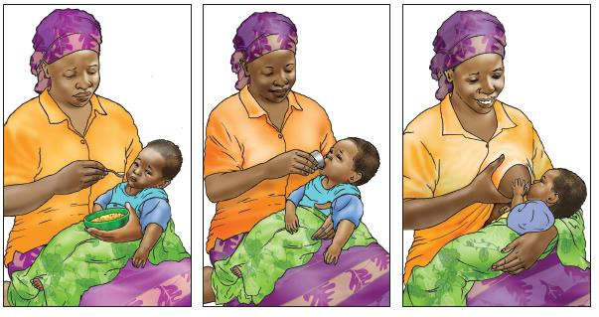



Practice 15. Importance of Vitamin A

What do you see on this picture? Where can you get vitamin A in your community? Why is a varied diet important? *[Discussion.]*

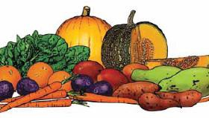Message for Husbands

Make sure that the pregnant and lactating women and the children between six months and two years of age in your household eat papaya, mango, and other orange and yellow fruits, as well as orange-fleshed sweet potatoes, dark green leafy vegetables, liver, and milk for their health.

More Information

Food rich in vitamin A will enrich breast milk with important nutrients to keep your baby healthy and strong.

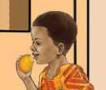A varied diet provides all the vitamins needed by women, children, and the family.

Give as much animal-source food (i.e., fish, eggs, chicken, liver, and other meat and milk) as possible to enrich the diet of pregnant women, breastfeeding women, and children aged six months up to two years.

* Eat fortified foods when they are available for purchase in stores.

Message for Mothers

As soon as your baby reaches six months of age, make sure she receives her first vitamin A supplementation to stay strong and healthy

More Information

Vitamin A is essential to your child's eyesight and helps to fight illness.

Ask a health worker to give vitamin A supplementation twice a year from six to 59 months of age.

Bring your child to vitamin A supplementation sessions on national immunization days or other events where vitamin A supplementation is provided.

Practice 16. Preventing Anemia in Children

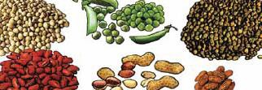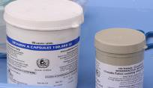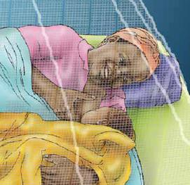How do you prevent your child from becoming anemic? Where can you get your children deworming medicine? Why is a varied diet important? Why sleep under an insecticide- treated mosquito net (ITN)? Why get deworming treatment? *[Discussion.]*

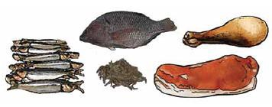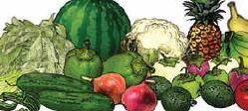

Message for Fathers

Make sure that the children between six months and two years of age in your household eat animal products like liver, red meat and small fish, as well as legumes, and dark green leafy vegetables to prevent anemia. Orange foods are also important, like papaya, ripe mango, and orange-fleshed sweet potatoes.

More Information

A varied diet will provide all the vitamins needed by women, children, and the family to protect health and strength.

Give as much animal-source food (i.e., fish, eggs, chicken, liver, and other meat and milk) as possible to enrich the diet of pregnant women, lactating women, and children aged six months up to two years.

* Eat fortified foods when they are available for purchase in stores.

Message for Mothers

As soon as your child reaches 12 months of age, make sure he receives deworming medicine and has another dose every six months to maintain healthy growth.

More Information

Intestinal parasites steal nutrients from the child, which will make her tired and unwell.

Ask a health worker for deworming medicine to be given twice a year. Continue up to five years.

* Deworming is often offered on national immunization days and your child should get all the treatments available.

Message for All Caregivers

All family members should sleep under an ITN—in particular, pregnant and lactating women and young children—to prevent malaria.

More Information

Malaria causes anemia.

All family members with a fever need to be taken to a health facility for immediate treatment.

Practice 17. Keeping the Environment Clean

What do you see in the picture? Why is it important to use a sanitary latrine? Why is hand washing after using the latrine necessary? *[Discussion.]*

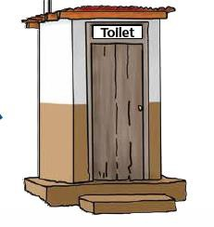Message for Mothers, Fathers, and Caregivers

To keep your environment clean and prevent illnesses, use a sanitary latrine, and teach your children how to use it.

More Information

Family members, especially young children, will get diarrhea or other diseases in a dirty environment. Germs easily travel from places of open defecation into food and water, making everyone sick.

Build a sanitary latrine if you don’t have one.

Keep your latrine clean to protect your environment, the water around your house, and your fields.

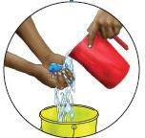To prevent flies, cover the hole of the latrine, and keep your entire compound clean and free of garbage.

Keep enough water in the latrine to clean it.

Install a hand washing station with soap just outside the latrine to encourage everyone to wash hands after every visit.

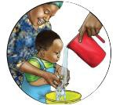

Practice 18. Hand washing

What do you see in the picture? Why is it important to wash your hands? *[Discussion.]*

Message for Mothers, Fathers, and Caregivers

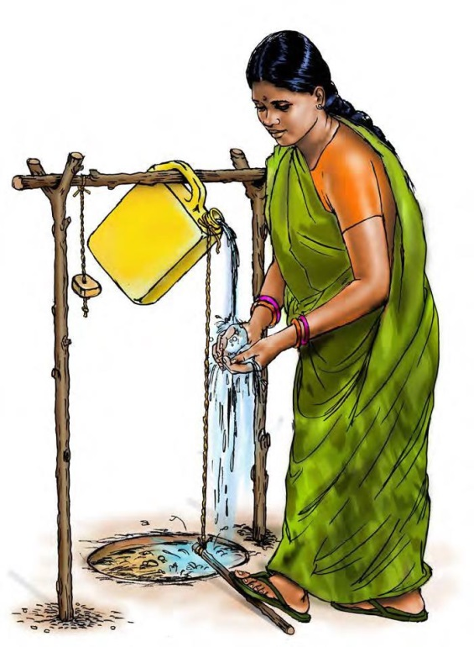Wash your hands with water and soap after using the toilet, cleaning children’s bottoms, before preparing food, and before eating or feeding your family, including your babies and children.

More Information

Thorough hand washing will help keep you and your family from getting sick.

Wash your hands before preparing and eating food.

Wash your hands before feeding your infants, babies, and children.

* Wash your hands after using the toilet or latrine.

Steps to Thorough Hand Washing

Rub your palms together.

Interlock your finger webs and rub them together.

Rub each palm against the back of the opposite hand.

Rub each palm over knuckles and finger tips on the opposite hand.

Rub each thumb.

Rub around your wrist and a ways up your forearms.

Rinse your hands with warm water suitable for drinking.

Dry your hands in the air or on a clean, hygienic cloth.

Practice 19. Washing a Child’s Hands Before Feeding

What do you see in the picture? Why is it important to wash your hands before feeding a baby or young child? *[Discussion.]*

Message for Caregivers

Small children can get very dirty exploring their surroundings. There are many germs on the ground that can make them sick. Thoroughly wash your child’s hands and your own hands before mealtimes—before preparing food, before feeding your child, and before eating. Always use soap and water.

More Information

Learn to wash your hands properly so you do not pass on any illnesses.

* Teach children to do the same.

Steps to Thorough Hand Washing

Apply soap and water to your hands.

Rub your palms together.

Interlock your finger webs and rub them together.

Rub each palm against the back of the opposite hand.

Rub each palm over knuckles and finger tips on the opposite hand.

Rub each thumb.

Rub around your wrist and a ways up your forearms.

* Rinse your hands with warm water suitable for drinking. Dry your hands in the air or on a clean, hygienic cloth.

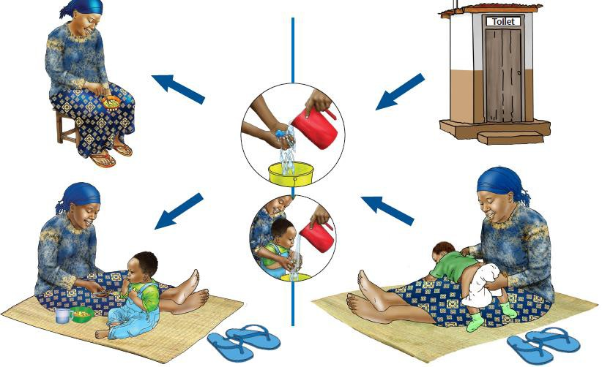

Practice 20. Washing Your Hands Easily Using   
Minimum Water

What do you see in the picture? How can you save water to make sure there is enough for regular hand washing? *[Discussion.]*

Message for Mothers, Fathers, and Caregivers

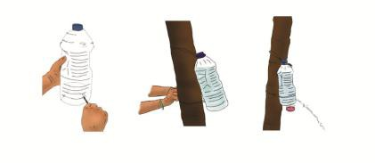Washing your hands is always important so that you and your family stay healthy and free from disease. Rigging a special water source in every location where you need to wash your hands will help you do so—using minimum water.

More Information

Set up water sources, known as “tippy taps,” near the cooking area, the child feeding area, and the toilet.

* 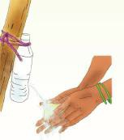Tippy taps prevent waste of water and motivate people to wash their hands.

How to Make and Use a Tippy Tap

Warm a nail. Then, using the nail, make a hole on one side of   
a salvaged water bottle, preferably one that can contain about   
five liters, or 1½ gallons.

Place the bottle in a raised position or hang up the bottle   
using a rope.

Fill the bottle with water, then close it with its cap.

Place soap next to the hanging water bottle. You can tie soap  
 in netting and attach it to the tippy tap so it stays in place.

To use the tippy tap, open the cap when you wash your hands   
and close it again when you’ve finished.

Practice 21. Keeping Food and Food Containers Clean

What do you see in the picture? Why is it important to keep containers clean, particularly containers for water storage and young children's food bowls or plates? *[Discussion.]*

Message for Mothers

Clean bowls and spoons with soap and water before you use them to feed babies and young children. Keep your drinking water in a narrow-necked container, and clean the container well before filling, to keep water clean. Always cover your family’s food and water to keep dirt and flies away. Your baby or young child can get diarrhea if their feeding bowl is dirty.

More Information

Clean water can get dirty if it is left uncovered in the open air.

Flies bring germs and dirt, and infect your food and your baby’s food.

* It is also important to reheat any food that has been stored to make sure it is germ-free.

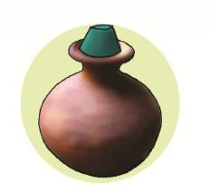



Practice 22. Growing Diverse Crops and Raising Small Animals for a Varied Diet

Why is it important for farmers to diversify their crops and to grow small animals? How does crop variety affect a family’s nutrition? *[Discuss with farmers, both male and female, wherever you find them: (micro)credit facilities, input shops, veterinary shops and service centers and markets)]*

Message for Farmers

Growing a wide variety of vegetables and fruits and rearing small animals and fish allows you to provide your family with a more varied, tasty and nutritious diet, while reducing the need to buy food in the market.

More Information

To keep your family members strong provide them with diverse, nutritious foods rich in energy, minerals and vitamins. Some essential groups are dark green leafy vegetables (amaranth, moringa, jute mallow, African nightshade and spinach), beans (soybeans, peanuts, cowpeas and others), orange and yellow fruits and vegetables (orange-fleshed sweet potato, pumpkin, papaya and ripe mango), and animal-source foods (eggs, chicken, liver, fish, meat and milk).

When you diversify your crops and have an successful harvests despite unpredictable rainfall or extreme temperatures.

Rearing small livestock, such as poultry and small ruminants, allows you to produce nutritious animal source foods such as eggs and milk for your own consumption or for income. The animal themselves can be sold at times when cash is needed for medicines or school fees and supplies.

For pregnant and breastfeeding women and for children aged six months up to two years to have all the vitamins they need and be strong and healthy, they should eat at least three or four of the different types of colorful foods mentioned above, in additional to the staple foods (cereals, tubers, etc.).

* It is important to keep the compound free of animal waste, especially poultry droppings, particularly in areas where children are spending a lot of time.

Message for Household Heads and Husbands

Leaving space around the house to grow vegetables, fruits and raise small livestock to provide nutritious foods to pregnant or breastfeeding women and to your children aged six months up to two years is a good and important decision.

Practice 23. Diversifying Crops for a Varied Diet

Why is it important for farmers to diversify their crops and for women and young children to have a varied diet? *[Discuss with agricultural extension agents and male and female farmers during visits in households and courtyards, to farmer nutrition schools, and in other farmer groups.]*

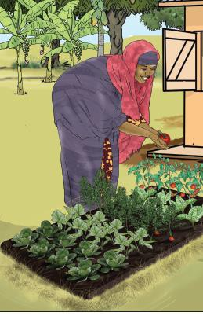Message for Farmers

Plant a variety of crops in your garden and irrigate when needed to yield harvests all year round and to be able to include at least two or three different types of colorful foods at each family meal.

More Information

Although babies under six months of age need only breast milk to grow strong and healthy, pregnant and breastfeeding women and children aged older than six months need a varied diet.

To keep your family members strong provide them with diverse, nutritious foods rich in energy, minerals and vitamins. Some essential groups are dark green leafy vegetables (amaranth, moringa, jute mallow, African nightshade and spinach), beans (soybeans, peanuts, cowpeas and others), orange and yellow fruits and vegetables (orange-fleshed sweet potato, pumpkin, papaya and ripe mango).

Growing and rotating a variety of crops will also keep your soil nourished and reduce pests.

Supplement the foods you grow by gathering wild fruit and plants when these are available

When you sell the products of your harvest, always keep some for your family, so that you can give two or three different types of food to your babies older than 6 months and young children at each meal to make them strong.

Dry or process some of your fruit and vegetable harvest to eat or sell later.

Store your bean and cereal grains in containers that are rat- and insect-proof.

A small irrigated garden also allows you to produce and consume throughout the year and be less dependent on the rainy season. If your production is more than what your family needs, you can conserve some produce by processing it, sell some produce in the market, or both.

Practice 24. Importance of a Varied Diet for Pregnant and Breastfeeding Farmers

Do woman farmers in your community understand the importance of a varied diet to the health of their babies and children? How do you manage your garden and farming practices to provide nutritious meals for your family? *[Discuss in households or among groups of male and female farmers.]*

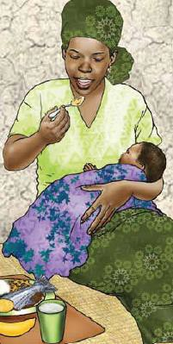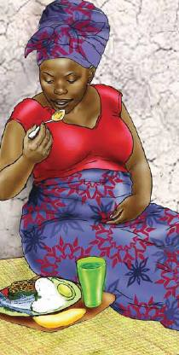Message for Female Farmers

If you are pregnant or breastfeeding, talk with your husband about how important it is for you to eat a varied diet containing as much animal-source food as possible to ensure your baby’s health. If you are pregnant, work with him to make a plan for you to reduce your workload and rest more. If you are breastfeeding, discuss how you can continue breastfeeding while slowly increasing your workload, to ensure the baby is being breastfed appropriately.

More Information

When a woman is pregnant or breastfeeding, she needs more food and a varied diet to stay strong and to have a baby who is healthy and strong. It is a good idea to reserve some animal-source food (i.e., fish, eggs, chicken, liver, and other meat and milk) for her to consume at home.

To prevent illness and grow well, a child from birth up to six months of age needs only breast milk—no water or other liquids and no solid food.

* At six months, a child needs additional food as well as breastfeeding until the age of two.

Tips for Female Farmers Who are Breastfeeding

As much as possible, take the baby with you to the field. Otherwise, before you leave your baby to go to the field, breastfeed baby until baby is completely satisfied.

* If possible, ask an older child to bring your baby to the field during the day for breastfeeding.

Message for Husbands, Household Heads and Family Members

If your wife or family member is pregnant or breastfeeding, encourage her to eat a varied diet containing animal-source foods. During her pregnancy, help her with chores so that she gets enough rest. While she is breastfeeding, discuss how you can help her continue to do so after she goes back to working in the field.

Practice 25. Raising and Eating Fish

How much fish is raised and eaten in your community? Why or why not? How much fish is consumed in your home?

*[Discuss in a household or a group of male or female farmers.]*

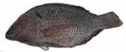Message for Farmers

Raising fish in a small pond near your house will help you diversify your family diet and make it more nutritious, and earn additional income.

More Information

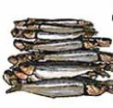Different types of fishes can be raised, including *[Ask participants for names of local fish.]*

Small fish are rich in vitamins, iron, and zinc.

Every day, try to keep at least one fish for your family’s meal especially if you have a pregnant or breastfeeding woman or children aged six months up to two years in your household.

Dry surplus fish harvests for later consumption.

Complement your aquaculture with a garden full of vegetables and fruits to enrich the diets of pregnant and breastfeeding women and of children aged six months up to two years.

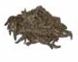To keep the pond productive and the fish healthy:

Keep your pond and its water clean; remove excess mud and unwanted fish.

Lime at recommended doses and frequency *[give names of local brands or products].*

Fertilize at recommended doses and frequency *[give names of local brands or products]*.

Stock fish in the number and size recommended given the space you have.

Protect fish from predators.

Regularly monitor fish growth and health.

Provide supplementary feed.

If feasible, harvest fish partially on a regular basis.

Practice 26. Producing and Consuming Small-Animal Products

Do members of your community understand the importance of small-animal products to the health of families? How have you changed your farming practices to enrich your family meals with small-animal products? *[Discuss in households or among groups of male and female farmers.]*

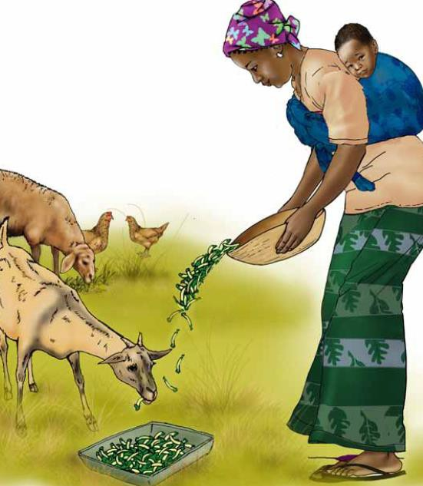Message for Farmers

Rearing poultry and/or small animals provides animal-source foods and helps diversify and enrich the family diet. Always keep some milk, eggs, and/or meat to eat at home, particularly for pregnant and breastfeeding women and a child aged six months up to two years, who require extra nutrients.

More Information

Eggs, milk and meat are rich in protein, vitamins, and minerals.

Raising poultry will provide eggs for home consumption and chicken for additional household income.

Raising small animals such as goats can provide milk and help you build up some reserves for difficult times.

Raising small animals also provides manure, a main ingredient for compost and excellent fertilizer for your crops

Try to set aside at least one or two eggs each day for your family’s meal—in particular for the health of pregnant and breastfeeding women and children after age six months. Eggs will help them grow strong and healthy.

Practice 27. Taking Care of Poultry

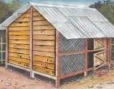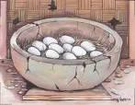Among community members who raise poultry, what are typical feeding and care practices? What hygienic measures are typically observed? What challenges have you yourself faced, and what have you learned about keeping chicken healthy and their environment clean. *[Discussion or group meeting with farmers.]*

Message for Farmers

To have healthy chickens and provide animal-source foods for your family, you must give your animals appropriate shelter, feed, and veterinary care.

More Information

Confine poultry (e.g., ducks and chickens, guinea fowl or quails) in sheds—it is cleaner and healthier for humans and animals and makes it easier to collect manure for the garden.

Set up a poultry shed with plenty of air, light, a raised floor and clean it weekly.

Separate chicks from brood hens right away for the health of the chicks and to keep egg production high.

Use vegetable wastes to feed chickens.

Take chicks to a veterinarian for vaccinations at the right time.

Add milk to family food for young children when they are older than six months. (Give only breastmilk, and no water or food until the child is six months of age.)

Raise poultry to ensure a healthy diet for your family, particularly if your household includes a pregnant or breastfeeding woman or children aged six months up to two years.

Keep at least one egg every day for family consumption—even more if you can—for consumption by pregnant or breastfeeding women and children aged six months up to two years. Raising chickens will also bring additional income.

|  |  |  |  |  |
| --- | --- | --- | --- | --- |
| AGE IN DAYS | VACCINES | DISEASES | ROUTE OF VACCINATION | DOSE |
| 1–7 | BCRDV | Ranikhet | Eye drop | 1 drop in each eye |
| 14–21 | BCRDV, booster dose | Ranikhet | Eye drop | 1 drop in each eye |
| 28–30 | Fowl pox | Pox | Punching with needle under wing (triangular shape) | 1 drop |
| 60 | RDV | Ranikhet | Intramuscular injection | 1 cc |
| 75 | Fowl cholera | Cholera | Subcutaneous injection | 1 cc |
| 90 | Fowl cholera,  booster dose | Cholera | Subcutaneous injection | 1 cc |

Immunization Schedule for Poultry

Practice 28. Composting

Do members of your community practice composting? Do you? What are the advantages, challenges and drawbacks to composting that you have seen? *[Discuss in households or among groups of male and female farmers.]*

Message

Preparing compost fertilizer is an easy technique to produce quality organic fertilizer and improve the yield of your home garden.

More Information

Compost can be prepared at a low cost or no cost from such organic materials as animal droppings, wood chips, branches, leaves, crop residues, vegetable peelings, and other organic household waste.

Using compost increases water retention and soil fertility. Compost aerates the soil, improves its texture and structure, and helps prevent erosion.

Adding compost adds nutrients and microorganisms to the soil to enable healthy and productive crops.

* Incorporate the compost into the soil just before sowing or planting your crops. When crop leaves turn pale yellow after a couple of weeks, more compost or a bit of mineral fertilizer can be added.

How to Prepare Compost for Fertilizer

Make a pit of maximum 1.5m deep, then add a layer of clay soil or ground termite hill

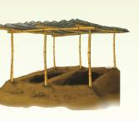Surrounding the hole, make a raised border either with clay or cement bricks

Above the hole, install roofing to provide shade and protect the compost bed from sunshine and rain.

Fill the pit with consecutive layers of organic material: grain stalks, cow dung, household waste (e.g., putrefied leaves, ash, plant residue), and the like.

Water each layer until it is properly soaked

There are many methods to make compost, but here are two simple ways of letting the compost mature:  
(1) **Without turning the soil (takes about 3 months).** Cover the filled pit with a layer of soil/clay and dry plant material such as dry grass, stalks or palm leaves and insert 2-3 wooden sticks into the pit to at least 1 meter depth. Check after about 1 month to see whether the material is properly decomposing by pulling up a stick or digging a deep (50 cm) hole in the material and checking the temperature. If the stick or the material is too hot to hold, add water to the pit. Check at regular intervals (every 2-3 weeks) from then on, adding water when needed. When the temperature of the decomposing material cools off and when the color turns black and the structure becomes fine, the compost is ready.   
**(2) With turning the soil (takes about a month).** Turn the material every 3-4 days and add water when it is very hot or when it appears too dry. After about 1 month, the compost should be of a dark color and ready to use in the field.

Practice 29. Water Management and Mulching

Do members of your community practice mulching and manage water in their garden? Do you? What challenges have you experienced? What have you learned? *[Discuss in households or among groups of male and female farmers.]*

Message for Male and Female Farmers

Harvest water to obtain a year round water supply to support the growth of your diversified crops and enable you to give your family a healthy diet.

How to Manage Your Water Supply Year Round

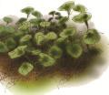Save and reuse waste water from household work (e.g., cooking, cleaning, washing hands, washing).

Collect water in the rainy season to use in the field during dry season. Connecting a gutter or downspout from a rooftop to a large container is one of the simplest methods of rain catchment.

Use mulch—mostly dried plant materials placed on top of the soil surface—to protect the soil from drying out quickly, maintain moisture, minimize the need for watering, and improve soil conditions.

As mulch, consider using water hyacinth, straw, leaves, wood dust, or coconut hulls.

Use mulch for pit crops in your household garden.

Use compost in conjunction with mulch to increases water retention, enhance the fertility of soil, and decrease the proportion of sand and salinity in the soil.

Practice 30. Farmers’ Role in Providing a Varied Diet to Their Pregnant and Breastfeeding Wives, and Young Children

What role do farmers in your community play in providing a varied diet for their families? How do you as a farmer support your family nutrition? What challenges have you experienced? What have you learned? How can market managers be encouraged to add variety to the food on sale in the market, so that there are many different types of colorful food? *[Discuss when you see farmers or men selling their harvest or buying foods, and during household visits and group meetings with farmers.]*

Message for Fathers and Male Farmers

A varied diet will keep your pregnant or breastfeeding wife and your young children aged older than six months growing strong and healthy.

Keep a variety of foods in your home. Buy two or three different types of foods to supplement what you grow.

More Information

If you have a household garden and fruit trees, and raise poultry and/or small livestock, always keep some of what you produce to ensure a variety of food for your family at each meal, with at least two different types of colorful food in addition to porridge and/or rice.

As much as possible, retain some milk, eggs, fish, or meat (fresh or dried) especially for consumption by pregnant or breastfeeding women and children aged six months up to two years.

When you have cash, buy nutritious, colorful foods such as amaranth and red amaranth, country bean, yard-long bean, ash gourd, bitter gourd, bottle gourd, sweet gourd, okra, papaya, radish, Indian spinach, and tomato. These foods are full of vitamins and help strengthen your family.

Always keep some cash on hand to buy fish or eggs for your pregnant or breastfeeding wife and for your children aged six months up to two years.

For your children’s optimal health, ensure that your babies receive breast milk only, and no water or food, until they are six months old; and that your wife continues breastfeeding until your baby’s second birthday.

Annex 1. Galidraa Negotiation Checklist

❑ **G**reet the mother and be friendly. Establish her confidence.

❑ **A**sk about feeding practices, her children’s ages, and their feeding status.

❑ **L**isten to the mother.

❑ **I**dentify feeding challenges and their causes. With the mother, choose one challenge to work   
 to overcome.

❑ **D**iscuss different feasible options with the mother.

❑ **R**ecommend and negotiate doable actions. Present options and negotiate with the mother to help her choose one practice to try.

❑ **A**gree on which practice the mother will try; ask her to repeat the agreed-upon practice   
 back to you.

❑ **A**ppointment made for follow-up visit.

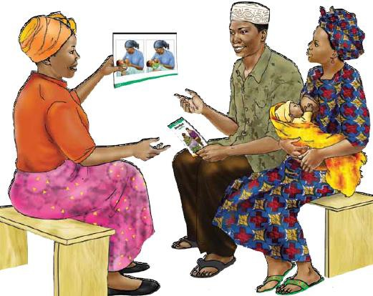

1. John Snow Incorporated, Senior Child Health and Nutrition Advisor
2. Helen Keller International, Senior Vice president
3. Helen Keller International, Senior Nutrition Advisor
4. CORE Group, Consultant
5. <http://www.who.int/nutrition/en/>
6. <http://www.thousanddays.org/>
7. The Lancet. Maternal and Child Undernutrition. The Lancet, 2008, [http://www.thelancet.com/series/maternal-and-child-undernutrition;](http://www.thelancet.com/series/maternal-and-child-undernutrition) and 2013, <http://www.thelancet.com/series/maternal-and-child-nutrition>. This landmark series estimated that effective, targeted nutrition interventions to address maternal and child undernutrition exist, and if implemented at scale during the 1,000-day-long window of opportunity, could reduce nutrition-related mortality and disease burden by 25 percent
8. Black, R. E., C. G. Victora, et al. (2013). “Maternal and child undernutrition and overweight in low-income and middle-income countries.” The Lancet
9. Bhutta, Z. A., J. K. Das, et al. (2013). “Evidence-based interventions for improvement of maternal and child nutrition: what can be done and at what cost?” Lancet.
10. World Health Organization. 2013. “Essential Nutrition Actions: Improving Maternal, Newborn, Infant and Young Child Health and Nutrition.” Geneva: World Health Organization. <http://www.who.int/nutrition/publications/infantfeeding/essential_nutrition_actions/en/.>
11. Guyon AB, Quinn VQ, Hainsworth M, Ravonimanantsoa P, Ravelojoana V, Rambeloson Z, and Martin L. (2009) Implementing an integrated nutrition package at large scale in Madagascar: The Essential Nutrition Actions Framework. Food & Nutrition Bulletin 30(3):233-44.
12. Hampshire, R. D., V. M. Aguayo, et al. (2004). “Delivery of nutrition services in health systems in sub-Saharan Africa: opportunities in Burkina Faso, Mozambique and Niger.” Public Health Nutr 7(8): 1047-1053.
13. (Ruel M, Alderman H, and the Maternal and Child Nutrition Study Group. Nutrition-sensitive interventions and programmes. *Lancet* 2013; published online June 6. <http://dx.doi.org/10.1016/S0140-> 6736(13)60843-0)
14. World Health Organization. 2013. “Essential Nutrition Actions: Improving Maternal, Newborn, Infant and Young Child Health and Nutrition.”

    Geneva: World Health Organization. [http://www.who.int/nutrition/publications/infantfeeding/essential_nutrition_actions/en/.](http://www.who.int/nutrition/publications/infantfeeding/essential_nutrition_actions/en/)