Examine the ground around and below each stack. Use a torch in dark places.
 | Is there spilled or leaking commodity on the floor?
 | Is there visible rodent excrement, insects, worms, dirt, or debris on the floor?
 | Are pallets broken?
Examine the exterior of each stack. |  | 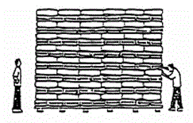
 | Are bags torn or containers broken?
 | Are containers stained or moldy?
 | Are there visible insects, cocoons, or webs?
 | Are the stacks properly interlaced and sides level?
Carefully look inside the stacks. |  | 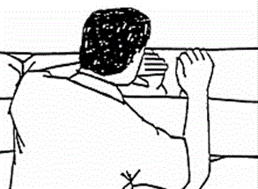
 | Are bags split, or are containers rusting or swelling?
 | Are there webs or cocoons between bags or in the seams?
 | Are there any unusual smells?
 | Does there seem to be “hardening” of bagged flour or blended foods?
Climb to the top of the stack, and spot-check bags or containers underneath the top layer. |  | 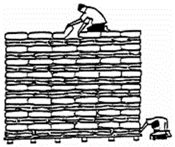
 | Is there visible rodent or bird excrement; insects or worms; dirt or debris?
 | Lift a bag in the middle of the top layer. Does the area under that bag seem unusually warm?
 | Are there any unusual sounds (e.g., crunching or buzzing of insects)?
If authorized, take samples from grain sacks using a sampling spear. Check samples for smell, insect damage, mold, or discoloration.

Remember: Look, listen, smell, and touch.

