- Always access the latest commodity calculator (see A. below) from the USAID Implementation Tools Page, available at: https://www.usaid.gov/what-we-do/agriculture-and-food-security/food-assistance/resources/implementation-tools
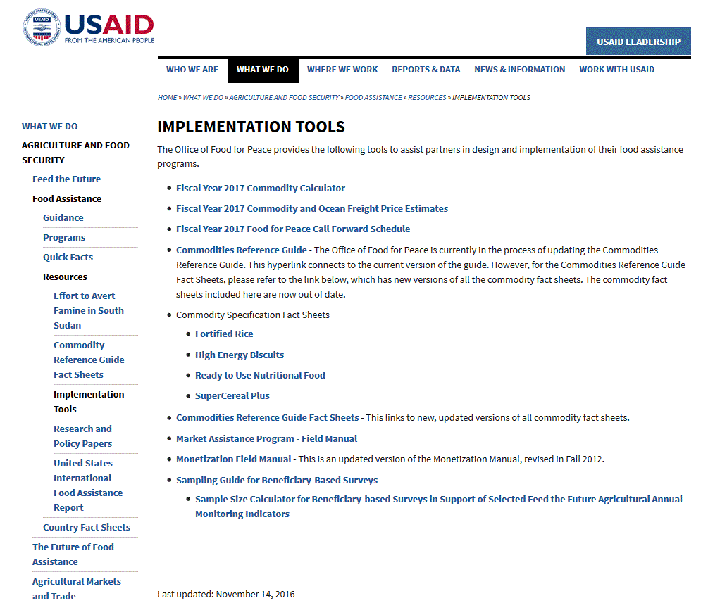
B.
A.
Figure 1: Screenshot of USAID Implementation Tools Page
  - To run the commodity calculator
- Select your commodity from the drop-down menu in the column labeled “Commodity”
- Enter the required number of metric tons in the column labeled “MT”
- Enter the Inland Rate ($/MT), if applicable
- Enter the current ocean freight estimate in the column labeled “Ocean Rate $/MT”
Always access the latest Ocean Freight Price Estimates (see B. above)
- Additional shaded columns will automatically fill
- If “Total Program Cost” exceeds budget, rerun calculator using a less expensive–and acceptable–alternative commodity.
To familiarize yourself with the commodity calculator: See the FY 2017 Commodity Calculation Worksheet on the next page, (which was applicable to the period October – December 2016).

