There are two ways to access the FFP Indicators Handbook for Baseline and Final Evaluation Surveys.
- The document in PDF format is available directly at: https://www.usaid.gov/sites/default/files/documents/1866/Part%20I_Baseline%20and%20Final%20Evaluation_04.13.2015.pdf

- The document – and other information on indicators – can be located on the USAID website.
a.) To enter the USAID FFP site, click (or copy and paste): https://www.usaid.gov/what-we-do/agriculture-and-food-security/food-assistance/guidance
b.) Select “Implementation and Reporting” from the menu on the left.
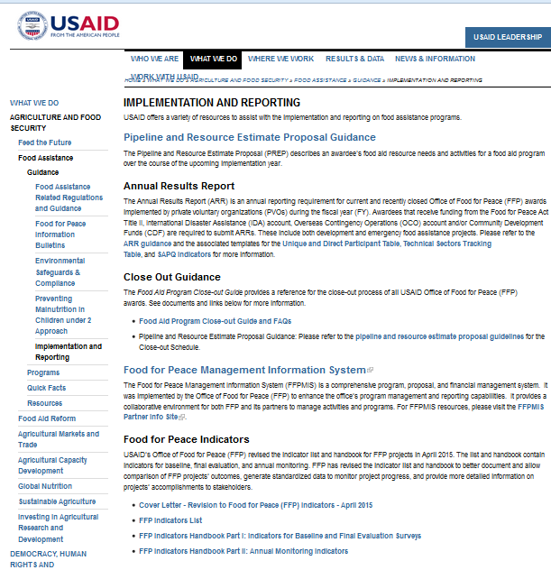
c.) Click on the link for “Part I.”

